|  |
| --- |
| Global sales analysis  2016  M6 Project – Introduction to Aalytics |
| Dhiren Pagrani Professor: Dr. Dee Chiluiza Ryes  October, 22,2020 |





## Global Sales Report

## *Introduction*

Global Super Store dataset is an informational collection of sales that has 1000 entries. The dataset is a customer-driven informational set, which has the information set through various sellers and markets all around the world.

***Graphical Analysis***

In this report, we will be analyzing the variables of the Super Store company to see which part of the world gives better revenue and which part needs improvement. Out of 24 variables in the dataset 10 are considered in this report. Graphs below are made using Descriptive analysis of 5 categorical variables taken in this report. These graphs reveal information about the contribution of individual variables in different regions.

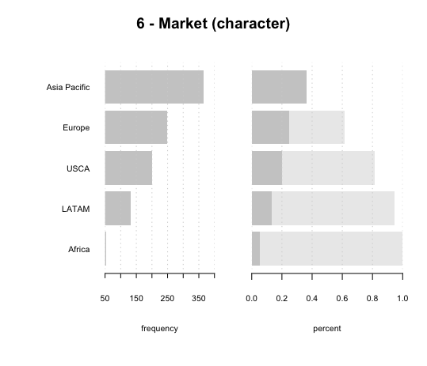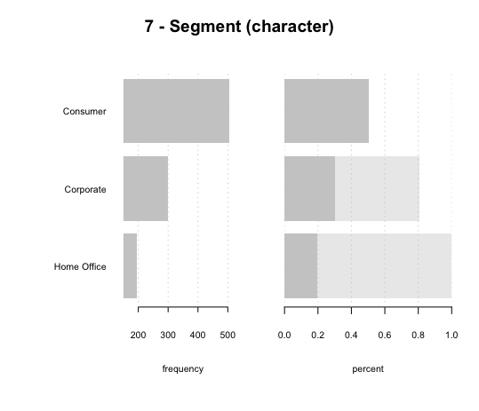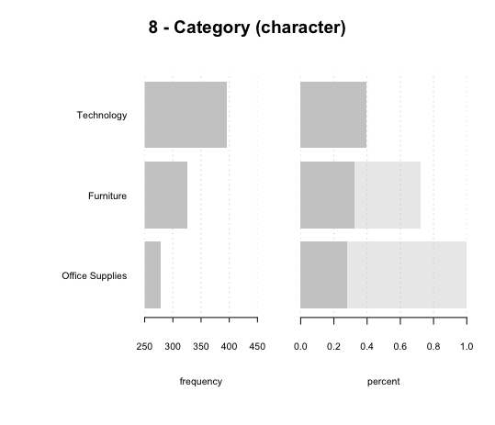

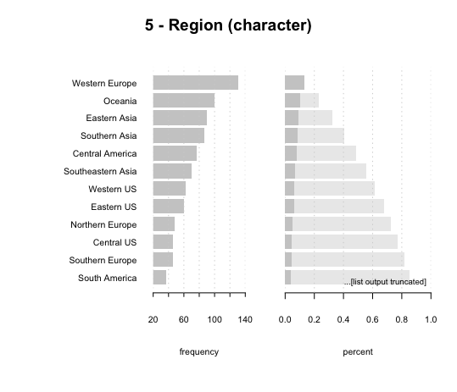 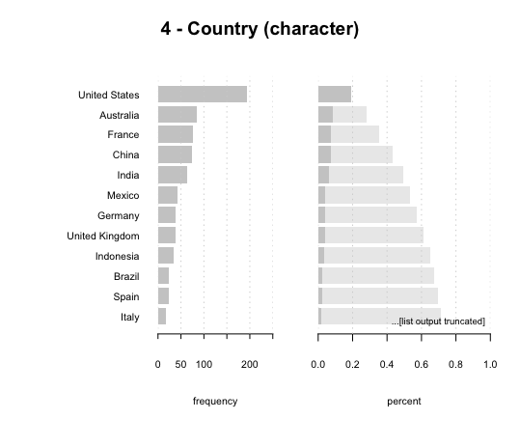

## *Statistical Analysis*

## Statistical analysis of numerical variables.

## 

## *Basic Descriptive Analysis*

## The company sells the highest products in the Asia Pacific and Africa being the lowest.

## Consumer products are sold the most followed by Corporate and then Home office.

## In terms of category, all 3 categories contribute almost equally to sales.

## Maximum products are sold in the US as a country but Region-wise Western Europe has the highest market.

## This shows that the US has a diversified market whereas Europe has a consolidated market.

## Sales figures are varying largely from a single minimum order of $1.91 to a maximum order of $9892.74.

## Profit margins and shipping vary depending on the product and market. We will focus more on the overall market sale by category in this report and not product wise sales.

## *Sales Report by Market*

## Let’s organize sales of the company by Market to better understand the spread of business in different countries.

## A Pie chart is created representing the percentage of Sales per country which is drawn by aggregating sales contribution in each country.

## Total Sales = Price per product * Quantity sold per product.

## 

## It can be found that the Asia Pacific has the highest market share and Africa being the lowest market contributor.

## Asia Pacific contributes almost half of the business of the company which shows a strong grip in the Asian market.

## To avoid complete reliability on the Asian market, the company should start focusing more on other countries also so that every country has equal distribution and market sales can flourish globally.

## Suggestions: 1) Creating stores in Europe, LATAM, USCA, and Africa or by creating a better supply chain with improved market tactics.

## 2) Online Advertising, creating Sub dealers regionally, providing better discounts.

## *Cumulative Sales by Region*

## The cumulative sales can be found out by summing up Total sales. Cumulative Sales by region will show how each region contributes to the total sales of the company.

## The figure below represents the Pareto Chart for Cumulative Sales by Region.

## 

## It can be visually analyzed that Canada contributes the lowest in cumulative sales and Western Europe contributing the highest in growing Total sales.

## As seen in the figure, Asian regions contribute most in sales followed by the US and African countries.

## Suggestions:

## Western Europe generates the highest revenue regardless of its being outside the US. This shows that Europe has great potential. We should start focusing on other regions of Europe. Also, the region with the lowest sales in Canada and Africa. But as there are many regions in Africa we should start focusing on growing sales in Africa and then Canada eventually.

## *Conclusion*

## Overall, African markets seem to have huge hidden potential. The company should start marketing their products and services to generate new orders.

## In terms of region-wise sales, the company should focus on growing sales in the region of Canada primarily as it has the lowest cumulative sales and then all the parts of Africa.

## Using statistical analysis, the Average profit of the product comes to $260.61 whereas the mean tends to be $411.98. This shows that there are huge variances in profit margins depending on the product.

## To increase product sales and widen the horizon of business, the company should start focusing more on products under Office Supplies.

## *Reference:*

## Li Liu, (n.d), *R Base Plotting*, Retrieved from

## https://rstudio-pubs-static.s3.amazonaws.com/503520_739f7eea9dca49cda61abe90b679e2aa.html

## Data Novia, *Top R colors Palettes to know for Great Visualization*

## https://www.datanovia.com/en/blog/top-r-color-palettes-to-know-for-great-data-visualization/

## STHDA, (n.d), *Add legends to plots in R software: the easiest way!*

## http://www.sthda.com/english/wiki/add-legends-to-plots-in-r-software-the-easiest-way

## *Appendix*

## An additional file containing the R codes has been attached to this report. The name of this file is M6Final_Pagrani_Dhiren.R