Analysis:

* 1. Introduction of analysis:

It’s an act, process or profession of studying the activity to define its goals and purpose and to discover its operation and procedures. In other word it’s a pratice of planning, designing and maintaining the software system. A system analyst usually involve in the planing of software, looking for solution and listing out the problem that may occur.

For the analysis part I have included requirement, Natural language analysis (NLA), Use case model or diagram, and class diagram.

In this project I have use SWOT analysis because it’s a technique for understanding your strengths and weakness as well as identifying the opportunities and threats that you will face.

SWOT stands for Strength, Weakness, Opportunities and threats.



Figure 1: SWOT Analysis

Strength:

It helps to identify that what advantage the system holds, what we do better than other etc.

In case of Fitness care system main strenght is its user friendly. User can get many tips about their healthy life.

Weakness:

It help to identify the weakness and where should we improve, those things that should be avoid etc.Fitness care system is a desktop application but most people don’t have desktop and people use mobile instead of desktop.

Opportunities:

It refers to favourable external factors which will give an organization a competative advantage. For the fitness care system there will be lot of helpful factor like online payement as well as buying online supplement.

Threats:

It refers to factors which will harm an organization.Milicious attack may be the threat for the system. May be of over power or large amount of data may make hang or slow the system. Satisfying the customer may be biggest solution for the threats.

2.2 **Feasilbilty study:**

It’s a process of anaysis and evalution of proposed to determine wether it is technically, estimated cost and profitable feasible or not. Feasibility study will make sure that wether my application will be fitted in real word or not. To check the feasiblity study on fitness care system in details is shown below:

Fitness care system is feasible in all aspect of the customers.

* **Financial Feasibility:** This will make sure that there will be financial issues. More than that there will always be limited financial/budget. In future financial/budget limit will not be extended.
* **Technical Feasibility:** This feasibility will chek wether the current technology can support hardware that can handle the system. For the fitness care even normal hardware can support although it’s desktop application. Windows 7 to windows 10 its perfects operating system for the application where windows XP and Vist may no support the application. In case of harddisk, Harddisk atleast contain 1 GB ram.
* **Legal Feasibility:** It’s a law defination. It is done by organization to determinr wether the particular action make sense from the economic standpoint. The goal of this test is to identify make or break issues that would agree against the action.

Here fitness care system didn’t break any law of country or state after implementation. While doing the study of in this project there werent any factos that voilet the laws.

* **Socal/Cultural Feasibility**: it’s a study of aspect of society and local or general cultures sentiment where they are affected by the system or not. Fitness care system wll be accepted by the locals and it will not affect the condition of regilon.
* **Time/Scheduling feasibility:** The project should be complete in given estimated time because the resources and financial/ budget wfor the project will be increase that’s why proper scheduling is necessary. Project will fail if it takes too long period to complete. This feasibility is measure of how reasonable the projext timetable is.
  1. **Requirement analysis**:

It is process of describing the expection of users for an application that is to be built or modified. This involves all the task that are need to be identify for the different stakeholders. Requirement analysis means analyze, document, validate and manage system requirement.

Functional requirement

It will specify a behaviour or function of system. Simply this requirement contan all the possible function that fitness managenet system will have.

Functional requirement can be gather by the help of different technique some of them are listem below:

1. Brainstorming:

Brainstorming is kind of group meating where lots of information and ideas can be gather from the people. In this process mostly possible solution for problems and discussing the oppurtinuties are listed.

For the Fitness care system people around me suggest different idea which I am going to give priotize because some of them are very useful for the customer and the system.

1. Survey:

Survey is a process of recording data in tick form as well as exmining data. It is one of the fastest way as well as less time consuming method to collect the people idea. It can be conduct via online where survey form is sent to different people and they can suggest the idea whenever they want and from where ever.

1. Interview:

It is a process of collecting data or idea from individual people in a locked room through asking questions. Require idea can be gathered from stakeholder and user by questioning them and listing their views and ideas because listening is a great way to analyse the infromation.

1. Observation:

An analyst can identify a process flow, problems and oppurtinuties for improvement just by obesrving the user. Although obesrvation have two type passive and active. Where passive is for getting feedback on prototype and active observation is better at getting an understanding of ana existing process.

1. Prototyping:

It’s a modern technique for gathering requirement where pre module is built for the system before implementing in system. It gather information and preliminary requirement that is going to be bulit.

This system is for providing the daily workout tips and nutration deit for the user.

For the fitness Care System function requirement are

* Interface requirement
* Authentication
* Online Supplement shopping
* Popup information
* Admin panel
* Workout tips
* Nutration tips

|  |  |  |  |  |  |
| --- | --- | --- | --- | --- | --- |
| FID | Function | Data | Rational | Dependency | Remark |
| D01 | Login | Admin’s username and password  User’s username and password | Security | D01 | Login for admin page |
| D02 | Admin panel | No data needed | Checking and posting | D01 | Checking user details, workout progress |
| D03 | Online supplement shopping | No needed | Buying supplement | D02 | Buying supplement |
| D04 | Popup information | No needed | Verifying and checking information and providing information through poopup massage | D02 | Providing information through poopup massage |
| D05 | Workout | Admin enter the workout tips | Daily workout tips for users | D01 | Tips for users |
| D06 | Nutration | Admin enter nutration tips | Daily nutration tips for userd | D01 | Tips for user about their nutration |

Software requirement:

OS: windows 7, Windows 10, Linux, Windows 8.1

Hardware Rewuirement:

Processor: i3, i5, i7

Memory: From 4 GB to above

Moscow priotization:

It’s a process or technique which help to set the priorities. Moscow stand for must have, should have, couldhave and wonthave this time.

Now the Moscow priotization for the Functional requirement are given below:

|  |  |  |
| --- | --- | --- |
| ID | Title | Priority |
| M001 | Login | Must have |
| M002 | Admin Panel | Must have |
| M003 | Online supplement shoping | Should have |
| M004 | Poopup Information | Could have |
| M005 | Workout | Must have |
| M006 | Nutration | Must have |

Non functional requirement:

It’s specifies how the system behaves in terms of Constraints. Non functional requirement list the expression of users like system should be fast, system should be secure, system should be portable and scalable etc.

Some of the non functional reuirement are security, Capacity, Performance, Reliability, Maintainability, and Usability.

|  |  |  |  |
| --- | --- | --- | --- |
| Nid | Function | Rational | Remarks |
| N1 | Security | To protact system from milicious attack and files | Security precation should be taken |
| N2 | Capacity | To handle and hold large amount of data without being hang | High capacity should be checked. |
| N3 | Performance | To maintain the system productivity and behaviour | Expectation should meet, good coding and good comunication should be done |
| N4 | Reliability | To maintain the system trust worthy |  |
| N5 | Maintainability | To repair and replace ffaulty component | Simple coding should be done for future use |
| N6 | Usability | User friendly | Interface should be userfriendly |

Moscow priotization for the non functional requirement are given below:

|  |  |  |
| --- | --- | --- |
| Id | Title | priority |
| N001 | Security | Must have |
| N002 | Capacity | Must have |
| N003 | Performance | Must have |
| N004 | Reliability | Must have |
| N005 | Maintainability | Must have |
| N006 | Usability | Must have |

Use case:

It’s a bussiness analysis presentation of the stage that define the interation between user and system. It helps to show interaction and how the user will work with in the system. Usecase model conatin two diiferent artifact i.e. use case diagram and Use case description.

Use case diagram: It’s a graphical reprensentation of showing which actor can operate which case.

Use case description: It’s a text based detailed, step by step interaction between actor and system.

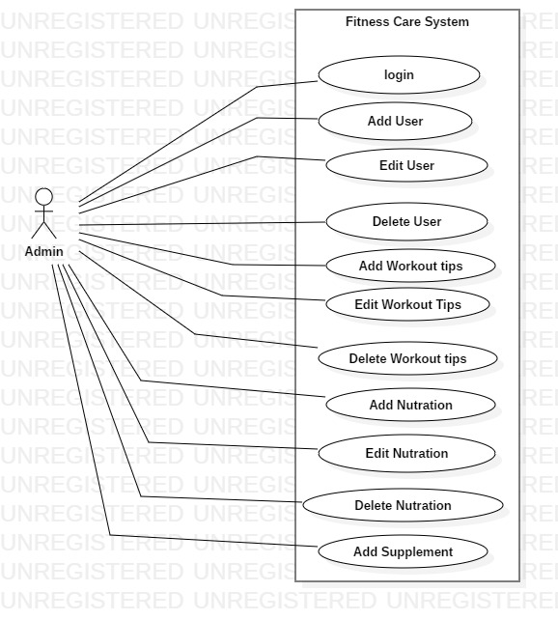

Figure 2: Use case for admin

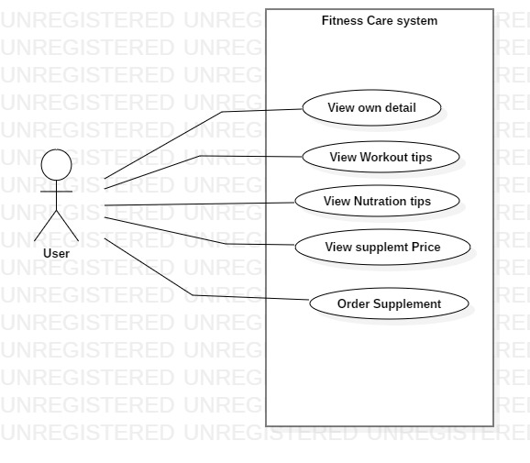

Figure 3: Usecase Diagram for user

Title: Login

|  |  |
| --- | --- |
| ID | U1 |
| Justification | Admin login into the system and operate the different task to add user and other stuff. |
| Primary Actor | Admin |

Title: Add User

|  |  |
| --- | --- |
| ID | U2 |
| Justification | To increase the customer for the system and entry all the record of new user |
| Primary Actor | Admin |

Tittle: Update user

|  |  |
| --- | --- |
| ID | U3 |
| Justification | Incase of error entry of user record admin update or resest the details of user |
| Primary Actor | Admin |

Tittle: Delete User

|  |  |
| --- | --- |
| ID | U4 |
| Justification | Unwanted or error data that contain in the system are deleted by admin and clear some space |
| Primary Actor | Admin |

Tittle: Add Workout tips

|  |  |
| --- | --- |
| ID | U5 |
| Justification | Adding new workout list for the new user |
| Primary Actor | Admin |

Title: Edit Workout tips

|  |  |
| --- | --- |
| ID | U6 |
| Justification | Updating the workout tips according the user body type for their healthy life |
| Primary Actor | Admin |

Tittle: Delete Workout tips

|  |  |
| --- | --- |
| ID | U7 |
| Justification | Same workout for long time may demotivate he user so unwanted and repeated workout should be removed |
| Primary Actor | Admin |

Title: Add Nutration tips

|  |  |
| --- | --- |
| ID | U8 |
| Justification | Promoting healty food by adding nutration tips into system and user will check the tips |
| Primary Actor | Admin |

Title: Edit Nutration tips

|  |  |
| --- | --- |
| ID | U8 |
| Justification | Wrong diet plan will be edited and updated to new deit paln by admin |
| Primary Actor | Admin |

Title: Delete Nutration tips

|  |  |
| --- | --- |
| ID | U10 |
| Justification | Wrong and repated deit will be removed and placed by new plan |
| Primary Actor | Admin |

Title: Add supplement

|  |  |
| --- | --- |
| ID | U11 |
| Justification | New and branded supplement will be inserted in the system so that user can buy the supplement through online. |
| Primary Actor | Admin |

NLA:

Fitness care system is a desktop application. In this application user can create their own account and get information of workput plan and diet plan. This application is developed through c# for the froten and backend and Sql server 2014 management studio for the database.

Writing in paper will not be safe for the comapany and those file may be mispalce or may be eaten by mice.Thats why our company decide to develop the application.This application will help to store data of customer as well as it will show the information of customer start and deadline date of month. In case if customer want to buy supplement then online supplement is available in this application.

|  |  |
| --- | --- |
| Noun | Fitness,Care,system,desktop,application,user,account, information,workout,Supplement,database,Customer,company |
| Verb | Get,develop,writing,store,decide,show,create,eaten,buy, |

Final Nouns: User, Workout, Nutration, Supplement, Customer

Initial class diagram:

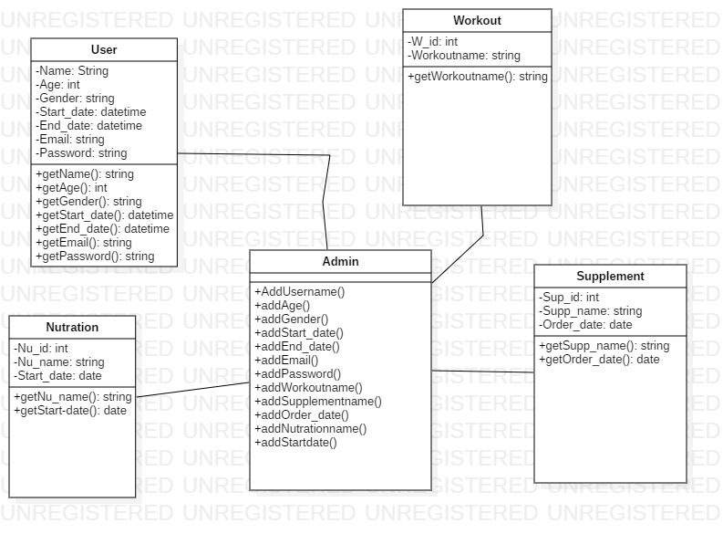

Figure : class diagram of Fitness care system