Design

Structural design:

Structural design is a systematic methodlogy to design specification of software.

Class diagram:

Class diagram is a static diagram which repesent the static view of an application. Class diagram help to identify the class and object of application. In my system class are user, workout, payement, supplement, nutration.

Importance of Class diagram:

1. It help tos how the static view of application
2. It shows the collection of class, interface, associatation, collabration, and constraint.
3. It describe the responsibilities of system.
4. It help in forward and reverse in engineering.

Notation used in Class diagram:





It represent the revelent concept of domain system like set of person, idea or object in the IT system. Some of the class that are in my system are user, supplement, and workout.

1. 

It reperesent the characterstics of class like attribute of class user are name, address, phone no etc.

1. 

It shows the relation ship between two classes.

1. 

It also show the relation between two classes.

1. 

It allows for the statement about the number of object that has been involved.

1. 

It is special case of associatation which means ‘consist of’.

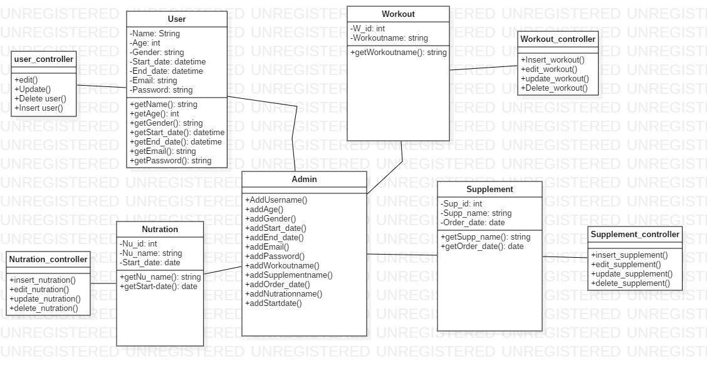

Figure : final class diagram

The above final class diagram is for the fitness care system. In this diagram all the class are seperated with their attribute and the diagram follow MVC pattern so that in realtime system development programmer will follow MVC pattern. Suitable class are seperated.

Data Flow Diagram:

The simple meaning of data flow diagram is its flow of data through the system with right data flow diagra software. Flow of information through the system.

Importanc of data flow diagram:

1. It show the process of system run by the user.
2. It can provide high level of system over view.
3. It provide detail representation of system componenets.
4. It help to visualize current system or the necessary factores that met the new requirement.

Notation of data flow diagram:  
1. 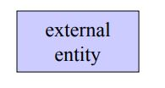

A producer or consumer of information that resides outside the bounds of the system to be modeled.

2. 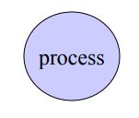

A transformation of system that resides within the bounds of the system to be modeled.

3. 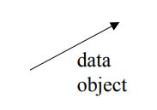

It indicate the direction of data flow

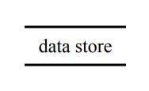4.

A

A repository of data that is to be stored for the use by one or more process.

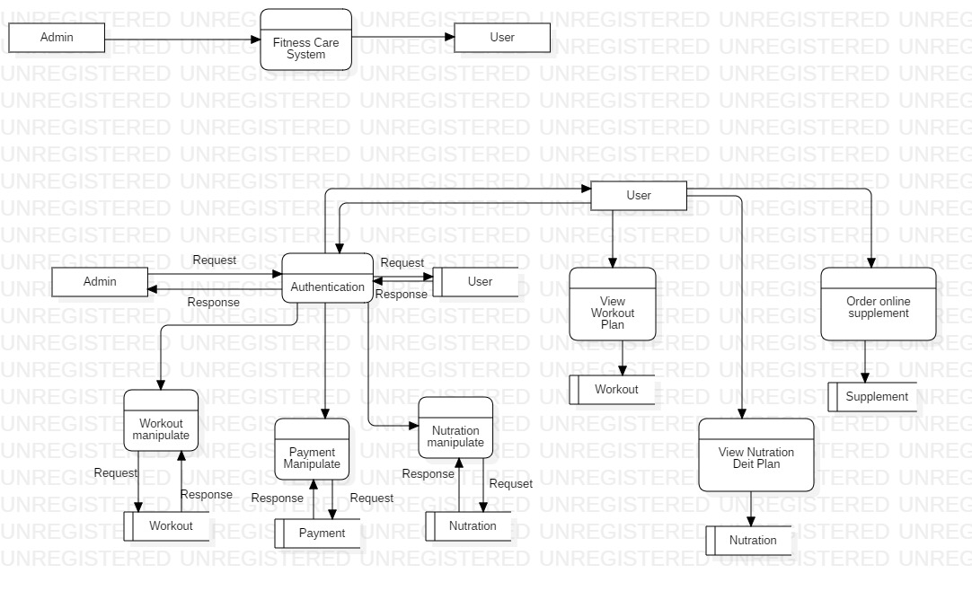

Figure : Data flow diagram

The above diagram is data flow diagram for the fitness care system. It show the flow of data in the diagram. Like for the authentication or enter the system admin or user have to login into the system to login into the system it request to the system and system check to the database whether the enterd email and password is valid or not. It show only admin is allowrd to edit update and add the workout plans, nutration plans etc. and users are only allow to view nutration plan, workout plan. Whenever user view the workout it check from the database and give them the result.

Behavioural Design:

It’s a design that identify common communication patterns between object and realize the pattern. It increase the flexibility in carrying out the communication.

Activity Diagram:

Activity diagram is a behavioural design which describe the dynamic aspect of the system. In fitness care system activity diagram it shows how the user and admin will operate the system. Wether they are allowed to operate the system if they are not register. To operate the system and gain the information that contain in system they have to login successfully.

Importance of Activity diagram

1. It identify pre and post condition for use case.
2. It identify candidate use cases, through the examination of business work flow.
3. Model work flow between or within the use cases.

Notation used in Activity diagram:

1. Initial Node

It indicate the begning of set of action or activities.

1. Final Node: 

It indicate the end of action or activites.

1. Action: 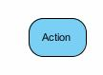

It indicate task to be performed.

1. Activity: 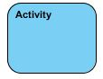

It used to indicate set of action.



1. Control/object flow:

It help to show the sequance of the execution/ show the flow of an object from one activity to another activity.

1. Object Node: 

It help to represent he object that is connect to the set of object flow.

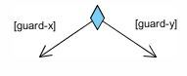

1. Decision Node:

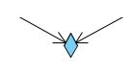It shows the condition to ensure that object or control flow only goes down one path.

1. Merge Node:

It helps in bring back different decision path that has been created.

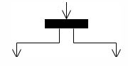

1. Fork Node:

It split behaviour into set of parallel or concurrent activities.

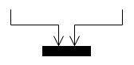

1. Join Node:

It bring back set of parallel or concurrent activities.

1. 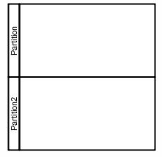Swimelane:

Group of activites performed by the same actor on an activity diagram.

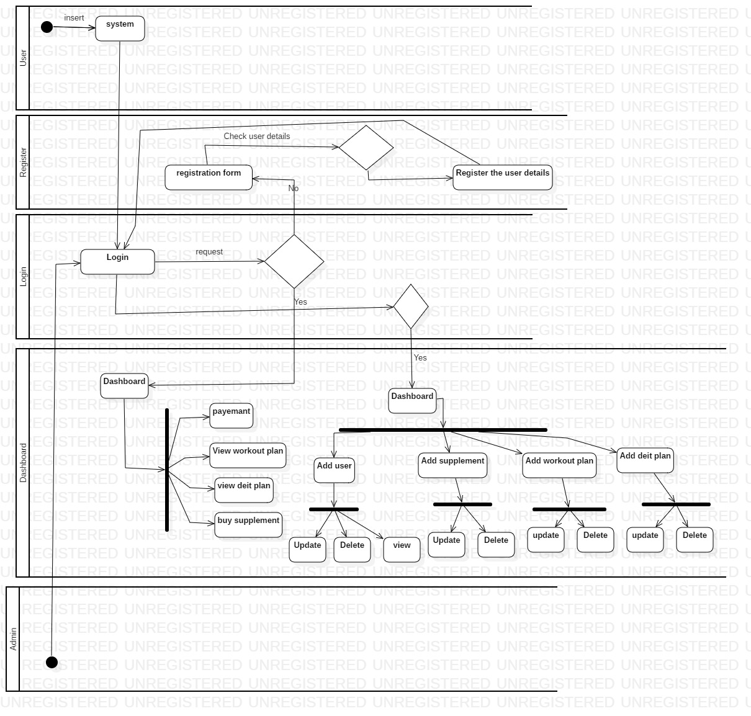

Figure : Activity diagram

In this activity diagram of fitness care system it show the pre and post condition of use case. This diagram show how the system will work like if the user want to know the workout plans or nutration plans they have to login into the system. It will show that what swith will perform what function. To login they have to press login button or to view any function they have to press the particular buttons.

Sequance Diagram:

Sequance diagram is an inetraction diagram that show how the operation are carried out. In case of Fitness care system sequance diagram is applied. They capture the interation between the object in the context of collabration. It’s a time focus and show the order of interacation by imagining the vertical axis of diagram.

Importance of Sequance Diagram:

1. Model high level of interaction between active object.
2. The interation between the object within the collabration of relazies on operation.
3. The interation between the object within the collabration of relazies a use case

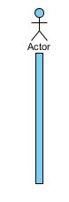

Notation use in Sequance diagram:

1. Actor:

It indicate the role played by the entity that interact with subject as well as it also indicate the external subject of system.

1. 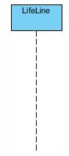Lifeline:

It represent an individual participant in the interaction.

1. Activation:

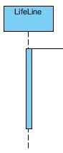

It’s a thin rectangle on a lifeline which represent the period during which an element is performing an operation.

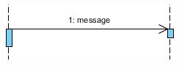

1. Call Message:

It defines particular communication between two different life lines of an ineraction.

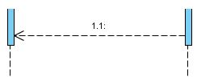

1. Return message:

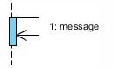It’s a massage that pass of information to the caller of a corresponded former message.

1. Self message:

This repesent the invocation of message of the same lifeline.

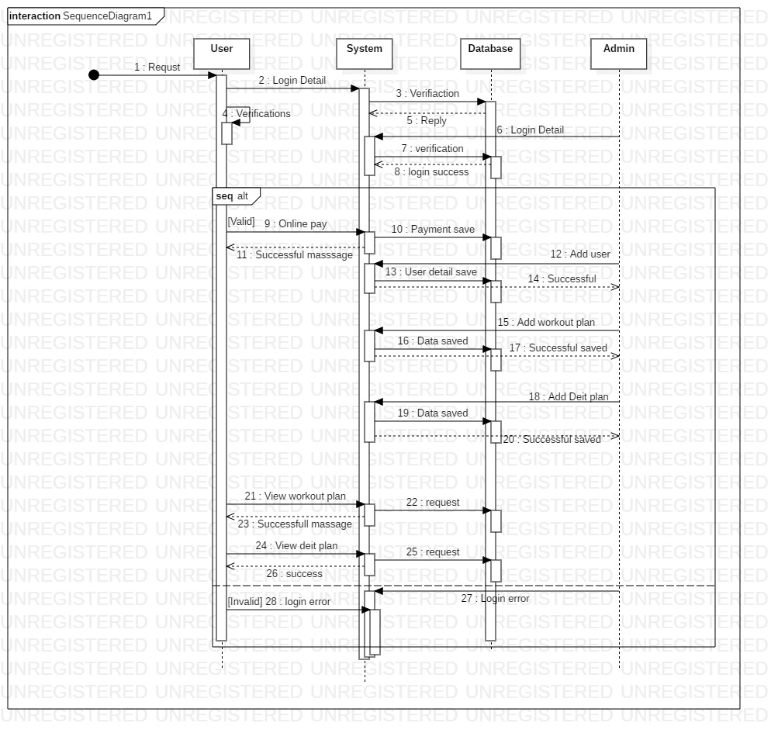

Figure : sequance diagram

Here in this sequance diagram it shows the dynamic function of system. Like all the class that has seperated in class diagram has its own life line and it is overlaped with activation. Every task that perform in the system by the user is requested to the system and it has been checked in database then they it sent reply massage to the users. Only limited task is performed by the user compare to admin. There will apply if else function for the better performance. If the username or email and password is valid then it will enter to dashboard and perform the other task but if it is invalid it will sent it to registration form to reenter the detail.

Database:

Database is a collection of information that is organized so that it can be easily managed, accessed and updated. It organized into rows, columns and tables. Data get updated, expanded and deleted as new information is added.

Data dictionary:

It is a collection of description of the data object or items in a data model for the benefits of programmer or whoever need to refer them. Data dictionary contains metadata.

Importance of database:

1. Details about all the table in the database.
2. Physical information about tables like where they are stored and how.
3. Table constraints like primary key, foreign key etc.
4. Name of all database table and their schemas.

User:

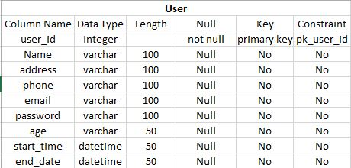

Workout:

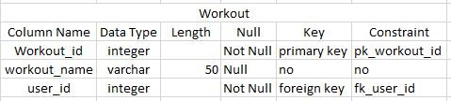

Supplement:

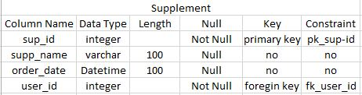

Nutration:  
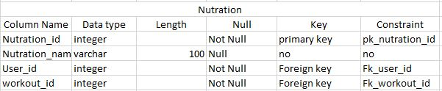

Payment:

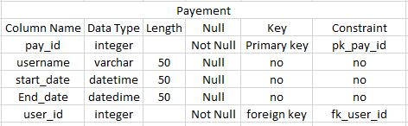

Er-Diagram:

Entity relationship diagram also known as entity relationship model which is a graphical representation of an information system that depicts the relationship among people, object, place etc within the system.

Importance of Er- diagram:

1. It provide the visual starting point for databasedesign.
2. It can be useful to orhanize data that can be represented by a relational structure.
3. Physical data model which can provides the blueprint for a physical manifestation.

Notation used in Er Diagram:

1. Entity:

Entity represent any real world object about which data can be stored. Some of the example of entity are book, student, users etc.

1. Weak entity: 

It doesnot have a primary key attribute and depends on other entity via foreign key.

1. Attribute:

 Each and every entity has properties and the properties of each entity are termd as attributes.

1. Multivalued attirbute

This attribute can hold more than one value that’s why it is termed as multivalued attribute.

1. Relationship:

It shows the bond and attachment between 2 or more entites.

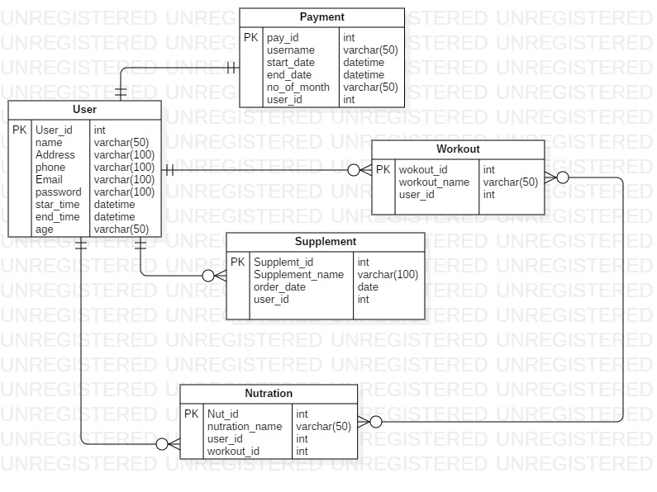

Prototype:

It is a first or preliminary version of software. It is also known as woring example through which new model or a new version of an existing product can be derived. It could be simple as hand drawn sketches.

Impotance of prototype:

1. It help in better understanding of the design intent
2. Early feedback
3. Early changes save time and cost
4. Validation before development
5. User research and testing.

Sample:

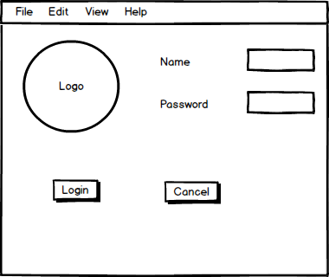Login

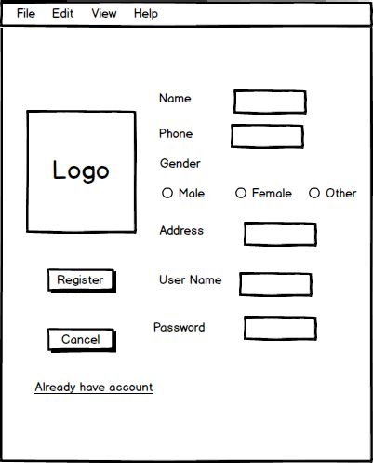Register:

Supplement:

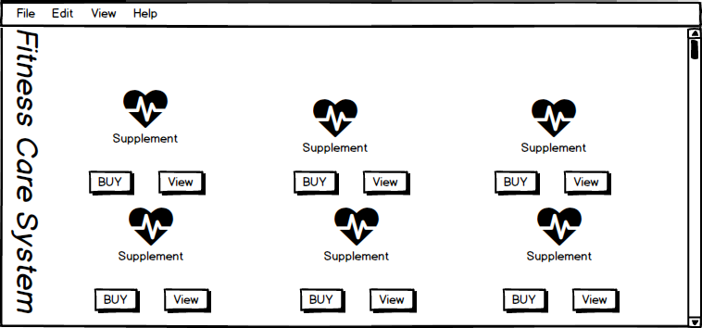

Workout:

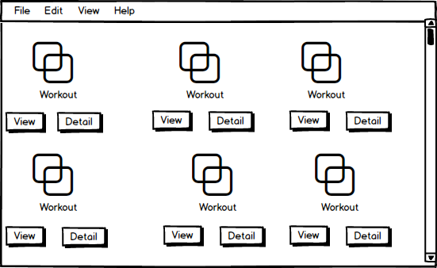

Payment:

