Chapter 4:

Implementations

It is a phase of implamenting actual system requirement into actual time. In this phase code is written to run the system in real time. Through the code actual system is developed for the bussiness purpose or for other purpose. Software development life cycle has different phase and in this phase backend is formed. To develop the system we have to use different tools and different program languages for the backend.

For this projecet i.e. Fitness care system I have choose c#.Net Entity Framework programming language. C# is best choice for developing desktop applcations. It is fast in its execution speeds which will directly save our time as well as it is object oriented progamming language which make easier to maintenance of system, structured programming language.

I have used Microsoft Visual Studio 2015 to develop my system i.e. Fitness Care System. Some of the features of Microsoft Visual studio 2015 are given belows.

1. Code editing: Microsoft Visual Studio 2015 has its own features that we can easily edit code by clicking on bulb icon. Some of the code can be easily generate by clicking on that bulb icon.
2. Debug: Microsoft visual studio 2015 has gave the facility of debuging the code like whenever yo found any error then you have no idea where error occure then you can use debug funtion to find the error during coding.

I have used mvc pattern so the picture that is shown below is of controller part and the rest of the picture of system is shown in user mannual.

User Controller:

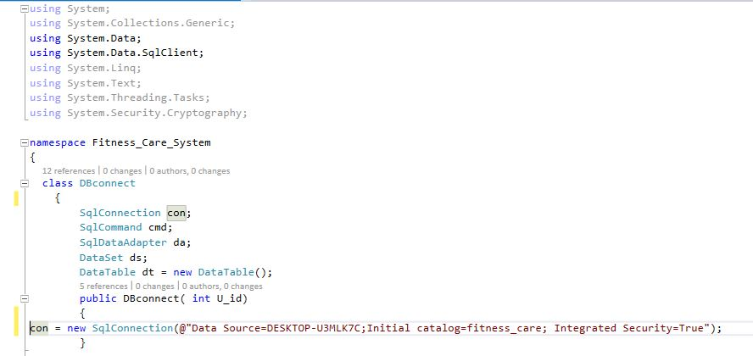

Figure 1: user controller

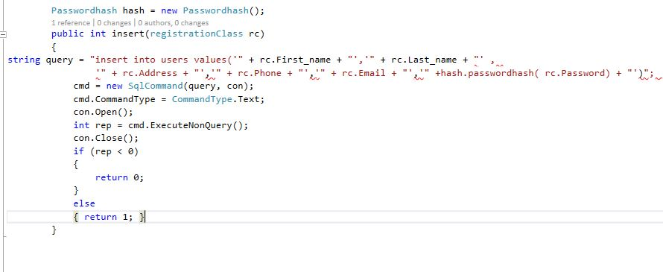

Figure 2: user controller

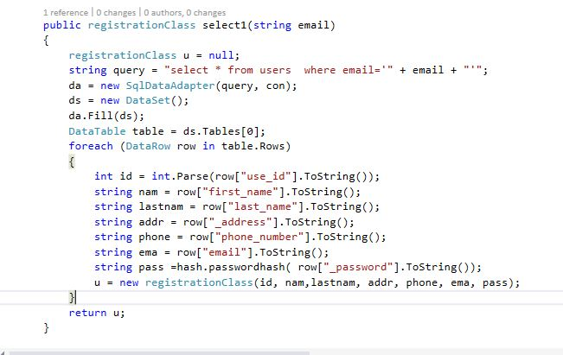

Figure 3: user controller

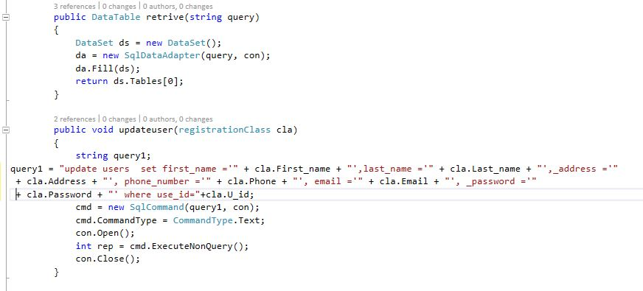

Figure 4: user contoller

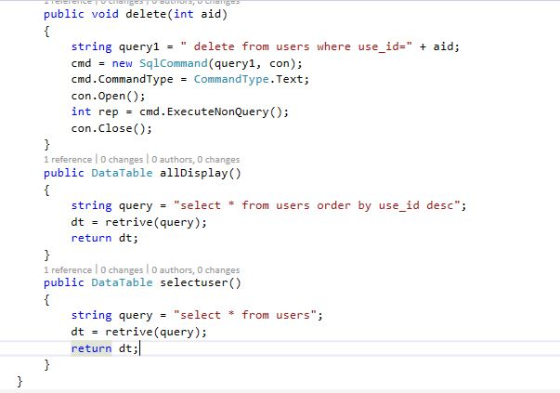

Figure 5: user controller

Payement controller:

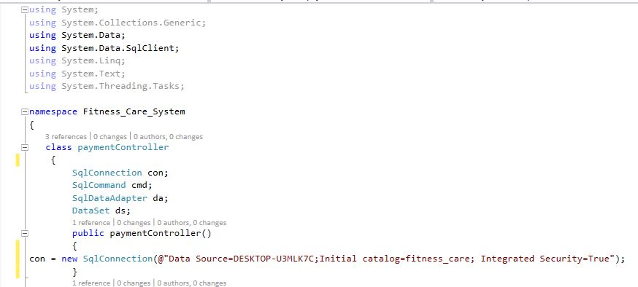

Figure 6: Payment Controller

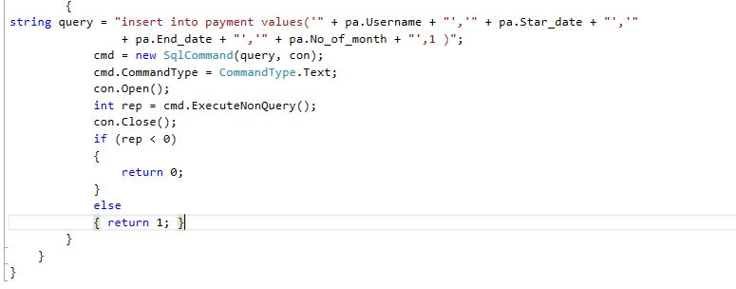

Figure 7: Payment Controller

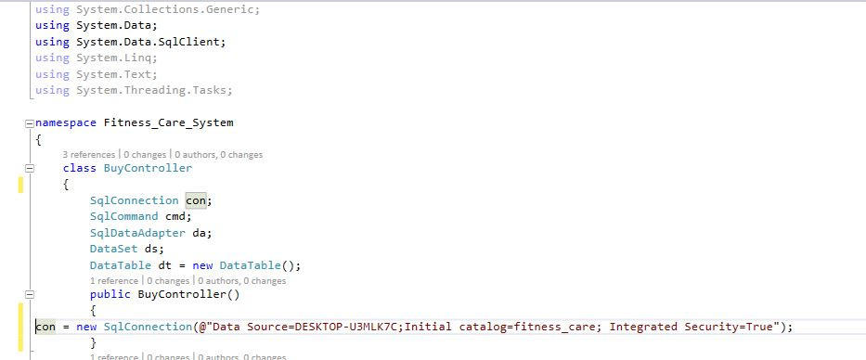Buy Controller

Figure 8: Buy controller

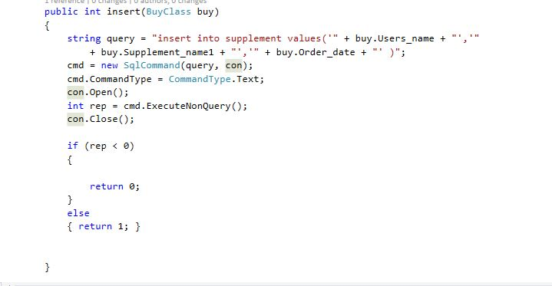

Figure 9: Buy controller