Chapter 5: Testing

It is a process of evaluating a system with the intent to find were it satisfies the specified requirenment. It helps to identify any gaps, errors or any missing requirement. For this project I have done 2 testing that is black box testing and whit box testing.

1. Black box testing:

Black box testing is based on the requirement and functionality. This testing is done for the users by thinking from users view point. This testing can be done once the system is complete. It is effective for large and complex systems.

Here, I have done black box testing in my system I.e. Fitness Care System. Screenshot of testing is shoown below.

Loign validation:

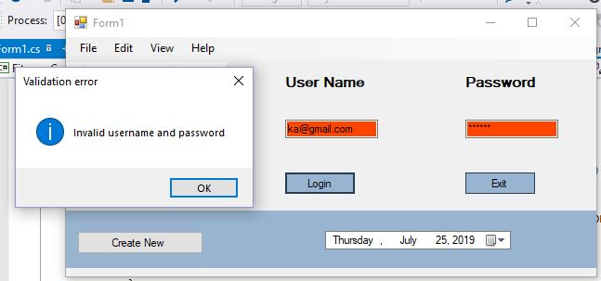

Figure 10: Black box testing in login

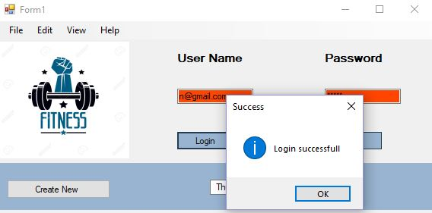

Figure 11: Black box testing in login

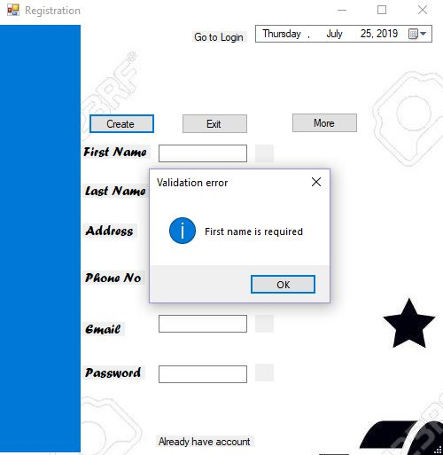

Figure 12: Black box testing in registration form

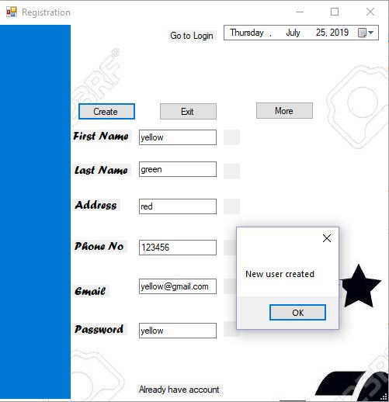

Figure 13: Black box testing in registration form

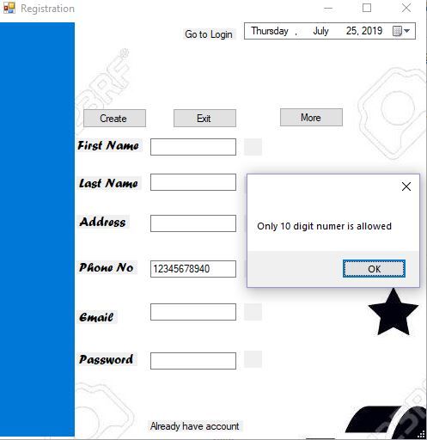

Figure 14: Black box testing in registration form

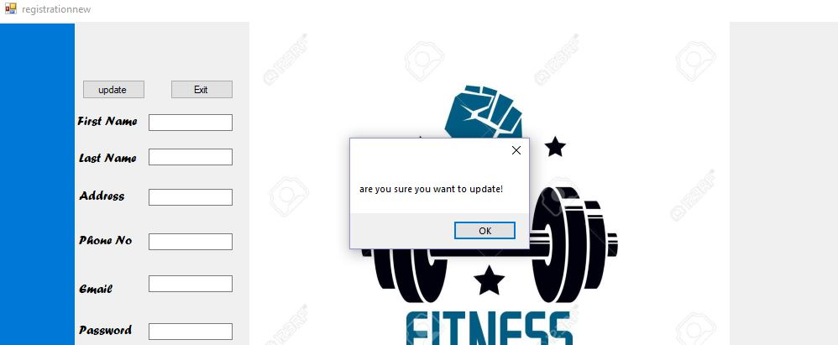

Figure 15: Black box testing in update

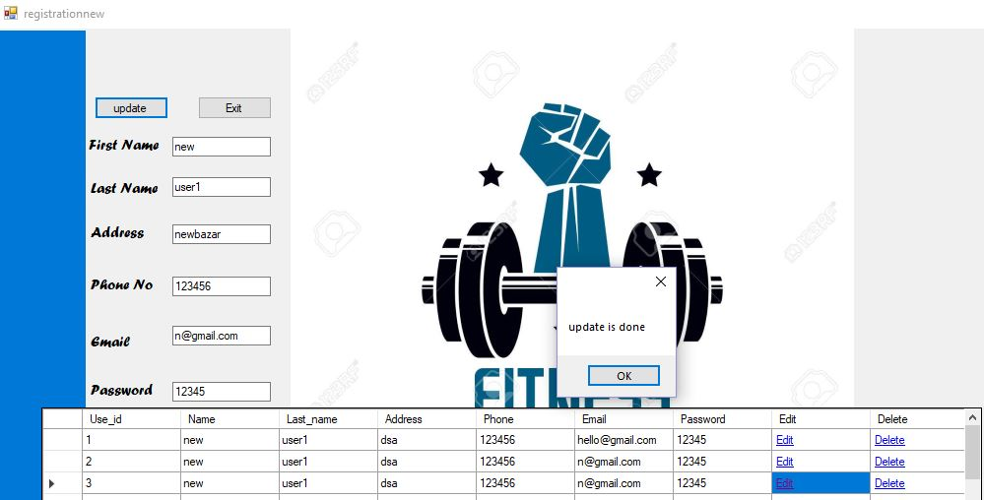

Figure 16: Black box testing in update

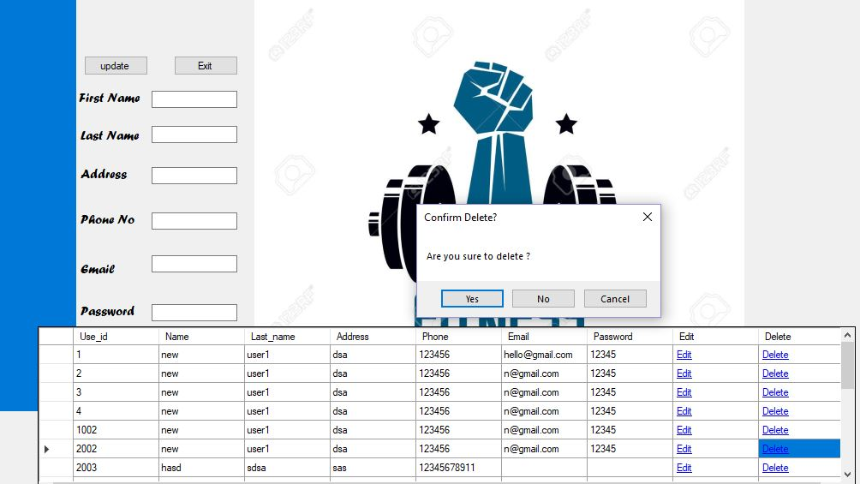

Figure 17: Black box testing in delete