Spring Framework Course
1. Spring Framework Course Overview | Content to cover | Prerequisite | Spring Tutorial in HINDI

Instagram (@Durgesh_k_t)

2. What is Spring Framework | Dependency Injection | Inversion of Control | Spring Core Module | HINDI

Q1. What is Spring?

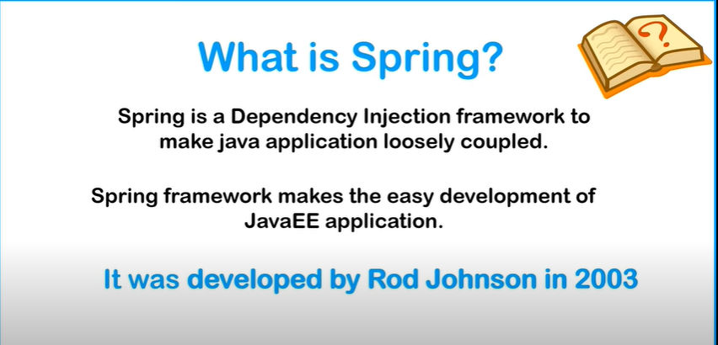

Q2.
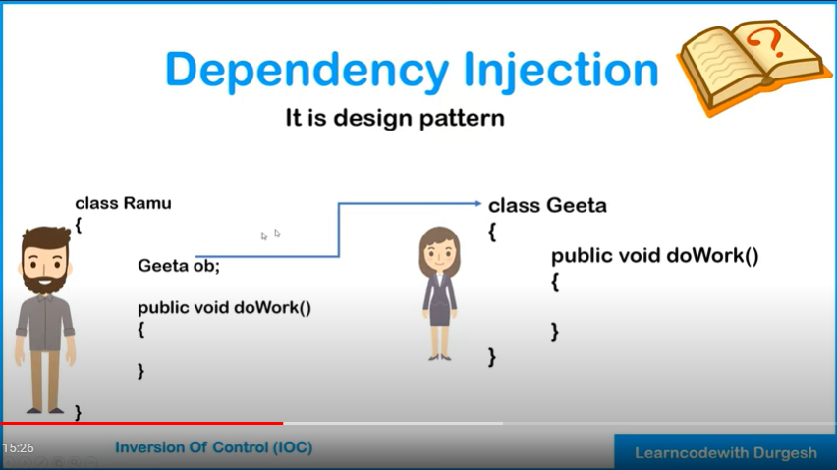

3. Overview of Spring Framework Modules | Spring Core | Spring Data Integration | Spring Web | Hindi

4. Spring IOC Container | What is Spring IOC Container | Spring Tutorial

5. Ways of Injecting dependencies | Types of dependencies handled by IOC Container | Spring Tutorial

6. New Maven Project | Adding Spring Dependencies | Create Config File | Setter Injection | Practical
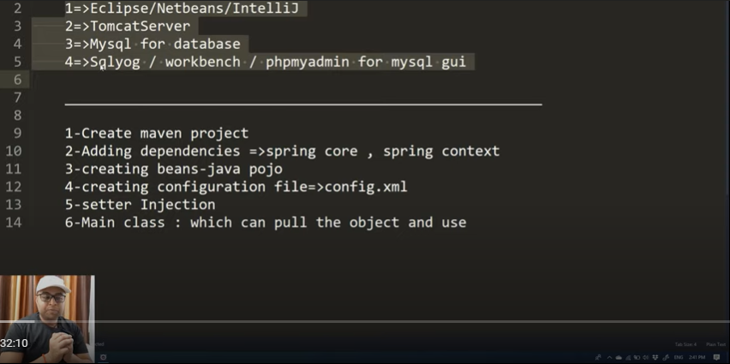

1. Project Start →Create Maven Project
1st Step → Click Next →
Select Catalog: Internal and (Group Id)org.apache.maven.archetypes
(Artifact Id ) → maven-archetype-quickstart

Click Next → (Group Id:) com.springcore → Group Id is basically for Uniquely Identified the project.
(Artifact Id) → Project Name hota hai. Eg SpringFramework
(Package) → com.springboot

POM.XML → Ye humari Project Object Model wali file hai. Iske anadar humlog dependencies batate hai. So hume koi bhi external dependencies lagani hoti hai to hum log POM.XML me add karte hai.

2. Adding dependencies => spring core and spring context.
Google – Search – spring core maven
https://mvnrepository.com/artifact/org.springframework/spring-core

1st Dependencies → Spring Core Dependencies (NOTE- Sabhi dependencies k version same hona chahiye. )

<!-- https://mvnrepository.com/artifact/org.springframework/spring-core -->
<dependency>
<groupId>org.springframework</groupId>
<artifactId>spring-core</artifactId>
<version>5.2.3.RELEASE</version>
</dependency>

2nd Dependencies → Spring Context Dependencies

<!-- https://mvnrepository.com/artifact/org.springframework/spring-context -->
<dependency>
<groupId>org.springframework</groupId>
<artifactId>spring-context</artifactId>
<version>5.2.3.RELEASE</version>
</dependency>

So humne Spring core and Spring Context dependencies add kiya but usse related dependencies automatic add ho gyi . If we want to see → go to Maven Dependencies in Project → Yha pe
spring-core-5.2.3.RELEASE.jar , spring-context-5.2.3.RELEASE.jar , like related add → spring-aop-5.2.3.RELEASE.jar , spring-beans-5.2.3.RELEASE.jar ,

If Error aa rahi hogi. Then go to project and right click and go to Maven → Update Project. And select our project and Click OK.

Q. humne Maven project hi q choose kiya?
Ans . Hum simple java ka core application bana sakte the. But problem ye hoti ki isme spring core and spring context ki dependencies jar alag se download kar k manually daalni padti. So is cheez se bachne k liye hum logo ne use kiya hai maven project. Jisse humne pom.xml lo dependencies batayi hai, baaki vo khud se manage kar lega. Hume kuch bhi nahi karna hoga.

3. creating Beans → Pojo class → Student.java

4. Creating configuration file → config.xml
in Project Go to → src/main/java and right click and go to xml file → create config.xml

Now we add config configuration with the help of Documentation with Google
Search → spring 5 documentation pdf.
https://docs.spring.io/spring-framework/docs/5.0.0.M1/spring-framework-reference/pdf/spring-framework-reference.pdf (Download this PDF for study purpose. )

Go to → Configuration metadata in pdf

and Paste
<beans xmlns="http://www.springframework.org/schema/beans"
xmlns:xsi="http://www.w3.org/2001/XMLSchema-instance"
xmlns:context="http://www.springframework.org/schema/context"
xmlns:p="http://www.springframework.org/schema/p"
xsi:schemaLocation="http://www.springframework.org/schema/beans http://www.springframework.org/schema/beans/spring-beans.xsd
http://www.springframework.org/schema/context http://www.springframework.org/schema/context/spring-context.xsd">
</beans>

Inside → we can use bean jo humne banaye hai. Like Student bean. Ki jab fetch kare to pura class fetch kar sake.
So class me pura naam dena hai. class=”com.springcore.Student” and name=”Student1” kuch bhi de sakte hai.

Here we give 2 things name=” ” and class=” ” of thant Student.Java Bean

<!-- This is our Student Bean Used as Setter Proper -->
<bean class="com.springcore.Student" name="student1">
<property name="studentId">
<value>22344</value>
</property>
<property name="studentName">
<value>Dhirender Yadav</value>
</property>
<property name="studentAddress">
<value>Kanpur</value>
</property>
</bean>

5. Stter Injection

6. Main Class : Which can pull the object and use.

//////
7. Property injection using p Schema and using value as attribute | Spring tutorial
<!-- This is our Student Bean Used value as Attribute Property →

<property name="studentId" value="22344" />

<property name="studentName" value="Dhirender Yadav" />

<property name="studentAddress" value="Kanpur" />

<!-- This is our 3rd Student Bean Value used as P Property given in above xml in line 5-->
<bean class="com.springcore.Student" name="student3" p:studentId="1234" p:studentName="Hanuman" p:studentAddress="Ayodhya" />

8. How to inject collection types List , Set , Map and Properties | Spring Tutorial

9. Injecting Collection Types[ List , Set , Map , Properties ] | Practical | Spring Framework Tutorial

10. Injecting Reference Type Practical Video | Spring Framework Tutorial

<bean class="com.springcore.ref.B" name="bref">
<property name="y" value="90" />
</bean>
<!-- <bean class="com.springcore.ref.A" name="aref">
<property name="x" value="12" />

<property name="ob">
<ref bean="bref"/>
</property>

OR

<property name="ob" ref="bref" />

</bean> -->

<!-- or -->

<bean class="com.springcore.ref.A" name="aref" p:x="33" p:ob-ref="bref"/>

11. Constructor Injection Complete Explanation | Spring Framework Tutorial

12. Ambiguity Problem and its Solution with Constructor Injection | Spring Framework Tutorial

Isme Ambiguity problem :- Humne ek class banaya . Addition.java

usme constructor banaya . Phle int,int …… then double,doube………
and humne iska addition.java ka bean diya uske ciconfig.xml me to usme uski value by default String String Rehti hai.

So jab vo class me jaega. String wala constructor search karega. But use vo nahi milega. To vo phle jo constructor hoga. Vo print karta hai. Suppose int,int phle to int,it=nt dega. Aur agar double,double constructor hoga to double,double print hoga. But Agar humne last me ek aur constructor diya. String,String kar k . to ciconfig.xml use search kar lega aur vo constructor print karaega. This is called Ambiguity problem with Constructor Injection. Exactly vo smjh nahi paa raha ki kya call karna hai.
eg. ciconfig.xml

<bean class="com.springcore.constructioninjection.Addition" name="add">
<constructor-arg value="12"/>
<constructor-arg value="24"/>
</bean>

Class. Addition.java

package com.springcore.constructioninjection;

public class Addition {

private int a;
private int b;

public Addition(int a, int b) {
this.a = a;
this.b = b;
System.out.println("Constructor : int,int");
}

public Addition(double a, double b) {
this.a = (int) a;
this.b = (int) b;
System.out.println("Constructor : double,double");
}

public Addition(String a, String b) {
this.a = Integer.parseInt(a);
this.b = Integer.parseInt(b);
System.out.println("Constructor : String,String");
}

public void doSum() {
System.out.println("Sum is = "+ (this.a + this.b));
}
}

Solution : Iska Solution ye hai ki jab hum apne ciconfig.xml me iska bean add karege then uske constructor-arg me type me int dena hoga.
eg. <bean class="com.springcore.constructioninjection.Addition" name="add">
<constructor-arg value="12" type="int"/>
<constructor-arg value="24" type="int"/>
</bean>

Hum lpg isme Value bhi aage peeche kar sakte with the help of index
eg. <bean class="com.springcore.constructioninjection.Addition" name="add">
<constructor-arg value="12" type="int" index="1"/>
<constructor-arg value="26" type="int" index="0"/>
</bean>
isme Index=0 ki value int a ko milegi and index=1 ki value int b ko milegi.

13. Life Cycle methods of Spring Bean | Spring Framework Tutorial in HINDI

14. Implementing Lifecycle methods Using XML | Spring Bean Lifecycle methods | Spring Framework Tut
init and destroy method call karne k liye hume. Lcconfig.xml me init-method and destroy-method dena padega.

<bean class="com.springcore.lifecycle.Samosa" name="samosa1"
init-method="init" destroy-method="destroy">
<property name="price" value="10" />
</bean>

//// Destroy method print k liye hume ek method call karna padta hai. context.registerShutdownHook(); but ye method hume ApplicationContext me nahi milta.
Iske liye AbstractApplicationContext method call karna padta hai. Iske baad Destoy method sysout me print hoga. For code clean up k liye.

package com.springcore.lifecycle;

import org.springframework.context.ApplicationContext;
import org.springframework.context.support.AbstractApplicationContext;
import org.springframework.context.support.ClassPathXmlApplicationContext;

public class TestLifeCycle {

public static void main(String[] args) {

AbstractApplicationContext context = new ClassPathXmlApplicationContext("com/springcore/lifecycle/lcconfig.xml");
Samosa samosa1 = (Samosa) context.getBean("samosa1");
System.out.println(samosa1);

context.registerShutdownHook();

}

}

15. Implementing bean life cycle using interfaces | IntializingBean | DisposableBean | Spring Tutorial

16. Implementing Bean LifeCyle using Annotations | @PostConstruct | @PreDestroy | Spring Tutorial

IMPORTANT NOTE : Note that both @PostConstruct and @PreDestroy annotations are part of Java EE. And since Java EE has been deprecated in Java 9 and removed in Java 11 we have to add an additional dependency to use these annotations:
https://www.baeldung.com/spring-postconstruct-predestroy

Use This Dependency <dependency> <groupId>javax.annotation</groupId> <artifactId>javax.annotation-api</artifactId> <version>1.3.2</version> </dependency>

eg. Example.java

package com.springcore.lifecycle;

import javax.annotation.PostConstruct;
import javax.annotation.PreDestroy;

public class Example {

private String subject;

public String getSubject() {
return subject;
}

public void setSubject(String subject) {
this.subject = subject;
}

public Example(String subject) {
super();
this.subject = subject;
}

public Example() {
super();
// TODO Auto-generated constructor stub
}

@Override
public String toString() {
return "Example [subject=" + subject + "]";
}

@PostConstruct
public void start() {
System.out.println("Starting Method ");
}

@PreDestroy
public void end() {
System.out.println("Ending method ");
}
}

by defualt annotationss desabled rehta hai. To vo Sysout me print nahi hota.
Hume saare ANNOTATION enable karne k liye: s
lcconfig.xml me → <context:annotation-config /> enable karna padta hai.
Note: - ye spring me hum jitne bhi annotation use karte hai. Sabhi ko enable kar deta hai.

eg. lcconfig.xml

<?xml version="1.0" encoding="UTF-8"?>
<beans xmlns="http://www.springframework.org/schema/beans"
xmlns:xsi="http://www.w3.org/2001/XMLSchema-instance"
xmlns:context="http://www.springframework.org/schema/context"
xmlns:p="http://www.springframework.org/schema/p"
xsi:schemaLocation="http://www.springframework.org/schema/beans http://www.springframework.org/schema/beans/spring-beans.xsd
http://www.springframework.org/schema/context http://www.springframework.org/schema/context/spring-context.xsd">
<context:annotation-config />

<!-- <bean class="com.springcore.lifecycle.Samosa" name="samosa1"
init-method="init" destroy-method="destroy">
<property name="price" value="10" />
</bean> -->
<!-- OR -->
<bean class="com.springcore.lifecycle.Samosa" name="samosa1"
init-method="hey" destroy-method="bye">
<property name="price" value="10" />
</bean>

<bean class="com.springcore.lifecycle.Pepsi" name="pepsi1">
<property name="price" value="50" />
</bean>

<bean class="com.springcore.lifecycle.Example" name="example1">
<property name="subject" value="Maths" />
</bean>

</beans>

NOTE:- If hume Particular annotation ko disable se enable karna hai . Then Uske liye.
1st. Hume ye comment karna padega.
In → lcconfig.xml → <!-- <context:annotation-config /> →
and isme ek bean banani padegi.

2nd Hume apne → TestLifeCycle.java class me CTRL+SHIFT+T press kar k
CommonAnnotationBeanPostProcessor us class me ja kar uska proper paath with class name lena padega and <bean class=”org.springframework.context.annotation.CommonAnnotationBeanPostProcessor”/> me add karna padega.
To humara ye wala(@PostConstruct and @PreDestroy) annotation work karega.

17. Autowiring in Spring Framework | Best Explanation | Spring Tutorial in HINDI

18. Autowiring using XML complete Session | byName | byType | byConstructor | Spring Tutorial

1. ByName → autowireconfig.xml → me autowire=”byName” hai to jo humari 2 class hai.

Humari 2 class hai. 1st Emp.java and 2nd Address.java . Humari emp class address class pe depend hai.
Jab hum autowire byname use karte hai tab vo bean ka name=”address” and emp class me private Address address; variable match karta hai. Agar vo same hai to vo output print karta hai. And Agar humne class ka variable name=”address” , xml k name=”address” alag hoga to null deta hai.
autowireconfig.xml →
<?xml version="1.0" encoding="UTF-8"?>
<beans xmlns="http://www.springframework.org/schema/beans"
xmlns:xsi="http://www.w3.org/2001/XMLSchema-instance"
xmlns:context="http://www.springframework.org/schema/context"
xmlns:p="http://www.springframework.org/schema/p"
xsi:schemaLocation="http://www.springframework.org/schema/beans http://www.springframework.org/schema/beans/spring-beans.xsd
http://www.springframework.org/schema/context http://www.springframework.org/schema/context/spring-context.xsd">

<bean class="com.springcore.auto.wire.Address" name="address" >
<property name="street" value="Rampuram"></property>
<property name="city" value="Kanpur"></property>
</bean>

<bean class="com.springcore.auto.wire.Emp" name="emp1" autowire="byName"/>

</beans>

2. ByType:- byType me Vo xml me uska bean ka class=”com.springcore.auto.wire.Address” dekhte hai. And Emp me vo class dekhte hai. Private Address address;.

19. @Autowired Annotation for Autowiring | Autowiring in Spring Framework | Spring Framework Tutorial

20. @Qualifier Annotation with Autowiring | Spring Framework Tutorial
ye annotation hum tab use karte hai jab hum config.xml me 1 se jyada bean dete hai. Aur hum alag alag bean ki value print karana chahte hai.

21.Spring Standalone Collections[List,Map,Properties] | Util Schema in Spring | Spring Tutorial

for standalone list we add some lines or schema ie. util schema in config.xml
1. xmlns:util="http://www.springframework.org/schema/util"
2. http://www.springframework.org/schema/util http://www.springframework.org/schema/util/spring-util.xsd

complete eg. <?xml version="1.0" encoding="UTF-8"?>
<beans xmlns="http://www.springframework.org/schema/beans"
xmlns:xsi="http://www.w3.org/2001/XMLSchema-instance"
xmlns:context="http://www.springframework.org/schema/context"
xmlns:p="http://www.springframework.org/schema/p"
xmlns:util="http://www.springframework.org/schema/util"
xsi:schemaLocation="http://www.springframework.org/schema/beans http://www.springframework.org/schema/beans/spring-beans.xsd
http://www.springframework.org/schema/context http://www.springframework.org/schema/context/spring-context.xsd
http://www.springframework.org/schema/util http://www.springframework.org/schema/util/spring-util.xsd">

<!-- standalone List -->
<!-- <util:list list-class="java.util.LinkedList" id="mybestfriends">
<value>Ashish</value>
<value>Javed</value>
<value>Jigyasa</value>
<value>Pooja</value>
<value>Bhavya</value>
</util:list> -->

<util:list list-class="java.util.Vector" id="mybestfriends">
<value>Ashish</value>
<value>Javed</value>
<value>Jigyasa</value>
<value>Pooja</value>
<value>Bhavya</value>
</util:list>

<!-- standalone Map HashMap-->
<!-- <util:map map-class="java.util.HashMap" id="fees">
<entry key="Spring Framework" value="8000"/>
<entry key="Django Framework" value="5000"/>
<entry key="Hibernate Framework" value="2000"/>
</util:map> -->

<!-- or -->
<!-- standalone Map TreeMap-->
<util:map map-class="java.util.TreeMap" id="fees">
<entry key="Spring Framework" value="8000"/>
<entry key="Django Framework" value="5000"/>
<entry key="Hibernate Framework" value="2000"/>
</util:map>

<!-- standalone Properties-->

<util:properties id="dbconfig">
<prop key="driver">com.mysql.jdbc.Driver</prop>
<prop key="username">dhirender</prop>
<prop key="password">dhirender123</prop>
<prop key="url">mysql:jdbc://localhost:3306/database</prop>
</util:properties>

<bean class="com.springcore.standalone.collection21.Person" name="person1">
<!-- <property name="friends">
<ref bean="mybestfriends"/>
</property> -->

<!-- or -->

<property name="friends" ref="mybestfriends" />
<property name="feestructure" ref="fees" />
<property name="properties" ref="dbconfig" />
</bean>

</beans>

22. Stereotype Annotations | @Component Annotation | @Value Annotation | Spring Tutorial in HINDI

isme hum log config.xml me bean nahi likhte hai, hum log
→ <context:component-scan base-package="com.springcore.stereotype22"/>
ye add karte hai. And then Student.java class me
→ @Component Annotation add karte hai.
By default null deta hai. So Value k liye hum log → @Value Annotation use karte hai.

23. Collections with @Value | Spring Framework Tutorial in HINDI

24. Spring Bean Scope | Singleton | Prototype | how to configure scope spring tutorial in hindi

In this we can use by both xml or annotation .
For annotation we can use → @Scope("prototype") for singleton to prototype

Singleton → kya karta hai. Hum jab bhi new object banate hai. Suppose Student ka new Object banaye to wo baar baar same hashcode lega. Sabhi new object of student k liye
but
→ prototype → kya karta hai, humesha new object k liye new hashcode laa kar deta hai.

Ye 2 type se kar sakte hum log.
1st → Annotation , 2nd → xml file k through.

Annotation → @Scope("prototype") use karte Class me ye. Humesha. @Component("jonaamhumdenge") k saath hi use hota.

Xml wala eg.
config.xml → bean add karte hum log.
<bean class="com.springcore.stereotype22.Teacher" name="teacher" scope="prototype"></bean>

25. Spring Expression Language | SpEL | what is SpEL | How to use Expression | Spring Tutorial in hindi

26. How to invoke static method , variables and creating object | Spring Expression Language | Tutorial

for static method we use conventions → eg. Demo class
→ @Value("#{T(java.lang.Math).sqrt(25)}")
private double z;

we use this convetion for getting static values .

We have syntax for creating new object also.

eg. Demo.java →

package com.springcore.spel25;

import org.springframework.beans.factory.annotation.Value;
import org.springframework.stereotype.Component;

@Component
public class Demo {
@Value("#{22+11}")
private int x;

@Value("#{2+5+56+33}")
private int y;

@Value("#{T(java.lang.Math).sqrt(25)}")
private double z;

@Value("#{T(java.lang.Math).E}")
private double e;

@Value("#{new java.lang.String('Dhirender Yadav')}")
private String name;

public double getZ() {
return z;
}

public void setZ(double z) {
this.z = z;
}
public int getX() {
return x;

}

public void setX(int x) {
this.x = x;
}

public int getY() {
return y;
}

public void setY(int y) {
}

public Demo() {
super();
}

public Demo(int x, int y) {
super();
this.x = x;
this.y = y;
}

@Override
public String toString() {
return "Demo [x=" + x + ", y=" + y + ", z=" + z + ", e=" + e + ", name=" + name + "]";
}

}

27. Boolean type with SpEL | Spring Expression Language | Spring Framework tutorial

@Value("#{8>3}")
private boolean isActive;

28. Removing Complete XML for Spring Configuration | @Configuration | @ComponentScan | @Bean Annotation

In Test class → ApplicationContext context = new AnnotationConfigApplicationContext(JavaConfig.class ); for remove config.xml file

and make a new java class for config → JavaConfig.java

→ package com.springcore.javaconfig28;

import org.springframework.context.annotation.ComponentScan;
import org.springframework.context.annotation.Configuration;

@Configuration
@ComponentScan(basePackages = "com.springcore.javaconfig28")
public class JavaConfig {

}

→ Student.java

package com.springcore.javaconfig28;

import org.springframework.stereotype.Component;

@Component("firststudent")
public class Student {

public void study() {
System.out.println("Student is reading book ");
}

}

NOTE:- when we are using @Bean Annotation
→ In JavaConfig.java class

@Bean
public Student getStudent() {

// Creating a new Student Object
Student student = new Student();
return student;
}
at this time , agar hum log → @ComponentScan(basePackages = "com.springcore.javaconfig28") nahi bhi use kiya tho vo chalega.

→ @Bean k time pe
package com.springcore.javaconfig28;

import org.springframework.context.annotation.Bean;
import org.springframework.context.annotation.ComponentScan;
import org.springframework.context.annotation.Configuration;

@Configuration
// @ComponentScan(basePackages = "com.springcore.javaconfig28")
public class JavaConfig {

@Bean
public Student getStudent() {

// Creating a new Student Object
Student student = new Student();
return student;
}

}

Student.java
→
package com.springcore.javaconfig28;

import org.springframework.stereotype.Component;

// @Component("firststudent")
public class Student {

public void study() {
System.out.println("Student is reading book... ");
}

}

29. What is Spring JDBC | Introduct to Spring JDBC | Why to use Spring JDBC | Spring JDBC Tutorial

30.Creating new Maven Project | Adding Spring JDBC Dependencies | Spring JDBC Tutorial

Adding 2 dependencies 1st → Spring JDBC and 2nd → mysql connector
for these 2 dependencies go to google and search spring jdbc maven dependencies.
And remember→ Search same version of Spring Core.
Webiste for all maven dependencies → https://mvnrepository.com/artifact/org.springframework/spring-jdbc

1st → <!-- This Dependency used for Spring JDBC Purpose -->
<!-- https://mvnrepository.com/artifact/org.springframework/spring-jdbc -->
<dependency>
<groupId>org.springframework</groupId>
<artifactId>spring-jdbc</artifactId>
<version>5.2.3.RELEASE</version>
</dependency>

2nd → <!-- https://mvnrepository.com/artifact/mysql/mysql-connector-java -->
<dependency>
<groupId>mysql</groupId>
<artifactId>mysql-connector-java</artifactId>
<version>5.1.30</version>
</dependency>

31. Database setup | Configuring Jdbc Template to execute query | Spring Tutorial in HINDI

