**Problem statement for public health awareness project**

Public health awareness projects are essential for promoting healthy behaviors and improving the health and well-being of individuals, families, and communities. However, many public health awareness projects are ineffective due to a variety of factors, such as poor planning, lack of resources, and failure to evaluate their impact.

In order to be effective, public health awareness projects must be carefully planned and implemented. The first step is to identify the specific public health issue that the project will address. Once the issue has been identified, the project team must develop a clear and concise problem statement that outlines the nature of the problem, the population affected, and the impact of the problem.

The problem statement should be used to guide the development of the project's goals, objectives, and strategies. The goals should be specific, measurable, achievable, relevant, and time-bound. The objectives should be smaller, more specific steps that will help to achieve the goals. The strategies should be specific actions that will be taken to implement the objectives.

It is also important to evaluate the impact of public health awareness projects. This can be done by collecting data on changes in knowledge, attitudes, and behaviors among the target population. Evaluation data can be used to improve future projects and ensure that they are using resources effectively.

**Here is an example of an problem statement for a public health awareness project**:

**Problem statement:**

Childhood obesity is a major public health problem in the United States. According to the Centers for Disease Control and Prevention, one in five children in the US is obese. Obesity is a risk factor for a number of chronic diseases, including heart disease, stroke, type 2 diabetes, and some types of cancer.

**Impact:**

Childhood obesity has a significant impact on children's health and well-being. Obese children are more likely to experience bullying, low self-esteem, and depression. They are also more likely to develop chronic diseases later in life.

**Solution:**

Public health awareness projects can help to address the problem of childhood obesity by educating parents and children about the importance of healthy eating and physical activity. These projects can also promote healthy environments and policies that support healthy behaviors.

**Goal:**

The goal of this public health awareness project is to increase awareness of childhood obesity and promote healthy behaviors among children and parents in the local community.

This problem statement is clear, concise, and informative. It outlines the nature of the problem (childhood obesity), the population affected (children and parents), and the impact of the problem (increased risk of chronic diseases, bullying, low self-esteem, and depression). The problem statement also provides a clear rationale for the project and its goals.

* lack of consensus on the content of the public health mission;
* inadequate capacity to carry out the essential public health functions of assessment, policy development, and assurance of services;
* disjointed decision-making without necessary data and knowledge;
* inequities in the distribution of services and the benefits of public health;
* limits on effective leadership, including poor interaction among the technical and political aspects of decisions, rapid turnover of leaders, and inadequate relationships with the medical profession;
* organizational fragmentation or submersion;
* problems in relationships among the several levels of government;
* inadequate development of necessary knowledge across the full array of public health needs;
* poor public image of public health, inhibiting necessary support; and
* special problems that limit unduly the financial resources available to public health

**Example:**

Piechart

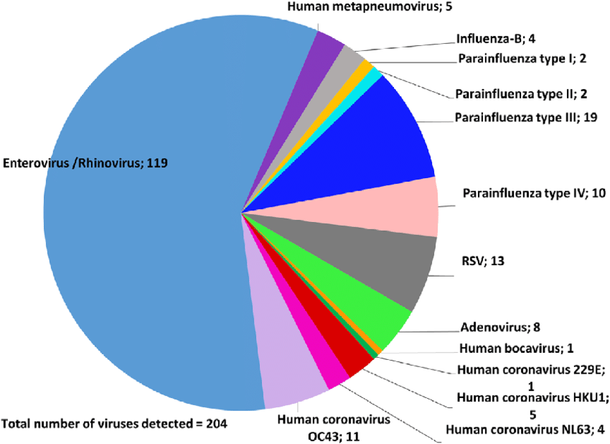

**Flowchart:**

