COMPARTABLITY TESTING

APP name : Book my show

Testing mode: Browsing Compartability Testing

Searching platform: Firefox

Searching platform: Chrome

Number of Bugs found: 05

BUG:1

Firefox :

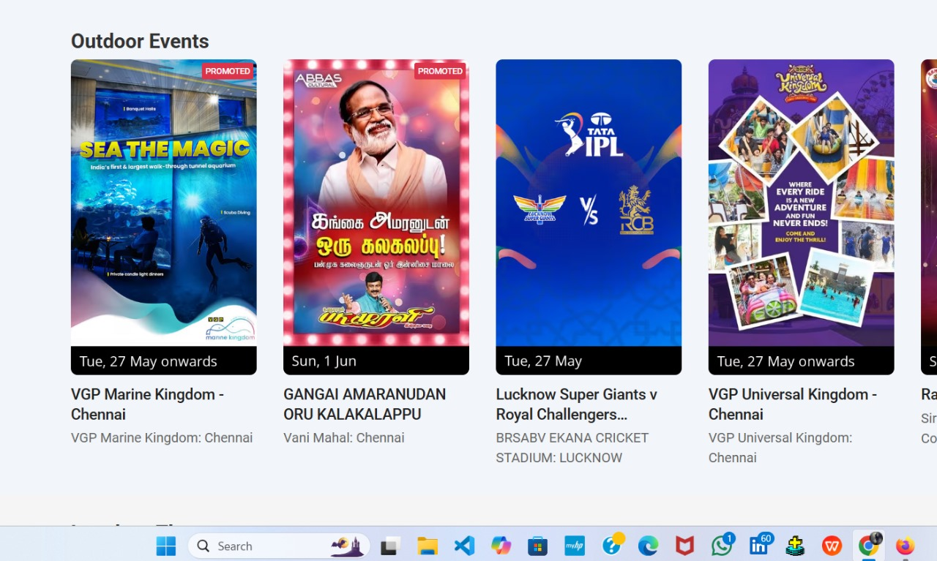

Chrome:

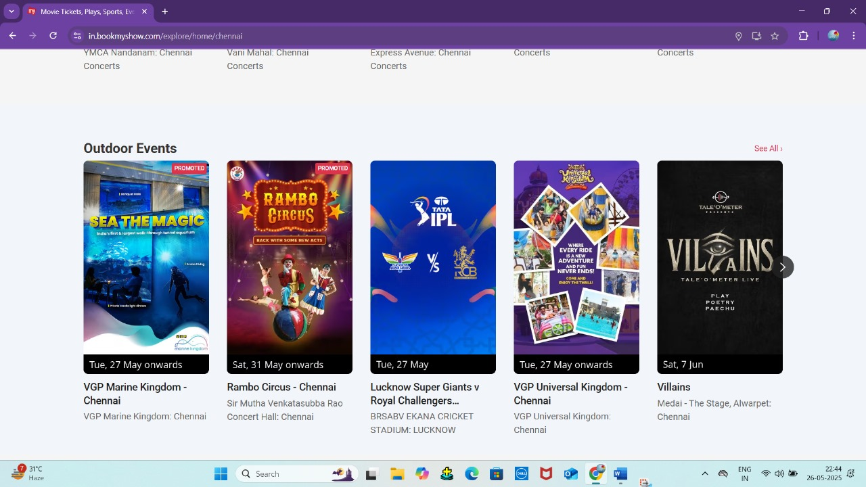Error Statement: The movie was alternatively stored in the outddor Events

Bug 2:

Firefox:

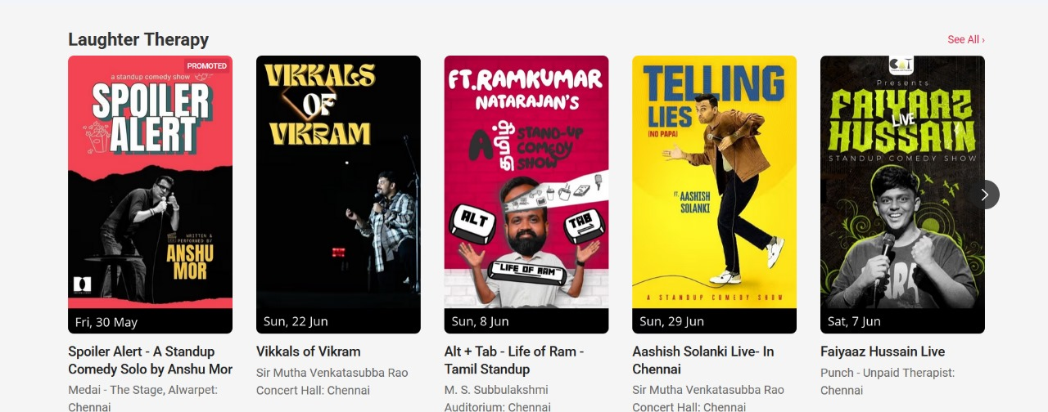

Chrome

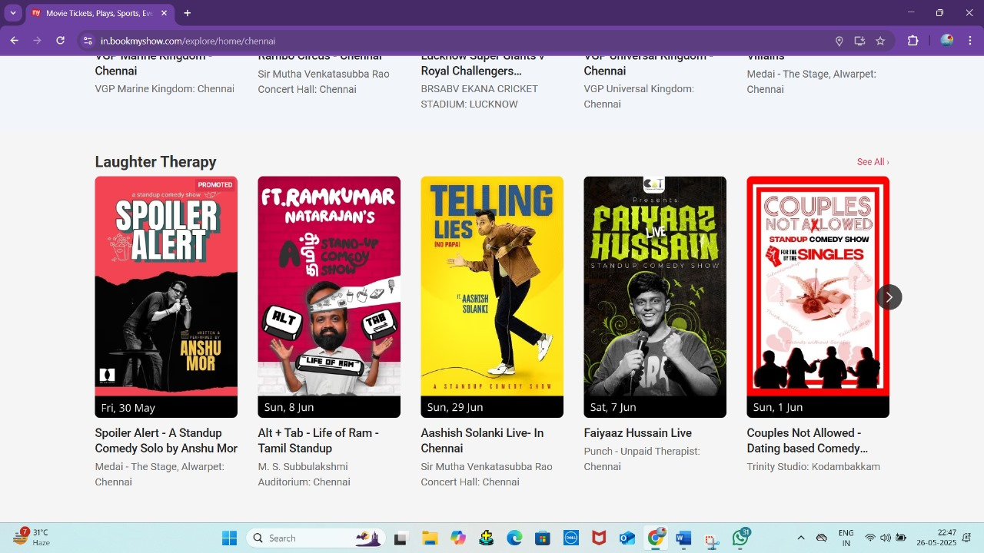

Error statement: In this laughter Therapy is miss matched from firefox and chrome

Bug 3:

Firefox:

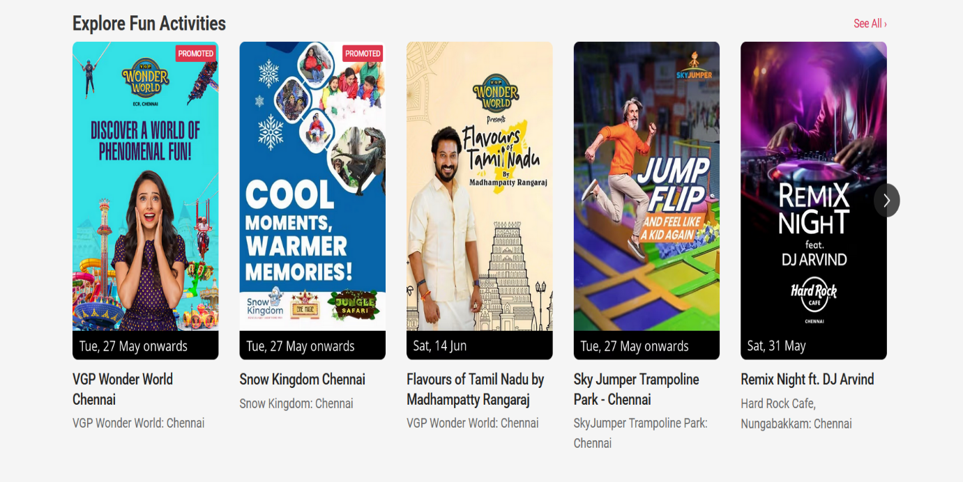

Chrome:

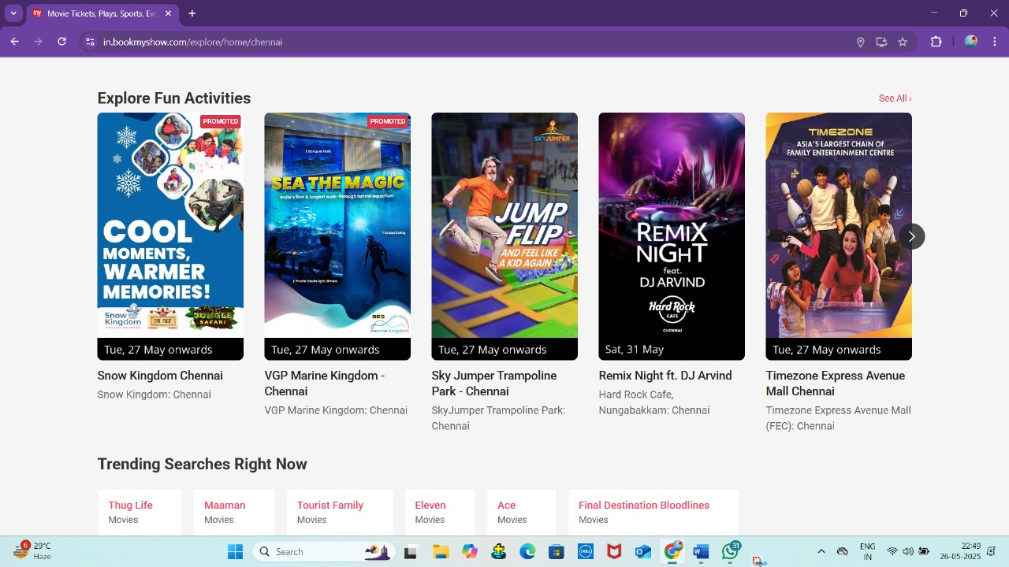

Error statement: The Explore Fun Activities is miss matched from firefox and chrome

Bug 4:

Firefox:

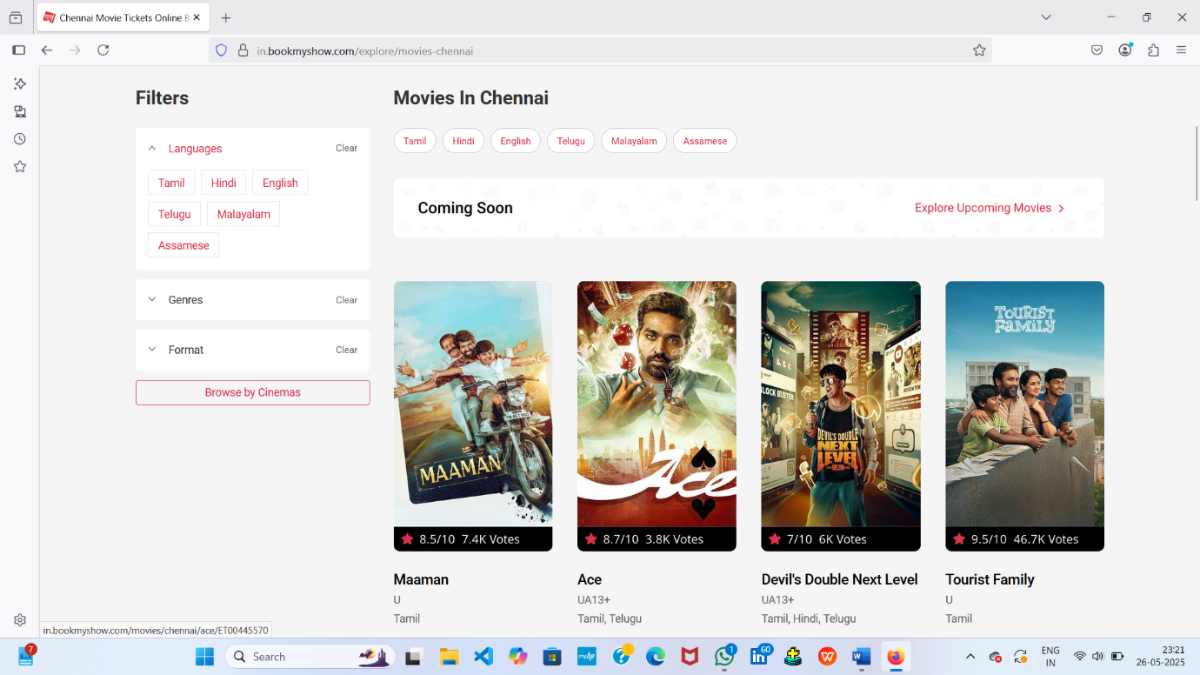

Chrome:

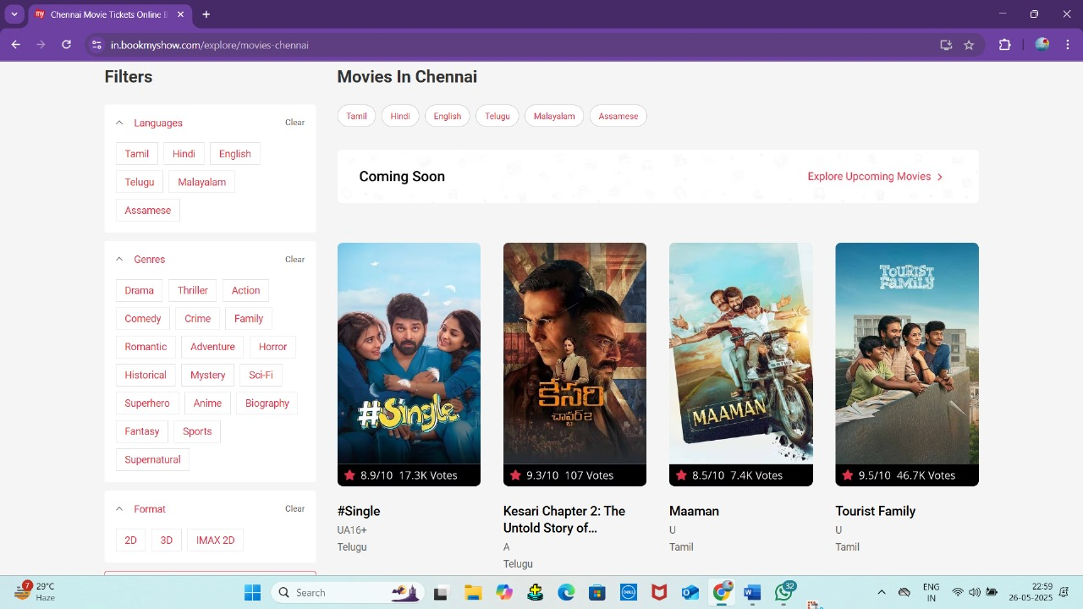

Error statement: The coming soon movies are updated in the chrome and in firefox it not updated yet..

Bug 5:

Firefox:

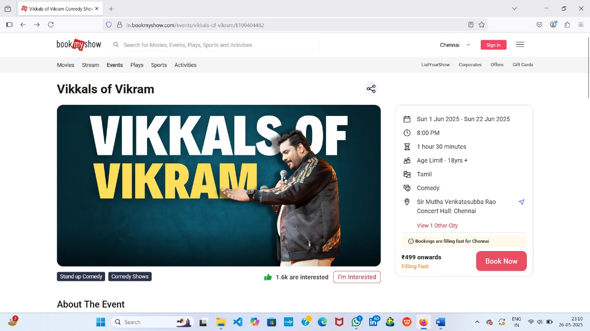

Chrome:

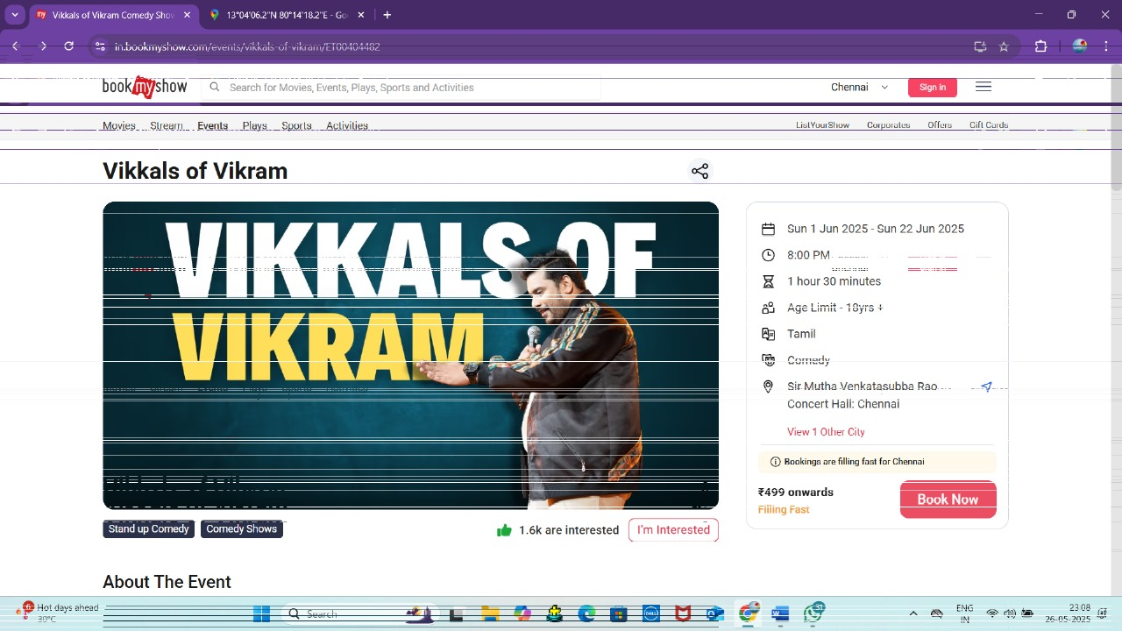

Error Statement: The navbar color is different from chrome and firebox