

**Name: Dhivagar M**

**E-mail: mdhivagar09@gmail.com**

**Mobile: 6380439422**

**LinkedIn: https://www.linkedin.com/in/dhivagar-m-275164176/**

**Github : https://github.com/Dhivagarm**

**Codechef profile link : https://www.codechef.com/users/mdhivagar18**

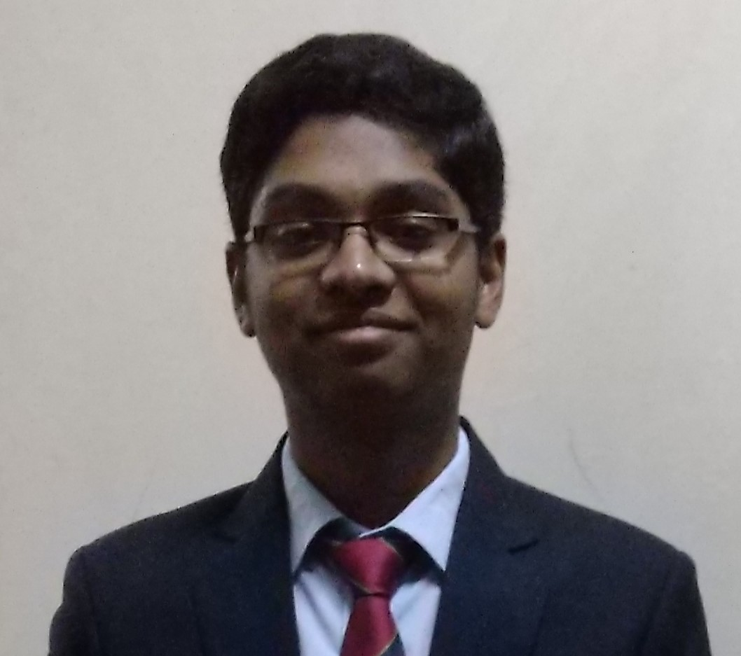

**ACADEMICS**

|  |  |  |  |
| --- | --- | --- | --- |
| **Year** | **Degree/Qualification** | **University/Board/School, City** | **Percentage** |
| 2018-22 | B Tech -Engineering Branch (Computer Science and Engineering) | Jaypee University Of Engineering And Technology, Guna | Result Awaited |
| 2018 | 12th (Computer Science) CBSE Delhi | Sri Venkateshwara international school, Gobi | 90.2% |
| 2016 | 10th CBSE Delhi | KMC public senior secondary school , Tirupur | 100% |

**PROFESSIONAL CERTIFICATIONS**

|  |  |  |
| --- | --- | --- |
| **Date** | **Name of Certification** | **Certifying University/ Organisation** |
| 30/01/2020 | Certificate of Excellence in Competitive Programming | Coding Ninjas |

**PROJECTS / INTERNSHIPS**

|  |  |
| --- | --- |
| **SUMMER INTERNSHIP PROJECT**  **1st june 2021 – 30th july 2021** | **Company: Algouniversity**  **Location: Hyderabad** |
| * Built an Online Judge * Used Docker in it for isolation * Main purpose is to evaluate untrusted code |
| **PROJECT**  **1st oct 2020 – 10th dec 2020** | **Project Name : Handyman Services** |
| * It is a website where you can book for Home service persons like Plumber , Cleaner , Carpenter etc. * User can create account and book for services. * It is built using MERN stack (MongoDB, Express.Js , React.Js, Node.Js) |
| **EXTRACURRICULAR ACTIVITIES**   |  |  | | --- | --- | | **Competitive Programming**  **(Achievements)** | * Codechef Max Rating 2269 (6 star) * Codeforces Max Rating 2116 (Master) * Global Rank of 98 in Google Kickstart round H 2020 * Secured 161st position in ICPC Asia Kanpur Preliminary Online Contest | | **Technical** | * Backend Development using NodeJs and MongoDB . * Dockers | | **Language** | * English, Tamil(Native) | | | | |