BLUETOOTH CONTROLLED SERVO MOTOR USING ARM7 LPC2129
A Mini Project Report

1. ABSTRACT
In this project, we control an SG90 servo motor wirelessly with an ARM7 LPC2129 microcontroller and an HC-05 Bluetooth module. A phone app sends a command to the HC-05, which passes it on to the LPC2129 over a UART serial link. The microcontroller reads the command and produces the control signal that turns the servo. An optional 16×2 LCD shows the command it received or what the system is currently doing. Along the way, the project gives real hands-on practice with Bluetooth interfacing, UART communication, PWM generation and embedded C programming.

2. INTRODUCTION
Many embedded systems today are controlled wirelessly, since it means a device can be operated without any cable running to the user. Bluetooth is a popular choice for this: it is a short-range wireless technology that is often used to send serial data between a smartphone and an embedded controller.
Here, the ARM7 LPC2129 is the brain of the system. The HC-05 picks up commands from the smartphone and hands them to the microcontroller through UART. Depending on the command it gets, the LPC2129 then sets the angle of the SG90 servo motor.

3. OBJECTIVE OF THE PROJECT
- To move a servo motor wirelessly from a smartphone.
- To connect the HC-05 Bluetooth module to the ARM7 LPC2129.
- To get a clear understanding of how UART serial communication works.
- To generate the right control signal for positioning the servo motor.
- To show the received command or the current status on a 16×2 LCD.

4. COMPONENTS REQUIRED
S. No. | Component | Purpose
1 | ARM7 LPC2129 development board | Main controller of the system
2 | HC-05 Bluetooth module | Wireless serial link to the phone
3 | SG90 servo motor | Moves to the commanded angle
4 | 16×2 LCD display | Shows command or status (optional)
5 | Regulated 5 V supply | Powers the servo motor
6 | Smartphone with Bluetooth terminal app | Sends commands to the HC-05
7 | Connecting wires | Wiring between the parts

5. HARDWARE DESCRIPTION

5.1 ARM7 LPC2129
The LPC2129 is an ARM7-based microcontroller and does all the processing in this project. It takes in the serial data coming from the Bluetooth module, works out what the command means, and then produces the output signal needed to drive the servo.

5.2 HC-05 Bluetooth Module
The HC-05 is a Bluetooth module for serial communication. It acts as the wireless link between the smartphone and the LPC2129, and it talks to the microcontroller through the UART TX and RX lines. Keep in mind that the supply voltage it needs depends on the specific breakout board you are using, and its logic levels must also be respected when wiring it up.

5.3 SG90 Servo Motor
The SG90 is a small servo motor that holds a set angle, and it has three wires: power, ground and signal. It usually runs from a regulated supply of about 5 V. To set its position, it is fed a repeating pulse signal with a period of roughly 20 ms and a pulse width of about 1–2 ms. The exact pulse widths vary a little from one motor and mechanical setup to another, so they should be calibrated.

5.4 16×2 LCD Display
The 16×2 LCD lets us see the command that arrived from the smartphone or what the system is doing at that moment. It is connected to the LPC2129 through the chosen GPIO pins and controlled with a suitable LCD driver routine.

6. BLOCK DIAGRAM
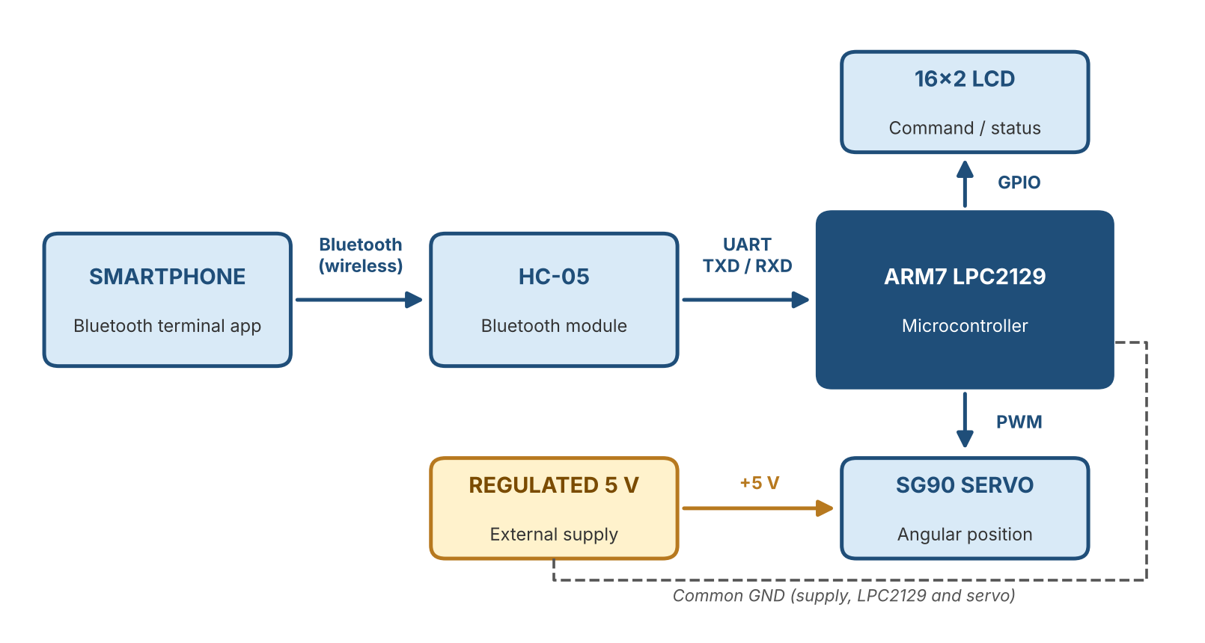
Figure 1: Block diagram of the Bluetooth controlled servo system
The smartphone sends a command over Bluetooth to the HC-05, and the HC-05 forwards it to the LPC2129 through UART. The LPC2129 then processes the command, updates the LCD if one is connected, and generates the control signal for the servo. The servo is powered from its own regulated 5 V supply, and all grounds are tied together.

7. CIRCUIT DIAGRAM AND INTERFACING
The HC-05 connects to the UART interface of the LPC2129. Its TXD pin goes to the LPC2129 UART RXD pin, and its RXD pin goes to the LPC2129 UART TXD pin, so the two lines are crossed. Before wiring, check the UART pin mapping in the board schematic and make sure the logic voltages are compatible.
The SG90 signal wire (usually orange or yellow) goes to an LPC2129 output pin that is set up to produce the PWM/control waveform. The red wire of the servo goes to a regulated 5 V supply, and the brown or black wire goes to the supply ground. The external supply ground must also be joined to the LPC2129 ground, so that the control signal has the same reference point on both sides.
If P0.21 is used as the servo control output, set the pin to the function you need by following the LPC2129 pin-function table and your program. Never connect the servo power wire to P0.21, because that pin should only carry the control signal.
The LCD data and control pins depend on how your development board is wired and on the LCD library you use. Once the circuit is assembled, note down the actual pin connections and add them here before you submit the report.
POWER-SUPPLY NOTE: Avoid running the SG90 from the 5 V rail of a weak development board. Use a separate regulated 5 V supply that can deliver enough current, and join the GND of that supply with the LPC2129 GND. Do not tie two 5 V outputs together unless the board documentation clearly says it is allowed.

8. WORKING PRINCIPLE
- Pair the smartphone with the HC-05 Bluetooth module.
- Open a Bluetooth terminal app on the phone and connect to the HC-05.
- Send a predefined character or command from the app.
- The HC-05 receives this data and passes it to the LPC2129 over UART.
- The embedded C program on the LPC2129 reads the incoming command and checks which one it is.
- Based on that command, the microcontroller generates the servo control pulses that are needed.
- The SG90 then turns to the matching angle, and the LCD (if fitted) shows the received command or the system status.

9. SOFTWARE REQUIREMENTS
- Embedded C as the programming language
- Keil µVision IDE to write and compile the program
- Flash Magic (or whichever programming tool the board supports) to download the program
- LPC2129 device header files and the LCD driver library
- UART setup and serial receive routines
- A routine that generates the servo control pulses

10. PROGRAM / SOURCE CODE
The firmware is written in Embedded C. The program first sets up the peripherals it needs, configures the UART and the LCD, then waits for data from the HC-05 and moves the servo according to the command it receives.
The overall flow of the program is as follows:
- Initialize the microcontroller and the I/O pins that are needed.
- Initialize the UART and the LCD.
- Wait for a command over Bluetooth.
- Read the received command and check that it is valid.
- Generate the servo control signal that matches the command.
- Show the command or status on the LCD.
- Keep repeating this loop continuously.
Paste the final, tested source code in this section. Make sure it shows the actual UART channel, pin assignments, baud rate and servo command mapping used on your hardware.

11. APPLICATIONS
- Wireless control of small robotic mechanisms.
- Prototypes of smart door latches and access control.
- Moving sensors or lightweight mechanisms from a distance.
- Teaching demos for embedded systems and automation.
- Other Bluetooth-based control prototypes.

12. ADVANTAGES
- It can be operated wirelessly from an ordinary smartphone.
- It relies on a simple serial communication interface.
- It gives hands-on practice with ARM7 microcontroller programming.
- It brings Bluetooth, UART, LCD and servo interfacing together in a single project.
- It can easily be extended to control other compatible output devices.

13. CONCLUSION
This project shows how a servo motor can be positioned wirelessly using commands from a smartphone. The phone talks to the HC-05 module, which passes the data to the LPC2129 through UART, and the microcontroller turns each command into the control signal the SG90 needs. Overall, the project builds practical knowledge of embedded C, UART communication, microcontroller interfacing and servo control.

