Assignment 1
Task 1:
1.Install MSSQL Server

Step 1: Install MS SQL Server
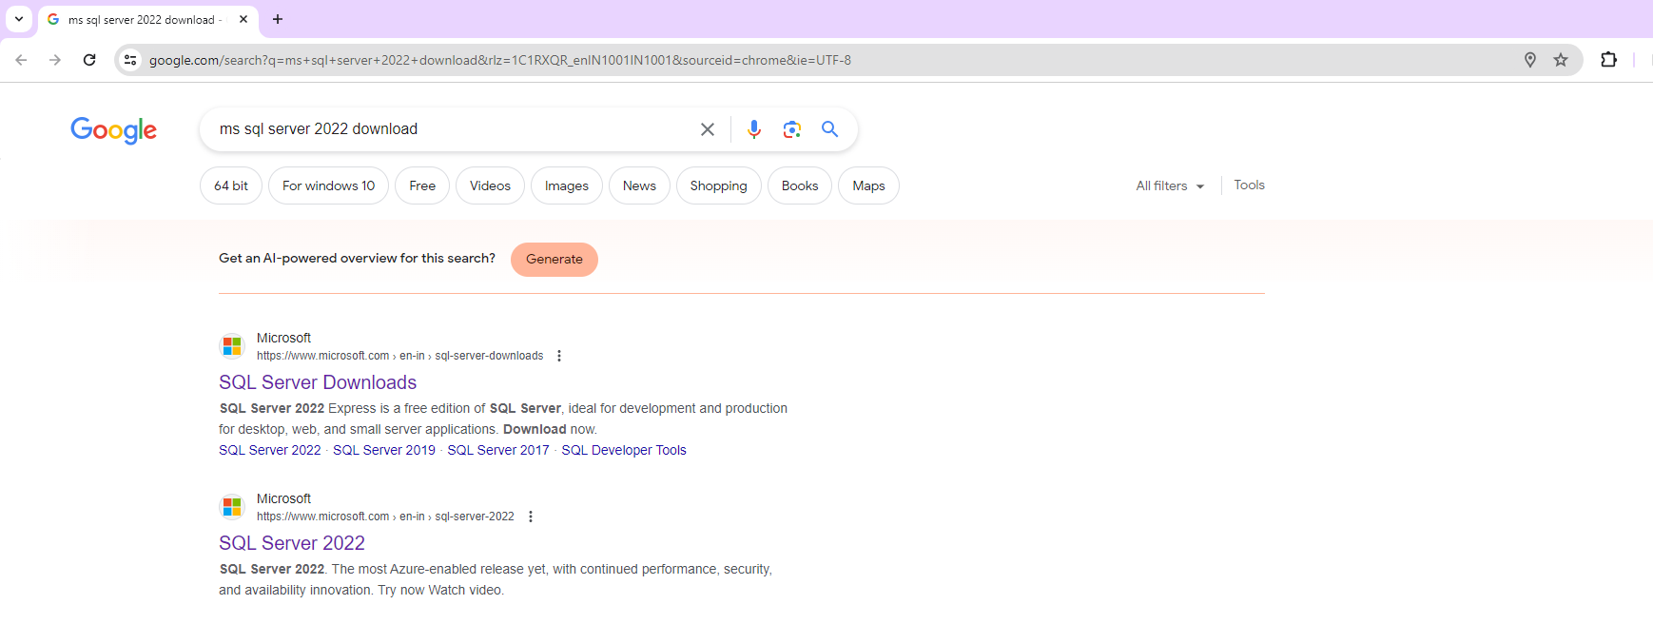
Click any link
Step 2: SQL Server Downloads- Select Developer
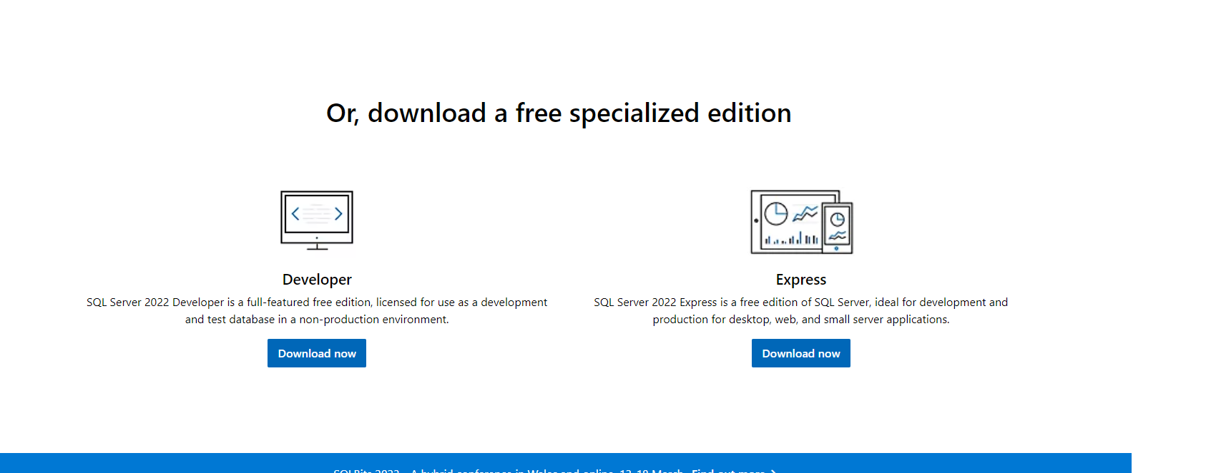
Developer edition completely free. Download the Developer Edition.
Step 3: After downloading Select Customs 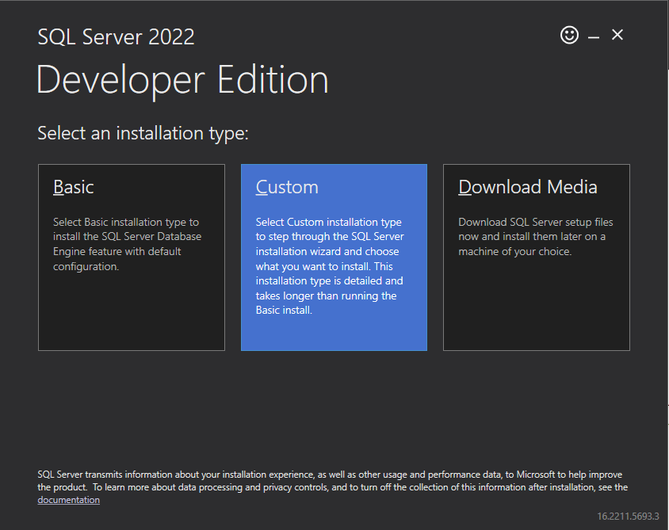

Step 4: Then Install the SQL server. After that, please click Installation
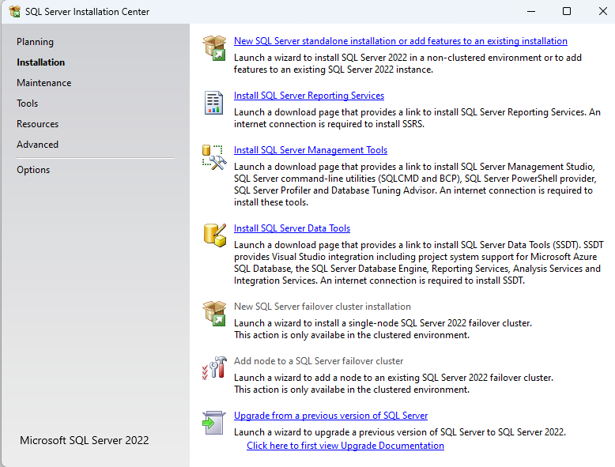
Click first one. Accept the license and Privacy policy
Step 5:
After installation must accept the license term and Privacy statement.
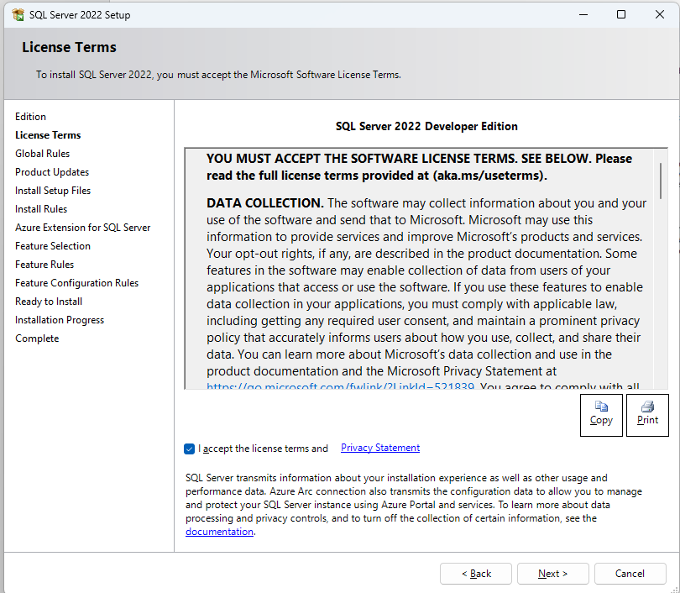
Step 6:
Then feature selection for Instance (Database Engine Services, SQL Server Replication). 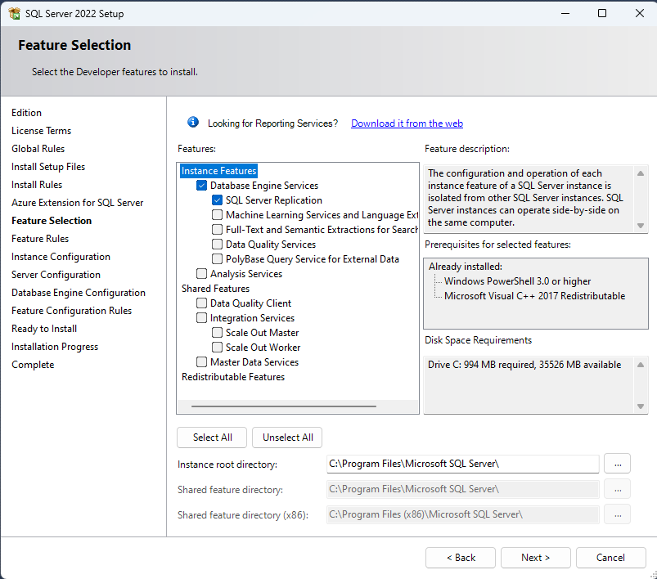

Step 7:
Then Instance Configuration need to be set instance name
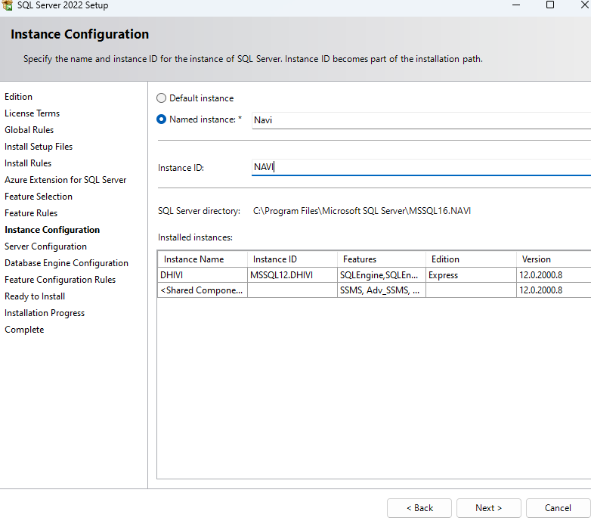
Step 8:
Server configuration set all the servers as automatic
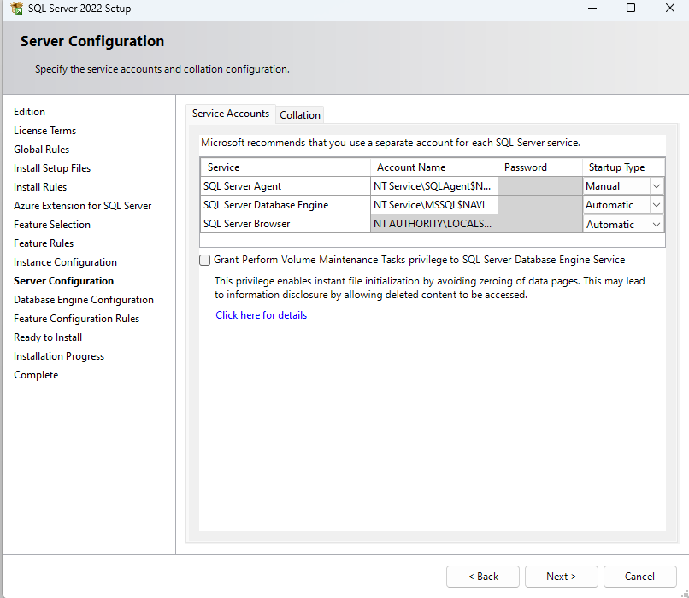
Step 9:
Then set Database Engine Configuration.
Set the security password for Mixed mode (SQL server authentication and windows authentication) and Add the user.
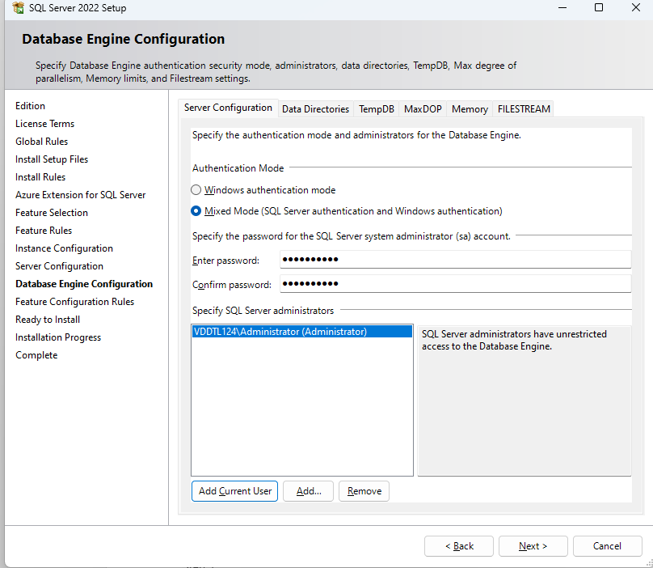

Step 10:
Finally ready to install.
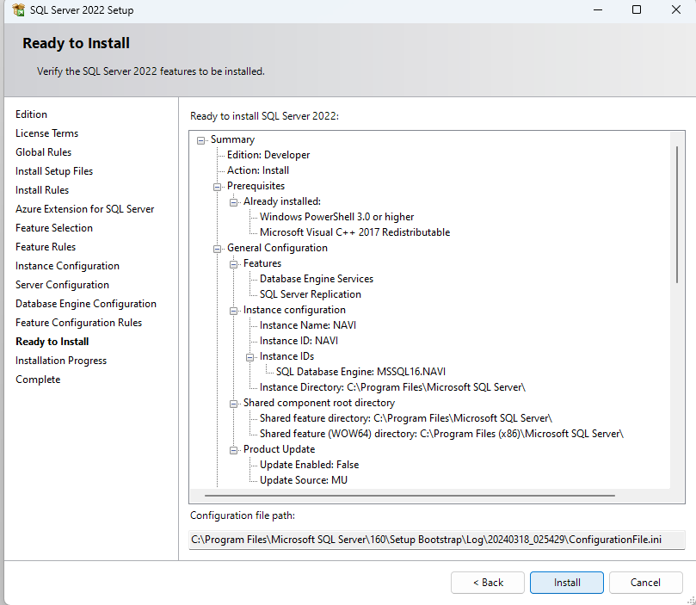
Step 11:

Installation Process and successfully installed.
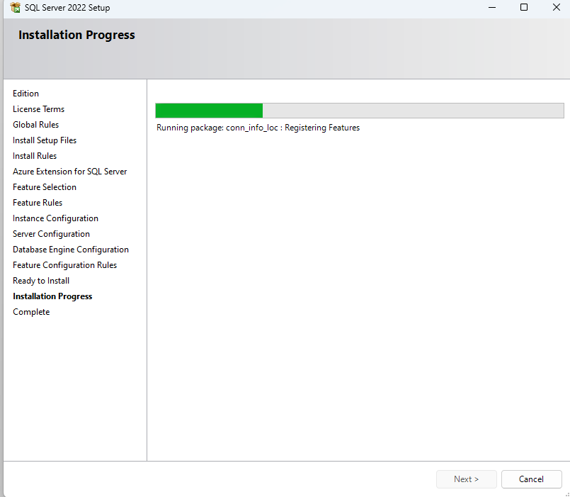

Task 2:
2. Give the difference between Char and Varchar data type.

CHAR:
• CHAR is a fixed-length character data type.
• It requires a predetermined amount of storage space regardless of the actual data length.
• When you define a CHAR column, you specify a maximum length, and each entry in that column will use that amount of storage, padding the data with spaces if necessary to reach the specified length.
• For example, if you define a CHAR(10) column and insert "hello" into it, it will occupy 10 characters of storage, with 5 characters followed by 5 spaces.
VARCHAR:
• VARCHAR is a variable-length character data type.
• It stores only the actual characters used plus some additional bytes for overhead.
• When you define a VARCHAR column, you specify a maximum length, but the actual storage used depends on the length of the data inserted.
• For example, if you define a VARCHAR(10) column and insert "hello" into it, it will occupy only 5 characters of storage, as it stores just the characters "hello" without any padding.
• VARCHAR is more space-efficient than CHAR when storing variable-length data because it doesn't waste space with trailing spaces.

Task 3:
3. Explain the types of SQL Commands.

Data Manipulation Language (DML) Commands:

DML commands are used for managing data within database tables.
Common DML commands include:
SELECT: Retrieves data from one or more tables.
INSERT: Adds new rows of data into a table.
UPDATE: Modifies existing data in a table.
DELETE: Removes rows of data from a table.
Data Definition Language (DDL) Commands:
- DDL commands are used for defining, modifying, and removing database objects such as tables, indexes, and constraints.
- Common DDL commands include:
- CREATE: Creates new database objects such as tables, indexes, views, etc.
- ALTER: Modifies existing database objects, such as adding, modifying, or dropping columns from a table.
- DROP: Deletes existing database objects such as tables, indexes, views, etc.
- TRUNCATE: Removes all rows from a table without logging individual row deletions.
Data Control Language (DCL) Commands:

- DCL commands are used to control access permissions on database objects.
- Common DCL commands include:
- GRANT: Assigns specific privileges to users or roles, allowing them to perform certain actions on database objects.
- REVOKE: Removes previously granted privileges from users or roles.
Data Query Language (DQL) Commands:

- DQL commands are used specifically for querying data from the database.
- The primary DQL command is SELECT, which retrieves data from one or more tables based on specified criteria.
Transaction Control Language (TCL) Commands:

- TCL commands are used to manage transactions within a database.
- Common TCL commands include:
- COMMIT: Saves all changes made during the current transaction to the database.
- ROLLBACK: Reverts all changes made during the current transaction to its starting point.
- SAVEPOINT: Specifies a point within a transaction to which you can later roll back.

Task 4:
Explain NVarchar and Nchar.

NCHAR and NVARCHAR are both data types in SQL used to store Unicode character data. The "N" prefix stands for "National" and indicates that the data is in Unicode format, which can represent characters from various languages and character sets. Here's an explanation of each:

NCHAR:

- NCHAR is a fixed-length Unicode character data type.
- When you define an NCHAR column, you specify a fixed length for each value in terms of the number of characters.
- Each character in an NCHAR column takes up two bytes of storage space, regardless of the actual character length, as it is Unicode.
- It is suitable for storing fixed-length, multilingual character data.
Example:
CREATE TABLE Table1 (
ID INT,
Name NCHAR(10)
);
In this example, the Name column will always occupy 20 bytes of storage (10 characters * 2 bytes/character), regardless of the actual length of the inserted string.

NVARCHAR:
- NVARCHAR is a variable-length Unicode character data type.
- When you define an NVARCHAR column, you specify a maximum length for each value in terms of the number of characters.
- Each character in an NVARCHAR column still takes up two bytes of storage space because it's Unicode, but the actual storage used depends on the length of the data inserted.
- It is suitable for storing variable-length, multilingual character data.
Example:
CREATE TABLE Table2 (
ID INT,
Description NVARCHAR(255)
);
In this example, the Description column can store up to 255 characters, occupying up to 510 bytes of storage (255 characters * 2 bytes/character) when fully utilized.

