Jival Jenson,

Dhivin Shaji,

Serah Varghese,

28th May,2018.

**PROJECT: User Interactive Web Application for Courier Services**

**INTRODUCTION:**

This project focuses on the implementation of a centralized digital management of the services offered by the courier industry. This application also provides features such as real time tracking of package and exclusive privileges for users based on their access levels.

**PROGRAM INTERFACE:**

On visiting the website the user has the provision to register as a new user. The sign up button redirects the user to the sign up page where the name, phone number, email id, username and password are entered by the user. The user cannot use a previously registered mobile number, email id or username. The user can access the services provided only once the Admin approves of the user. The Admin may choose to terminate the access privileges of the user at any given point.

Apart from being a normal user, he/she may be assigned the role of being an Admin or a Transaction Manager. The dashboard displays different functionalities dynamically based on the type of user with the help of responsive UI.

SCREENSHOTS:



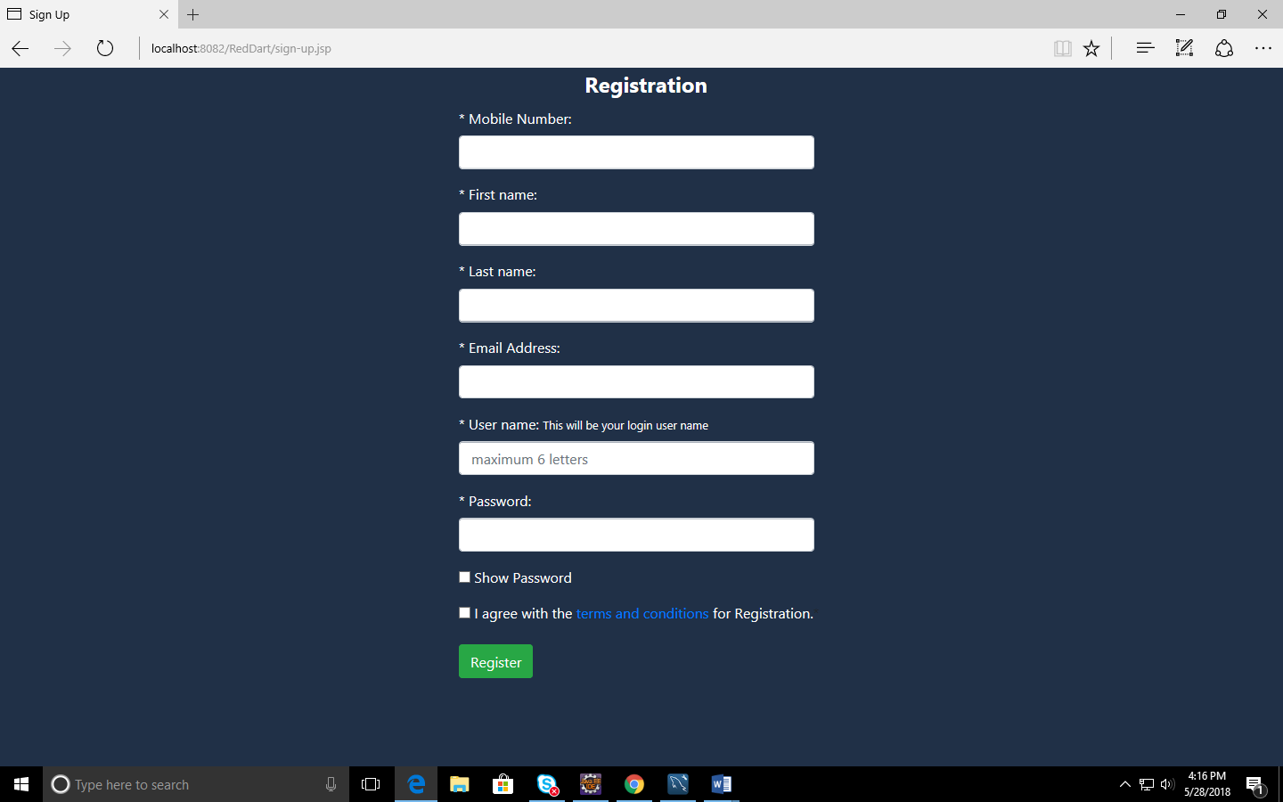

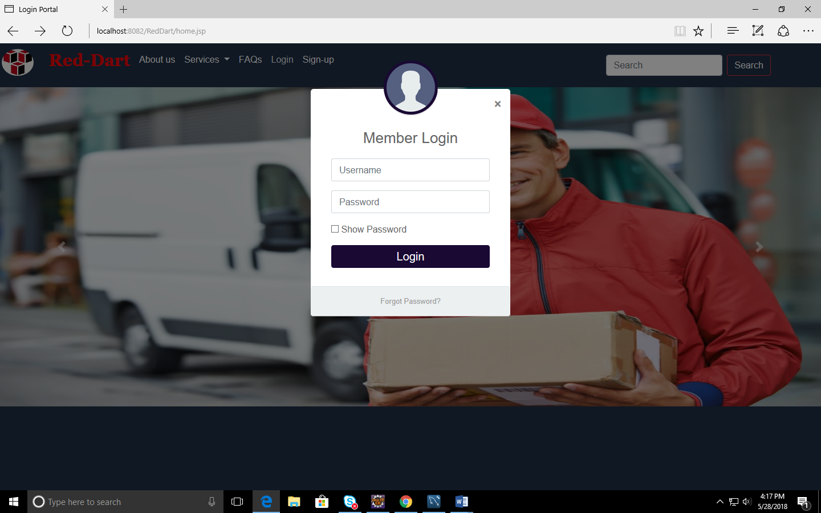

Super Admin’s dashboard

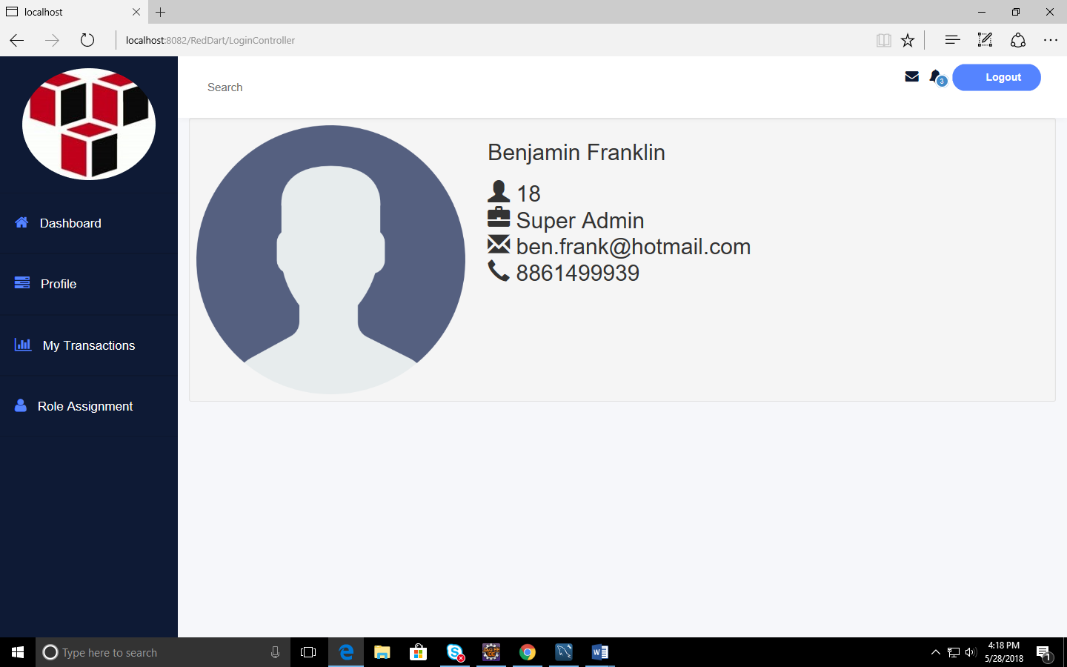

A user with all privileges:

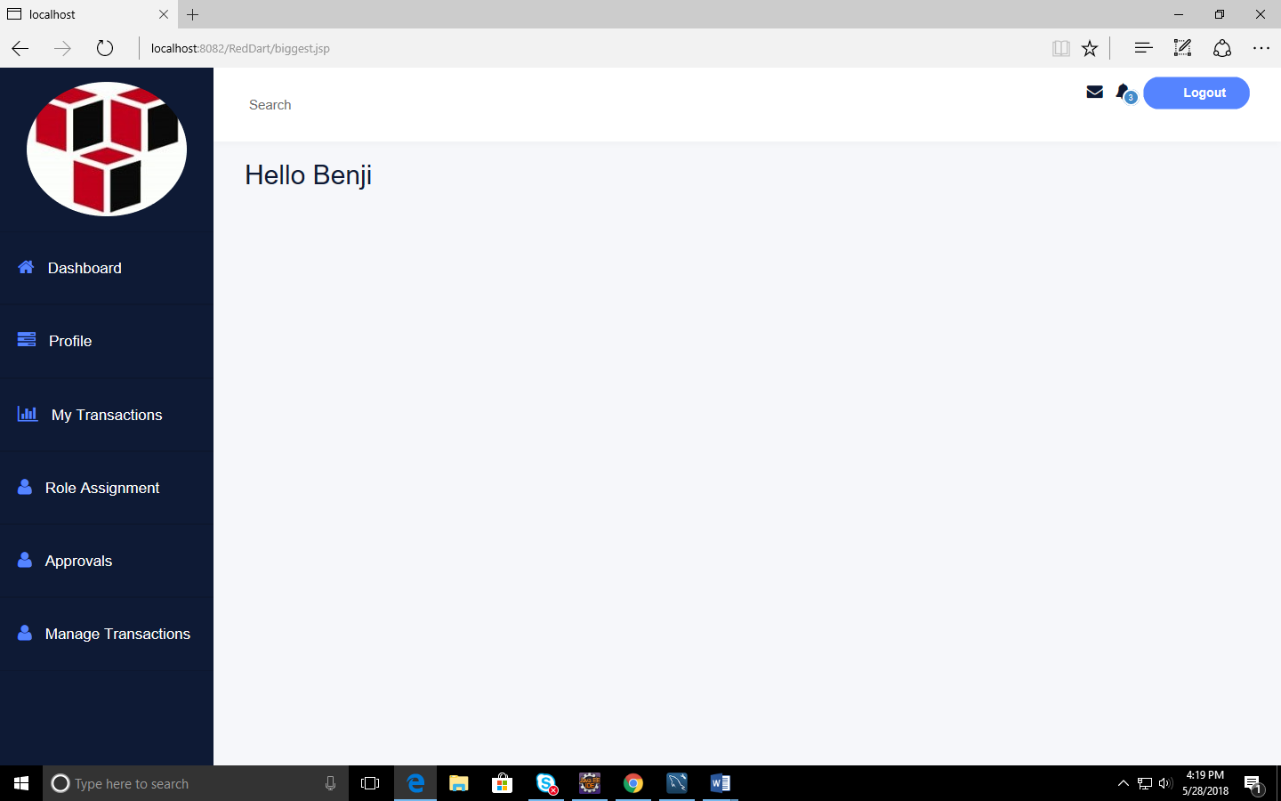

**PROGRAM EXECUTION:**

On Registration, the new user’s password is stored in an encrypted form in the database to enhance security. The new user can login only if the super admin approves of him.

The user may also be given extra privileges .

The transaction mangers update the database once the package reaches a particular hub.

Updation can only happen sequentially .

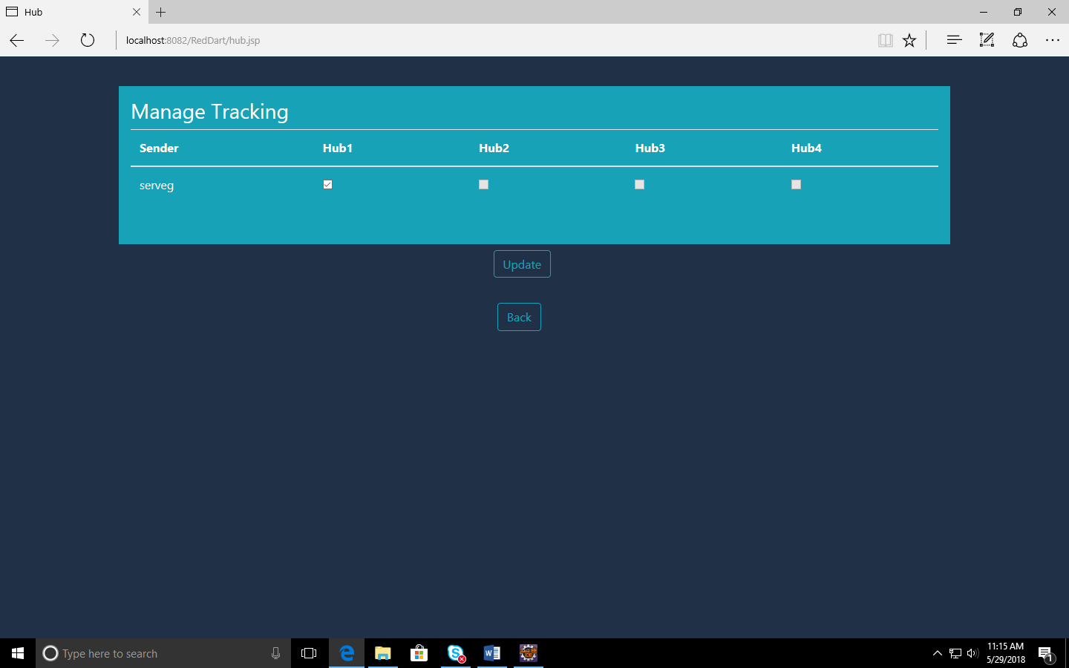

The Admin has the privilege to approve or disapprove any user apart from the basic services.

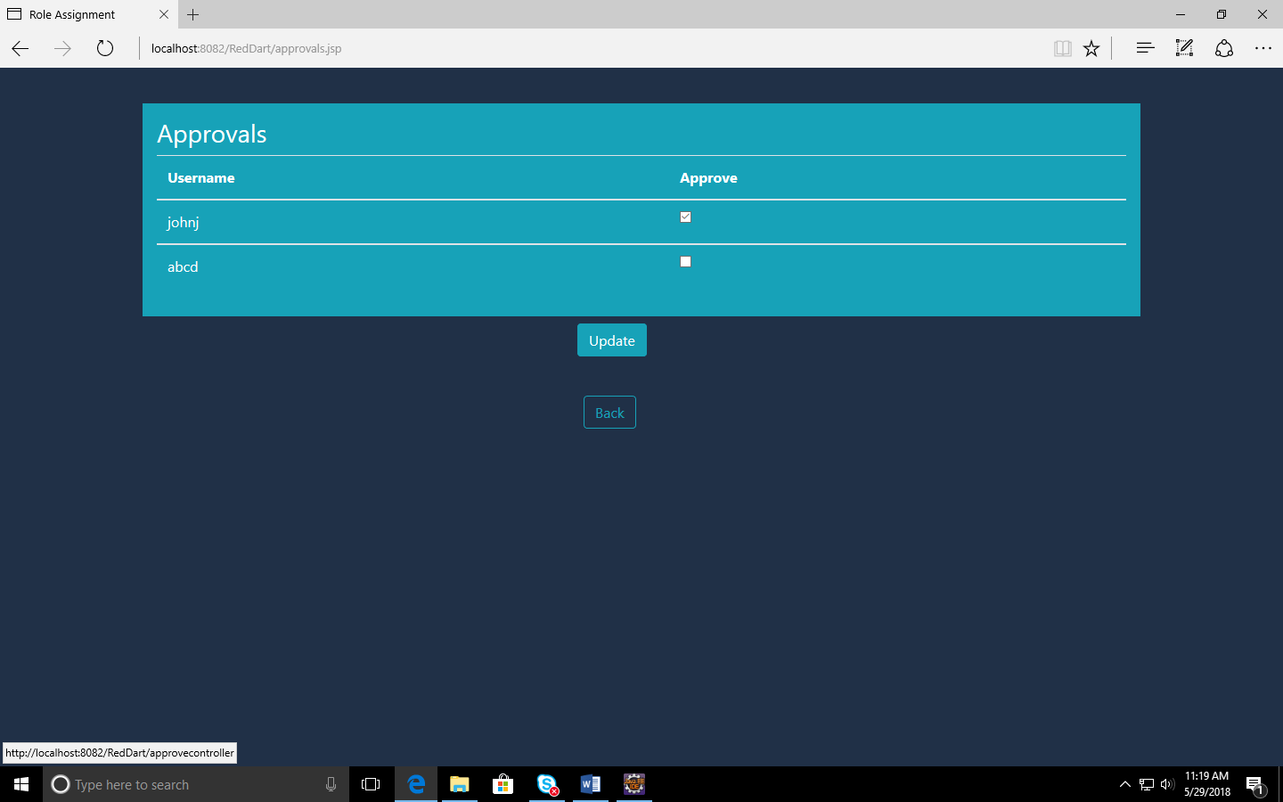

The user can also track his package by entering his package ID .

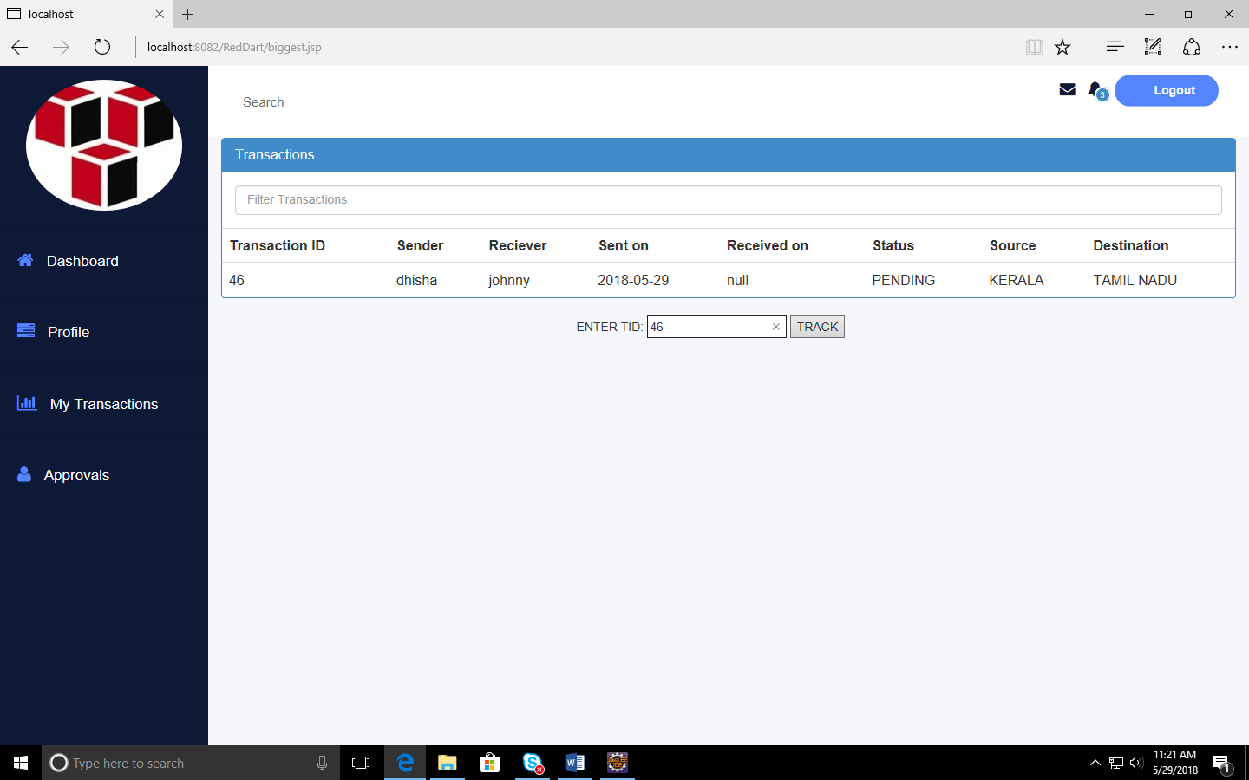

On clicking the TRACK button ,a map appears with the marker indicating where the package has arrived.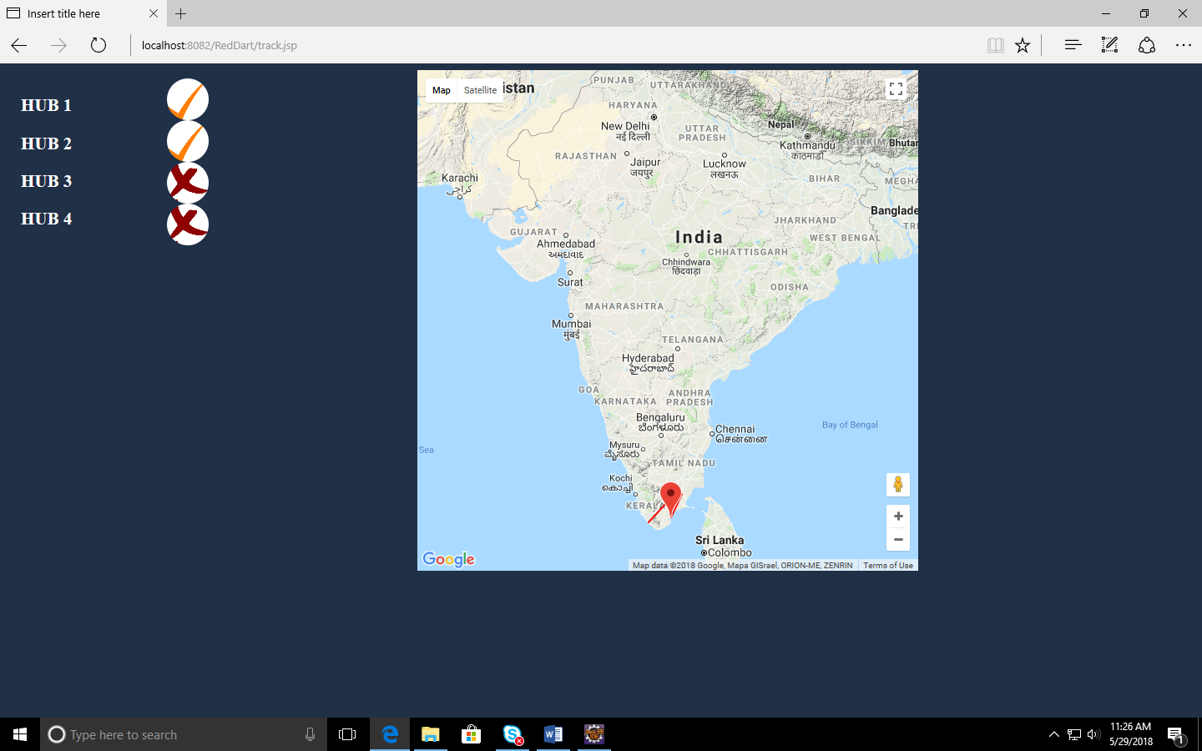

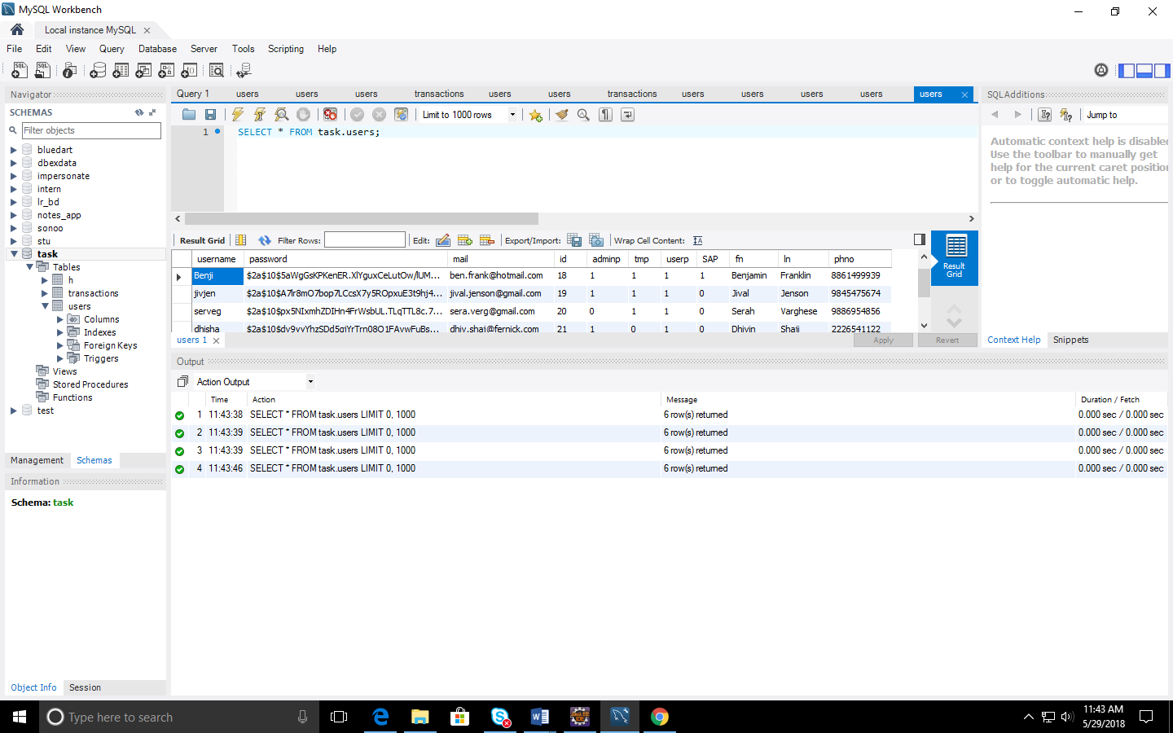

**FEATURES:**

* Password Encryption: - The new passwords are stored in an encrypted form using Bcrypt which generates a salt value ensuring better security.
* Real time tracking of packages:-At every hub the package reaches, the marker is dynamically reflected in the map route.
* Role Assignment: - The Super Admin can assign domains that certain users can access.
* Approvals: - The admin can approve or disapprove any user.
* Transaction Management:-Updation of hubs.
* Responsive UI: - Html, CSS, Bootstrap were used to build the UI.
* JSP and servlets:- two level model.