**MySQL : Creation of database IMDB and tables along with PRIMARY KEY, FOREIGN KEY creation and insertion of data into tables.**

CREATE DATABASE IMDB;

USE IMDB;

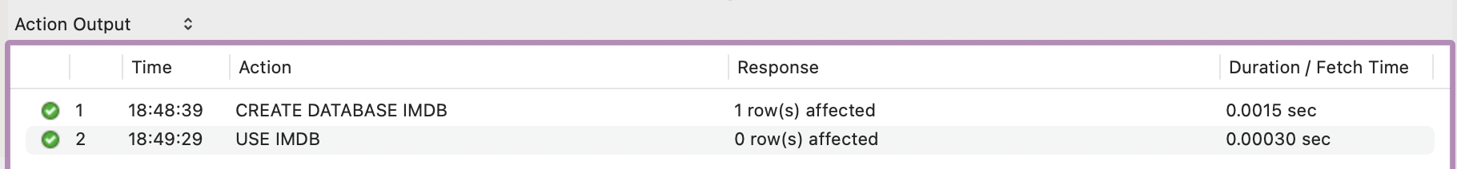

CREATE TABLE movie(

**movie_id INT PRIMARY KEY NOT NULL,**

title VARCHAR(100) NOT NULL,

director VARCHAR(100) NOT NULL,

release_year YEAR

);

INSERT INTO movie(movie_id,title,director,release_year) VALUES

(101,'Dangal','Nitesh Tiwari',2016),

(102,'Baahubali2','Rajamouli',2017),

(103,'PK','Rajkumar Hirani',2014),

(104,'Leo','Lokesh Kanagaraj',2023),

(105,'RRR','Rajamouli',2022);



SELECT * FROM movie;

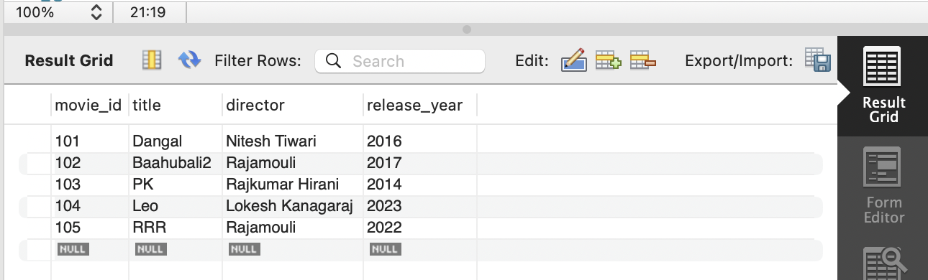

**#movie_id is used as a FOREIGN KEY**

CREATE TABLE media(

**media_id INT PRIMARY KEY AUTO_INCREMENT,**

movie_id INT,

media_type VARCHAR(200),

media_url VARCHAR(200),

**FOREIGN KEY(movie_id) REFERENCES movie(movie_id)**

);

INSERT INTO media(movie_id,media_type,media_url) VALUES

(101,'Dangal.mp4','https://dangal.mp4'),

(102,'Baahubali2.jpeg','https://baahubali.mp3'),

(103,'PKteaser.mp4','https://web//pk.mp4'),

(104,'Leotrailer.mp4','www.leo.mp4'),

(105,'RRR.png','<https://rrr.mp3>');

SELECT * FROM media;

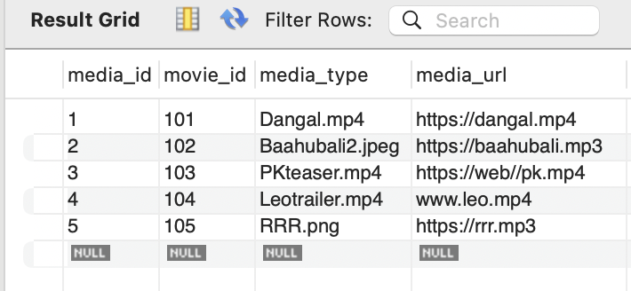

CREATE TABLE genre(

**genre_id INT PRIMARY KEY AUTO_INCREMENT,**

movie_id INT,

movie_genre VARCHAR(100),

**FOREIGN KEY(movie_id) REFERENCES movie(movie_id)**

);

INSERT INTO genre(movie_id,movie_genre) VALUES

(101,'Sports'),(102,'History'),(102,'Adventure'),(103,'Crime'),(103,'Suspense'),

(104,'Mystery'),(104,'Gangster'),(105,'War');

SELECT * FROM genre;

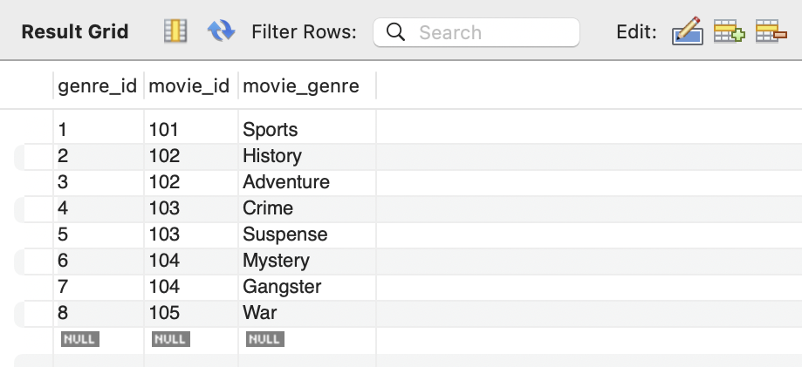

CREATE TABLE user(

**user_id INT PRIMARY KEY NOT NULL,**

**movie_id INT,**

influencer VARCHAR(50),

people VARCHAR(50),

film_critics VARCHAR(50),

journalists VARCHAR(50),

**FOREIGN KEY(movie_id) REFERENCES movie(movie_id)**

);

INSERT INTO user(user_id,movie_id,influencer,people,film_critics,journalists) VALUES

(111,101,'Andrea David','Ritu','Deepak Dua','Anupama Chopra'),

(112,102,'Rishab Raj','Diya','Sucharita Tyagi','Khalid Mohamed'),

(113,104,'Ayush Mehra','Charan','Rajeev Masand','B. K. Karanjia');

SELECT * FROM user;

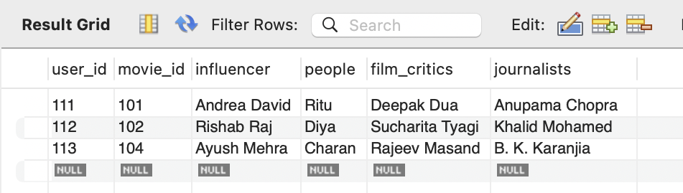

CREATE TABLE reviews(

**review_id INT PRIMARY KEY AUTO_INCREMENT,**

**user_id INT,**

**FOREIGN KEY(user_id) REFERENCES user(user_id),**

comments VARCHAR(200)

);

INSERT INTO reviews(user_id,comments) VALUES

(111,'DANGAL is a masterpiece'),

(112,'Baahubali2 is the finest film to come out of the film industry in a long time'),

(113,'Leo flashback segments seemed unconvincing, which affected the second half'),

(111,'Vijay delivers a commendable performance in both of his roles'),

(113,'Allu Arjun is so powerful that it looks like there is no real antagonist');

SELECT * FROM reviews;

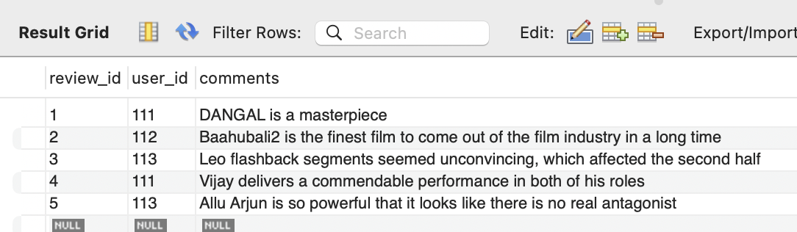

CREATE TABLE artist(

**artist_id INT PRIMARY KEY,**

**movie_id INT,**

artist_name VARCHAR(100),

skills VARCHAR(100),

**FOREIGN KEY(movie_id) REFERENCES movie(movie_id)**

);

INSERT INTO artist(artist_id,movie_id,artist_name,skills) VALUES

(201,101,'Aamir Khan','Martial Arts'),

(202,101,'Fatima Sana','Dancer'),

(203,102,'Prabhas','Fighter'),

(204,102,'Anushuka','Acting'),

(205,103,'Allu Arjun','Acting'),

(206,104,'Vijay','Singer'),

(207,104,'Vijay','Dancer');

SELECT * FROM artist;

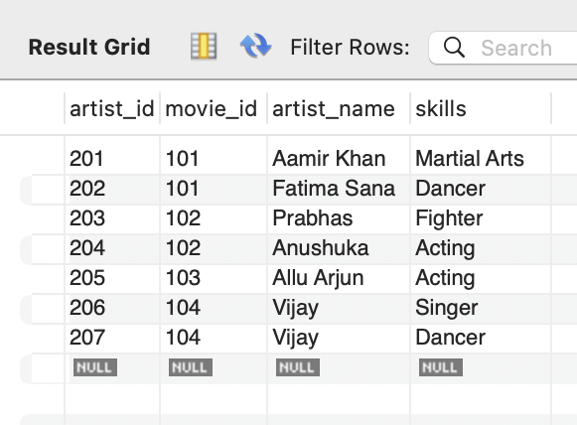

CREATE TABLE roles(

artist_id INT,

artist_role VARCHAR(100),

**FOREIGN KEY(artist_id) REFERENCES artist(artist_id)**

);

INSERT INTO roles(artist_id,artist_role) VALUES

(201,'Trainer'),

(202,'Student'),

(203,'Hero'),

(204,'Heroine'),

(205,'Thief'),

(205,'Hero'),

(206,'Police');

SELECT * FROM roles;

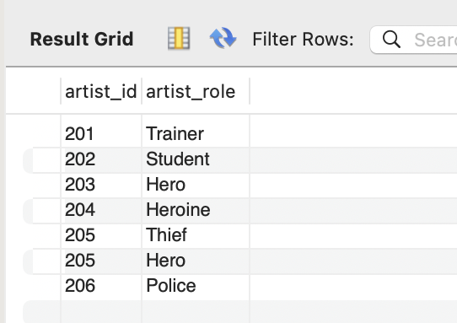

**SQL Queries performed on the created tables:**

SELECT movie_id,title,director from movie where release_year **IN (2014,2017);**

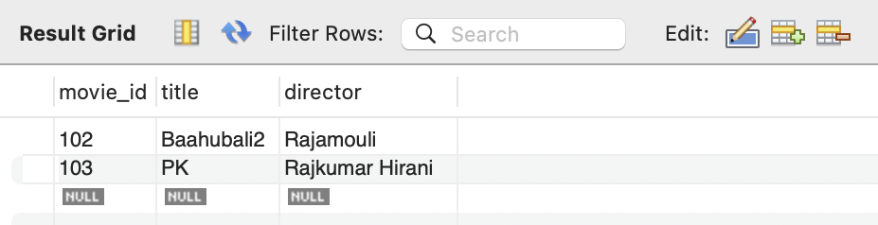

SELECT movie_id,director from movie where director LIKE 'R%';

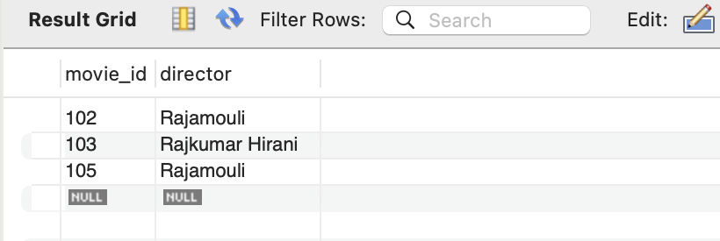

SELECT movie_id,**media_type as media_video, media_url as url** FROM media;

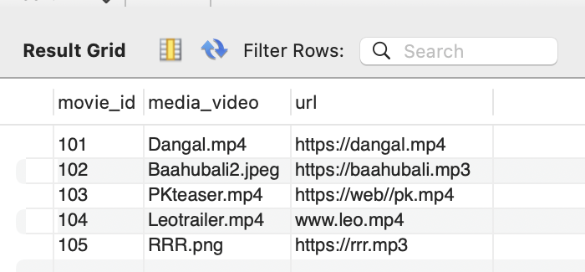

**UPDATE genre set movie_genre='Epic-War' where movie_id=105;**

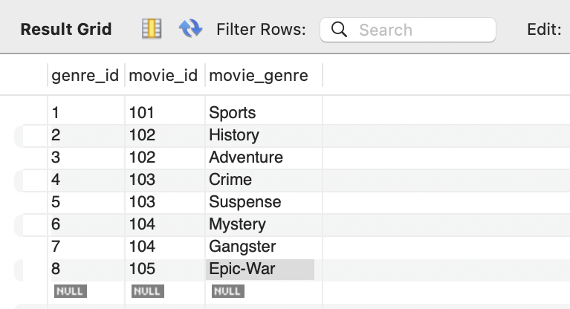

SELECT movie_id**,COUNT(*)** from artist **GROUP BY** movie_id;

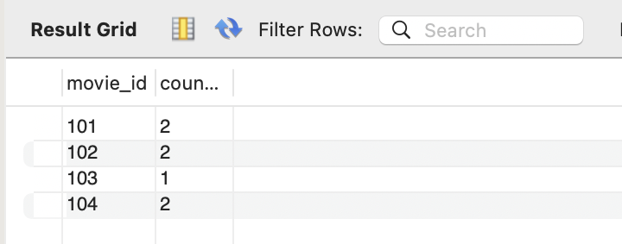

Select title,artist_name from movie

**INNER JOIN** artist where movie.movie_id=artist.movie_id;

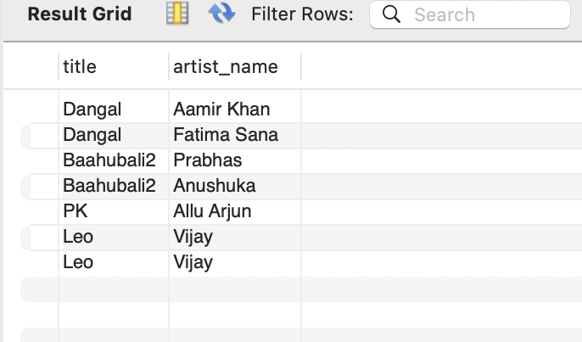

SELECT artist_name, artist_role FROM artist

**RIGHT JOIN** roles on artist.artist_id=roles.artist_id;

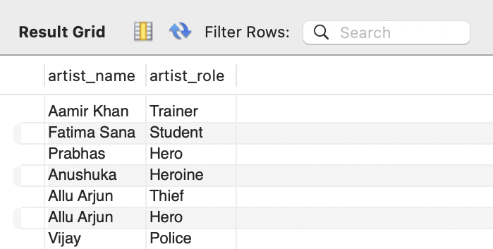

SELECT user_id,comments FROM reviews where **user_id= (SELECT user_id from user LIMIT 1);**

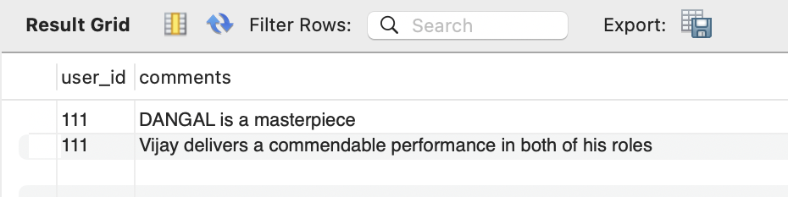

DROP TABLE roles; #deletes the entire table

DROP DATABASE IMDB; #deletes the entire database