**CAPSTONE PROJECT- APPLICATION DEPLOYMENT**

Github URL: <https://github.com/Dhivnatra/Capstone-Project.git>

Deployed site URL: <http://34.236.148.232/>

Docker Images: dhivnatra/dev:latest

dhivnatra/prod:latest

**Project work description:**

**Installation:**

* Installed and configured the mentioned tools and plugins in AWS EC2 instance.
  + - Git
    - Docker
    - Docker Compose
    - Jenkins
    - Prometheus
    - Node-exporter
    - Grafana

**Codes written:**

* Dockerfile
* Docker-compose.yml
* build.sh
* deploy.sh
* Jenkinsfile

**Docker:**

* Dockerized the application using the Dockerfile.

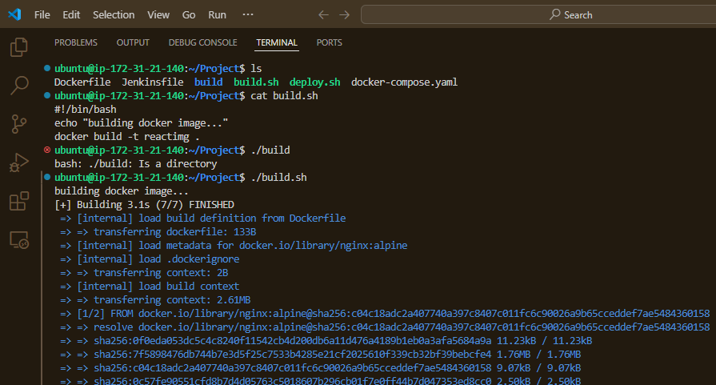

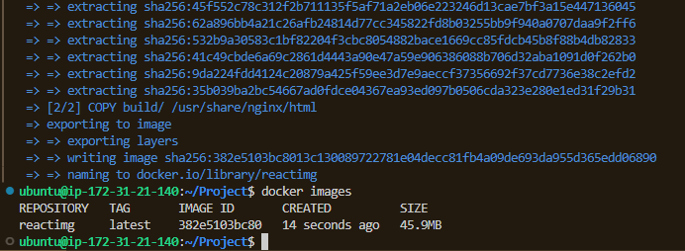

* Using the docker compose to use the dockerized application image.

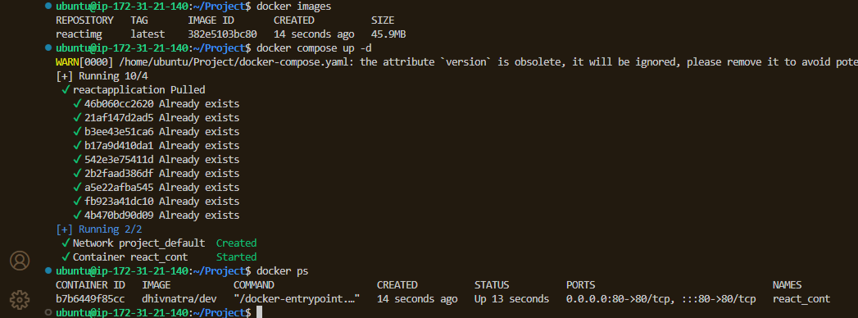

* Deployed application- site

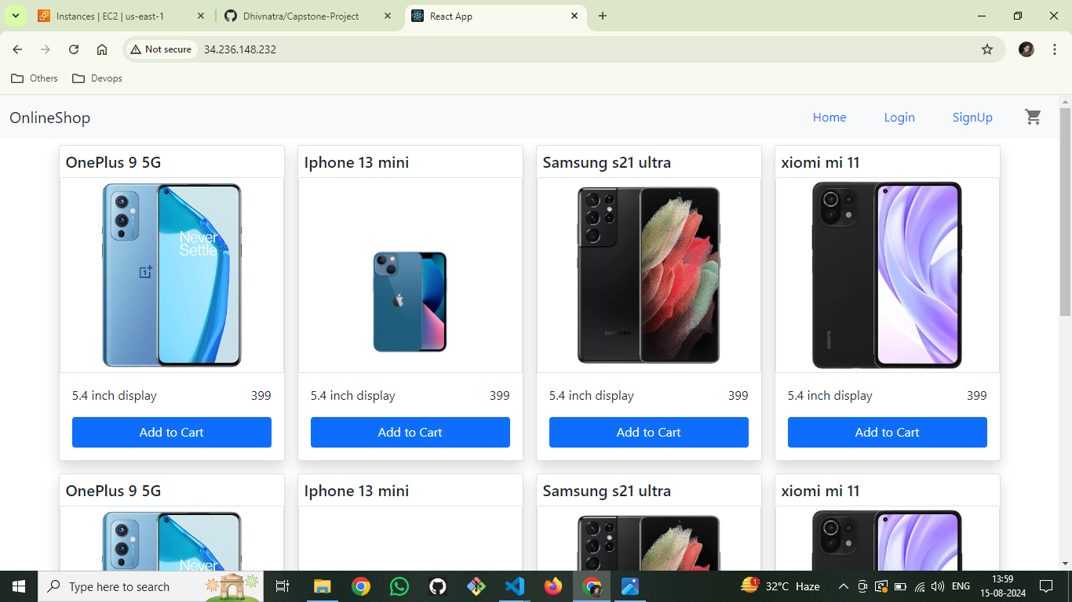

**DockerHub:**

* Created two Dockerhub repositories to facilitate docker image push and pull.
  + - Public Repo- dhivnatra/dev
    - Private Repo - dhivnatra/prod

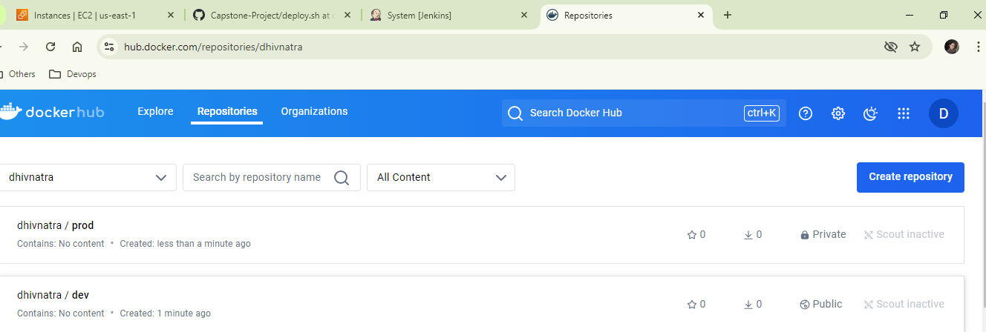

**VCS:**

* Initiated a new github repo , pushed the required codes to the dev branch via CLI.

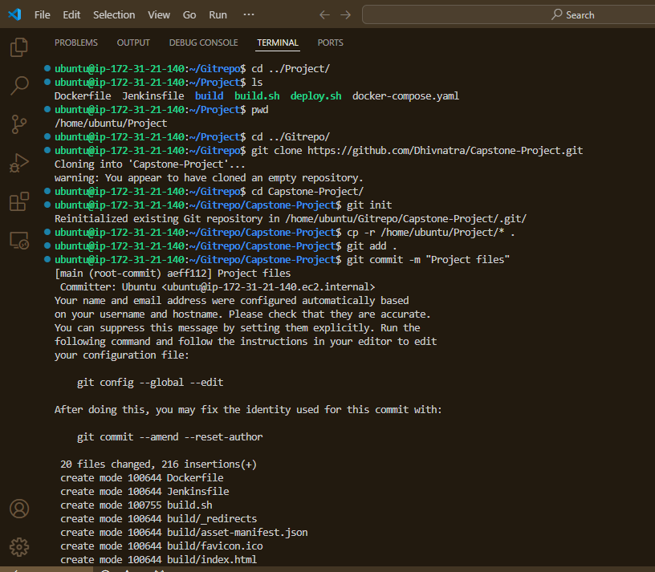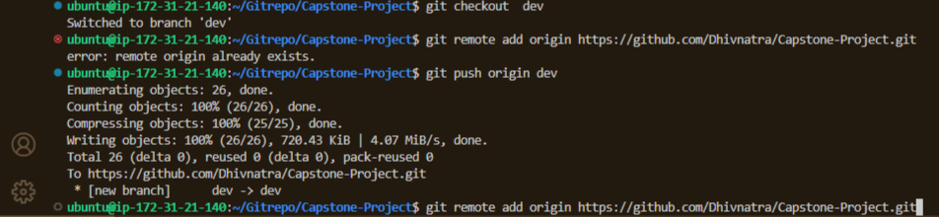

**Jenkins:**

* Configured and logged into Jenkins.

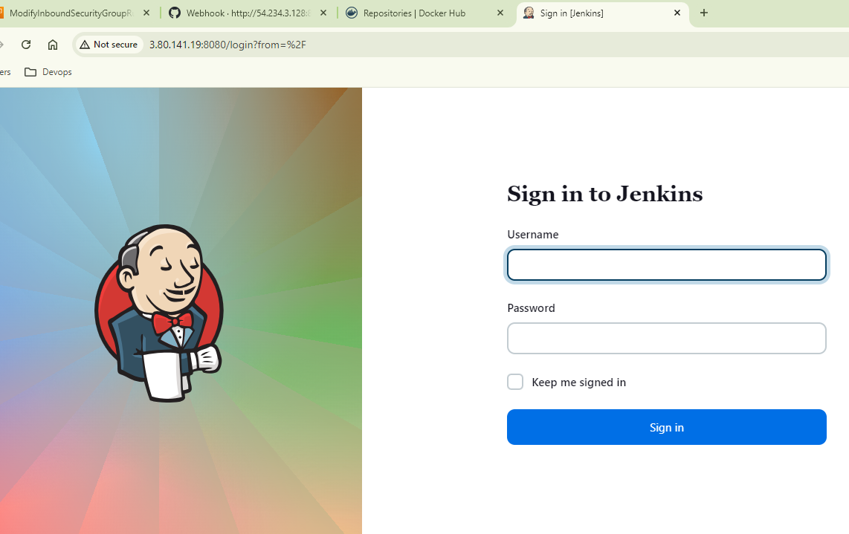

* Installed required plugins

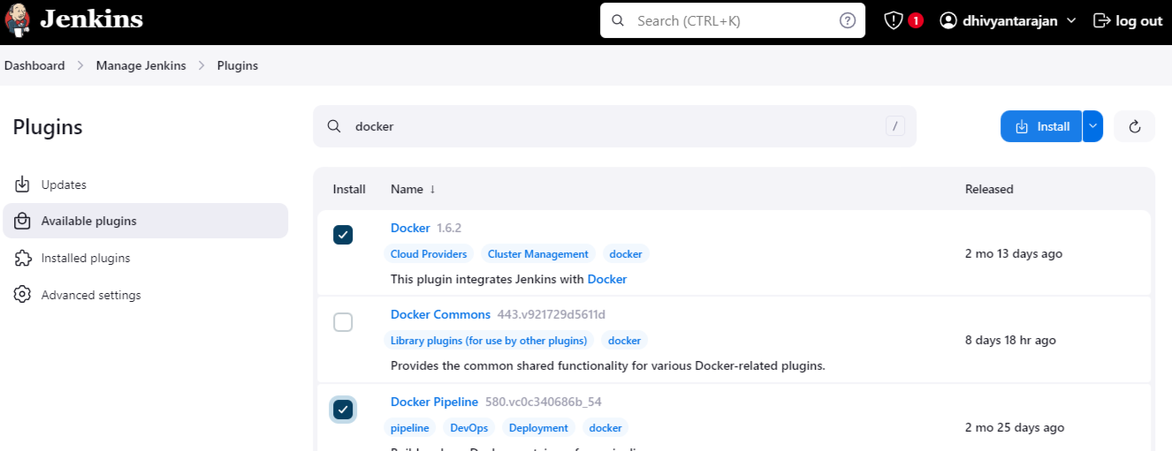

* Configured ,declared Environmental variables and values

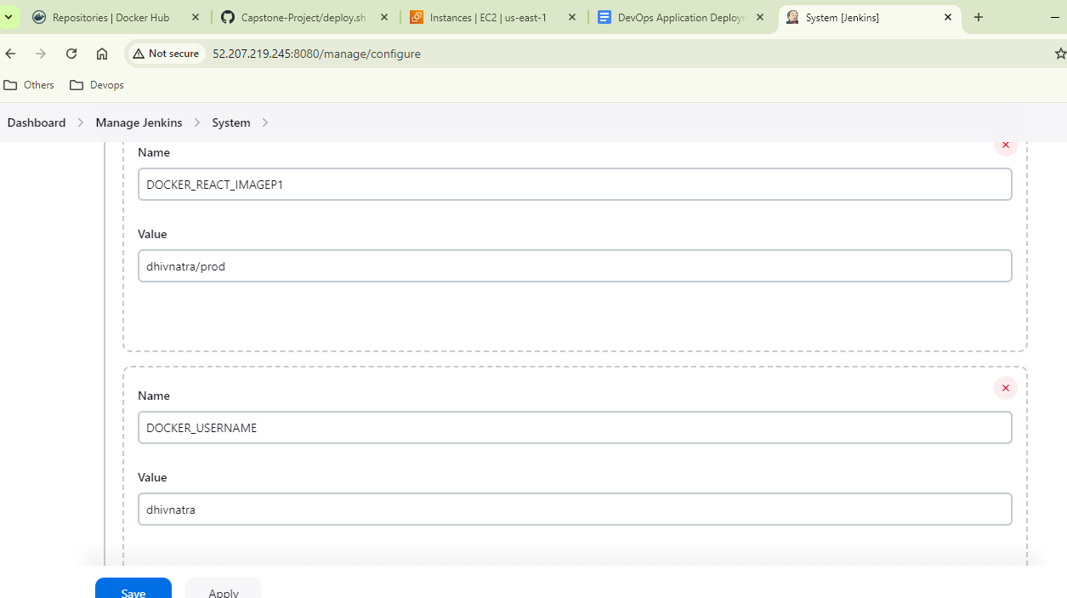

* Configured the Job Pipeline to facilitate build and push docker images.

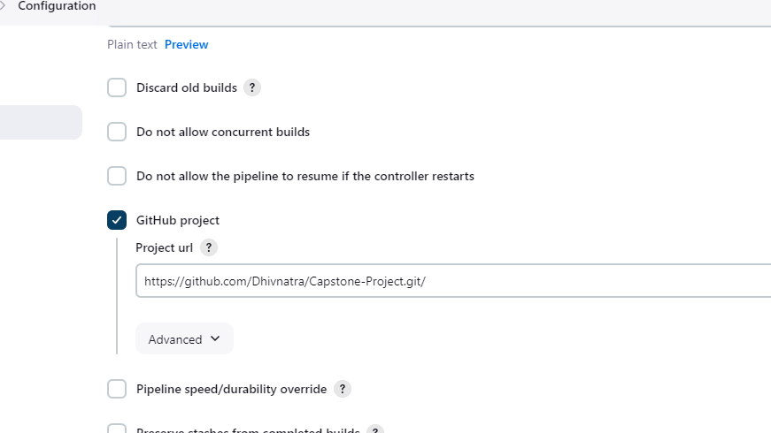

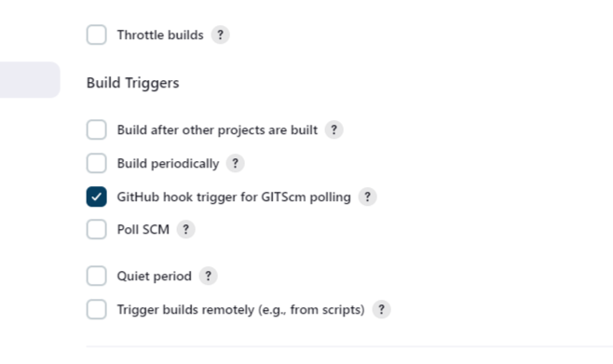

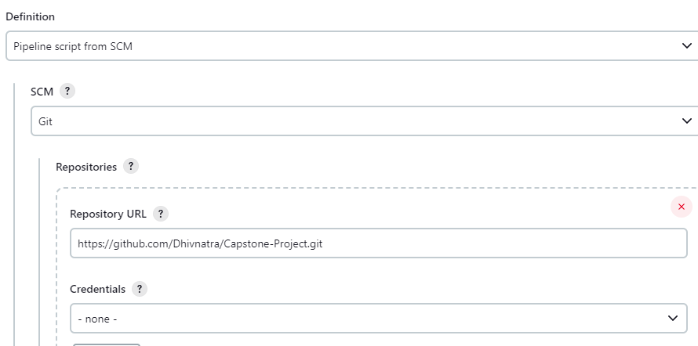

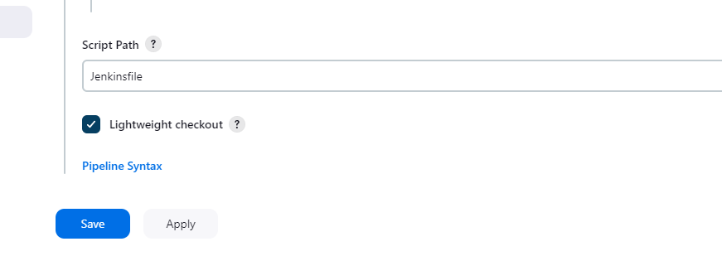

* Webhooks configuration in github to facilitate automated image build and push via Jenkins.

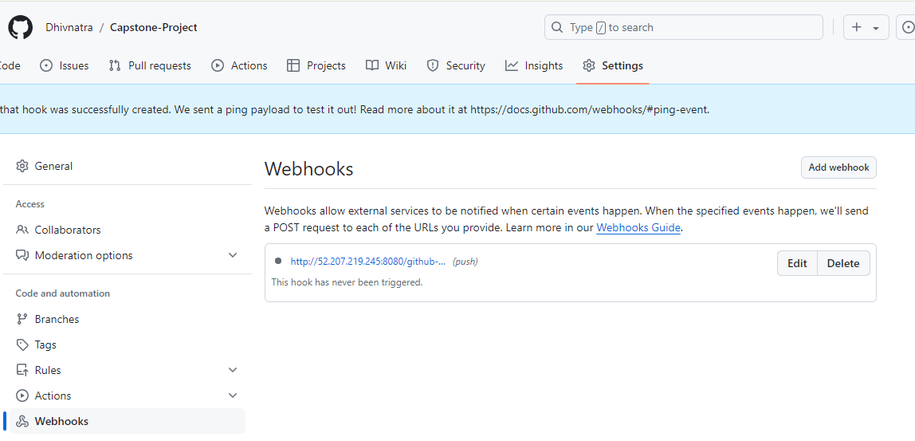

* Code pushed to github dev branch. Jenkins, automates the image build and pushes the image to dockerhub dev repo.



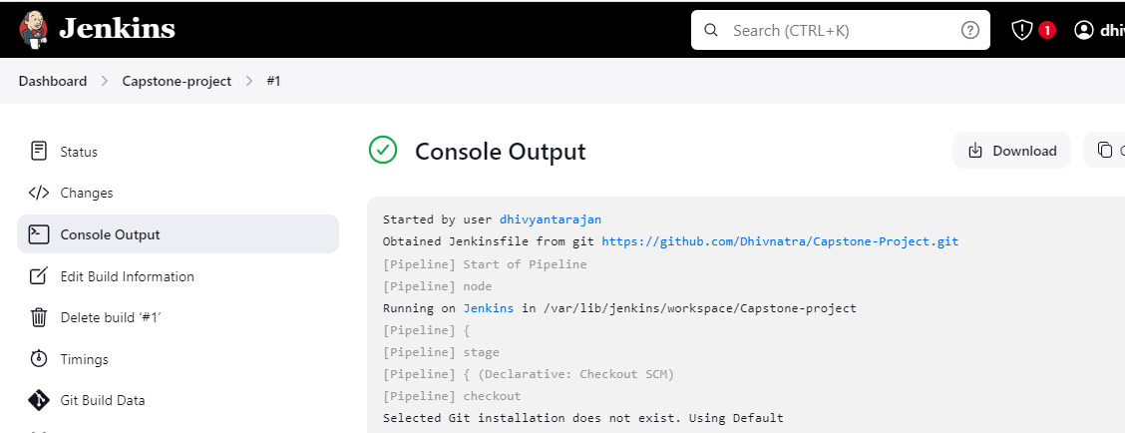

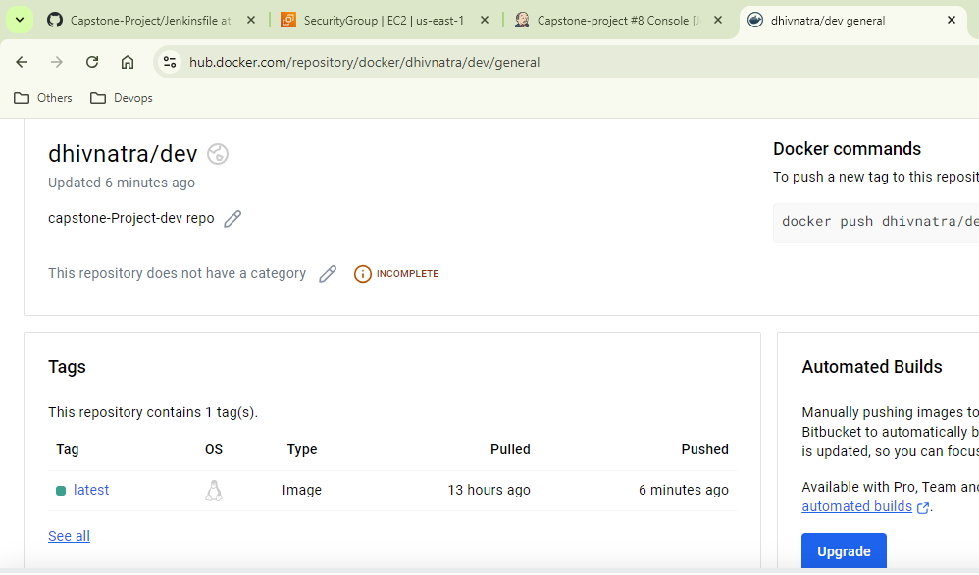

* Github dev branch merged to main branch. Jenkins ,automates the image build and pushes the image to dockerhub prod repo.

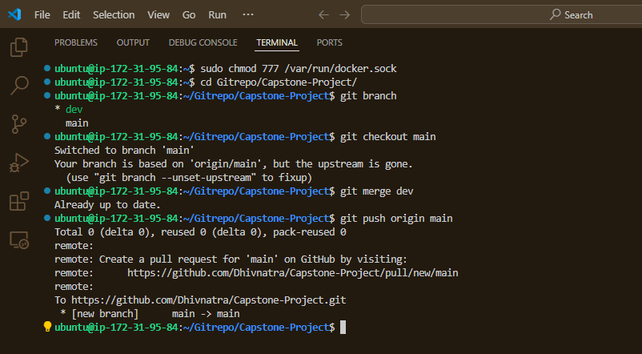

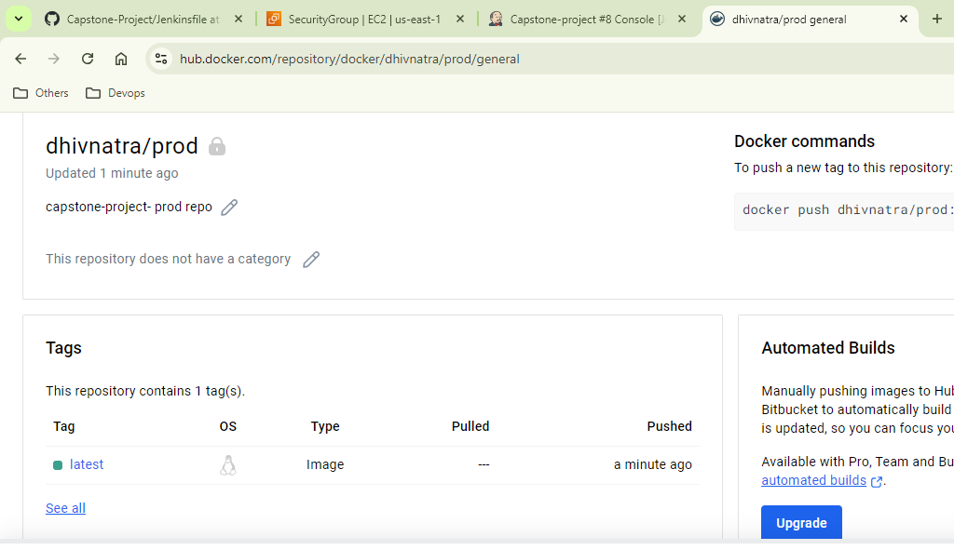

**AWS:**

* Launched a t2.micro instance and deployed the given application.

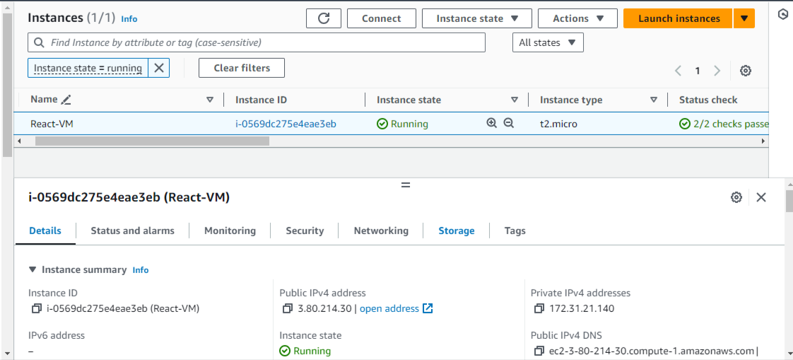

* SG is configured to facilitate login to the server only from my IP and anyone with the ip address can access the application.

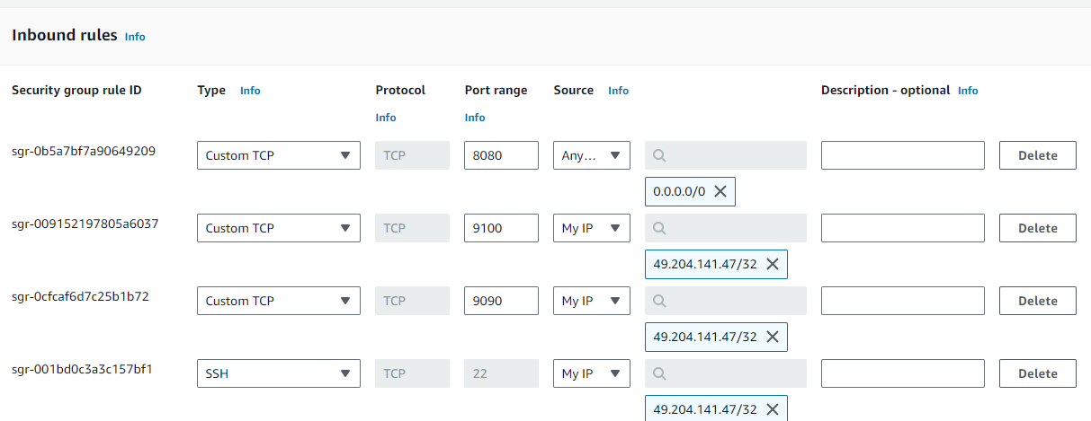

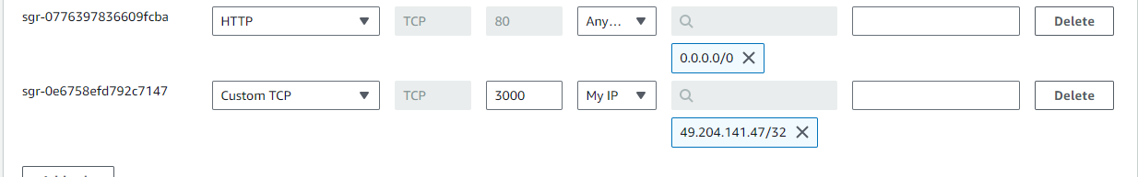

**Monitoring:**

* Installed Prometheus, node exporter ,Grafana for monitoring and visualising the health metrics.

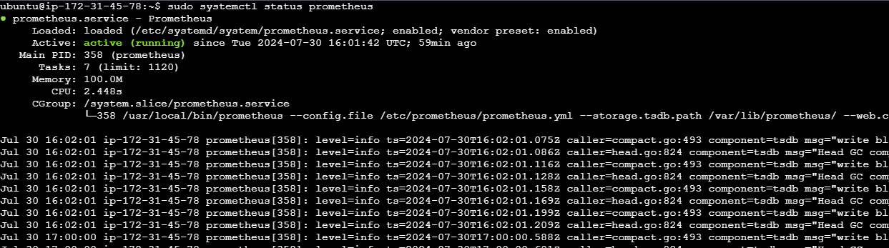

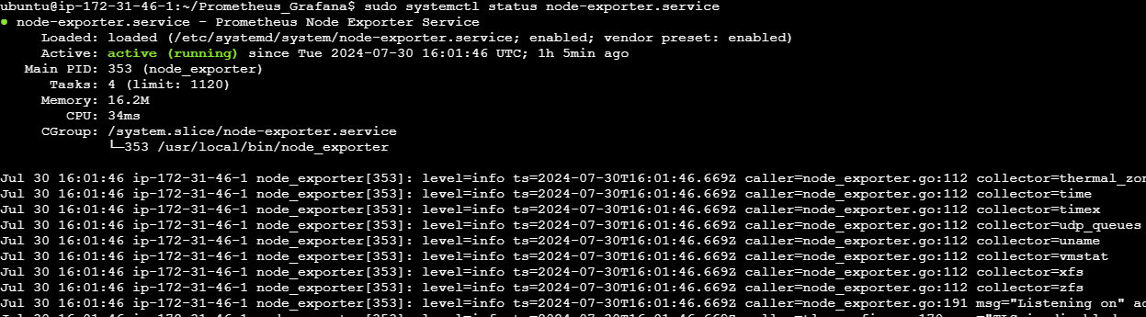

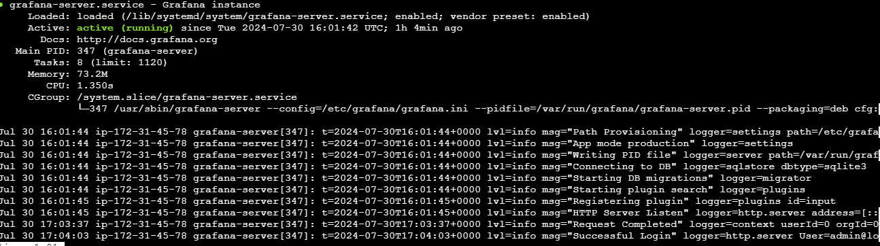

* Configured targets in Prometheus and visualising the health metrics via Grafana Dashboards.

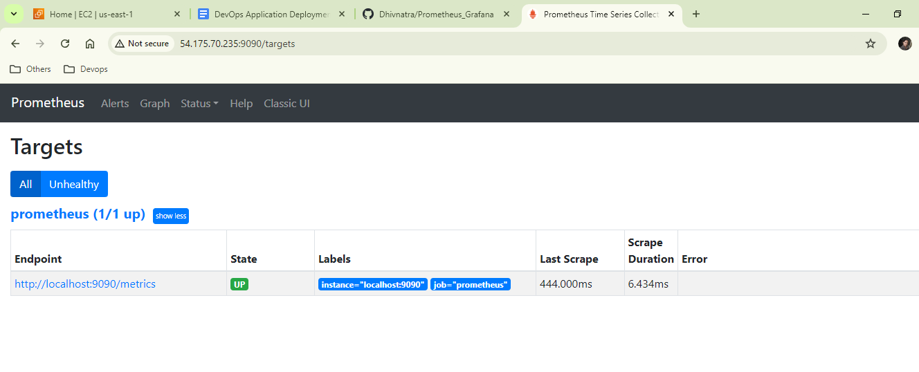

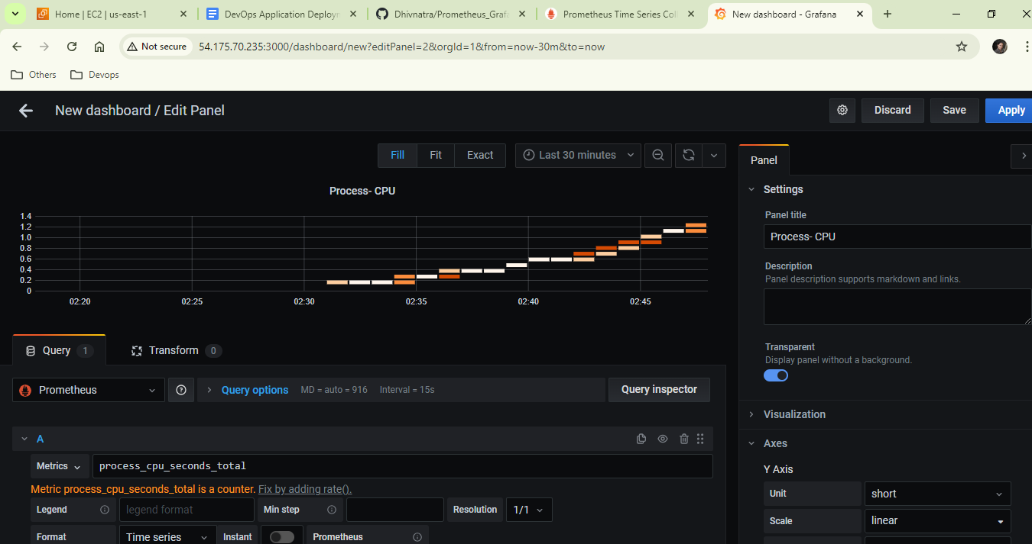

***Submission:***

* Github URL: <https://github.com/Dhivnatra/Capstone-Project.git>
* Deployed site URL: <http://34.236.148.232/>
* Docker Images: dhivnatra/dev:latest

dhivnatra/pro:latest