DEPARTMENT LIBRARY MAGEMENT SYSTEM

OUTPUT:

Home page

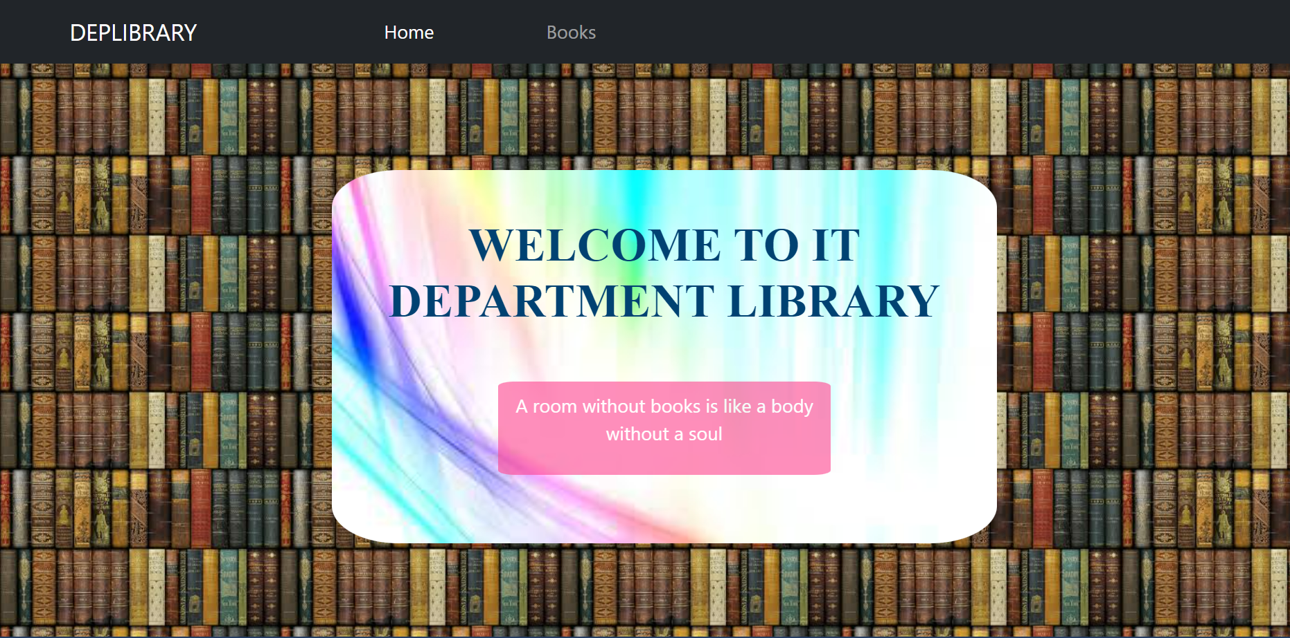

Books page

