

[Big Data Analysis and Application]
Case Study Report Template

Question 3: [1 Report] Max Marks: [50/100]

Student’s Mark:

Report
8-Fit
8fit helps people to build healthy habits for life with simple, made-for-you solutions that embrace your differences, your struggles and your successes – all that makes us human. The 8fit approach draws on powerful pairings: between nutrition and exercise, mind and body, and 8fit and user. You’re not in this alone – we’re with you every step of the way.
We make healthy living simple by providing tailored guidance, including workouts and meal plans, in one easy-to-use app.
8fit is a rapidly growing international team based in Berlin. 8fit push for progress over perfection, choose the best solution over the quick fix, and helps people enjoy the journey to healthiest body and mind yet.

Executive Summary

Back-up Meal plan to include bananas - Always give the client a backup meal plan which contains either Banana or any of the frequent selling item, so that in-case if a person miss the ingredients, the backup meal plan can still help the person to stay on track

Create Meal Plan with Readily Available items at home.

Include Organic Bananas, Organic Strawberries, Organic Baby Spinach, Organic Hass Avacado and Organic Avacado, Lemon, Limes, Raspberries, Zucchini in the diet.

Segment the clients into weekday and weekend shoppers

Segment the clients into weekly buyer and monthly buyer.

Best time to send the Ingredients list will be on early morning.

Create a meal plan that people will actually follow.

Flexible lunch plan for Office-goers.

Segment clients into different tiers and Focus on different target groups based on their needs.

Make a memorable face to face chat.

Understanding the Client’s Shopping Behaviour - Insights from Instacart

Instacart is an American company that operates as a sometimes-same-day grocery delivery service. Customers select groceries through a web application from various retailers and the order is delivered by a personal shopper. Up until the end of 2017, Instacart only had operations and services in the United States. In November 2017, the company announced plans to begin delivery in Toronto and Vancouver.

The shoppers behavior is observed with Instacart dataset, so that 8-fit can understand more about a person’s shopping behavior and suggest a diet plan accordingly.

Back-up Meal plan

Analysing the dataset from Instacart it was very clear that Bananas are more frequent selling item, which means the at any point of time Bananas will be readily available in a person’s home. Always give the client a backup meal plan which contains either Banana or any of the frequent selling item, so that in-case if a person miss the ingredients, the backup meal plan can still help the person to stay on track

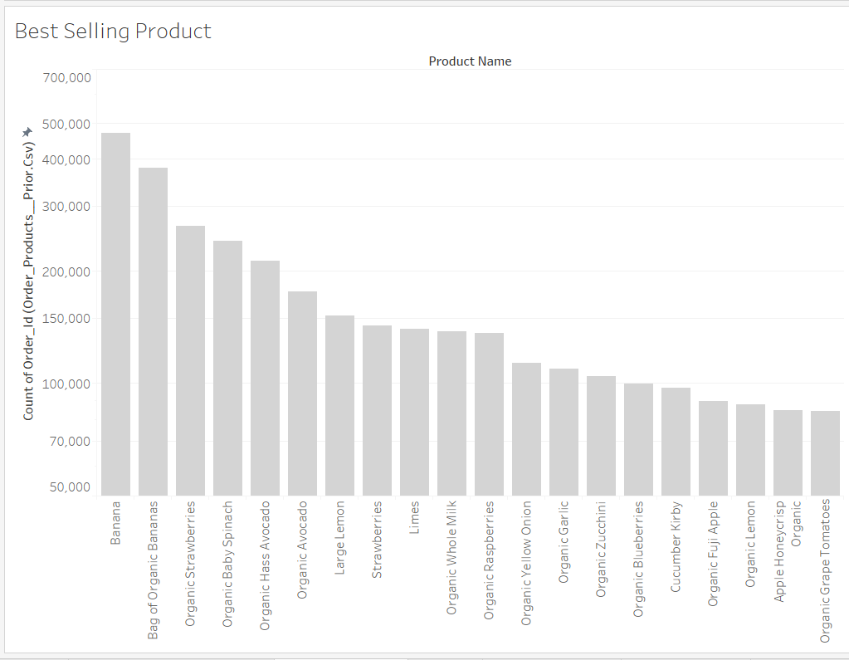

Create Meal Plan with Readily Available items at home.

Include Organic Bananas, Organic Strawberries, Organic Baby Spinach, Organic Hass Avacado and Organic Avacado, Lemon, Limes, Raspberries, Zucchini in the diet. Because as per the above chart it’s very clear these top selling items are available most of the time at clients refrigerator.

Personalized diet plan to the clients

It’s impossible to establish a great eating plan if we don’t know our clients existing eating habits. Once we know what
our clients are eating we probably have an idea of what we would like them to change by focusing on the most important things first. There are also a couple constants, like adding a multi-vitamin and fish oil that almost every client would get an immediate measurable benefit from doing. For the most part clients know what needs to be fixed. People aren’t stupid. They know that two cans of Coke a day is what’s making them fat or that binge eating on pizza at night after a stressful day of work is curbing their results.

Allowing them to take ownership over the decision and choosing what modification they want to make next is a powerful buy-in on their part. It’s their decision. They’re invested in sticking to it. The best coaches know what questions to be asked and help devise an effective strategy based on the answers.

Don’t recommend speaking to clients about alcohol intake at night, which may be a huge issue with lot of clients.

Alcohol at night is usually a compensatory behavior for somebody who’s stressed out or needs to separate from his or her anxieties. Everybody knows it’s unhealthy. We don’t need to say anything. Once they follow all the other habits along with our exercise plan they’ll start to feel better and will stop drinking on their own. It’s empowering for them.

Segment clients based on the day of shopping and send ingredients at appropriate day of the week for different target groups.

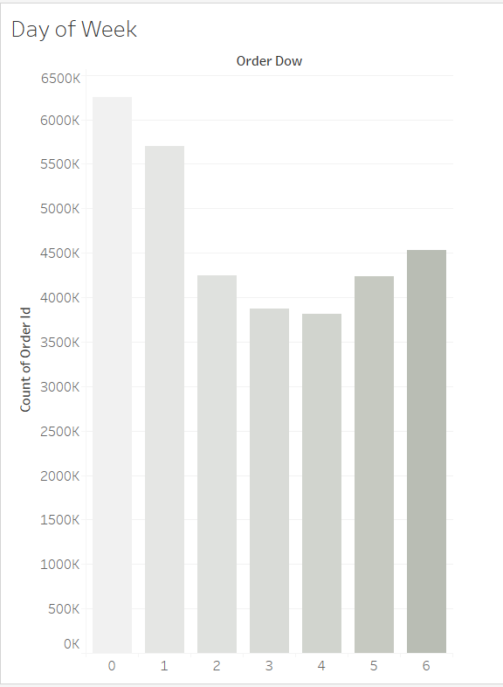
Segment the clients into various groups based on the day they prefer grocery shopping. From the chart its clear that clients can be grouped into below segments:

Weekend Shopper

Weekday Shopper

Now Weekend Shoppers should have their ingredients in hand by Friday, whereas the Weekday Shoppers segment of people should receive it by Monday. Targetting the clients based on these segments makes 8-fit more friendly with the clients and can connect emotionally with them.

Segmenting Client based on their Shopping Routine

The ingredients list for the meal plan has to be sent well in advance, so that clients can include them in their groceries list.

Few people buy groceries every week regularly, whereas majority of people buy once in a month. Now sending the list of ingredients for the entire month’s meal plan for all clients makes it tough for clients who buy groceries every week. If Ingredient list is sent every week, it’s tough for monthly buyers to keep track of the list. It’s better to segment clients based on their shopping routine.

Weekly buyer

Monthly buyer

The Instacart shoppers data reveals that majority of their customers buy the products on the first weekend of a month or on the beginning of a month. Also as discussed earlier, most shoppers buy groceries on weekends. This is also proved in the below chart.

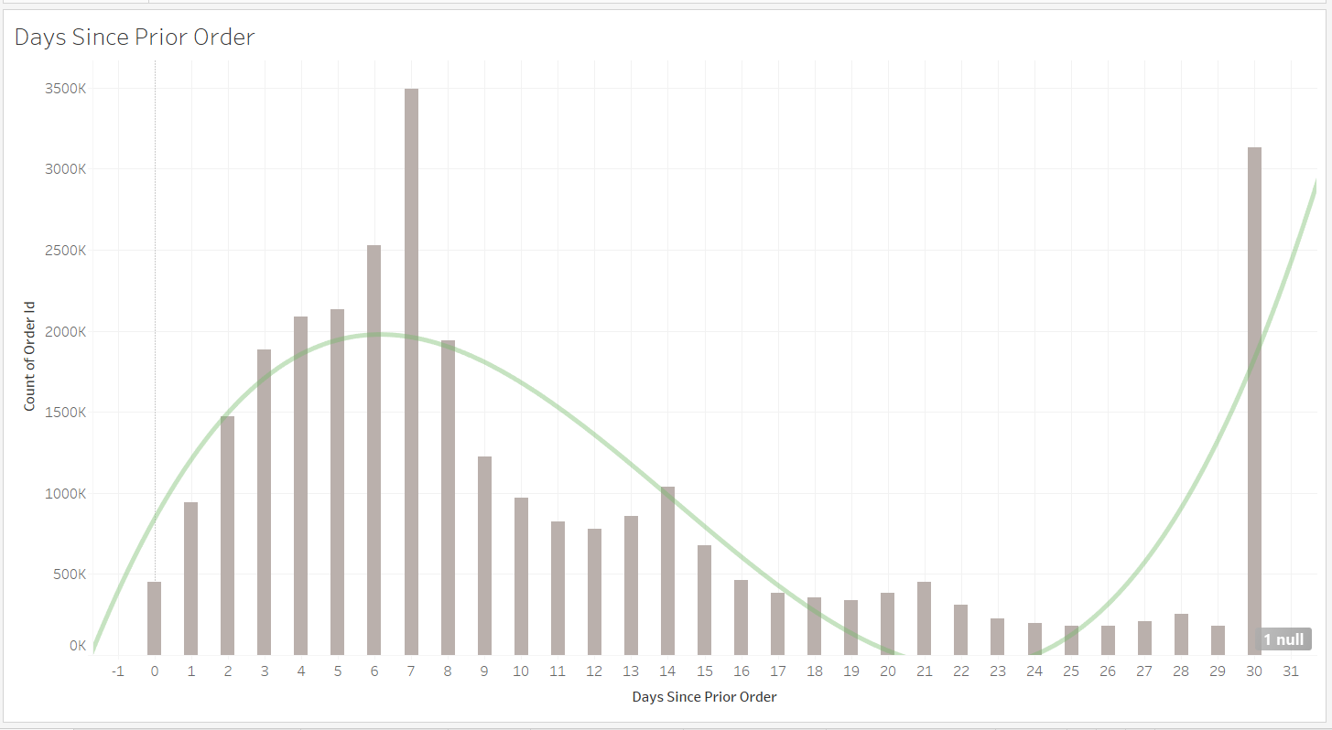

Best time to send the Ingredients list will be

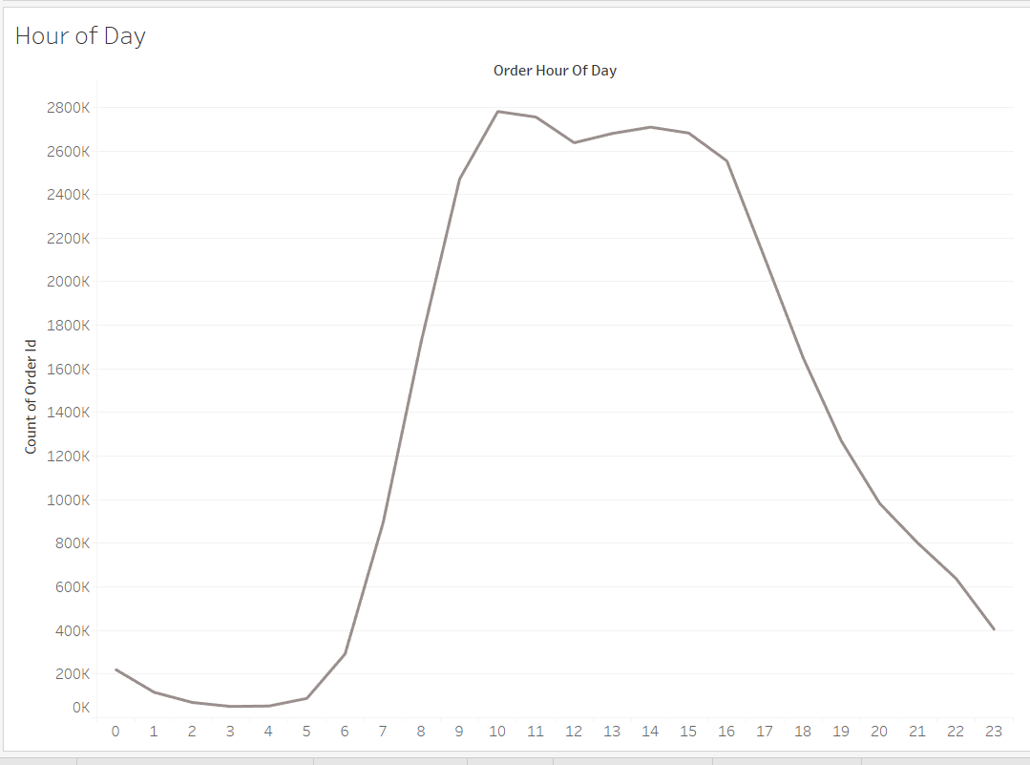
Early Morning.

Its highly evident from the chart that most of the buyers are in between 9am-4pm. 8-fit can send the list of ingredients preferably in the early morning, so that its more convenient for clients to include them in their grocery list.

Maybe for few clients sending the list of ingredients in the evening may be comfortable but majority of customers who prefer shopping in the peak hours must have completed the week’s or month’s shopping and may feel irritated to do shop once again and tend to skip the diet plan.

Create a meal plan that people will actually follow
Anyone could craft the perfect meal plan to get any client lean and shredded in record time - In theory at least. If followed, each individual client would reach their goals, no doubt about it.
The dietary plan can be “perfect” on paper, but if a client won’t follow it, it will never deliver results. So how to create a meal plan that people will actually follow is a main issue under consideration. We assume that every client is just as dedicated, disciplined and motivated as us. That they’ll happily put their lives on hold to achieve results, and have their goals and progress at the forefront of their minds the whole time … not the case.
My issue was giving my clients diets plans that, while effective, would never work, as they’d never be followed.
So, that leaves us with the question – “What are the diet strategies they’ll actually follow?”

- Make it easy
  - This is less of a diet strategy, but more of a general advice. Advise the client to take fish oil or a multivitamin everyday, if they cant keep up with the diet plan.
  - Well, it requires so little effort.
  - All your client needs to do is leave a bottle on their kitchen counter, or in their desk at work.
  - Popping that pill will have absolutely no direct affect on fat loss whatsoever, but it gets them into the habit of making positive changes.
  - Mentally, it’s a huge step, and sets them up for moving ahead and creating bigger, more effective habits.
- Personalised Meal Plans
  - 5 years ago, every single trainer would give a client a meal plan
07:00 – 6 egg whites, ½ cup of oats made with water, 1 scoop greens supplement
09:30 – 2 scoops of whey protein, 1 medium orange, 1 oz almonds
That kind of thing
  - But situation is not the same today. Every person’s need, expectations and tolerance are different and need individual attention.
  - Spend time with the client and try to know more about the clients behavior and suggest meal plans to them.
- Ask Client to send pictures of their food
  - People are busy, and often won’t fill in their log until the end of a day, by which time they’ve forgotten what they’ve eaten.
  - Writing stuff down, in today’s tech-savvy age, is a little boring, and it’s easy to get off track and miss a few days.
  - That’s why its good idea to ask clients to take pictures of their food. They love doing this.
  - A visual representation is far more useful to both. As the trainer, it lets you see the quantities your client is consuming (because when the meal plan says “handful of”, and one person’s “handful of” is very different to the next.)
  - Second, it really makes the client think about what they’re eating too.

Make flexible diet plan for Office-goers.
Lunch options can be a godsend for 8-fit busy office worker clients too. Ask them what they have local to them,
and give them a ton of options.
- McDonalds – grilled Southwest, Ranch, or sweet chilli chicken wrap, with a side salad or apple slices and
any diet drink, Americano or skinny cappuccino.
- Subway – 6″ turkey, turkey and ham, chicken breast or steak. Or any of these as a salad, plus
a bag of Baked Lays.
- Chipotle – any bowl with cheese OR sour cream, or 3 tacos (any filling but no cheese) or a salad
with everything in.
Again, we are encouraging flexibility and choice, but giving guidance at the same time.
This gets the clients thinking for themselves, and taking on some accountability, yet they know 8-fit is there, in their corner, helping them out too.

Segment clients into different tiers and Focus on different target groups based on their needs.

Expecting clients to make radical changes to their diet overnight is ideal. The cold hard truth though, is that the vast majority of the general public simply can’t do this, and therefore, it’s up to 8-fit, to make things as straightforward as possible, to increase adherence, and get them the results they desire.
Separate them into 3 Segments:
- Those who need very little assistance from 8-fit.
- Those who are really struggling.
- Those who are somewhere in the middle.
The top tier clients probably don’t need too much from 8-fit – Just send them a text or an email to see how everything’s going?
The middle folk – they likely need a quick analysis of their daily meals.
As for the clients who are struggling – ring them up. Tell them 8-fit have been doing some thinking, and have some highly effective, very simple ways to help them out with their diet, and would like to chat through these.

Make a memorable face to face chat.
Getting the clients from where they are now to where they want to be in the process, and it certainly isn’t smooth sailing.
But 8-fit can make that journey a lot easier, and a lot more enjoyable for them with simple, actionable steps.
Clients meet with 8-fit twice, ot thrice a week. The time is valuable and it needs to be used in the most efficient manner possible. With a simple, memorable term like green food.
“Green food” is sticky. When a client goes into their fridge to get food they’ll remember the words and immediately know whether the food choice they’re making is a good one or bad. Also, print out a smiley green face and give it to them.
Obviously this is a simple and superficial guideline.

A food that’s either green (or a vegetable) and has or used to have good protein.
- Teach your client what green face is and tell them that it’s your only diet recommendation. Tell them that apart from first thing in the morning and pre/post workout all foods should be green.
- Every day when they walk into the gym look at them and say, “Have you been eating green food?” Soon this will turn into a simple, “Green food?”

Few Insights from Instacart Dataset
Reordered Items
Analysis from the dataset reveals that 60% of the items in total order are re-ordered items, which means that people tend to stick with the prior ordered items and changing the grocery list with new items. Lets consider the clients grocery list before changing it completely with the new list of ingredients
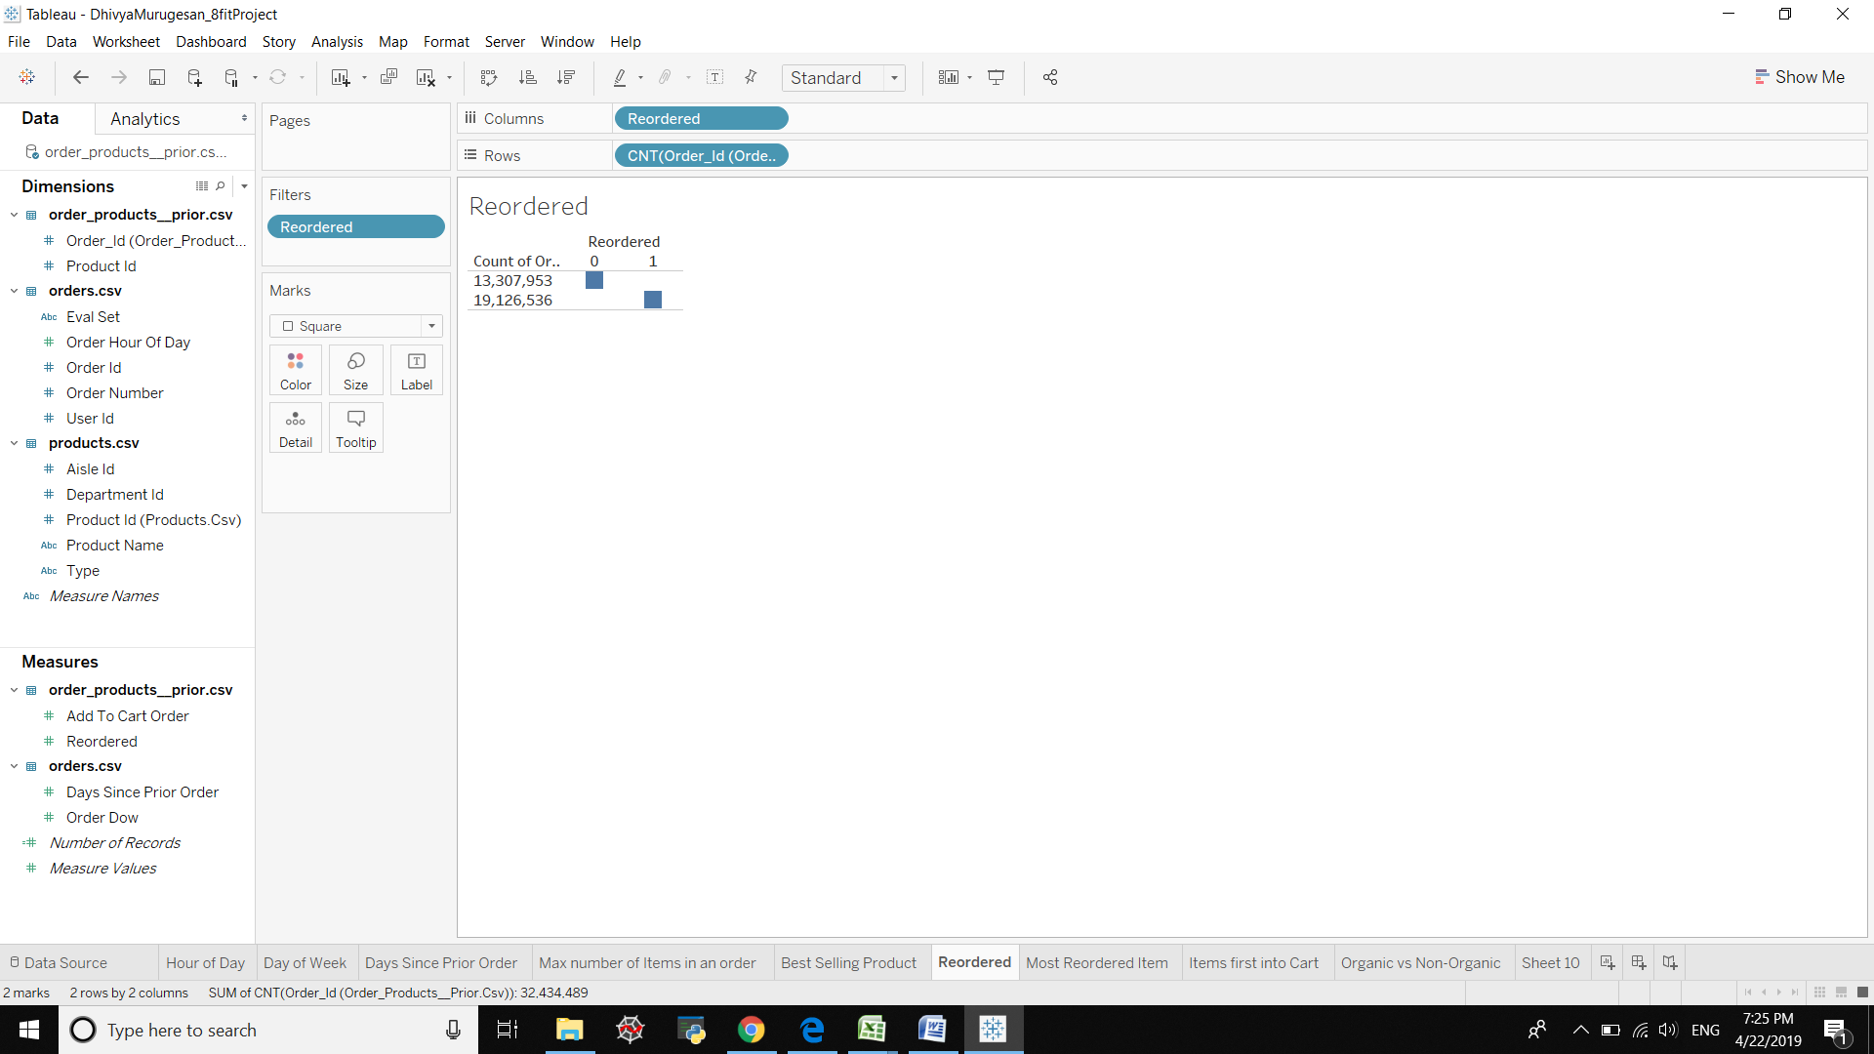
And the list of re-ordered items are….
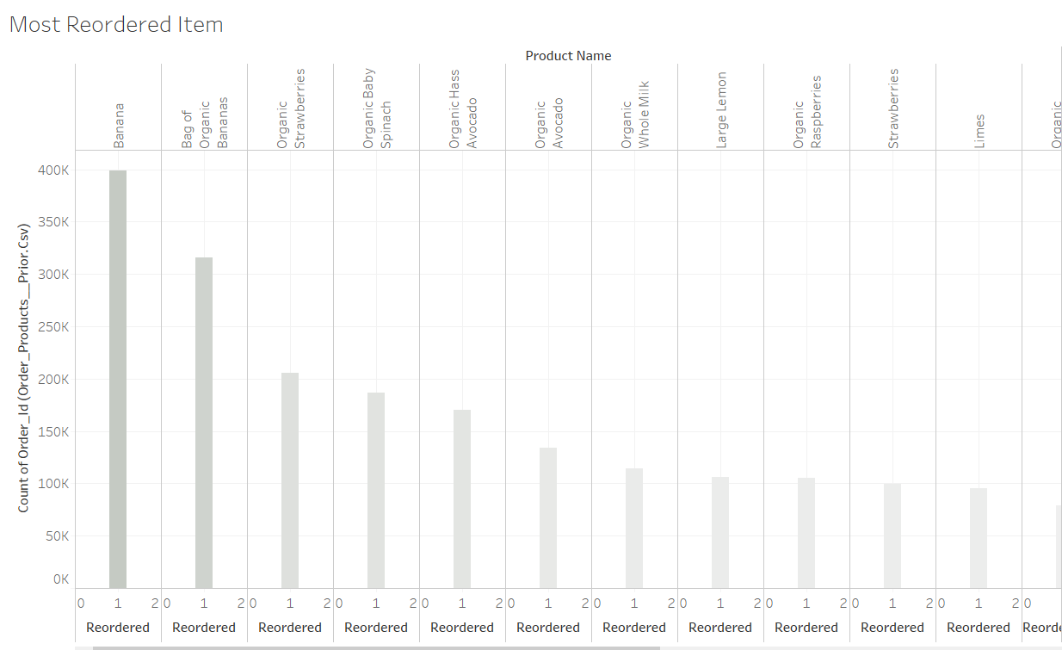
Order of Items into Cart.
Its clearly evident that Bananas are the first to enter into cart in majority of the orders. Followed by other vegetables, fruits and milk.
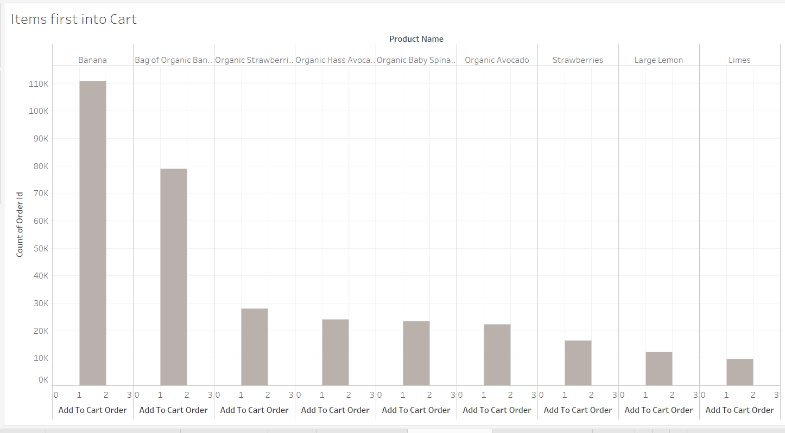

Conclusion:

Understand the clients shopping behavior and suggest a personalized diet plan to the clients.

Segment clients based on the day of shopping and send ingredients at appropriate day of the week for different target groups.

Segmenting Client based on their Shopping Routine.

Best time to send the Ingredients list will be on early morning.

Create a meal plan that people will actually follow.

Ask clients to report every meal with a photo.

Make flexible lunch plan for Office-goers.

Segment clients into different tiers and Focus on different target groups based on their needs.

Make a memorable face to face chat.

Reference:
Readers Digest
8-fit.com
Instacart.ca

