##### **Creating ASP.NET Core Web API Project Using Visual Studio 2022**

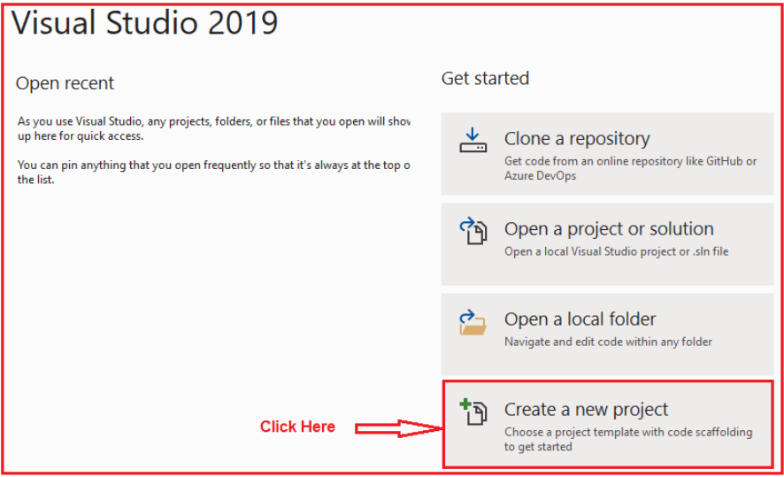

Once you click on the Create a new project option, the following Create a new project window will open. Here, you can find two projects template for creating the **ASP.NET Core Web API**project. One is using C# language and the other one is using F# language. I am going to use C# as the programming language, so I select the project template which uses C# Language as shown in the below image.

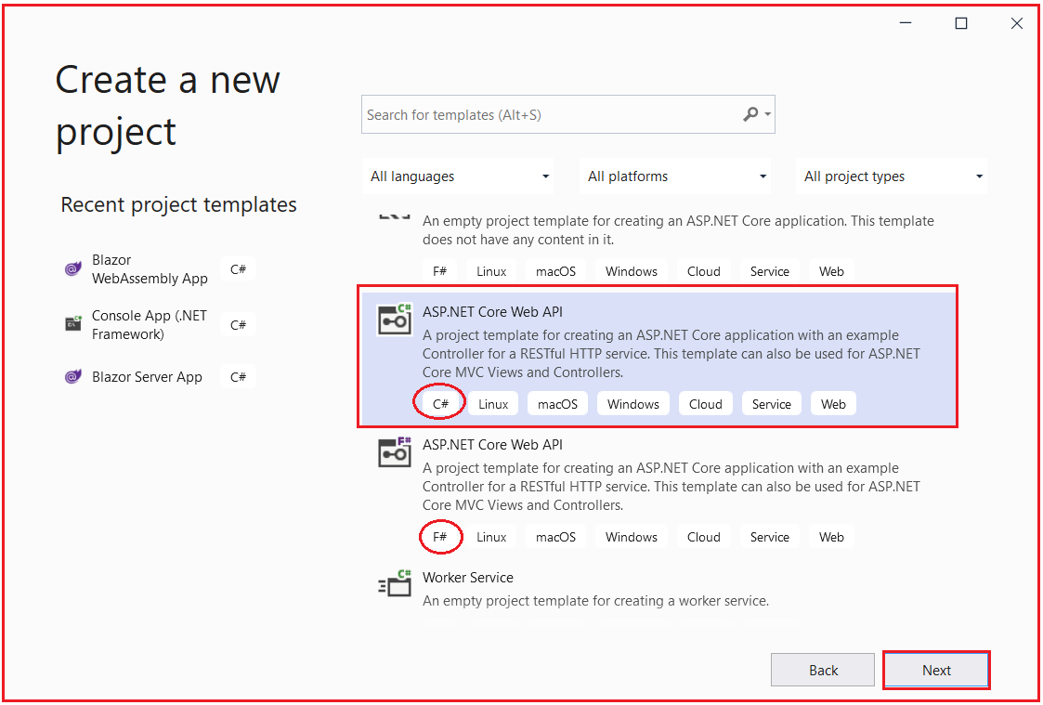

Once you click on the **Next** button, then the configure your new project window will open. Here, you need to specify the Project name Solution name, and the location where you want to create the project. I am providing the Project name as StudentAdmissionManagement, solution name as SchoolManagementSystem, and finally, click on the **Next**button as shown in the below image.

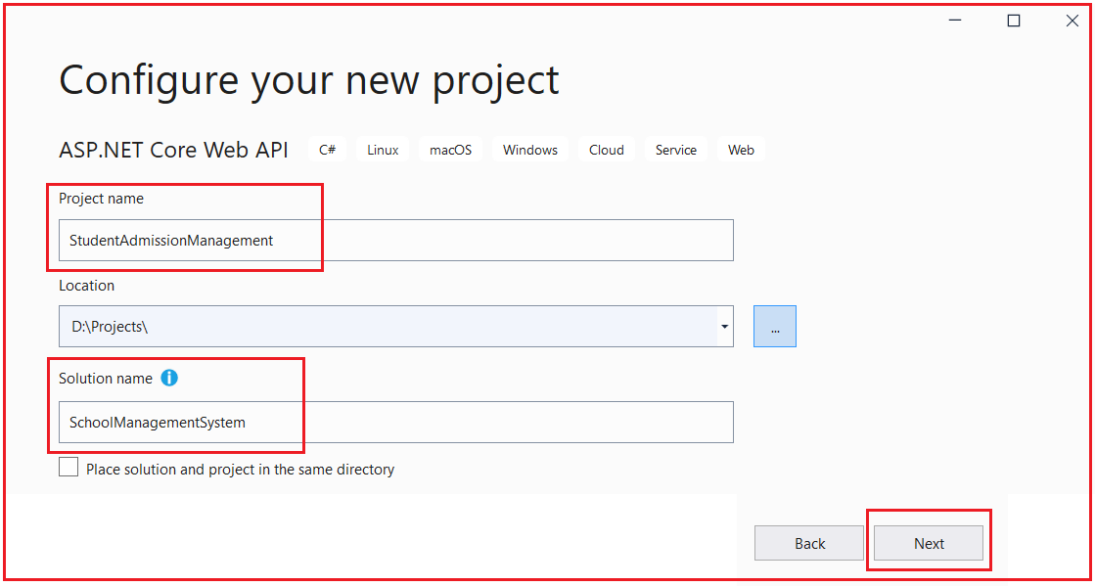

Once you click on the Next button, it will open the Additional Information window. Here, you need to select the Target .NET Framework version. The authentication Types. Whether you want to configure HTTPS and enable Docker. Select .NET Core 3.1 for now because it is having long Term support from Microsoft, select authentication type as None, check the Configure for HTTPS and uncheck the Enable Docker checkboxes and then click on the Create button as shown in the below image.

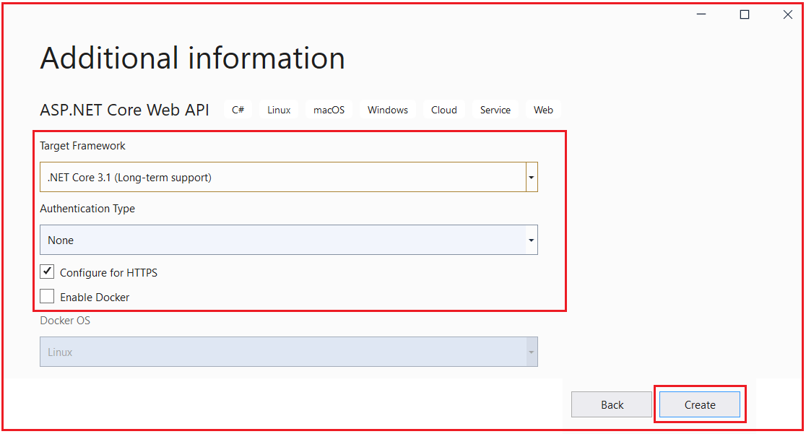

Once you click on the Create button, it will create the ASP.NET Core Web API project with the following file and folder structure. Initially, I have created only one separate project for student admission purposes which can be considered as a single microservice that works for student admission.

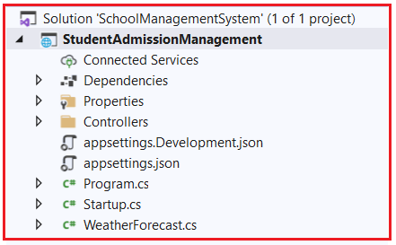

Let us create one more project under the solution which is another microservice for purpose of student attendance. To do so, right-click on the solution and then select Add => New Project option from the context menu as shown in the below image.

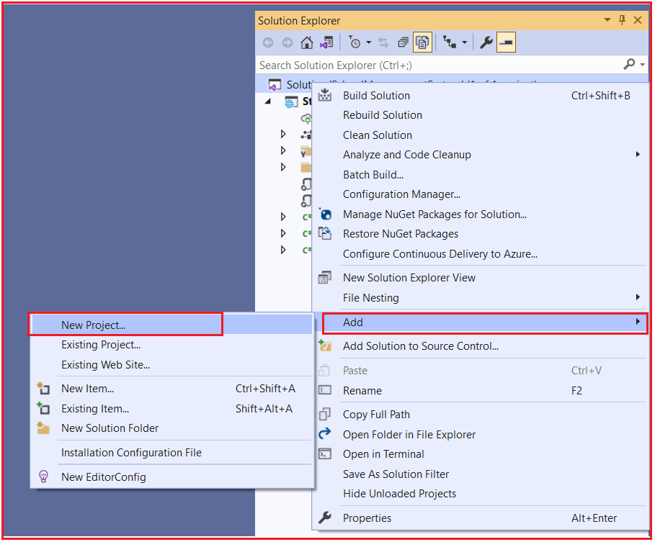

Once you click on the Add => New Project option, it will open the Add New Project window. From this window, select ASP.NET Core Web API (which uses C# language) and click on the Next button as shown in the below image.

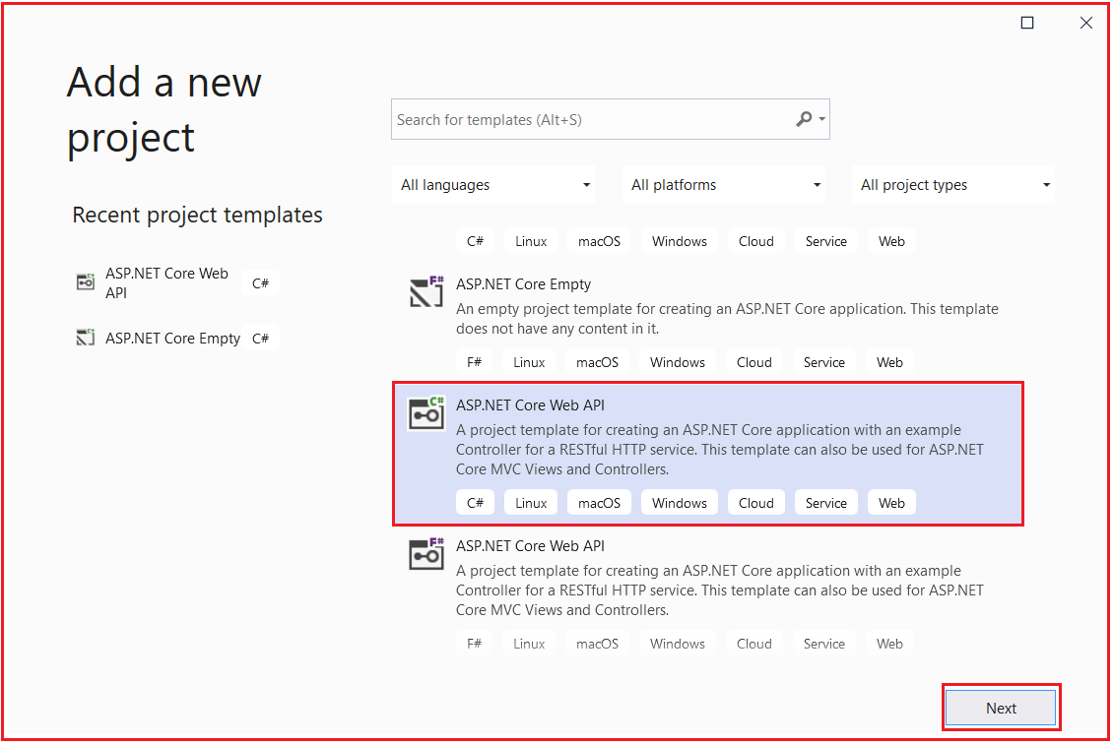

Once you click on the Next button, it will open Configure your new project window. From this window, provide the project name as StudentAttendanceManagement and click on the Next button as shown in the below image.

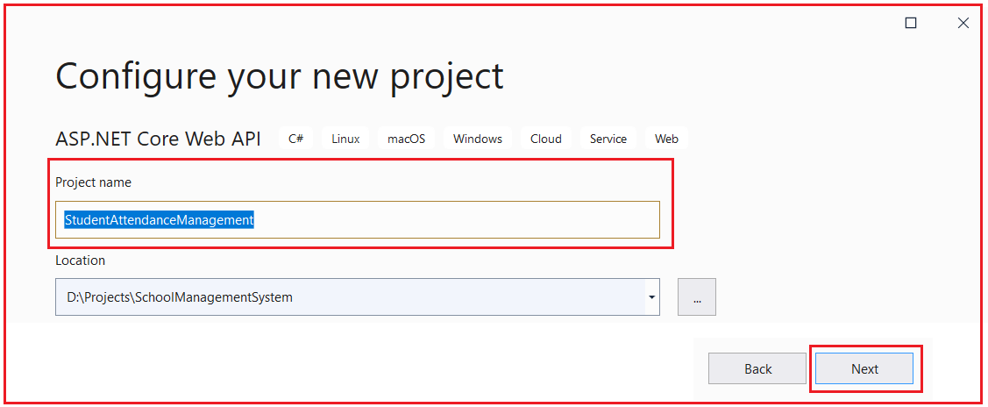

Once you click on the Next button, it will open the Additional Information window. Here, Select .NET Core 3.1 as Target Framework, select authentication type as None, check the Configure for HTTPS and uncheck the Enable Docker checkboxes and then click on the Create button as shown in the below image.



Once you click on the Create button, then it will add the new project to the existing solution. Now, our solution containing two projects with the following file and folder structure.

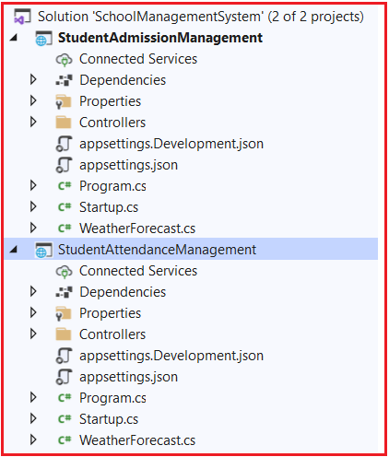

Now we have two microservices defined one for Student Admission purposes and the other for Student Attendance purposes.

##### **Creating Models:**

Now let’s create a model class to hold details of Admission and Attendance in both the projects respectively and create a CRUD operation Controllers in each of project respectively under the Controllers folder. So, right-click on the StudentAdmissionManagement project and add a class file with the name StudentAdmissionDetailsModel.cs and then copy and paste the following code in it.

**using** *System;*

**namespace** *StudentAdmissionManagement*

**{**

**public** **class** StudentAdmissionDetailsModel

**{**

**public** **int** StudentID **{** **get**; **set**; **}**

**public** **string** StudentName **{** **get**; **set**; **}**

**public** **string** StudentClass **{** **get**; **set**; **}**

**public** DateTime DateofJoining **{** **get**; **set**; **}**

**}**

**}**

Now, right-click on the StudentAttendanceManagement project and add a class file with the name StudentAttendanceDetailsModel.cs and then copy and paste the following code in it.

**namespace** *StudentAttendanceManagement*

**{**

**public** **class** StudentAttendanceDetailsModel

**{**

**public** **int** StudentID **{** **get**; **set**; **}**

**public** **string** StudentName **{** **get**; **set**; **}**

**public** **double** AttendencePercentage **{** **get**; **set**; **}**

**}**

**}**

##### **Creating Controllers:**

Now Let us create controllers which are endpoints for microservices for defining CRUD operations. Right-click on the Controllers folder of StudentAdmissionManagement and then select Add => Controller option from the context menu as shown in the below image.

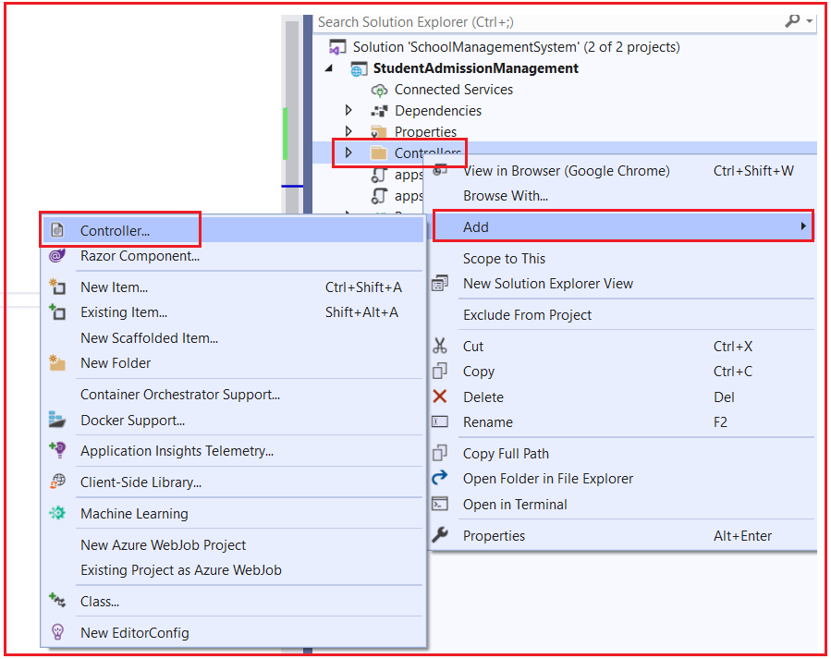

Once you select the Add => Controller option, then it will open the Add New Scaffolded Item window. Here, first, select the API template and then select the Add Controller with read/write action template and click on the Add button as shown in the below image.

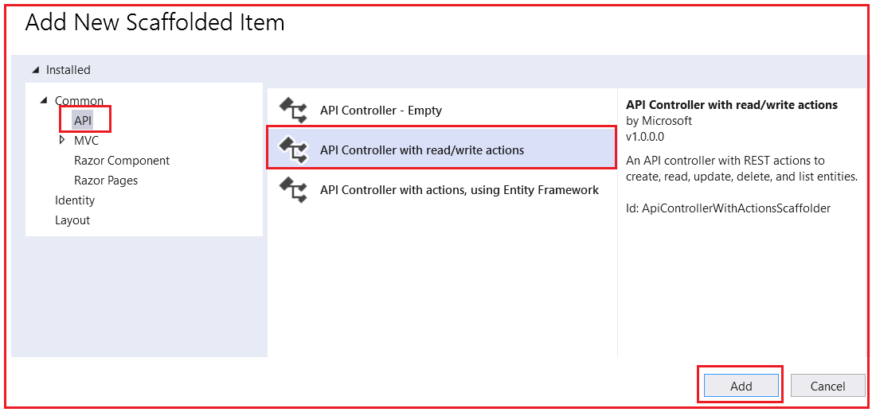

Once you click on the Add button, from the next window provide the name for your controller. Here, I am providing the name as StudentAdmissionController and click on the Add button as shown in the below image.

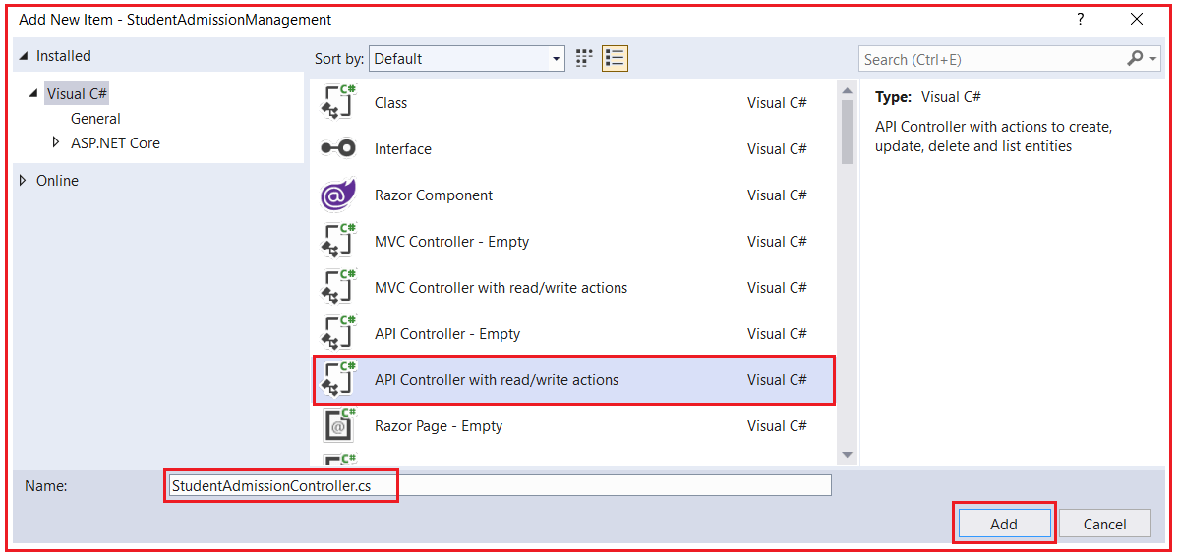

Once you click on the Add button, then it will add the StudentAdmissionController within the Controllers folder of your StudentAdmissionManagement project.

For the demonstration purpose, we create a GET endpoint with details of two students which will return details of two students to client request over HTTP GET. So, modify the StudentAdmissionController as follows.

**using** *Microsoft.AspNetCore.Mvc;*

**using** *System;*

**using** *System.Collections.Generic;*

**using** *System.Linq;*

**using** *System.Threading.Tasks;*

**namespace** *StudentAdmissionManagement.Controllers*

**{**

**[**Route**(**"api/[controller]"**)]**

**[**ApiController**]**

**public** **class** StudentAdmissionController : ControllerBase

**{**

// GET: api/<StudentAdmissionController>

**[**HttpGet**]**

**public** IEnumerable**<**StudentAdmissionDetailsModel**>** Get**()**

**{**

StudentAdmissionDetailsModel admissionobj1 = new StudentAdmissionDetailsModel**()**;

StudentAdmissionDetailsModel admissionobj2 = new StudentAdmissionDetailsModel**()**;

admissionobj1.StudentID = 1;

admissionobj1.StudentName = "Adam";

admissionobj1.StudentClass = "X";

admissionobj1.DateofJoining = DateTime.Now;

admissionobj2.StudentID = 2;

admissionobj2.StudentName = "Brad";

admissionobj2.StudentClass = "IX";

admissionobj2.DateofJoining = DateTime.Now;

List**<**StudentAdmissionDetailsModel**>** listofobj = new List**<**StudentAdmissionDetailsModel**>**

**{**

admissionobj1,

admissionobj2

**}**;

**return** listofobj;

**}**

**}**

**}**

Now, Right-click on the Controllers folder of StudentAttendanceManagement and then select Add => Controller option from the context menu as shown in the below image.

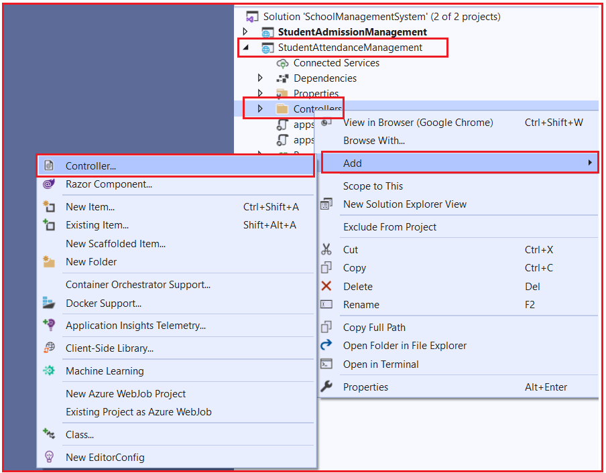

Once you select the Add => Controller option, then it will open the Add New Scaffolded Item window. Here, first, select the API template and then select the Add Controller with read/write actions and click on the Add button as shown in the below image.



Once you click on the Add button, from the next window provide the name for your controller. Here, I am providing the name as StudentAttendanceController and click on the Add button as shown in the below image.

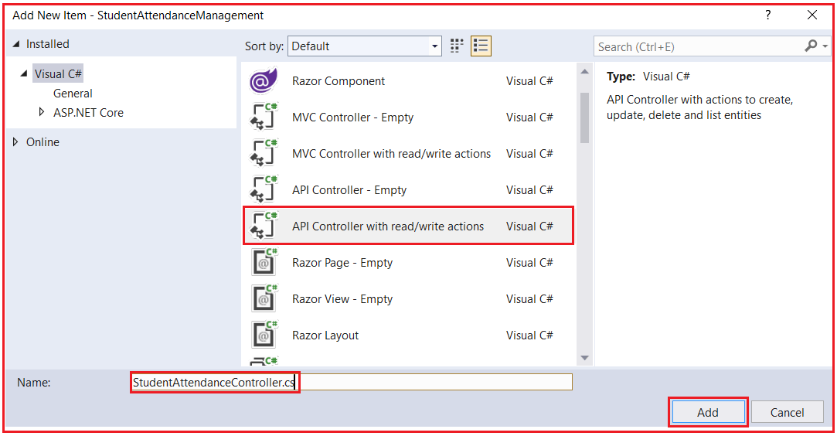

Once you click on the Add button, then it will add the StudentAttendanceController within the Controllers folder of your StudentAttendanceManagement project. For the demonstration purpose, we create a simple Get method for returning the two students’ attendance percentage on HTTP GET requests. So, modify the StudentAttendanceController as follows.

**using** *Microsoft.AspNetCore.Mvc;*

**using** *System;*

**using** *System.Collections.Generic;*

**using** *System.Linq;*

**using** *System.Threading.Tasks;*

**namespace** *StudentAttendanceManagement.Controllers*

**{**

**[**Route**(**"api/[controller]"**)]**

**[**ApiController**]**

**public** **class** StudentAttendanceController : ControllerBase

**{**

// GET: api/<StudentAttendanceController>

**[**HttpGet**]**

**public** IEnumerable**<**StudentAttendanceDetailsModel**>** Get**()**

**{**

StudentAttendanceDetailsModel attendanceObj1 = new StudentAttendanceDetailsModel**()**;

StudentAttendanceDetailsModel attendanceObj2 = new StudentAttendanceDetailsModel**()**;

attendanceObj1.StudentID = 1;

attendanceObj1.StudentName = "Adam";

attendanceObj1.AttendencePercentage = 83.02;

attendanceObj2.StudentID = 2;

attendanceObj2.StudentName = "Brad";

attendanceObj2.AttendencePercentage = 71.02;

List**<**StudentAttendanceDetailsModel**>** listObj = new List**<**StudentAttendanceDetailsModel**>**

**{**

attendanceObj1,

attendanceObj2

**}**;

**return** listObj;

**}**

**}**

**}**

Let’s build the solution and launch both the Web API services (Microservices) simultaneously. For this, we have to set both the projects as starting projects. For that, open the properties window of Solution and then select multiple startup projects radio button and set the action to start for both the projects as shown in the below image.

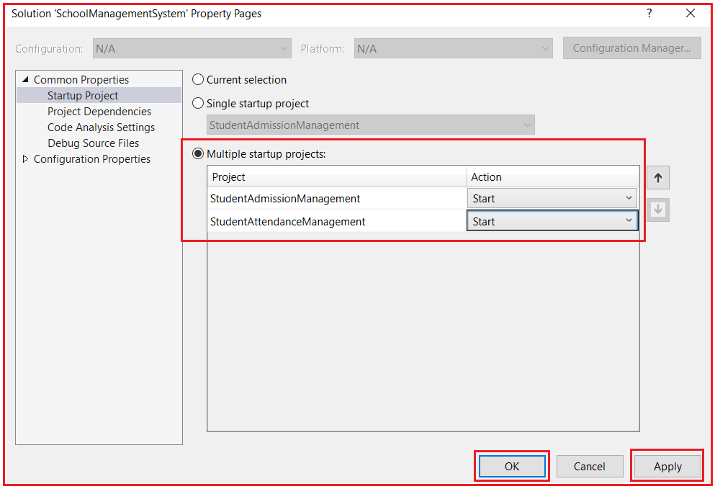

##### **Running Applications and Showing Outputs**

Click on the Start button and then we get two browsers opened and point to the controllers from browsers like below. Browser by default sends GET HTTP Verb.

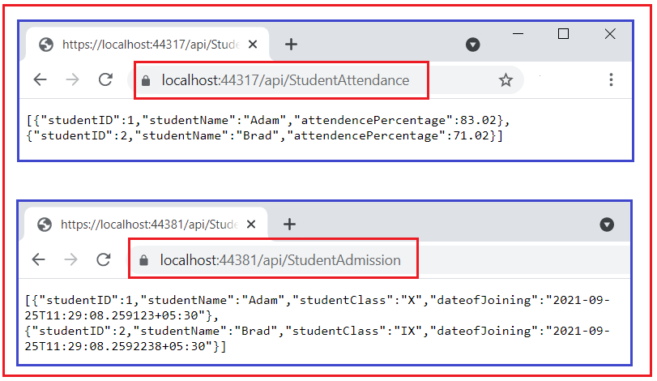

They returned the details as expected. So, this is how microservices are developed and our two microservices are available to serve the user requests over HTTP request and response. To test Microservices with Postman application please refer to the Testing section provided at end of this learning path.

Till now we have observed the implementation of independent APIs (Microservices) which hold separate concerns of business functionalities, one is to get admission details of all the students and the other is to get the attendance percentage of all the students in examples. Which are directly exposed to the Client.

##### **Creating an API Gateway in ASP.NET Core**

In this section let’s implement an API gateway, which will be responsible to re-direct the incoming request from the client (Browser / Postman App / any Client Application) to the Microservice and returns the response to the client. Observe the following diagram, depicting role of API Gateway,

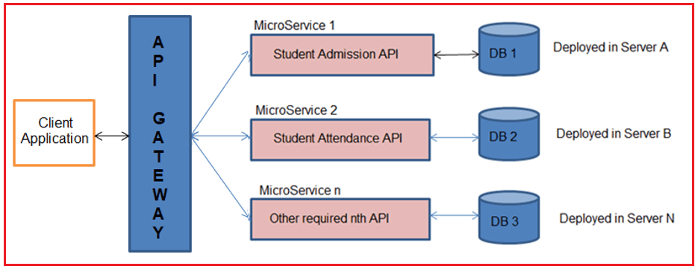

##### **Creating API Gateway Project using Ocelot**

Let’s create a separate ASP.NET Core Web API project with the name SchoolAPIGateway like how we created projects in the solution earlier. Once the project is created it would look like below in the Solution Explorer window.

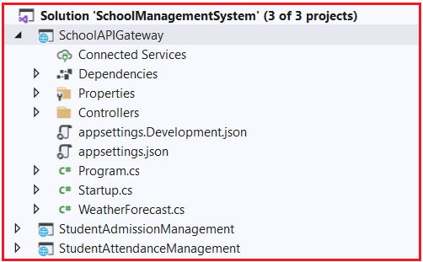

##### **Installing Ocelot package**

Let’s install the Ocelot Package. This makes the project behave as an API gateway. To do so, open click on Tools => NuGet Package Manager => Package Manager Console option from the context menu as shown in the below image.

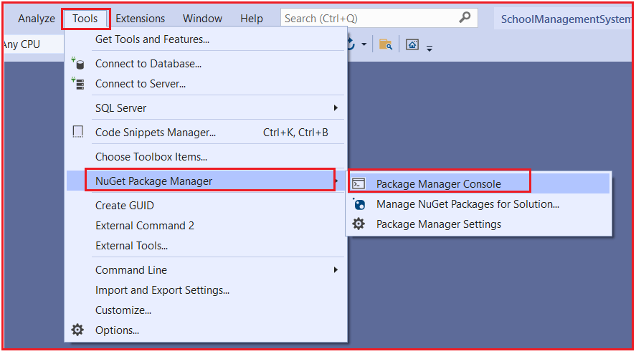

Once you open the Package Manager Console window, choose SchoolAPIGateway as the default project and then type Install-Package Ocelot -Version 15.0.7 and press enter as shown in the below image.

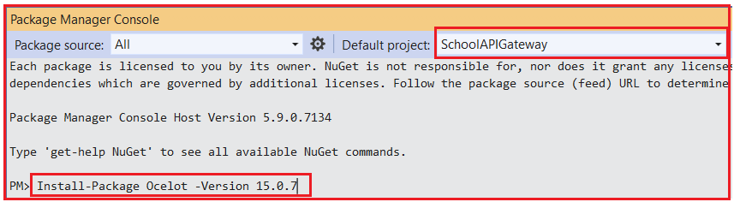

If you face installation issues, due to a mismatch of .NET versions, you can try the different versions of Ocelot, you will find the versions on the official NuGet website.

[**https://www.nuget.org/packages/Ocelot/**](https://www.nuget.org/packages/Ocelot/)

After successful installation, you can see the Ocelot package in the packages folder as shown in the below image.

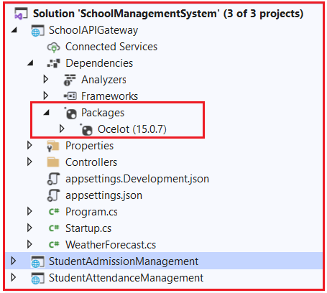

##### **Configure API Gateway and Integrate Microservices.**

let’s configure the project and define the Microservices endpoints.

##### **Configure Ocelot as a middleware**

Let’s configure the Ocelot to work with our application. Go to the Program.cs class file of the SchoolAPIGateway Project and change the CreateHostBuilder() method as follows.

**using** *Microsoft.AspNetCore.Hosting;*

**using** *Microsoft.Extensions.Configuration;*

**using** *Microsoft.Extensions.Hosting;*

**using** *Microsoft.Extensions.Logging;*

**using** *System;*

**using** *System.Collections.Generic;*

**using** *System.Linq;*

**using** *System.Threading.Tasks;*

**namespace** *SchoolAPIGateway*

**{**

**public** **class** Program

**{**

**public** **static** **void** Main**(string[]** args**)**

**{**

CreateHostBuilder**(**args**)**.Build**()**.Run**()**;

**}**

**public** **static** IHostBuilder CreateHostBuilder**(string[]** args**)** =**>**

Host.CreateDefaultBuilder**(**args**)**

.ConfigureWebHostDefaults**(**webBuilder =**>**

**{**

webBuilder.UseStartup**<**Startup**>()**;

**})**.ConfigureAppConfiguration**((**HostingContext, config**)** =**>** **{**

config.SetBasePath**(**HostingContext.HostingEnvironment.ContentRootPath**)**

.AddJsonFile**(**"Ocelot.json", optional: **false**, reloadOnChange: **true)**;

**})**;

**}**

**}**

In the above code, we are configuring the app to read the Ocelot.json file from the root directory of the project which we obtained from HostingContext class. The Ocelot reads the route configuration from the JSON config file, through that the ASP.NET Core 3.1 Application is able to access the settings. Remember that we yet to have created the Ocelot.json file. We will be creating it after we have configured the Ocelot Middleware.

In the project SchoolAPIGateway open the Startup.cs class file and add Ocelot to the ConfigureServices method by adding services.AddOcelot() statement. And in the Configure( ) method adds the Ocelot Middleware to the ASP.NET Core Application Pipeline as follows.

**using** *Microsoft.AspNetCore.Builder;*

**using** *Microsoft.AspNetCore.Hosting;*

**using** *Microsoft.AspNetCore.HttpsPolicy;*

**using** *Microsoft.AspNetCore.Mvc;*

**using** *Microsoft.Extensions.Configuration;*

**using** *Microsoft.Extensions.DependencyInjection;*

**using** *Microsoft.Extensions.Hosting;*

**using** *Microsoft.Extensions.Logging;*

**using** *System;*

**using** *System.Collections.Generic;*

**using** *System.Linq;*

**using** *System.Threading.Tasks;*

**using** *Ocelot.DependencyInjection;*

**using** *Ocelot.Middleware;*

**namespace** *SchoolAPIGateway*

**{**

**public** **class** Startup

**{**

**public** Startup**(**IConfiguration configuration**)**

**{**

Configuration = configuration;

**}**

**public** IConfiguration Configuration **{** **get**; **}**

// This method gets called by the runtime. Use this method to add services to the container.

**public** **void** ConfigureServices**(**IServiceCollection services**)**

**{**

services.AddControllers**()**;

services.AddOcelot**()**;

**}**

// This method gets called by the runtime. Use this method to configure the HTTP request pipeline.

**public** **void** Configure**(**IApplicationBuilder app, IWebHostEnvironment env**)**

**{**

**if** **(**env.IsDevelopment**())**

**{**

app.UseDeveloperExceptionPage**()**;

**}**

app.UseHttpsRedirection**()**;

app.UseRouting**()**;

app.UseAuthorization**()**;

app.UseEndpoints**(**endpoints =**>**

**{**

endpoints.MapControllers**()**;

**})**;

app.UseOcelot**()**.Wait**()**;

**}**

**}**

**}**

##### **Configuring Ocelot Routes in ASP.NET Core**

This is the most important part of configuring Gateway to reroute the incoming requests to a definite API service. In the Ocelot.json file, you have to configure the Upstream / Downstream routes for the API Gateways, which makes Ocelot understand the routes to redirect the requests to microservices. Let’s understand the following terms

1. **DownstreamPathTemplate** is the path of the actual endpoint in the Microservice to which the API Gateway redirects the incoming request from the client.
2. **DownstreamScheme** is the scheme used by Microservice, which is HTTPS.
3. **DownstreamHostAndPorts** defines the location of the Microservice. Where we will add the host details and port number details.
4. **UpstreamPathTemplate** is the path that is directed to Ocelot API Gateway exposed to send requests from the client.
5. **UpstreamHttpMethod** is the supported HTTP Method by the API Gateway such as GET/PUT/POST/DELETE. Based on the Incoming HTTP Method, Ocelot forwards a similar HTTP method request to the microservice as well.

Upstream and Downstream are the two terms that you have to be clear with. Upstream Request is nothing but the Request sent by the Client to the API Gateway and Downstream request is the request sent to the specific Microservice by the API Gateway. All these are visualized from the API Gateway perspective.

Let’s add a basic route setting so that you can understand how it works. We will start with Student Admission and Student Attendance Microservices which we built earlier. Let’s say the client wants to get all the student’s admission and student attendance details via the API Gateway this time.

We have the URL for Student Admission Microservice which we built earlier and tested in Browser

**https://localhost:44381/api/StudentAdmission ->** Downstream URL

**https://localhost:44317/api/StudentAttendance ->** Downstream URL

Create a new Ocelot.json file in the root directory of the SchoolAPIGateway Project. This file carries the routing configurations needed for Ocelot. To do so add a JSON file with the name Ocelot.json into the root directory of the SchoolAPIGateway Project and then copy and paste the following code into it.

**{**

"ReRoutes": **[**

**{**

"DownstreamPathTemplate": "/api/StudentAttendance"**,**

"DownstreamScheme": "https"**,**

"DownstreamHostAndPorts": **[**

**{**

"Host": "localhost"**,**

"Port": 44317

**}**

**],**

"UpstreamPathTemplate": "/apigateway/AttendanceService"**,**

"UpstreamHttpMethod": **[** "GET"**,** "PUT"**,** "POST" **]**

**},**

**{**

"DownstreamPathTemplate": "/api/StudentAdmission"**,**

"DownstreamScheme": "https"**,**

"DownstreamHostAndPorts": **[**

**{**

"Host": "localhost"**,**

"Port": 44381

**}**

**],**

"UpstreamPathTemplate": "/apigateway/AdmissionService"**,**

"UpstreamHttpMethod": **[** "GET"**,** "PUT"**,** "POST"**]**

**}**

**]**

**}**

Ocelot reads the JSON file and takes Array of Route Objects. As the first element in the array, let’s configure the Student Attendance Microservice with access to GET, PUT and POST HTTP Verbs. Here in the example project we are currently using only GET HTTP Verb. And another Microservice Student Admission is also added similar to Student Attendance.

Let’s test it now. As per our configuration, we have to request the SchoolAPIGateway project defined Gateway API endpoints in UpstreamPathTemplate that is located at localhost:44389 which you can find in launchSettings.json file in the same project i.e. SchoolAPIGateway as shown in the below image.

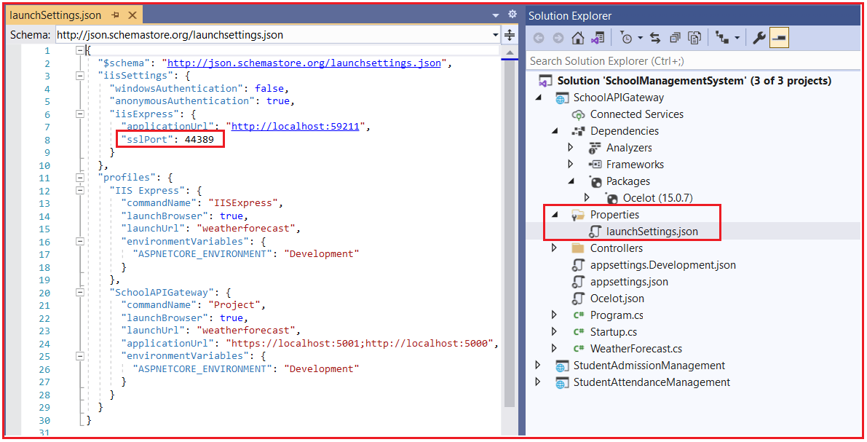

Build the entire solution. Now, there is one thing to change. We have 3 APIs now. Let’s set up the solution so that all three APIs get launched when you run the application. Because we will need all the APIs actively working to test the functionality.

To launch Multiple Startup Projects, Go to the Solution Properties window. Select the Multiple Startup Projects radio button and set the Start option in the Action dropdown for each project and then click on the Apply and OK button as shown in the below image.

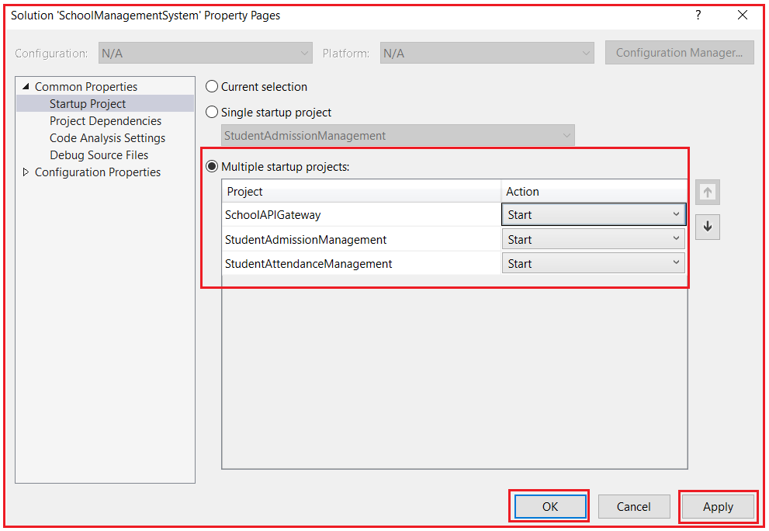

At the route **https://localhost:44389/apigateway/AdmissionService**, we are expecting to get the results directly from the microservice which is located at localhost:44381. Now, navigate to **apigateway/AdmissionService** and you will get the following result as expected.

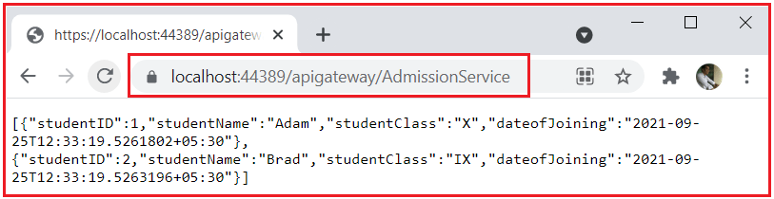

And also, for /apigateway/AttendanceService in API Gateway you will get results from Student Attendance Microservice as expected as shown in the below image.

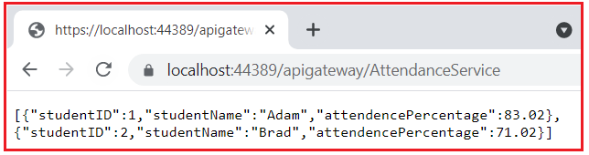

We have successfully developed API Gateways and created a Microservice Architecture in ASP.NET Core.

##### **Testing Microservices using POSTMAN application**

Postman is a web API testing tool that is easy to understand and effective in testing all kinds of HTTP Verbs like POST, GET, PUT, DELETE and etc., along with multiple kinds of request headers, Using Postman we can submit HTTP requests on behalf of actual client application where we are using this microservices / Web APIs. This is the official link where you can download the Postman application.

[**https://www.postman.com/downloads/**](https://www.postman.com/downloads/)

##### **Testing Microservices**

Make sure that the Student Attendance and Student Admission microservices are running in visual studio and are available to serve the client HTTP requests before requesting from the postman to get the expected outputs. I have given the Student Attendance microservice URL directly into the Postman and clicked the send button. We got the expected output with status 200 OK which means the client request is successfully resolved.

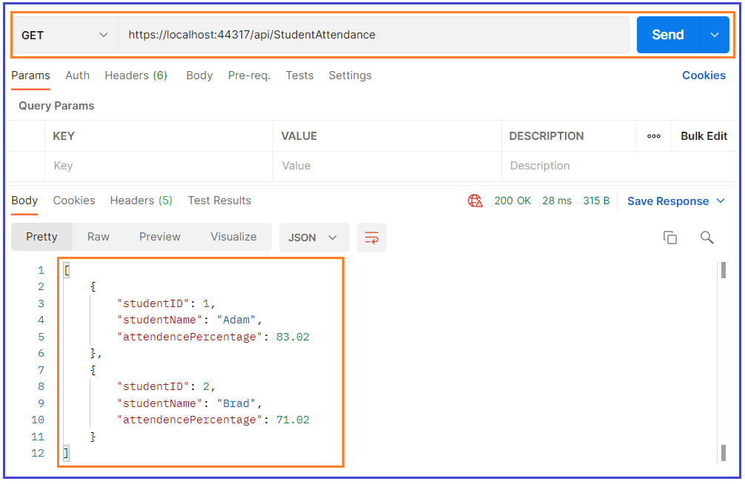 And now testing the other microservice Student Admission, I have given the URL with GET request and we received the expected result with status 200 OK.

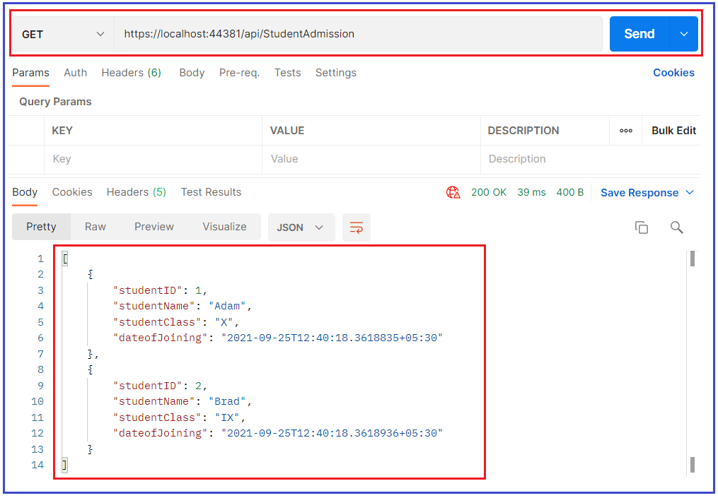

##### **Testing the Microservice through API Gateway**

Now we will try to test the API gateway URLs which we defined for calling Student Attendance microservice and Student Admission Microservice.

Make sure that all three projects are running, SchoolAPIGateway project, Student Admission Management, and Student Attendance Management, so that the First request will be sent to SchoolAPIGateway it will redirect to the respective microservice and gets a response.

I have given the API gateway URL defined to get Student Attendance details in Postman with GET and sent the request. We received the expected output.

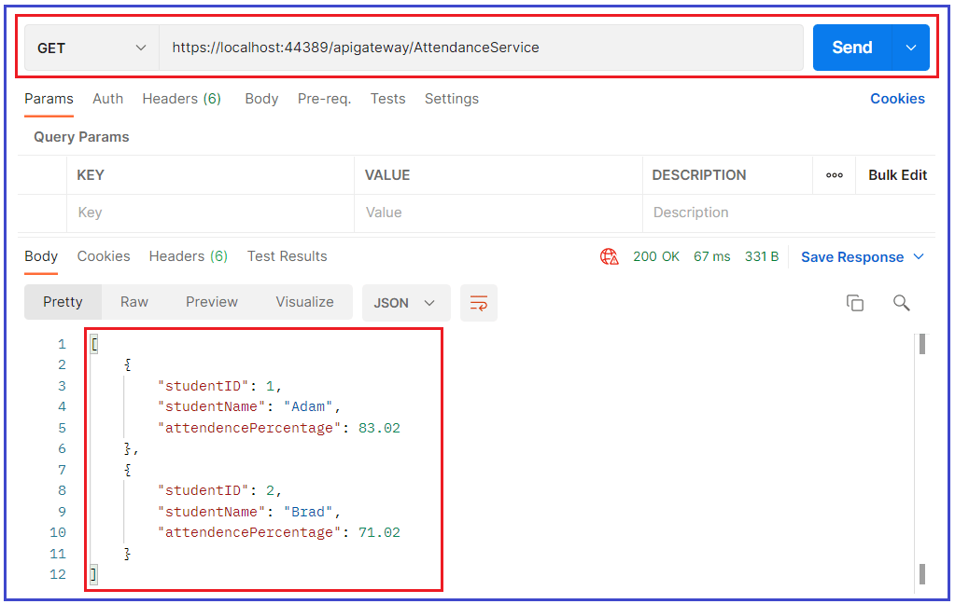

Similarly, I have initiated the request to API gateway URL defined to get Student Admission details in Postman with GET and sent request, We received expected output.

