PART 1
Receipt.py

receipt = """
RESTAURANT BILL
-------------------------
Item: Pizza
Quantity: 2
Price: Rs. 250
Total: Rs. 500
-------------------------
Payment: Cash
Thank you! Visit Again!
"""

print(receipt)

OUTPUT:

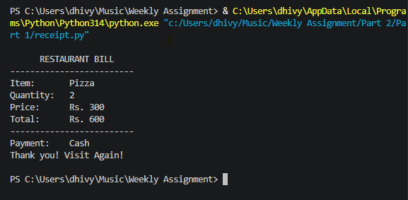

Bug.py
# Bug 1: Missing closing parenthesis
price = 100
quantity = 3
print("Total price:", price * quantity)

# Bug 2: Variable name is case-sensitive
name = input("Enter your name: ")
print("Welcome", name)

# Bug 3: Convert input to an integer
mark = int(input("Enter your mark: "))
if mark >= 35:
print("Pass")
else:
print("Fail")

# Bug 4: Correct list index
subjects = ["Python", "Java", "SQL"]
print(subjects[1])

# Bug 5: Use == for comparison
number = 10
if number == 0:
print("Zero")
else:
print("Non-zero")

# Bug 6: Add the missing colon
for i in range(1, 6):
print(i)

# Bug 7: Multiply the number, not the string
weeks = 4
print("Total days:", 7 * weeks)
OUTPUT:

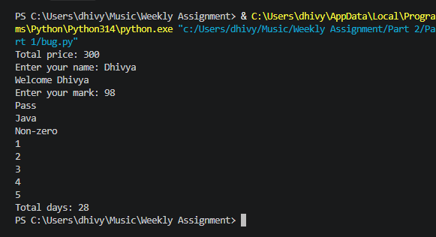

PART 2
email.py
name = input("Enter your full name: ")

name = " ".join(name.strip().lower().split())
parts = name.title().split()

first_name = parts[0].lower()
last_name = parts[-1].lower()

email = first_name + "." + last_name + "@gmail.com"
initials = "".join(part[0].upper() for part in parts)

print("\nEmail:", email)
print("Initials:", initials)

OUTPUT:

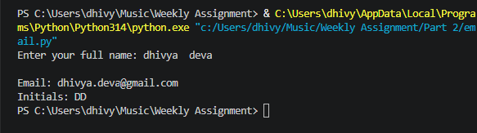

bill.py

bill = float(input("Enter bill amount: Rs. "))
tip_percent = float(input("Enter tip percentage: "))
people = int(input("Enter number of people: "))

tip = bill * tip_percent / 100
total = bill + tip
share = total / people

print(f"\nBill amount: Rs. {bill:.2f}")
print(f"Tip amount: Rs. {tip:.2f}")
print(f"Total bill: Rs. {total:.2f}")
print(f"Per person: Rs. {share:.2f}")

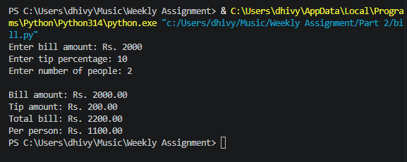
life.py

age = int(input("Enter your age in years: "))

months = age * 12
weeks = age * 52
days = age * 365
hours = days * 24

print("\nUnit\t\tValue")
print("------------------------")
print(f"Years\t\t{age}")
print(f"Months\t\t{months}")
print(f"Weeks\t\t{weeks}")
print(f"Days\t\t{days}")
print(f"Hours\t\t{hours}")

OUTPUT:

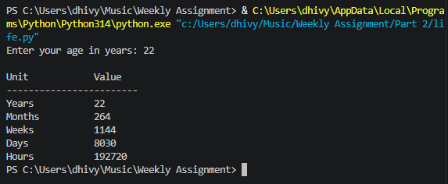

PART 3
secret.py

message = input("Enter your secret message: ")
message = message.strip().upper()
encoded = ""
for char in message:
if char.isalpha():
encoded += str(ord(char) - ord('A') + 1) + " "
elif char == " ":
encoded += "| "
encoded = encoded.strip()
secret = encoded[::-1]
width = len(secret) + 4
border = "*" * width
print("\nSecret Message:")
print(border)
print("* " + secret + " *")
print(border)

OUTPUT:

