**Question 1  
 C Program**

#include <stdio.h>

#include <stdlib.h>

#include <math.h>

#include <stdbool.h>

#define MAX_DATA_SIZE 1000

#define PLOT_WIDTH 70

#define PLOT_HEIGHT 20

void load_data(const char *filename, double *data, int *size) {

FILE *file = fopen(filename, "r");

if (file == NULL) {

perror("Error opening file");

exit(EXIT_FAILURE);

}

*size = 0;

while (fscanf(file, "%lf", &data[(*size)++]) != EOF);

fclose(file);

}

void find_peaks(double *data, int size, int *peaks, int *num_peaks, int distance, double prominence) {

*num_peaks = 0;

for (int i = distance; i < size - distance; i++) {

bool is_peak = true;

for (int j = 1; j <= distance; j++) {

if (data[i] <= data[i - j] || data[i] <= data[i + j]) {

is_peak = false;

break;

}

}

if (is_peak && data[i] > prominence) {

peaks[(*num_peaks)++] = i;

}

}

}

void plot_ascii(double *data, int size, int *peaks, int num_peaks, int *minima, int num_minima, const char *label) {

double max_val = data[0], min_val = data[0];

for (int i = 1; i < size; i++) {

if (data[i] > max_val) max_val = data[i];

if (data[i] < min_val) min_val = data[i];

}

char plot[PLOT_HEIGHT][PLOT_WIDTH];

for (int i = 0; i < PLOT_HEIGHT; i++) {

for (int j = 0; j < PLOT_WIDTH; j++) {

plot[i][j] = ' ';

}

}

for (int i = 0; i < size; i++) {

int x = (i * PLOT_WIDTH) / size;

int y = (int)((data[i] - min_val) / (max_val - min_val) * (PLOT_HEIGHT - 1));

plot[PLOT_HEIGHT - 1 - y][x] = '*';

}

for (int i = 0; i < num_peaks; i++) {

int x = (peaks[i] * PLOT_WIDTH) / size;

int y = (int)((data[peaks[i]] - min_val) / (max_val - min_val) * (PLOT_HEIGHT - 1));

plot[PLOT_HEIGHT - 1 - y][x] = 'M';

}

for (int i = 0; i < num_minima; i++) {

int x = (minima[i] * PLOT_WIDTH) / size;

int y = (int)((data[minima[i]] - min_val) / (max_val - min_val) * (PLOT_HEIGHT - 1));

plot[PLOT_HEIGHT - 1 - y][x] = 'm';

}

printf("\n%s\n", label);

for (int i = 0; i < PLOT_HEIGHT; i++) {

for (int j = 0; j < PLOT_WIDTH; j++) {

printf("%c", plot[i][j]);

}

printf("\n");

}

}

void find_and_plot_peaks(double *data, int size, const char *label) {

int peaks[MAX_DATA_SIZE], num_peaks;

double inversed_data[MAX_DATA_SIZE];

find_peaks(data, size, peaks, &num_peaks, 20, 0.5);

for (int i = 0; i < size; i++) {

inversed_data[i] = -data[i];

}

int minima[MAX_DATA_SIZE], num_minima;

find_peaks(inversed_data, size, minima, &num_minima, 20, 0.5);

// Plot the data, peaks, and minima using ASCII art

plot_ascii(data, size, peaks, num_peaks, minima, num_minima, label);

}

int main() {

double data1[MAX_DATA_SIZE], data2[MAX_DATA_SIZE];

int size1, size2;

load_data("Data_1.txt", data1, &size1);

load_data("Data_2.txt", data2, &size2);

find_and_plot_peaks(data1, size1, "Data_1");

find_and_plot_peaks(data2, size2, "Data_2");

return 0;

}

**Output**

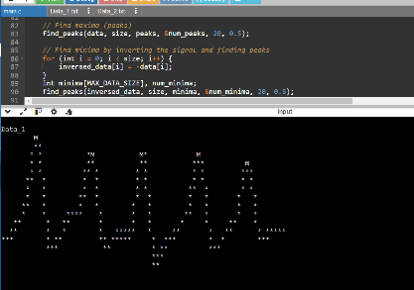

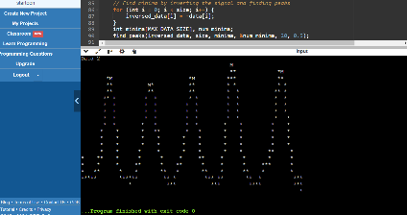

**Python code:**

import numpy as np

import matplotlib.pyplot as plt

from scipy.signal import find_peaks

*# Load data*

data1 = np.loadtxt('/content/Data_1.txt')

*# Define a function to find and plot peaks*

def find_and_plot_peaks(data, label):

*# Find maxima (peaks)*

peaks, _ = find_peaks(data, distance=20, prominence=0.5)

*# Find minima by inverting the signal and finding peaks*

inversed_data = -data

minima, = find_peaks(inversed_data, distance=20, prominence=0.5)

plt.figure(figsize=(10, 6))

plt.plot(data, label=f'{label} Signal', color='black')

plt.plot(peaks, data[peaks], 'ro', label='Maxima')

plt.plot(minima, data[minima], 'bo', label='Minima')

plt.title(f'{label} Signal Peaks')

plt.xlabel('Index')

plt.ylabel('Amplitude')

plt.legend()

plt.grid(True)

plt.show()

*# Analyze and plot for both datasets*

find_and_plot_peaks(data1, 'Data_1')

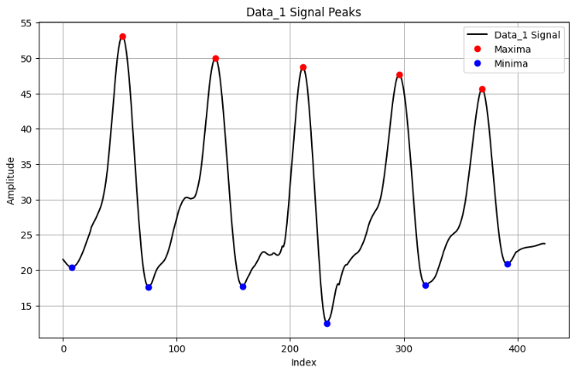

import numpy as np

import matplotlib.pyplot as plt

from scipy.signal import find_peaks

*# Load data*

data1 = np.loadtxt('/content/Data_2.txt')

*# Define a function to find and plot peaks*

def find_and_plot_peaks(data, label):

*# Find maxima (peaks)*

peaks, _ = find_peaks(data, distance=20, prominence=0.5)

*# Find minima by inverting the signal and finding peaks*

inversed_data = -data

minima, _ = find_peaks(inversed_data, distance=20, prominence=0.5)

plt.figure(figsize=(10, 6))

plt.plot(data, label=f'{label} Signal', color='black')

plt.plot(peaks, data[peaks], 'ro', label='Maxima')

plt.plot(minima, data[minima], 'bo', label='Minima')

plt.title(f'{label} Signal Peaks')

plt.xlabel('Index')

plt.ylabel('Amplitude')

plt.legend(loc='center left', bbox_to_anchor=(-0.15, 0.5))

plt.grid(True)

plt.show()

