# Route Anywhere

Route Anywhere is a basic navigation application which is prepared to demonstrate the route direction between two locations.

Route Anywhere is a simple interface for users to get directions between two points on a map using the NextBillion Maps API.

# Story

The aim was to Develop a demonstration that allows a user to search for a given Point Of Interest near his position and get walking and/or driving directions to it.

# Approach

- The demonstration was started by analysing the requirement and the resources available.

- The objective was set to develop a simple application and not to build a complex model in this case.

- The resources available were the api's of nextbillion.ai with the required api key.

- The following steps were adapted for building the demo application.

- The html code of nextbillion's direction api was obtained from code sandbox (https://codesandbox.io/s/fjgq7?file=/v2/directions.html).

- The html code was tweeted a bit to include origin and destination place holders for user's inputs.

- The "getCurrentPosition" function was used to get the user's current position using the geolocation api provided by the browser, which will be the input for the origin.

- The "map.on" function was used in the code, by which the user can select his/her desired destination POI on the map by a single click.

- The code was checked and run.

# Supports Used

- Brackets 2.1.3 - for coding.

- ChatGPT Feb 13 Version. Free Research Preview - for error handling and code understanding.

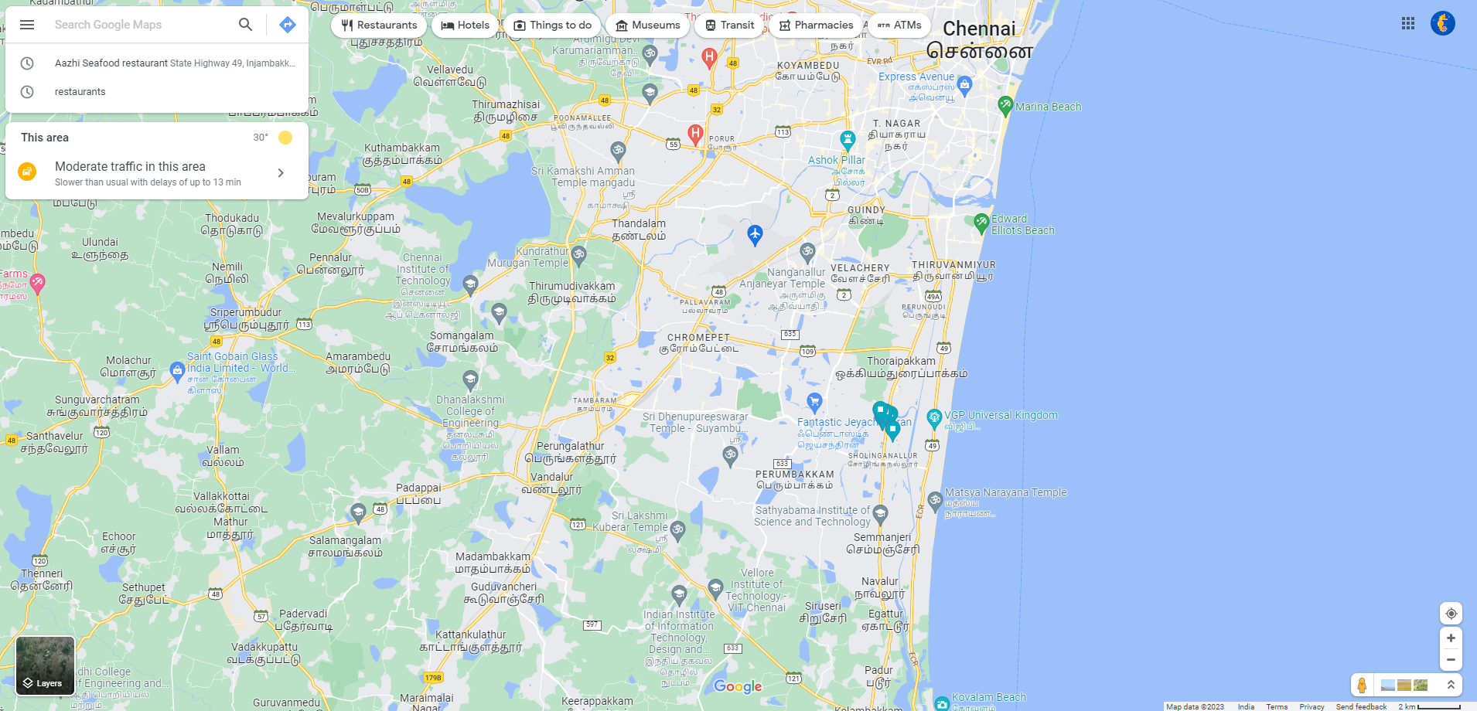

# How to use the application

- Opening the Application

- Open the Route_Anywhere.HTML from the Github Repository.

- Click on Raw.

- Right click and save as in your desired file path.

- Now double click and open the saved file.

- The application opens in your default browser.

- Supported Browsers

- Google Chrome.

- Firefox.

- Use Case

- Click on 'Current Location' button to get your current location as origin.

- Click on any desired destination POI on the map.

- Click on 'Request Direction' Button.

- The application will generate the direction between the origin and destination.

- Click on 'Remove Direction' and repeat the above Use Case steps to find the direction to a different POI.

# Challenges Faced

- Unable to pull in the Directions and Search api into the HTML script, even though the json call was successful.

# Further Improvisations

- Make a better UI for the application by a professional UI developer.

- Improvise the code to zoom to the user's location once the origin is given.

- Suggest nearby POIs like Restaurants, Hospitals etc. to the user using the search api.

- Add more functionalities like scale bar, lat long display, compass, etc.

- Use distance api to choose the mode of transport and generate the distance accordingly.

# Closure

Overall I enjoyed a lot working on this exercise!