**BIG DATA ANALYSIS USING IBM CLOUD DATABASES**

**TEAM LEADER:** DHIVYA T (822721106012)

**PHASE 3:**Development Part 1

**Problem Title:** Big Data Analysis

**Problem Statement:** Dive into the world of big data analysis with IBM Cloud Databases. Uncover hidden insights from vast datasets, from climate trends to social patterns. Visualize your findings and derive valuable business intelligence. Embark on data-driven adventures, exploring the endless possibilities of big data!

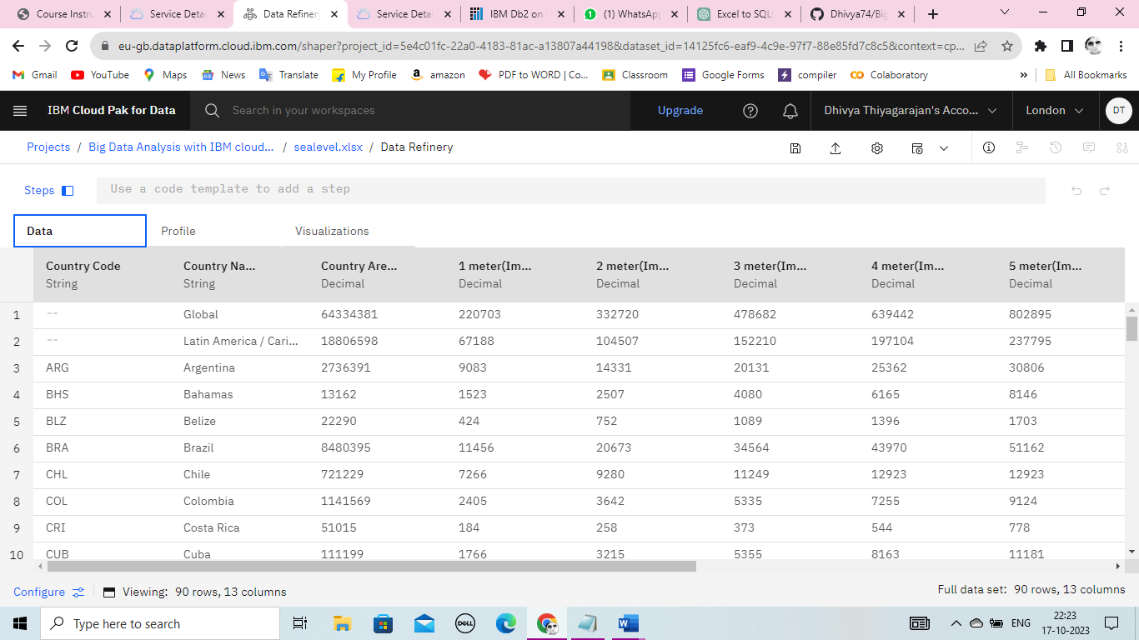**PRE-LOAD THE DATASETS:**

**WORK-FLOW TO LOA D THE DATASETS:**

VISUALIZE THE RESULTS

LAUNCH IN

IBM WATSON STUDIO FOR CLOUD PAK OF DATA

PROJECT CREATION

CREATE ASSEST TO LOAD THE DATASETS

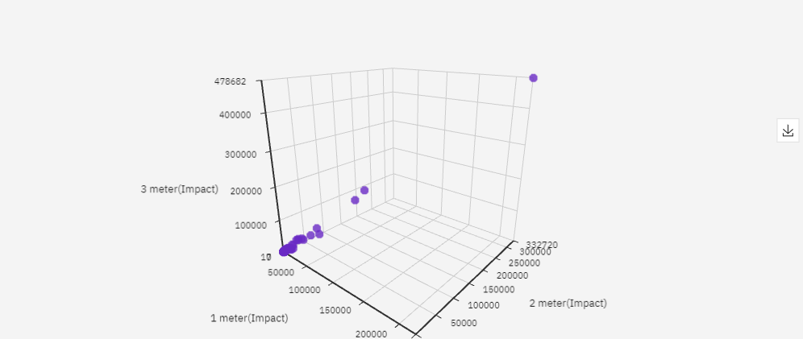**VISUALIZED RESULT:**