B Linux Shell Commands

1. File and directory commands
a. ls, ls -l
b. cd, cd .., cd /, cd ~
c. mkdir
d. cat (displaying, creating, appending options)
e. cp
f. mv
g. chmod
h. wc
i. find

a. ls

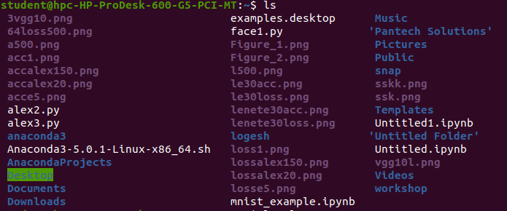

b. ls -l

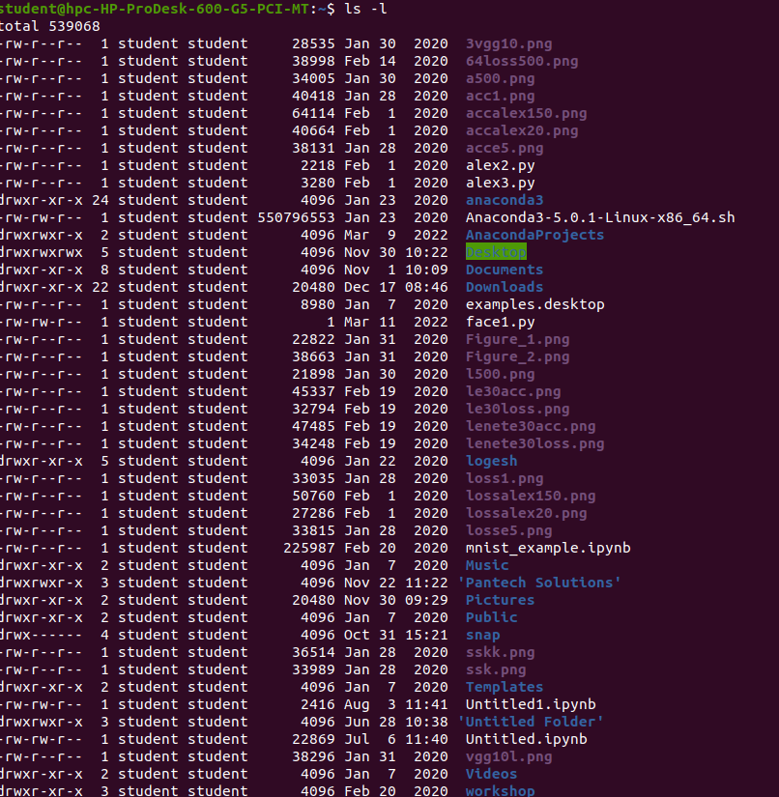
c. mkdir

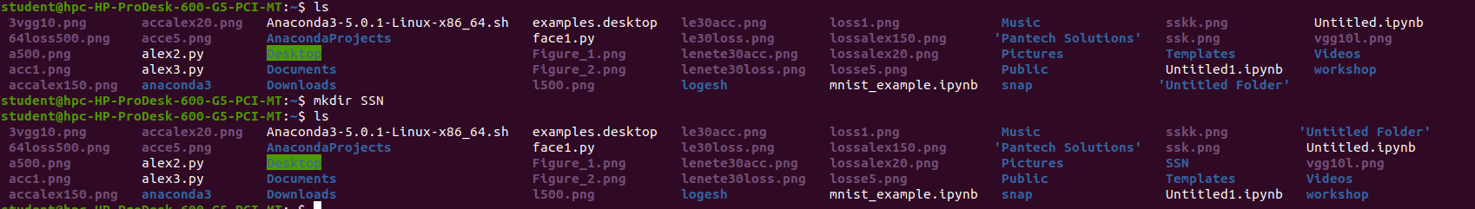

d. cat (displaying, creating, appending options)

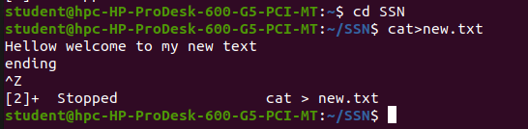
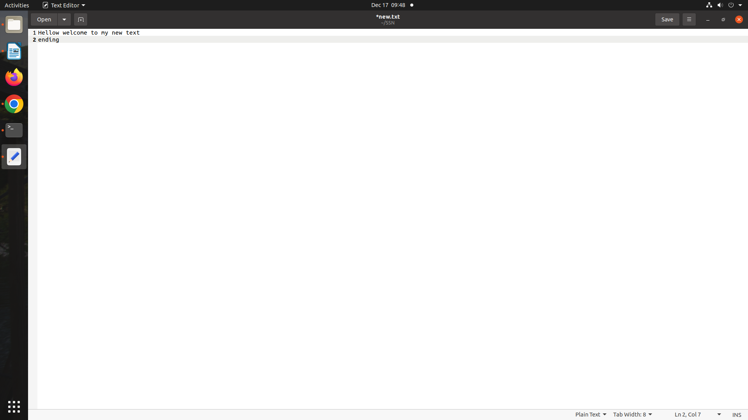

e. cp

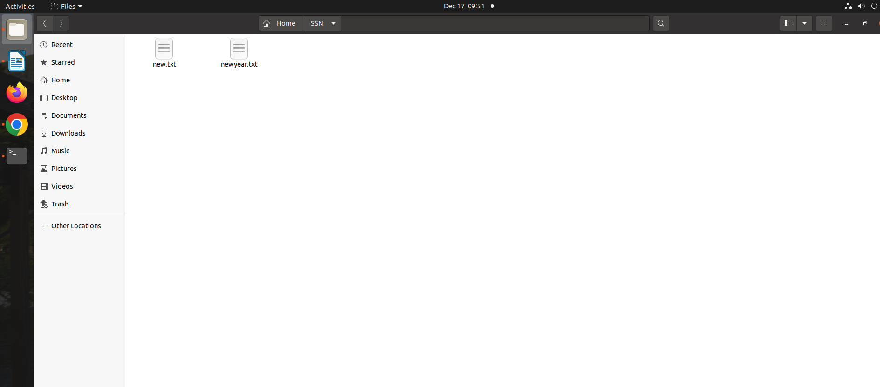

f. mv

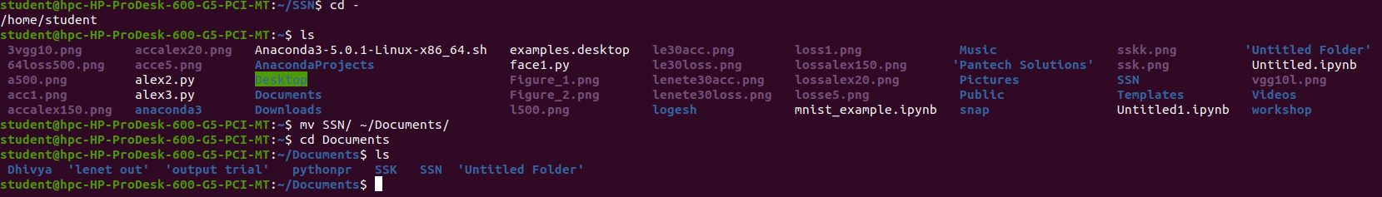

g. chmod

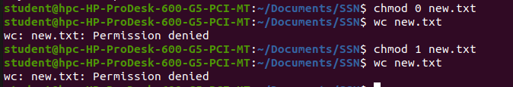
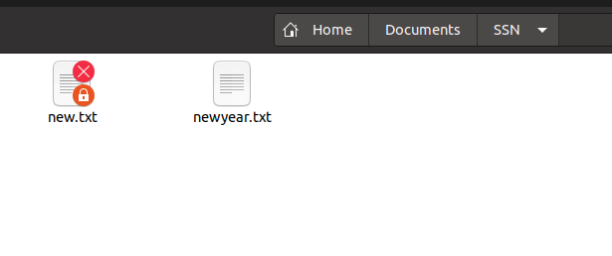

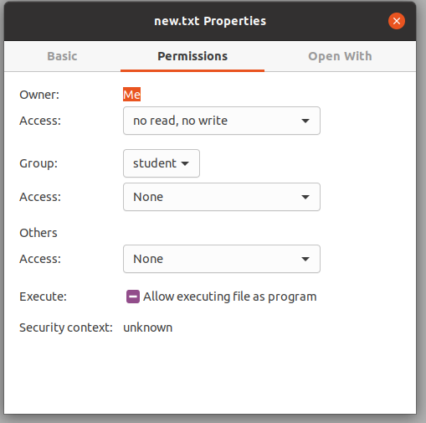

h. wc --> Number of lines, words, characters

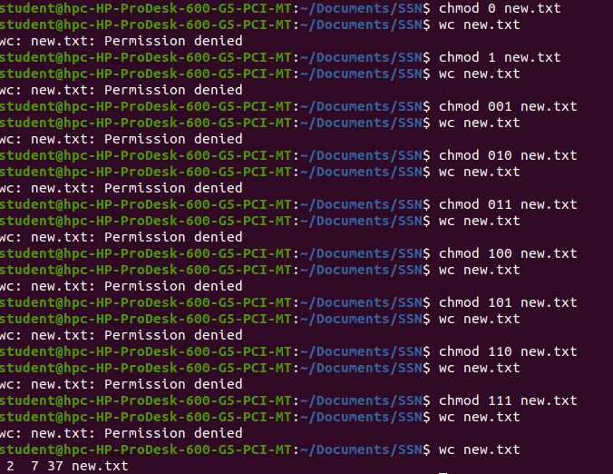

i. find

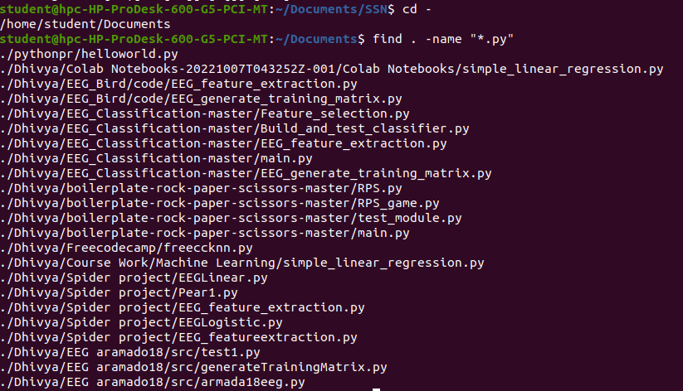

2. System related commands

a. who
b. whoami
c. pwd
d. date
e. man
f. echo
g. cal
h. bc

a. who

b. whoami
c. pwd
d. date

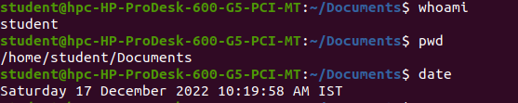

e. man

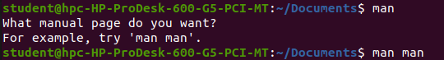
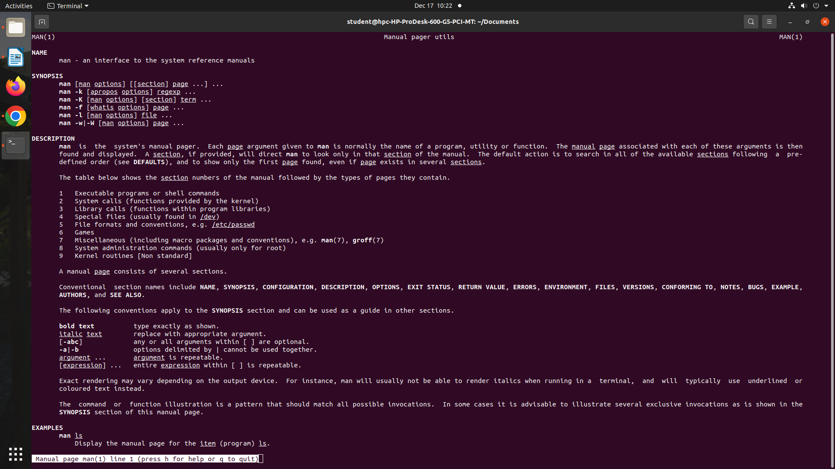

f. echo

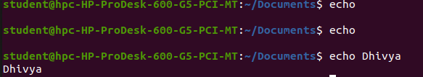
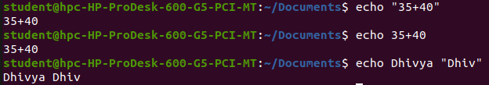

g. cal

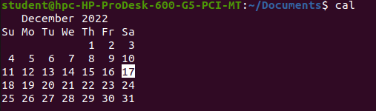
h. bc – binary calculator

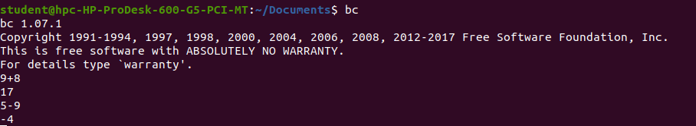

3. Create a new directory named “SSN”, a subdirectory &quot;BE&quot; under SSN and create a
file named “firstyear.txt” and write about the SSN orientation programme.

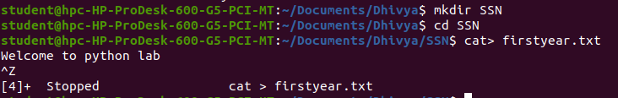
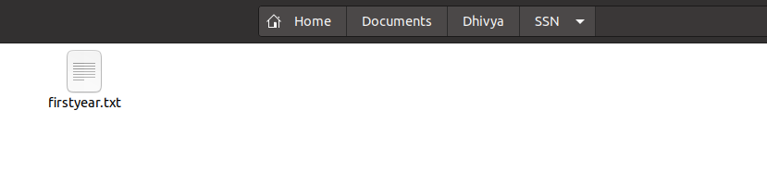

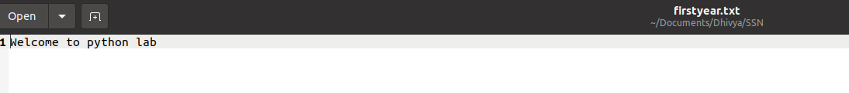

4. Rename the firstyear.txt file as orientation.txt

5. Give all permissions to user and only reading permission to others

6. Create a file &quot;AboutMe.txt&quot;. Write about yourself and your ambitions.

7. Create two directories namely “dept_x” (x being your dept name), “SEC_X” inside “SSN” folder.

8. Create a file named “dept.txt” and write about your department in that file.

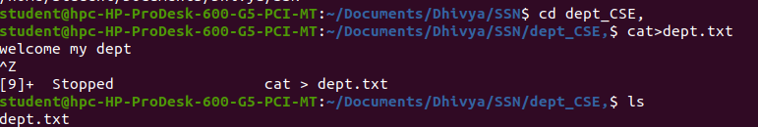

9. Copy the file named “first_year.txt” to “SEC_X” folder.

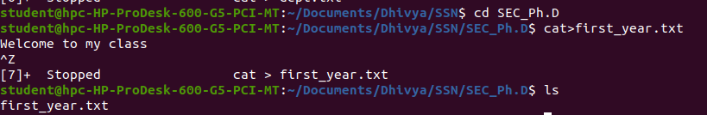

10. Move the file “dept.txt” to “SEC_X” folder.

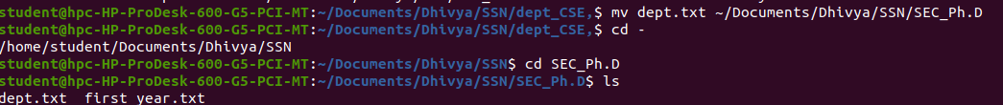

11. Enter into folder “SEC_X” and list the folder content.

12. Move to “SSN” folder and list all the contents.

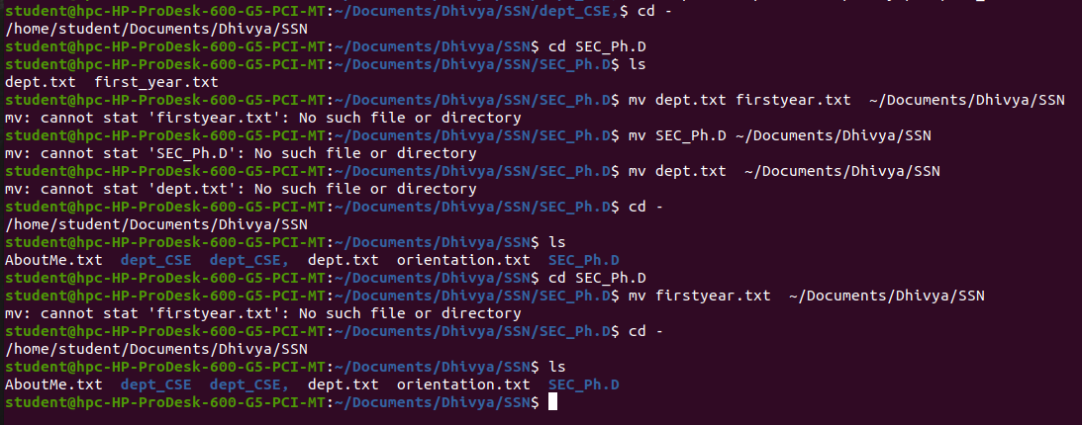

C. Working in Python Interactive Mode:

1. Create a variable named num1 with some integer value and display the value &amp; its
datatype.

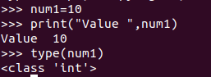

2. Create another variable named num2 with some integer value and display its datatype.
Use the same variable to store a floating value and write your inference.

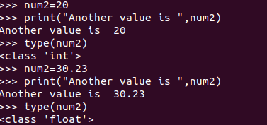

3. Create a variable name with your name as input

4. Display the value of num1, num2 and name.

5. Display the type of num1, num2 and name.
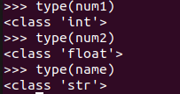

6. Display “Hello “along with your name.

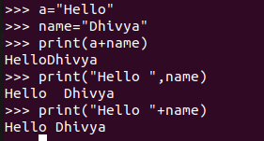

7. Find the output of 4+6*7 /2 directly.
8. Find the output of 4+5*7 /3 directly.
9. Find the output of 4+5*7 //3 directly.
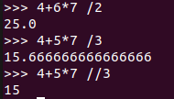

10. Find the output of num1 raised to power of num2
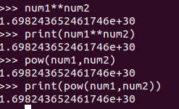

11. Get the input from the user and display the value.

