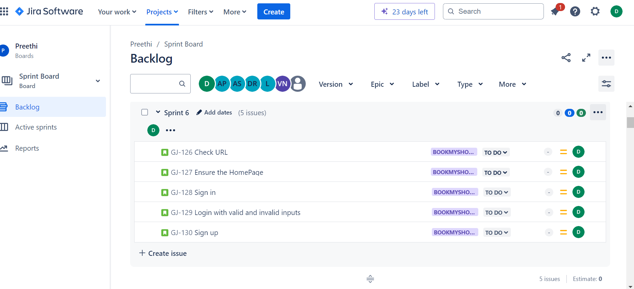

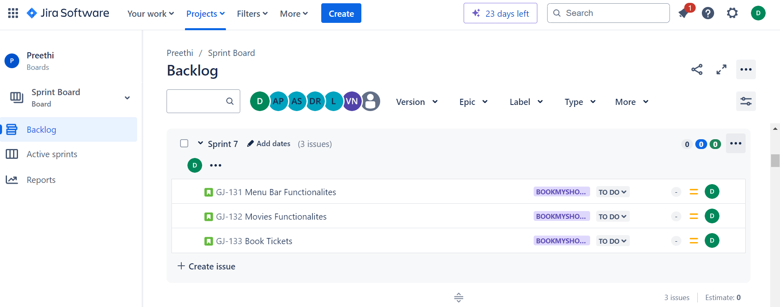

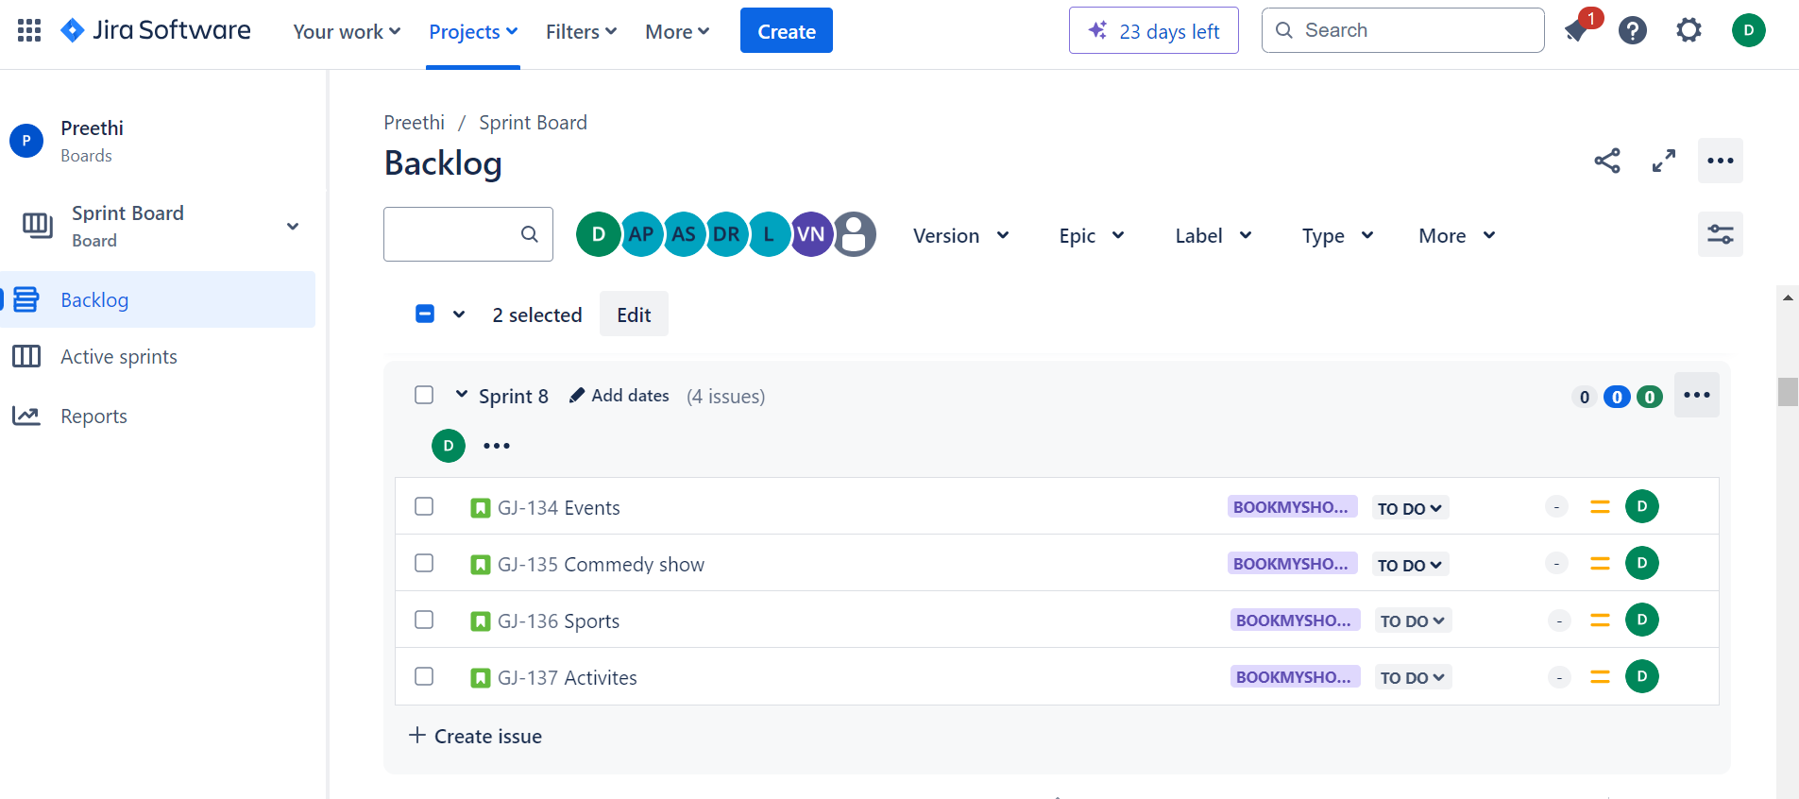

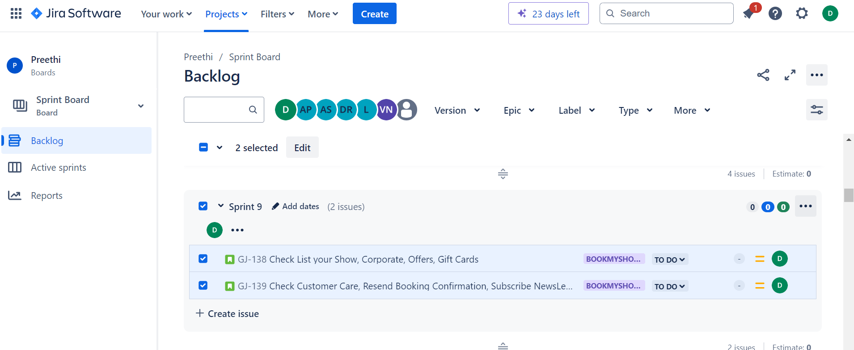

**Note:**

1. In Jira Tool I can go with only creating sprint stage, There is no option for start Sprint, to do further I need permission from Admin, Due to time constraint I can complete only in excel. I have done almost everything in Jira, the only pending is “Importing test cases from excel “.
2. Instead of uploading Excel Screenshot, I have uploaded the Excel file “BookmyshowTestcase.xlsx” in remote repository
3. I request you to refer both screenshot and excel file for my Task evaluation