**Day 8th Task (29 April 2024)**

Question No:1

**package** DailyTasks;

**public** **class** Task8 {

**public** **static** **void** main(String[] args) {

**int** a=100,b=200,c=50,d=150;

**if**((a+b)>(c+d))

{

System.***out***.println("Sum of a&b is Greater than sum of c&d");

}

**else**

System.***out***.println("Sum of a&b is not Greater than sum of c&d");

}

}

Output

Sum of a&b is Greater than sum of c&d

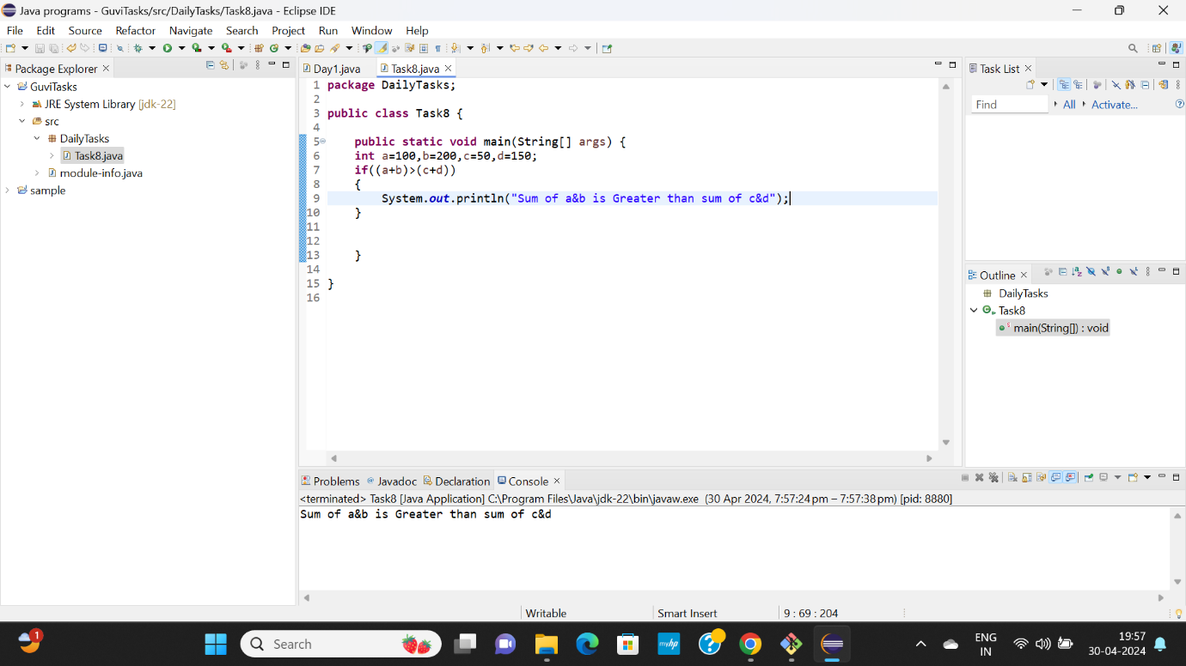

Question No:2

**package** DailyTasks;

**public** **class** Task8 {

**public** **static** **void** main(String[] args) {

**int** a=10;

**if**(a % 2 == 0)

System.***out***.println(a+ " is even ");

**else**

System.***out***.println(a+ " is odd ");

}

}

Output

10 is even

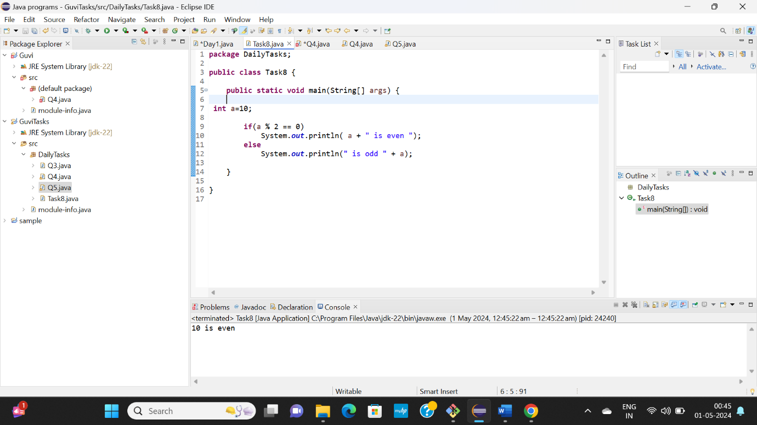

Question No:3

**package** DailyTasks;

**public** **class** Q3 {

**public** **static** **void** main(String[] args) {

**char** ch;

**for**(ch = 'A'; ch <= 'Z'; ++ch)

System.***out***.print(ch + " ");

}

}

Output

A B C D E F G H I J K L M N O P Q R S T U V W X Y Z

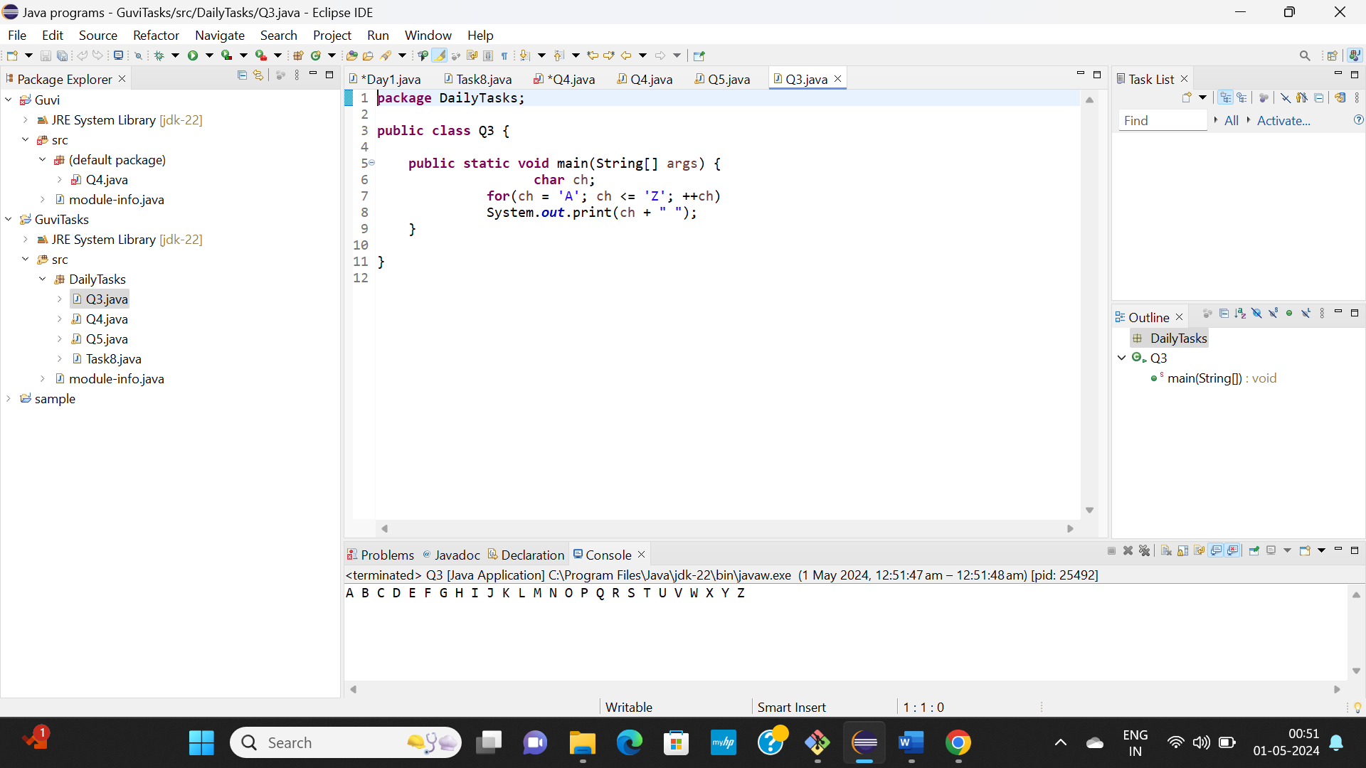

Question No:4

**package** DailyTasks;

**import** java.util.Scanner;

**public** **class** Q4 {

**public** **static** **void** main(String[] args) {

**int** x, y, t;// x and y are to swap

Scanner sc = **new** Scanner(System.***in***);

System.***out***.println("Enter the value of X and Y");

x = sc.nextInt();

y = sc.nextInt();

System.***out***.println("before swapping numbers: "+x +" "+ y);

/*swapping */

t = x;

x = y;

y = t;

System.***out***.println("After swapping: "+x +" " + y);

System.***out***.println( );

}

}

Output

Enter the value of X and Y

53

47

before swapping numbers: 53 47

After swapping: 47 53

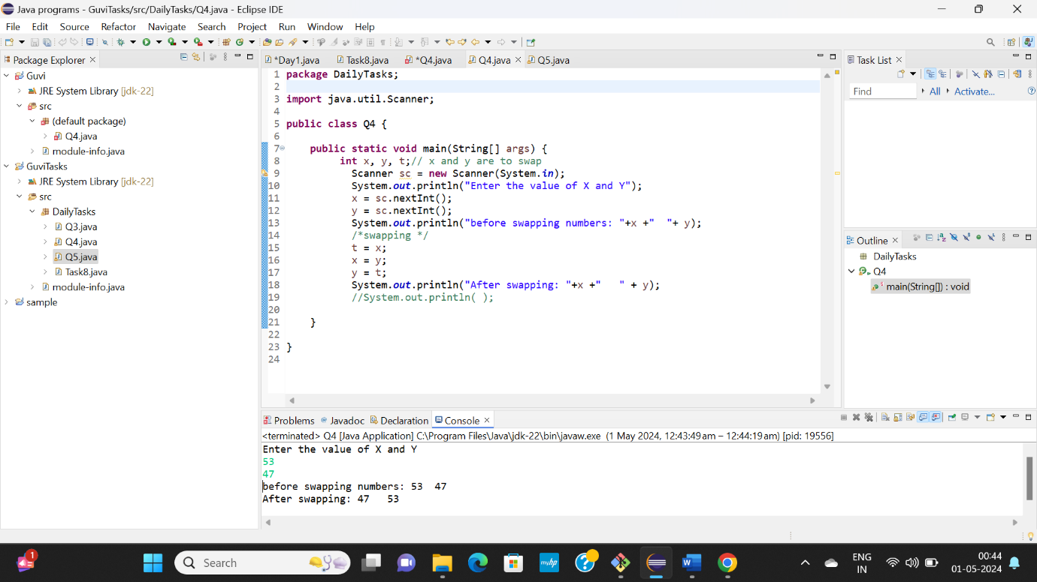

Question No:5

**package** DailyTasks;

**public** **class** Q5 {

**public** **static** **void** main(String[] args)

{

**int** num = 10;

**boolean** flag = **false**;

**for** (**int** i = 2; i <= num / 2; ++i)

{

// condition for nonprime number

**if** (num % i == 0)

{

flag = **true**;

**break**;

}

}

**if** (flag=**false**)

System.***out***.println(num + " is a prime number.");

**else**

System.***out***.println(num + " is not a prime number.");

}

}

Output:

10 is not a prime number.

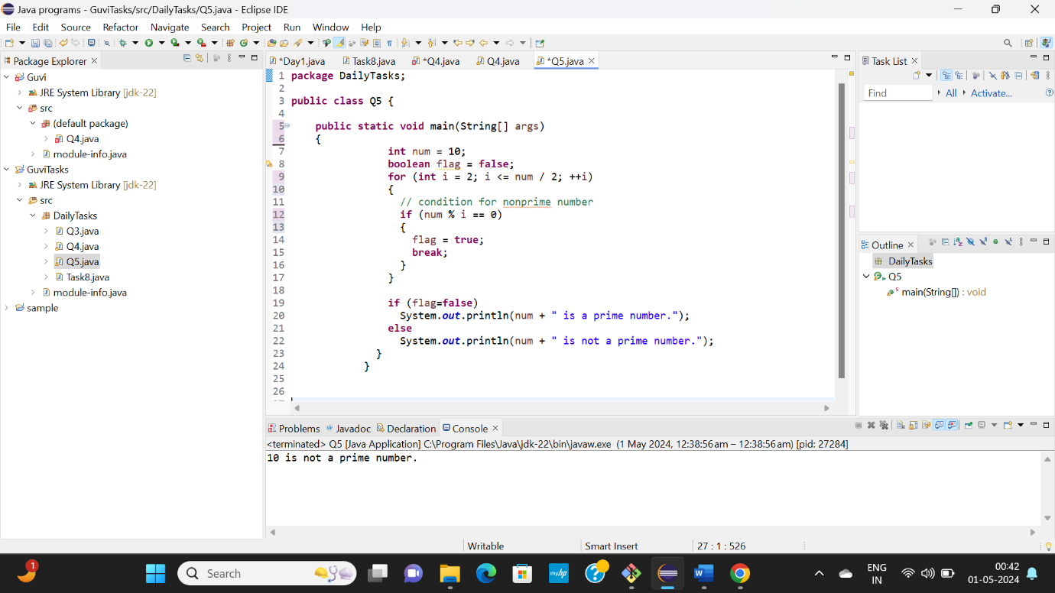

Question No:6

**package** DailyTasks;

**public** **class** Q6 {

**public** **static** **void** main(String[] args) {

**int** num = 4;

**long** factorial = 1;

**for**(**int** i = 1; i <= num; ++i)

{

// factorial = factorial * i;

factorial *= i;

}

System.***out***.printf("Factorial of %d = %d", num, factorial);

}

}

Output:

Factorial of 4 = 24

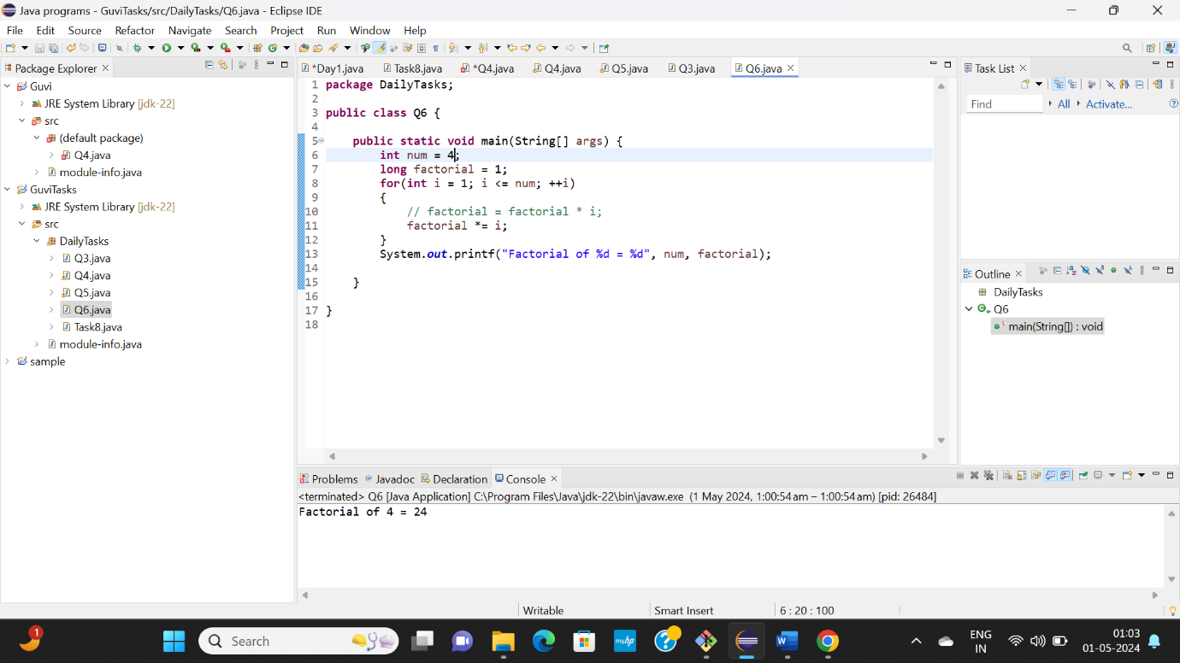

Question No:7

**package** DailyTasks;

**public** **class** Q7

{

**public** **static** **void** main(String args[])

{

String s1="Guvi Geek";

System.***out***.println("The length of the given string is " + s1.length());

}

}

Output:

The length of the given string is 9

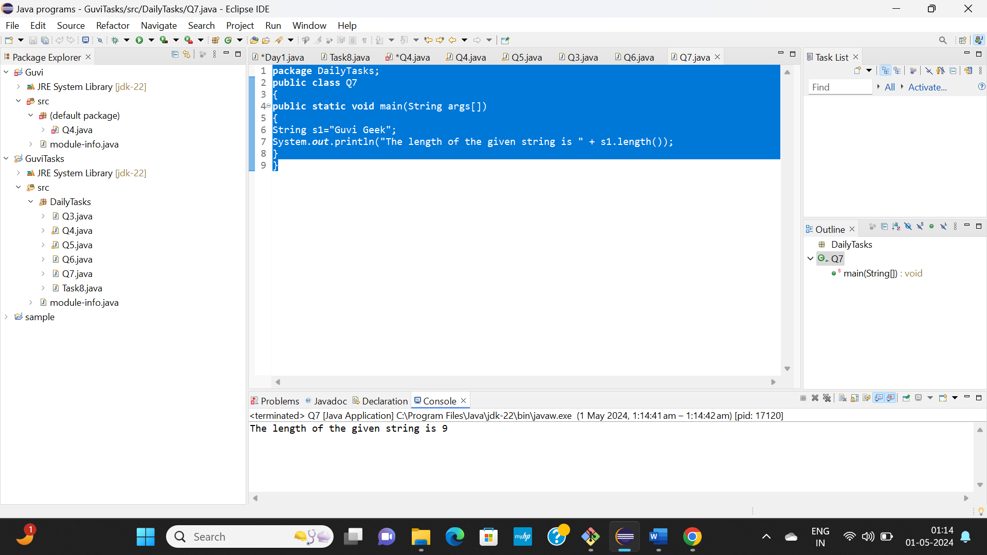

Question No:8

**package** DailyTasks;

**public** **class** Q8 {

**public** **static** **void** main(String[] args)

{

**for**(**int** i=1;i<=10;i++)

System.***out***.println("WELCOME TO GUVI");

}

}

Output:

WELCOME TO GUVI

WELCOME TO GUVI

WELCOME TO GUVI

WELCOME TO GUVI

WELCOME TO GUVI

WELCOME TO GUVI

WELCOME TO GUVI

WELCOME TO GUVI

WELCOME TO GUVI

WELCOME TO GUVI

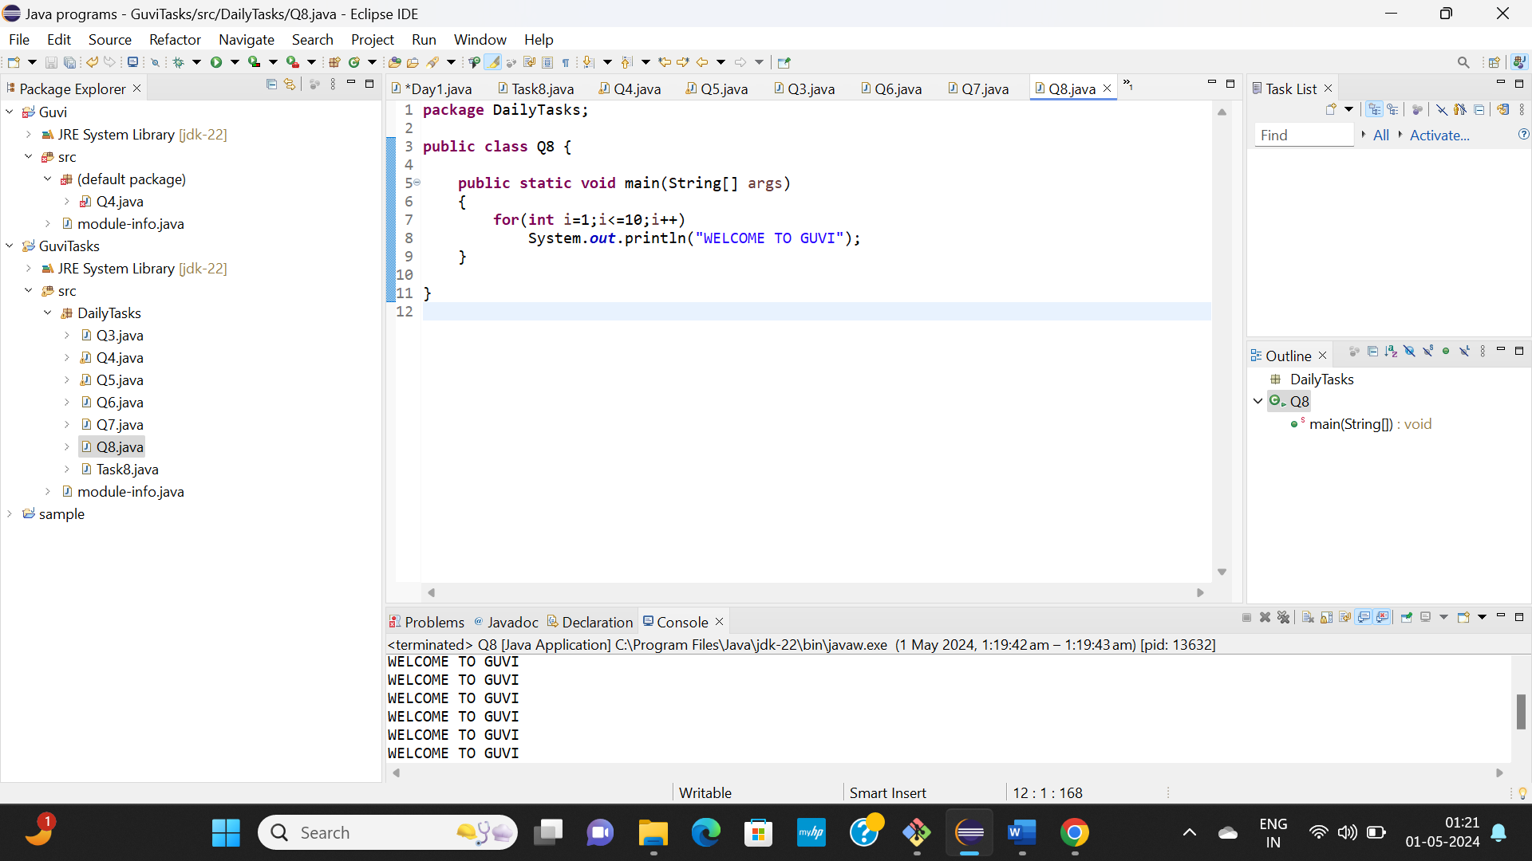

Question No:9

**package** DailyTasks;

**import** java.util.Scanner;

**public** **class** Q9 {

**public** **static** **void** main(String[] args)

{

**int** age;

Scanner sc= **new** Scanner(System.***in***);

System.***out***.println("Enter the Person's age: ");

age=sc.nextInt();

**if**(age>60)

System.***out***.println("The Person is a Senior Citizen");

**else**

System.***out***.println("The Person is not a Senior Citizen");

}

}

Output:

Enter the Person's age:

82

The Person is a Senior Citizen

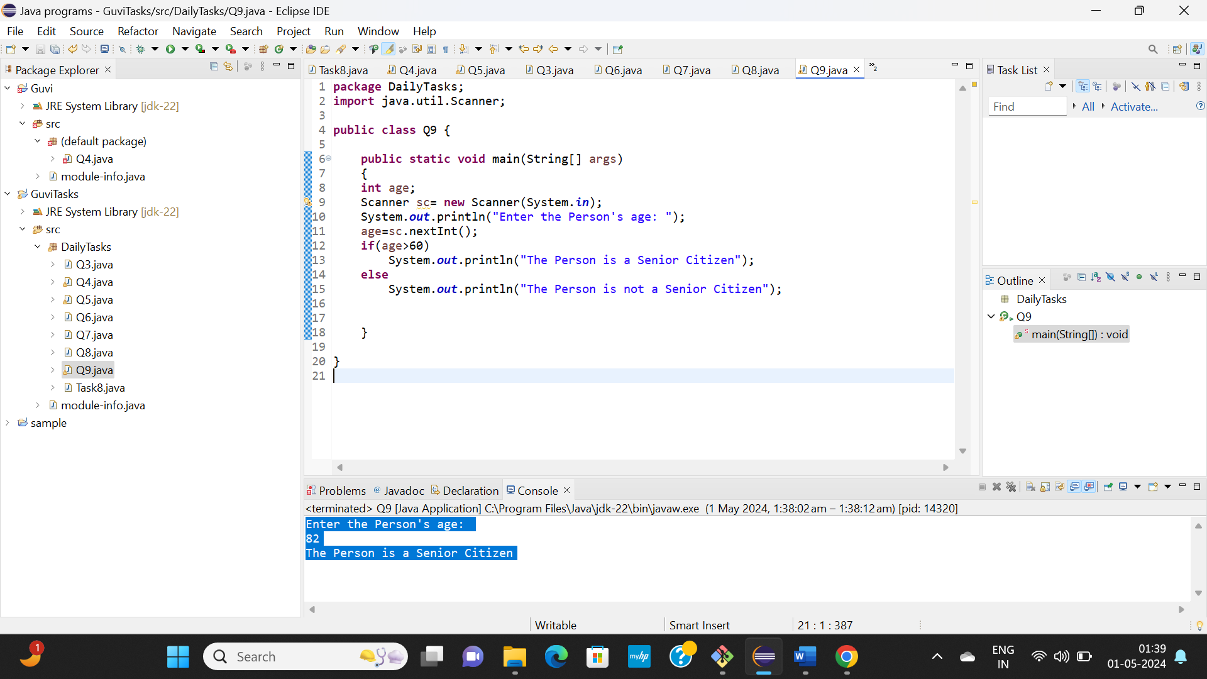

Question No:10

**package** DailyTasks;

**public** **class** Q10 {

**public** **static** **void** main(String[] args)

{

**int** count = 0, num = 123452;

**while** (num != 0) {

// num = num/10

num /= 10;

++count;

}

System.***out***.println("Number of digits: " + count);

}

}

Output:

Number of digits: 6

