iOS Programming Assignment

Requirements

1. Use the latest Xcode and the project is created through File >New.

XCode 5.0.2

1. ARC enabled. By default ios7 enabled ARC.
2. Must support iOS 6 or higher. iOS6 deployment target
3. Must support iPhone 4S and iPhone 5 screen sizes.

ScreenSize of iphone5 640 x 1136 pixels and 4s 640 x 960 pixels .Have maintained a if condition in view controller to check the version and sizes are handled accordingly.

Assignment.

1. Review the Macy’s Objective C Style Guide.

<https://github.com/johnnst/objective-c-style-guide>

1. Review the current Macy’s app.

<https://itunes.apple.com/us/app/macys/id341036067?mt=8>

1. Create a new app that showcases the current Macys first view.
   1. Tapping on any of the buttons and/or cells should present a view controller with a label that says “Tap #1”. Increment the tap number by 1 whenever another button and/or cell is tapped.

Made use of collection view to represent cells, When any of the cell is tapped instantiated a viewcontroller with storyboard

And passed the cell index to represet the tapnumber with auto increment.

Collectionview acts as a container where it contains the customisecollectioncell which helps in adding upto n number of items

* 1. Please deliver view controllers and cells as h, m, and nib files. The only exception is the first view controller launched from the storyboard.

Have designed all the viewcontrollers from storyboard

* 1. Please use as much as possible, UI objects from the native framework. UIImageView,UIButton,UILabel,UICollectionView,UISearchBar,UIAlertView,UINavigationBar,UIStoryBoards
  2. Feel free to use any images or crop what’s available in the existing app.

Cropped images from the app and implemented with uiimageview and added functionality for Shopnow and Scan button.

* 1. Please code to the Macy’s Objective C Style Guide. Also provide a summary of your approach and design decisions.

**DesignApproach:**

MockUpDesign:

1.NavigationController(rootview)

2.FirstViewController 3.SecondViewController

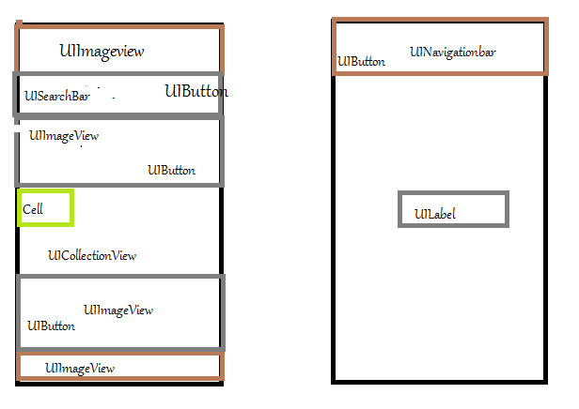

*Designed all the viewcontrollers in storyboard

*Placed Navigationcontroller as rootview to perform push and pop of view controller

*Have added imageview to place the image in header and footer.

*Placed button control in the place of shopnow and scan and added uialertview to show the functionality of button.

*AddedSearchbar to perform search and added three delegates for cancel buttom and textediting.

-When text is entered cancel button appears which helps in resigning the responder of keypad.

-When the keypad resigns the cancel button visibility is made false.

-Resizing of the searchbar to display the cancelbutton

*Implemented Collection view to display the grid layout,single generic function can be maintained to place the image in each cell.

-Collection view is mutable so based on the image count it can be shrinked or resized

-Based on the cell taped index path is maintained and navigated to second view controller

**Profiling:**

**\***Used instrument allocation, timer to see the execution tim and allocation and to identify the function overhead.

* 1. Document any 3rd party libraries used and why.

-No 3rd party implemented.

* 1. Unit tests is optional but a big plus.

Implemented only for instantiating storyboard couldn’t proceed with collection view.



Example of the first view

1. After you are done, submit by either methods.
   1. Github URL.

https://github.com/DhivyaRamesh/MacyIOSAssignment.git

* 1. Zip the project folder and send it. If above 10MB, use cloud storage links like Dropbox or Box.