**Structural Diagram:**

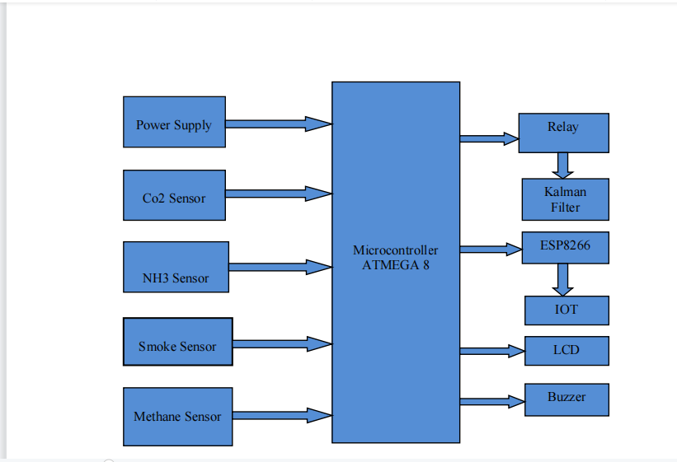

**Behavioural Diagram:**

No0

ESP8266

IoT Gateway

Yes

LCD & Buzzer

Microcontroller Atmega

Sensors output> Fixed Value

Turn on power supply

Start

Kalman Filter