*Ex 2: Simple Python* Programming

**Assignment:**

1. **Suppose the cover price of a book is ₹X, but bookstores get a discount of Y%. Shipping costs incurs ₹ Z for the first copy and ₹ P for each additional copy. What is the total wholesale cost for 60 copies? Develop a program to print the wholesale cost of a single book and the wholesale cost of 60 copies.**

cp=int(input("Enter the cost price:")) dis=int(input("Enter the discount:")) Y=cp-(cp*(dis/100))

Z=int(input("Enter the shipping cost of first copy:")) P=int(input("Enter the shipping cost of every additional copies:")) a=Y+Z

b=a+((cp-(cp*(dis/100)+P)))*59 print("Wholesale price of 60 copies:",b) print("Wholesale price of 1 copy:",a)

# OUTPUT:

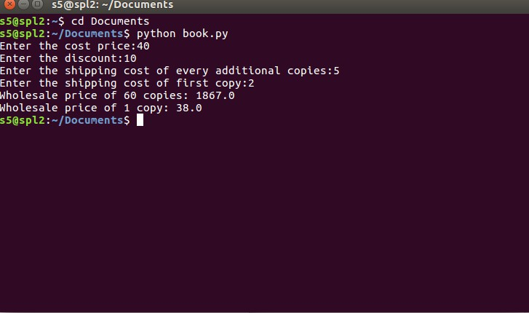

1. **Get the date of birth of a person and calculate his age in years and months**

a=int(input("ENTER YOUR YEAR OF BIRTH:")) b=int(input("ENTER YOUR MONTH OF BIRTH:")) c=int(input("ENTER CURRENT YEAR:")) d=int(input("ENTER CURRENT MONTH:"))

yr_diff=c-a month_diff=d-b

if month_diff < 0: yr_diff-=1 month_diff+=12 print("YOUR AGE IS:")

print(yr_diff,"year",month_diff,"month") else:

print("YOUR AGE IS:")

print(yr_diff,"year",month_diff,"month")

# OUTPUT:

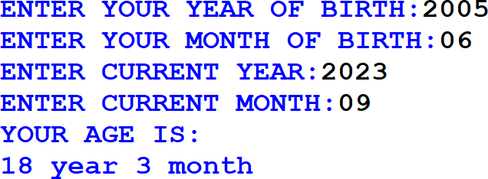

1. **Read two complex numbers from the user and find their a. sum, b. difference c. product.**

a=complex(input("Enter complex no.1=")) b=complex(input("Enter complex no.2=")) sum1=a+b

diff=a-b prod=a*b print(sum1) print(diff) print(prod)

# OUTPUT:

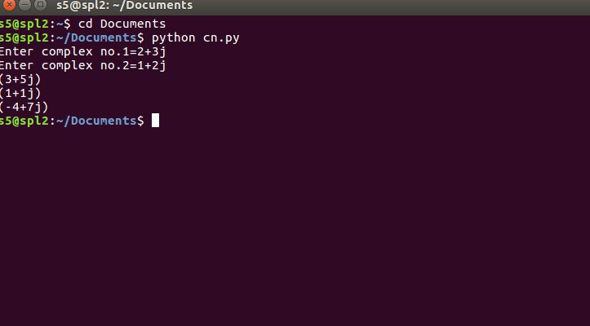

**Additional Programs:**

1. **Swapping two numbers**

a=int(input("Enter the value of a")) b=int(input("Enter the value of b")) c=a

a=b b=c

print("After Swapping") print(a,b)

# OUTPUT:

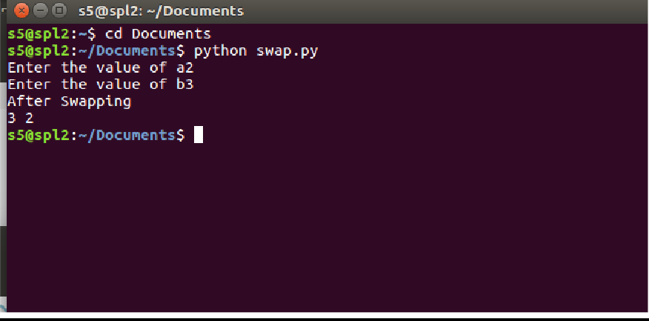

1. **Temperature conversion from Fahrenheit to Celsius**

F=int(input("ENTER FARENHEIT VALUE:")) C=5/9*(F-32)

print("Conversion from Farenheit to Celcius=",C)

# OUTPUT:

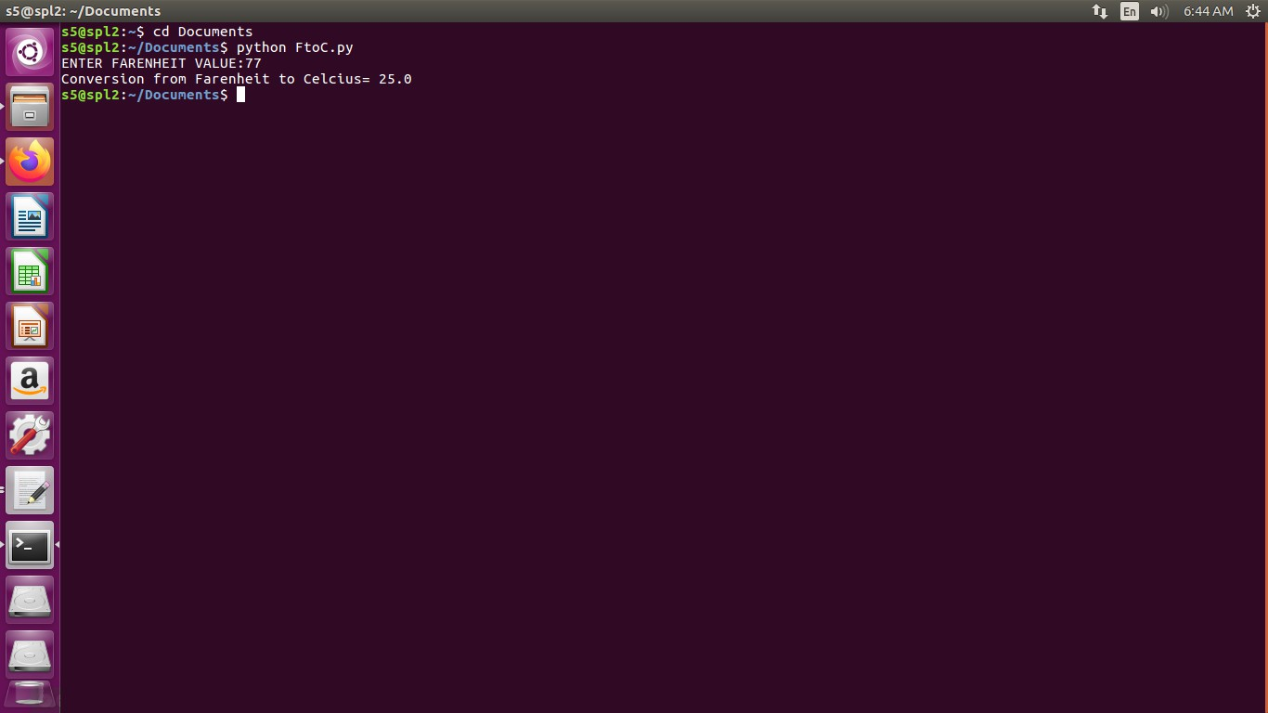

1. **Compute the gross and net salaries of an employee for the given basic pay (BP) based on the allowances and deductions. Gross pay includes basic and all allowances, Net pay is the difference between gross pay and deductions. Allowances: DA = 62% of BP HRA = 8% of BP Deductions: Insurance = Rs. 2000 PF = 12% of BP**

basic_pay=int(input("Enter the basic pay")) da=0.62*basic_pay

hra=0.08*basic_pay Insurance=2000 pf=0.12*basic_pay gp=da+hra+pf np=gp-Insurance-pf

print("Gross pay",gp) print("Net pay",np)

**OUTPUT:**

