Data Analytics with Cognos Project

**PROJECT TITLE:**

PRODUCT SALES ANALYSIS

DEVELOPMENT PART 2

**TEAM MEMBERS:**

|  |  |
| --- | --- |
| DHIVYADHARSHINI S B ([**dhivyadharshu07@gmail.com**](mailto:dhivyadharshu07@gmail.com)) | 2021115029 |
| DHARINI  ([**dhariniathithakumar@gmail.com**](mailto:dhariniathithakumar@gmail.com)) | 2021115027 |
| DHAVASRI  ([**indradhavasri212@gmail.com**](mailto:indradhavasri212@gmail.com)) | 2021115028 |
| DILEEP  ([**dilleep18@gmail.com**](mailto:dilleep18@gmail.com)) |  |
|  |  |

**Exploratory Data Analysis**

# Visualization

In the product sales analysis project, visualization plays a pivotal role in transforming complex data into clear, actionable insights. Utilizing IBM Cognos, a powerful business intelligence tool, enables the creation of intuitive and interactive visualizations. Through compelling charts, graphs, and dashboards, patterns and trends in product sales data become immediately apparent. Visualizations allow stakeholders to grasp sales performance across products, regions, and time periods effortlessly. This visual representation not only enhances data-driven decision-making but also facilitates the communication of key findings, empowering businesses to strategize effectively, optimize inventory, identify market opportunities, and enhance overall sales performance.

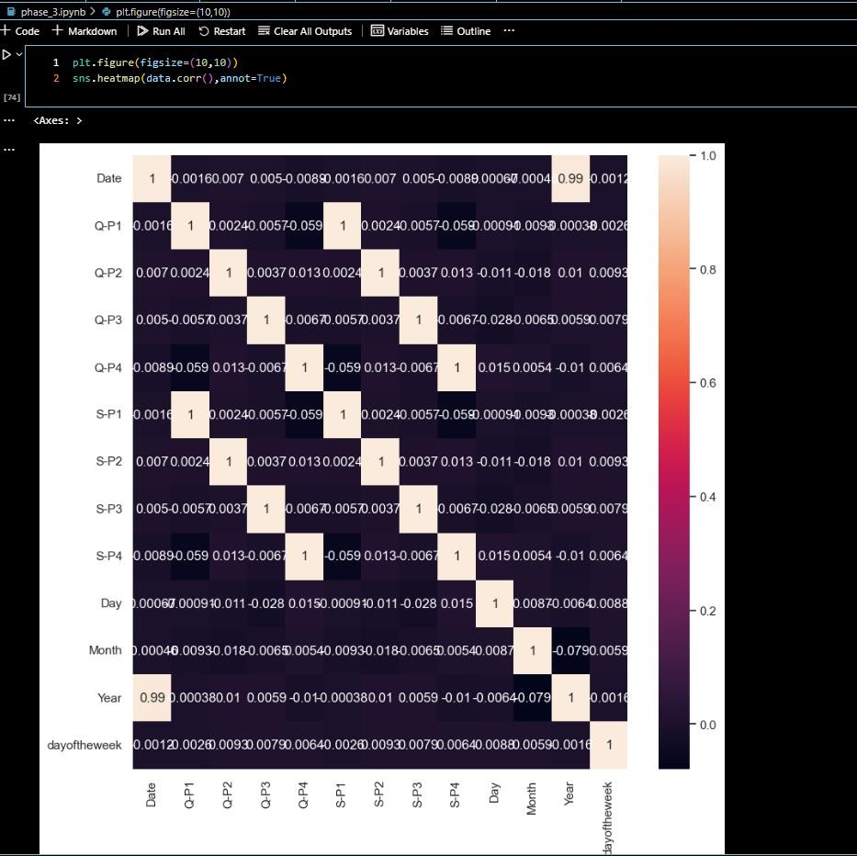

There is no strong correlation between the columns

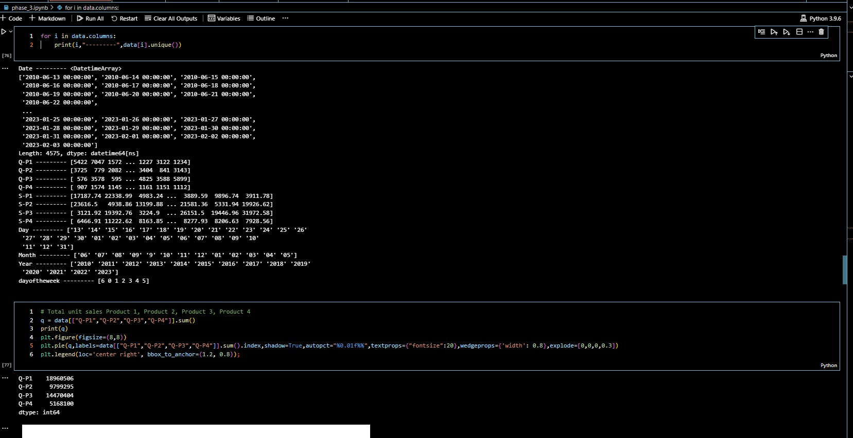

* + Total unit sales Product 1, Product 2, Product 3, Product 4

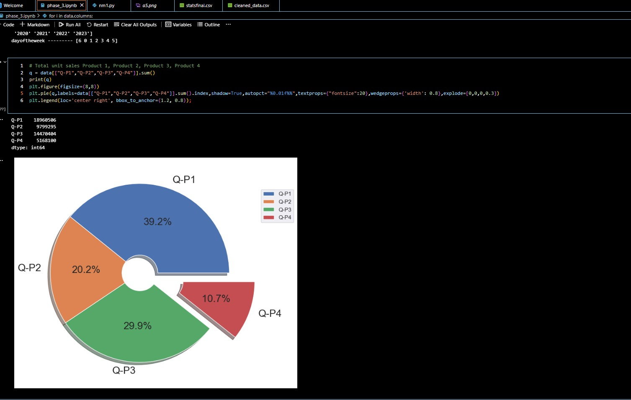

* + Total Revenue percent from sales from Product 1, Product 2, Product 3, Product 4

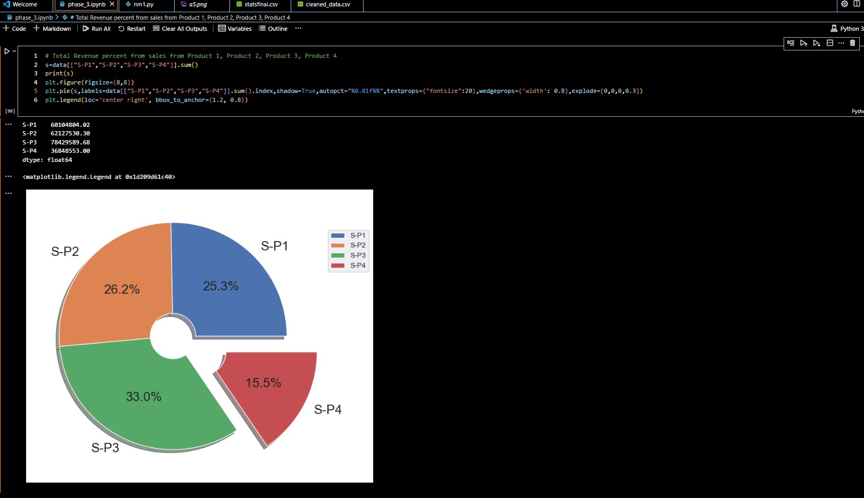

* + Graph between Q-P1 and S-P1

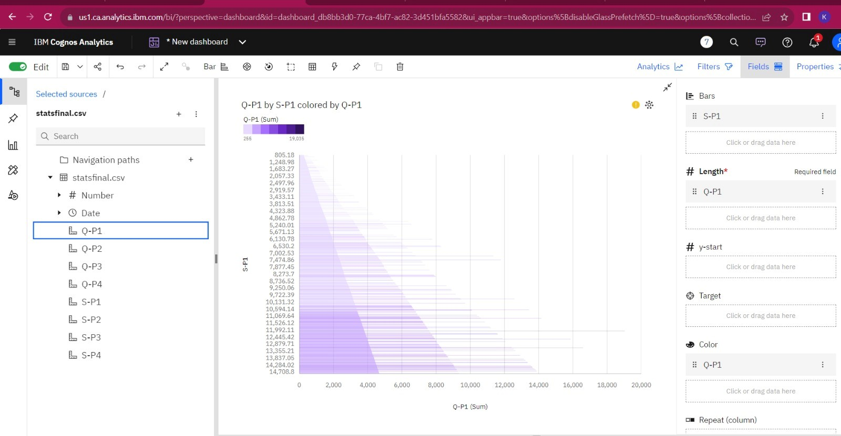

* + Graph between Q-P2 and S-P2

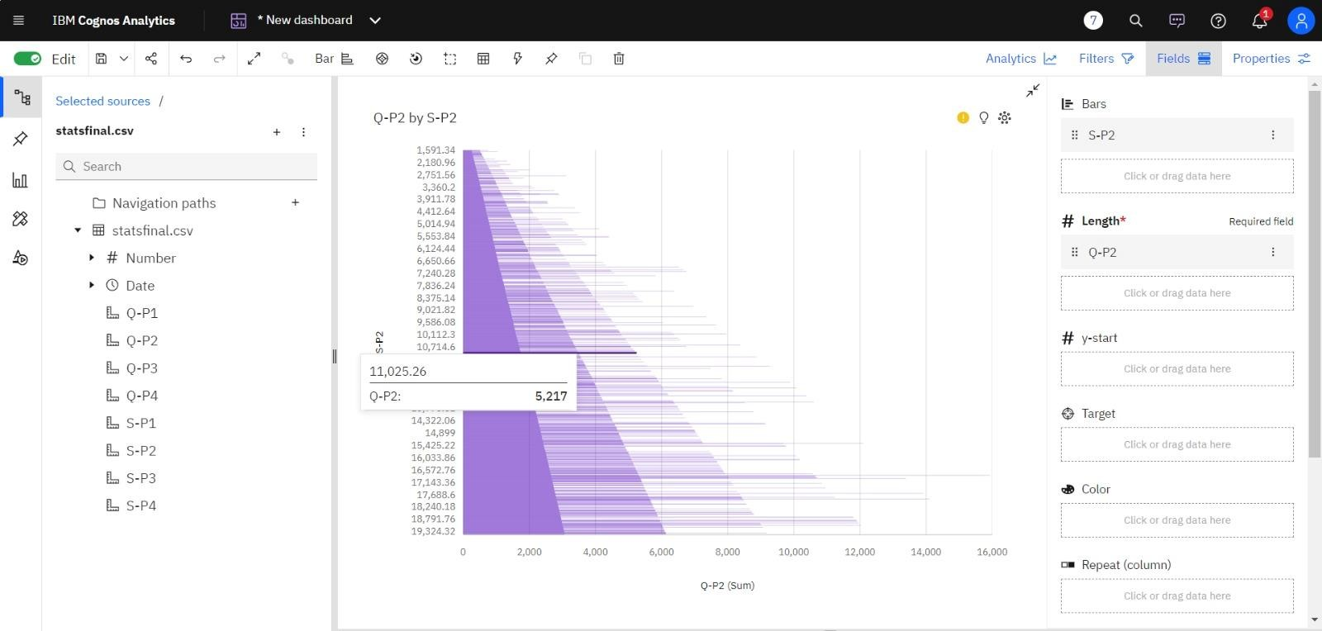

* + Graph between Q-P3 and S-P3

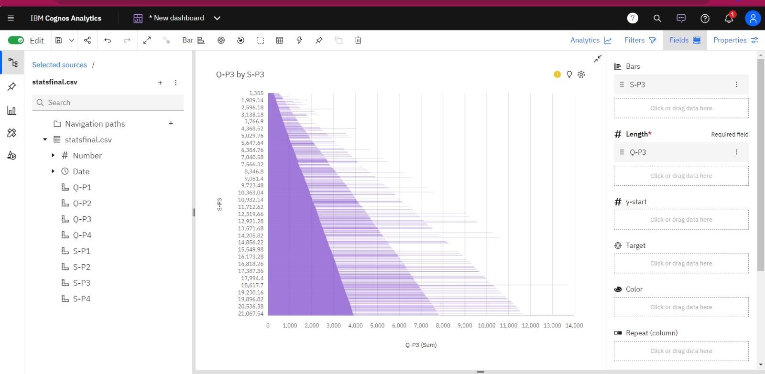

* + Graph between Q-P4 and S-P4

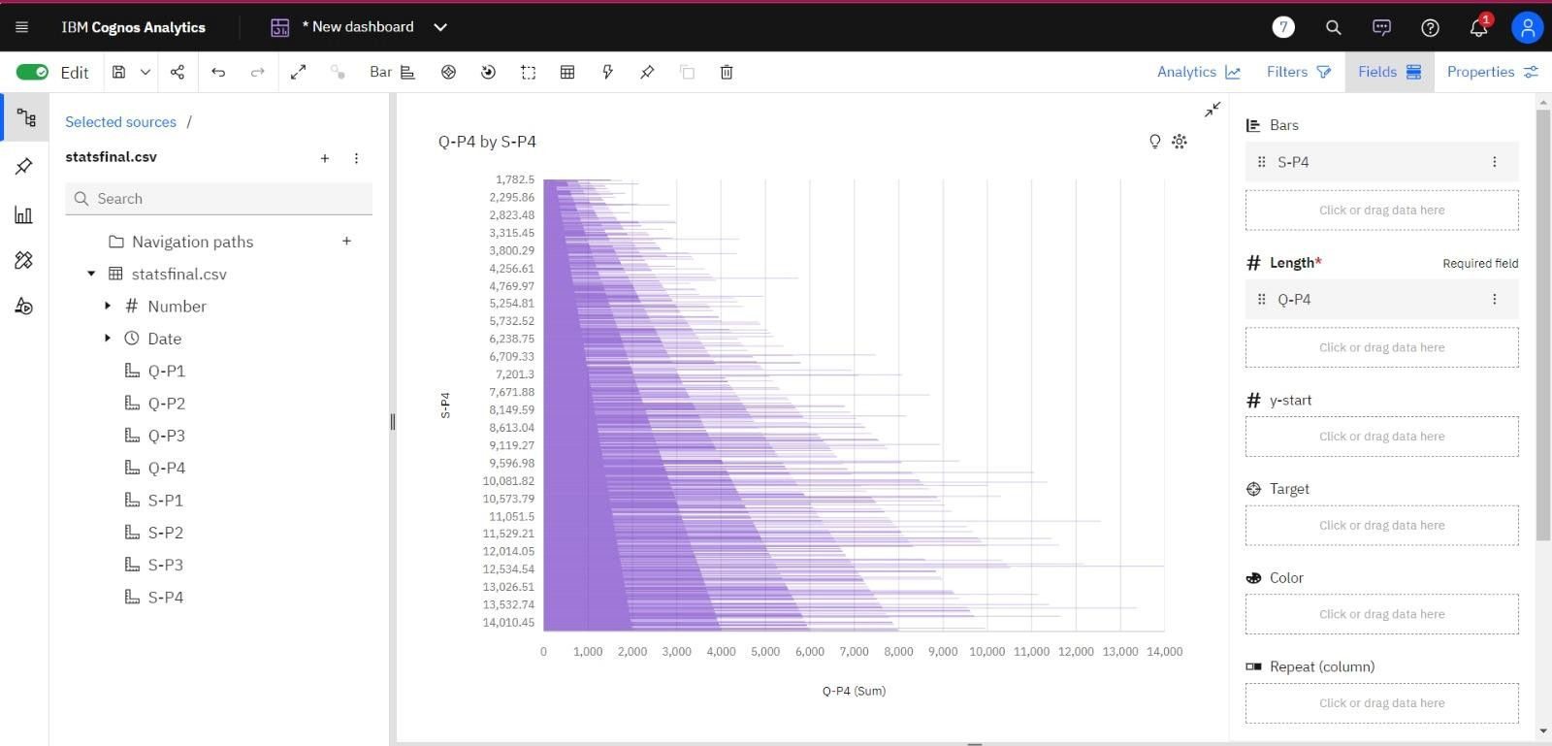

* + Graph between Q-P3 and S-P3

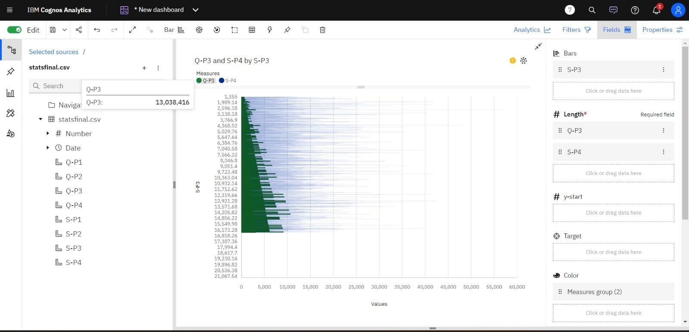

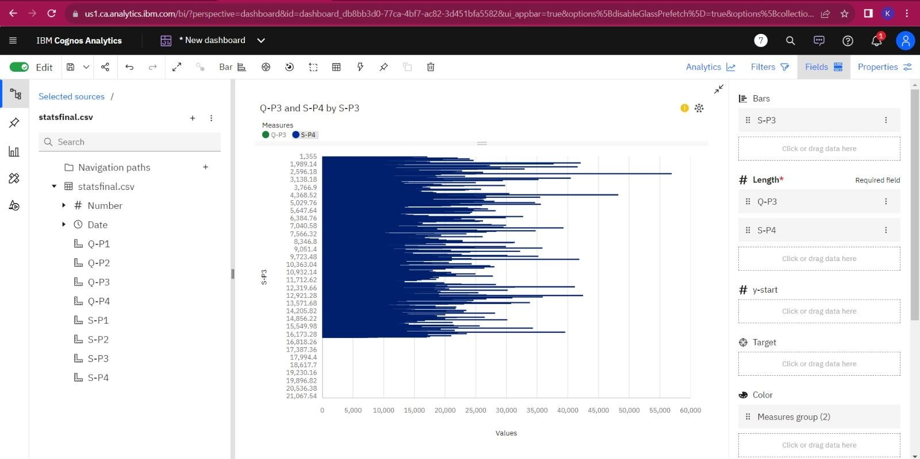

* + Bar graph represents which is most occurring month

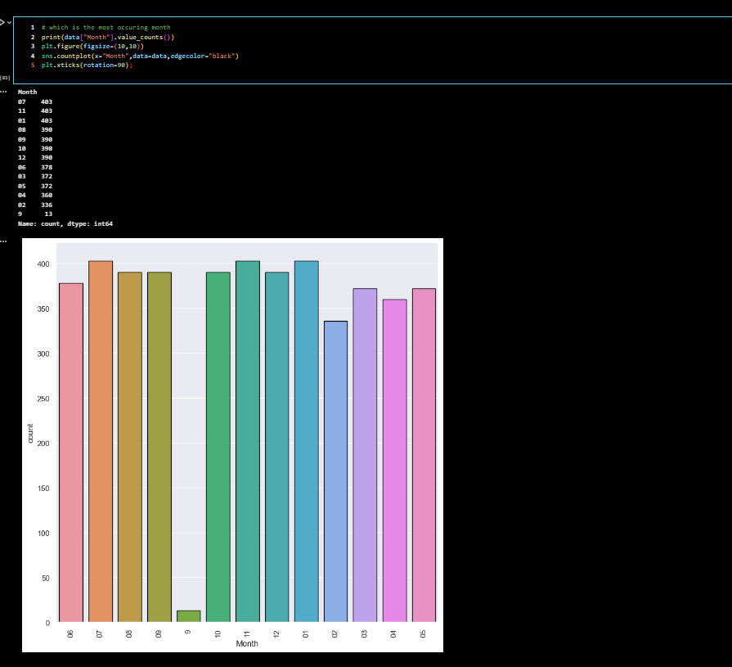

* + Bar graph represents which is most occurring day

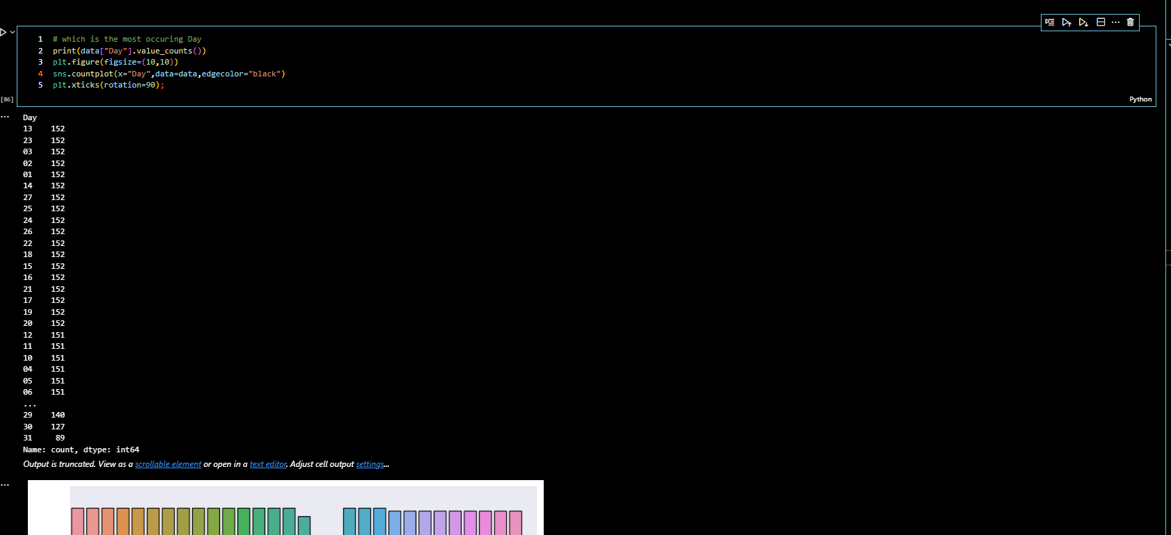

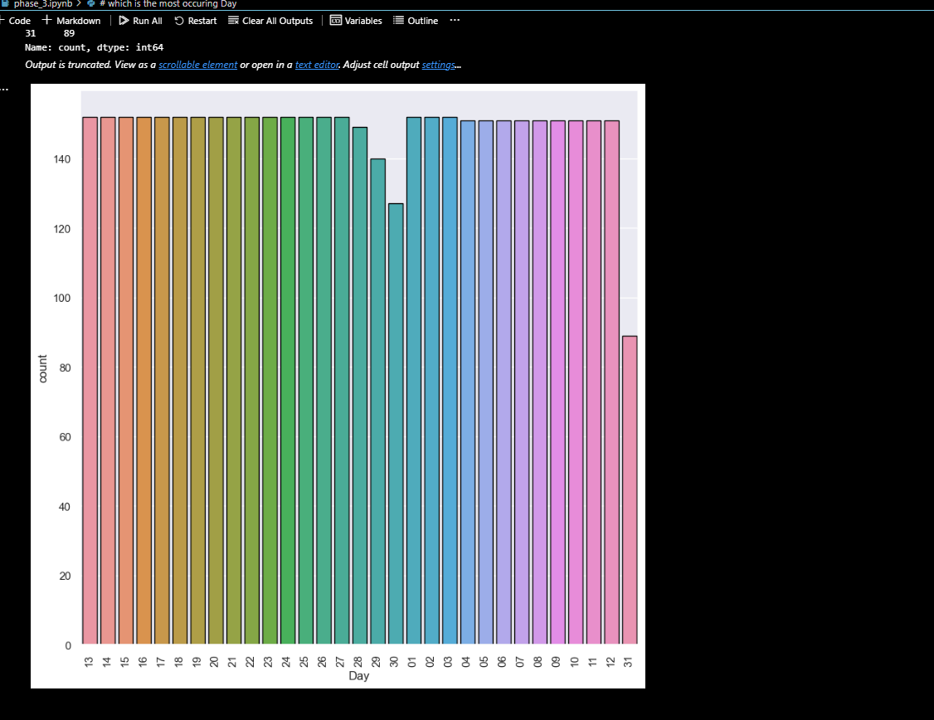

* + Bar graph represents which is most occurring year

