1. Various method of console function
2. Console.log()

* The **console**. log() is a **function in JavaScript** which is used to print any kind of variables defined before in it or to just print any message that needs to be displayed to the user.



1. Console.error()



1. Console.warn()



1. Console.clear()

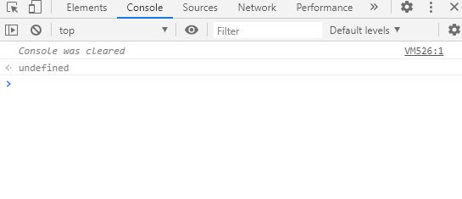

1. console .time() &console.timeEnd()

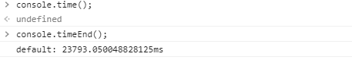

1. Console.count()

used to count the number and by default is assigned 0 ,as in calling it’s incremented.

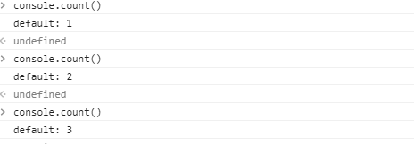

1. Console.table()

 The input must be an array or an object which will be shown as a table.

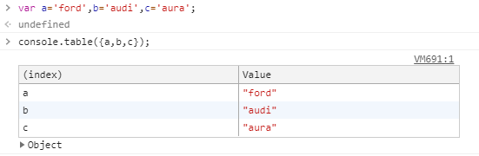

1. console.group() and console.groupEnd()

group() and groupEnd() methods of the console object allows us to group contents in a separate block, which will be indented.

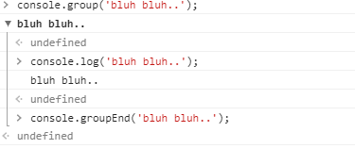

1. Difference between constant ,let and variable

|  |  |  |
| --- | --- | --- |
| Var(variable) | let | Const ( constant) |
| **var** declarations are globally scoped or function scoped | **let** allows you to declare variables that are limited to the scope of a block statement, or expression on which it is used, unlike the var **keyword**, which defines a variable globally, or locally to an entire function regardless of block scope. | **const** are block scoped ,it is a signal that the identifier won't be reassigned |
| **var** variables can be updated and re-declared within its scope | **let** variables can be updated but not re-declared | **const** variables can neither be updated nor re-declared. |

Var that are declared globally/functional block ,interfere with window function

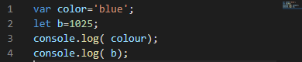

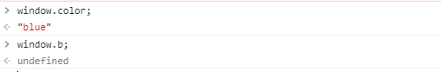

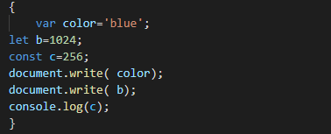

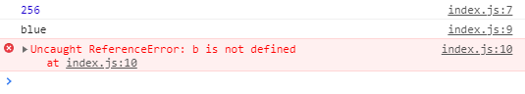

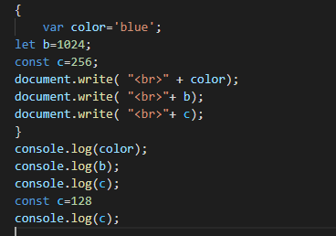

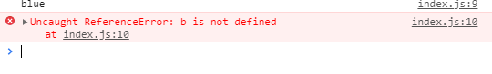

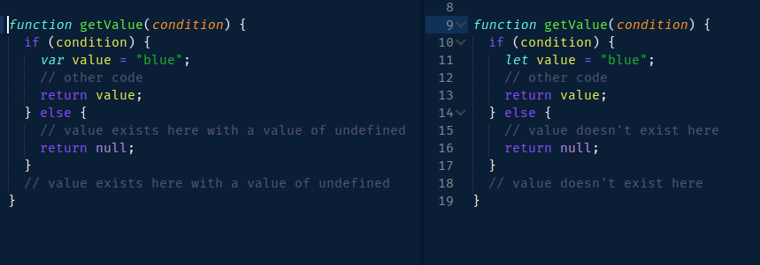

When let and const are declared in scope ,data is being used/reused(~constant) doesnot interfere with window function or after terminating the scope

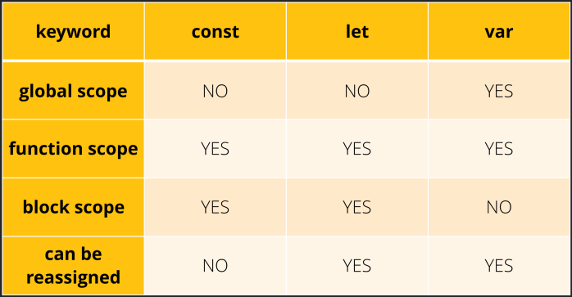

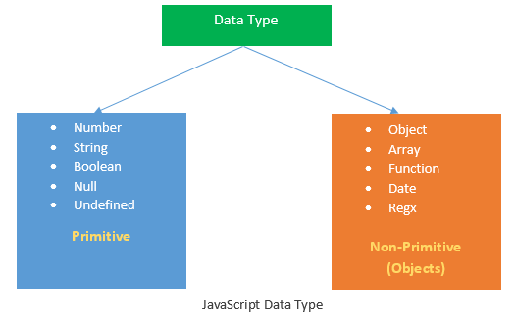

DATATYPE in JS : There are 3 types of data types in JavaScript.

1. primitive (or primary) : String, Number, and Boolean
2. composite (or reference) : Object, Array, and Function
3. special  data types : Undefined and Null are special data types.

|  |  |  |
| --- | --- | --- |
| primitive | Composite (non primitive) | special  data types (non primitive) |
| String: represents sequence of characters | An array is a type of object used for storing multiple values in single variable. | special data type that can have only one value-the null value |
| Number : represents numeric values | The function is callable object that executes a block of code | The **undefined data type** can only have one value-the **special** value **undefined** |
| Boolean: represents boolean value either false or true | A javaScript object is an entity having state and behavior  New is a keyword used to create object |  |