Digital Twin-Enabled Explainable Structural Health Monitoring Framework for Bridge Infrastructure

Dr. V. Devisurya¹, Dhivyashri K K², Hemavarshini V³

¹ Assistant Professor (SLG), Department of Information Technology, Kongu Engineering College, Perundurai, Tamil Nadu, India; devisurya.it@kongu.edu

²,³ Department of Information Technology, Kongu Engineering College, Perundurai, Tamil Nadu, India;dhivyashrikk.23it@kongu.edu; hemavarshiniv.23it@kongu.edu

Abstract. Bridges require continuous and interpretable condition monitoring, yet change detection, condition classification and model explanation are rarely combined and evaluated together on a common benchmark. This paper presents a digital-twin monitoring prototype that integrates Bayesian online change point detection (BOCPD), an XGBoost condition classifier, SHAP attribution and a validation-gated risk score in one configurable pipeline, and reports its exact behaviour on the Z24 bridge benchmark. All 306 recordings of the progressive damage tests (17 scenarios, 10 189 channels at 100 Hz) were divided into 1 324 504 windows described by time-domain, spectral and modal features, the latter comprising four natural frequencies identified by frequency domain decomposition. Applied to the scenario sequence of natural frequencies, BOCPD detected the state changes with a precision of 0.833 and a recall of 0.625 (CUSUM: 0.579 and 0.688). The classifier reached a ROC-AUC of 0.919 (95% CI 0.872–0.956) under recording-grouped cross-validation but 0.629 (0.505–0.743) when whole scenarios were held out, below a natural-frequency shift threshold (0.821); the validation gate therefore excluded it from the risk score. SHAP analysis of all held-out windows attributed 99.8% of the model output to the modal features, led by f2, f4, f1. A label-free novelty score calibrated on the two pre-intervention measurements reached a balanced accuracy of 0.856, and on the one-year monitoring data temperature-compensated BOCPD raised its first alarm one day after the start of the damage tests. The prototype runs end-to-end and exposes every intermediate evidence stream to the engineer, while the results show that natural-frequency features and baseline-relative change detection generalise better to unseen damage states than the supervised classifier.
Keywords: Bayesian online change point detection; digital twin; explainable artificial intelligence; SHAP; structural health monitoring; XGBoost; Z24 bridge.
GIT LINK: https://github.com/Dhivyashri-6/Digital_twin_bridge.git

1. INTRODUCTION
Road bridges are among the most critical assets of transport networks, and a growing share of them is operating beyond its original design life. Periodic visual inspection remains the main source of condition information, but it is labour-intensive, partly subjective and blind to changes that occur between visits. Structural health monitoring (SHM) addresses this gap by recording the dynamic response of a structure continuously and converting it into quantitative evidence about its state [1], [2].
The premise of vibration-based SHM is that changes in stiffness, mass or boundary conditions alter the measured dynamic response, so that damage can be inferred from changes in vibration characteristics [3], [4]. Over the last decade, machine-learning and deep-learning methods have been applied extensively to this problem [5]–[8]. In practice, however, the analytical stages that an engineer needs – detecting when the behaviour changed, estimating what condition a measurement resembles and understanding why a model reached its output – are usually developed and evaluated separately.
Digital twins offer a way to bring these stages together. A digital twin couples a physical asset with a virtual representation that is updated from measured data and supports decision making throughout operation and maintenance [9]–[11]. Recent reviews and frameworks for civil and bridge infrastructure [12]–[17] emphasise the integration of sensing, analytics and

visualisation, but also note that many implementations stop at data management. Lu et al. [18] showed that Bayesian change point detection can serve as the anomaly-detection engine of a digital twin for built assets, using pump data from a building. Their framework did not include a supervised classification stage or a model-explanation layer, and it was not applied to bridge vibration data.
Explainability matters in SHM because an alarm without supporting evidence is difficult to audit or act upon. SHAP [19] attributes a model output to its input features in a consistent, additive way and is available in exact form for tree ensembles such as XGBoost [20]. BOCPD [21] complements supervised models because it needs no labelled damage data, which is rarely available for bridges in service.
This paper describes a digital-twin monitoring prototype for bridge SHM that chains BOCPD, XGBoost, SHAP and a weighted risk score, and reports the exact results obtained when the implemented pipeline is run on the Z24 bridge benchmark [22], [23]. All numerical values in Section 5 are taken directly from the pipeline outputs or recomputed from the saved model and data. Section 2 reviews related work, Section 3 describes the benchmark and the data used, Section 4 presents the method, Section 5 reports the experimental results, Section 6 discusses the results and Section 7 concludes the paper.
2. RELATED WORK
2.1. Vibration-based SHM and machine learning
Farrar and Worden [1] framed SHM as a statistical pattern-recognition problem comprising operational evaluation, data acquisition, feature extraction and statistical model development, and Farrar et al. [24] set out this paradigm in detail for vibration-based monitoring. Worden and Dulieu-Barton [2] reviewed intelligent fault detection and highlighted feature selection and data fusion as central issues. The early literature reviews of Doebling et al. [3] and Sohn et al. [25], together with the survey of Carden and Fanning [4], catalogued damage-identification methods based on modal parameters, frequency response functions and time-domain signal statistics, while Taha et al. [26] compiled the uses of the wavelet transform for denoising, feature extraction and damage detection.
More recent surveys document the shift towards data-driven approaches. Avci et al. [5] traced the move from traditional methods to machine-learning and deep-learning techniques in civil structures, Hou and Xia [6] reviewed vibration-based damage identification developed between 2010 and 2019, Malekloo et al. [7] discussed machine learning with emerging sensing technologies and high-dimensional data, and Sun et al. [8] reviewed how big data and artificial intelligence support bridge monitoring from condition assessment to damage detection. Operational and environmental variability is the main obstacle for such methods: Figueiredo et al. [27] compared machine-learning algorithms that normalise damage-sensitive features for changing temperature and loading, and Santos et al. [28] extended the comparison to kernel-based algorithms that model nonlinear relationships between the features and the environment. A recurring observation in these studies is that environmental effects can mask or mimic damage-induced changes, so that reliable validation requires data from independent measurement campaigns.
2.2. Digital twins for civil and bridge infrastructure
Kritzinger et al. [11] distinguished digital models, digital shadows and digital twins by the degree of automatic data exchange between the physical object and its virtual counterpart, and Jones et al. [10] characterised the digital twin through a systematic literature review of its constituent parts and open research questions. For civil structures, Torzoni et al. [9] proposed a digital-twin framework that combines physics-based reduced-order models with deep learning for structural health monitoring and decision making, and Sun et al. [12] reviewed the development of digital twins for SHM of civil infrastructure, covering sensing, data acquisition, modelling and health assessment.
Bridge-specific studies have grown quickly in recent years. Franciosi et al. [17] examined digital twins for streamlined bridge maintenance and sustainability, Jiménez Rios et al. [13] reviewed digital-twin-based anomaly detection systems for bridge management, and Nhamage et al. [14] analysed strategies for maximising the value of digital twins in bridge management and structural monitoring. Yousuf et al. [15] surveyed digital twins for bridge health assessment and management, and Chaudhari et al. [16] reviewed how artificial intelligence, the Internet of Things and digital twins are being combined in vibration-based bridge monitoring. These works motivate pipelines in which sensing, analysis and visualisation share the same evidence, which is the design principle of the prototype described here.
2.3. Change detection and explainable models
BOCPD, introduced by Adams and MacKay [21], maintains a posterior distribution over the run length – the number of observations since the last change – and updates it recursively as data arrive. Lu et al. [18] embedded Bayesian change point detection in a digital-twin-enabled anomaly-detection process for asset monitoring during operation and maintenance. XGBoost [20] is a regularised gradient-boosted tree ensemble that performs well on tabular feature data, and SHAP [19] provides additive, game-theoretic feature attributions whose exact tree variant makes it a natural companion for XGBoost.
For bridges, the Z24 benchmark [22] and its one-year monitoring campaign [23] remain standard references, notably because they show how temperature-driven changes of the natural frequencies can be as large as damage-induced changes. Peeters and De Roeck [29] developed reference-based stochastic subspace identification, which estimates modal parameters from output-only measurements using a subset of reference sensors, and Maeck et al. [30] used vibration monitoring of the progressive damage tests to identify the induced damage. Taken together, the reviewed works treat change detection, condition classification and explanation largely as separate stages; the present study combines them in one digital-twin workflow and evaluates each stage on the complete Z24 progressive damage tests.
3. PRELIMINARY STAGE
3.1. Z24 bridge benchmark
The Z24 bridge was a post-tensioned concrete box-girder bridge in Switzerland that crossed the A1 motorway between Bern and Zurich. Before its demolition at the end of 1998 it was monitored for about one year [23] and then subjected to progressive damage tests (PDT) comprising 17 scenarios [22]. Scenarios 01, 02 and 08 are reference measurements, and the remaining scenarios introduce controlled changes of increasing severity (Table 1). Ambient vibration was recorded in several sensor setups per scenario [22].
Table 1
Progressive damage test scenarios of the Z24 bridge [22] and labels used in this study
No. | Scenario | Label
01 | First reference measurement | REF
02 | Second reference (lowering system installed) | REF
03–06 | Lowering of pier by 20, 40, 80 and 95 mm | ALT
07 | Lifting of pier, tilt of foundation | ALT
08 | Third reference measurement | REF
09–10 | Spalling of concrete (12 and 24 m²) | ALT
11 | Landslide at abutment | ALT
12 | Failure of concrete hinge | ALT
13–14 | Failure of anchor heads (two stages) | ALT
15–17 | Rupture of tendons (three stages) | ALT

3.2. Data used in this study
All progressive-damage-test recordings were processed: 17 scenarios, the ambient (AVT) and forced (FVT) vibration test of each scenario and all 9 sensor setups, i.e. 306 recordings with unique identifiers of the form S<scenario>_<test>_setup<NN>. The 891 ASCII (.aaa) files of scenarios 06 and 17 and the 18 MATLAB files inside the scenario-08 archives were read and compared with the MATLAB data: all 891 ASCII channels are sample-for-sample identical to MATLAB columns and all 18 archived files are byte-identical, so every physical channel is used once. Every ASCII header declares a sample interval of 0.01 s, confirming the 100 Hz sampling rate used for all records. The data comprise 10 189 channels (4 945 AVT, 5 244 FVT) of 65 026–65 536 samples (Table 2). The 5 653 hourly records of the long-term monitoring system (EMS) are analysed in Section 5.7.
Table 2
Data processed by the pipeline
Item | Value
Recordings (scenarios × tests × setups) | 306 (17 × 2 × 9)
Unique recording identifiers | 306
.mat / .aaa / zipped .mat files | 306 / 891 / 18
Duplicates verified identical | 891 + 18
Sampling rate (all .aaa headers) | 100 Hz
Unique channels (AVT / FVT) | 10 189 (4 945 / 5 244)
Windows, 10 s, 50% overlap | 1 324 504
REFERENCE / ALTERED windows | 232 830 / 1 091 674

3.3. Label assignment
Scenarios 01, 02 and 08 are labelled REFERENCE and the other 14 scenarios ALTERED_CONDITION (Table 1). The regular-expression label rules agree with the scenario numbers for all recordings (0 mismatches). The labels describe the test protocol, not measured damage. Because the windows of one recording are strongly correlated, all evaluations are grouped by recording or by scenario.
4. METHOD
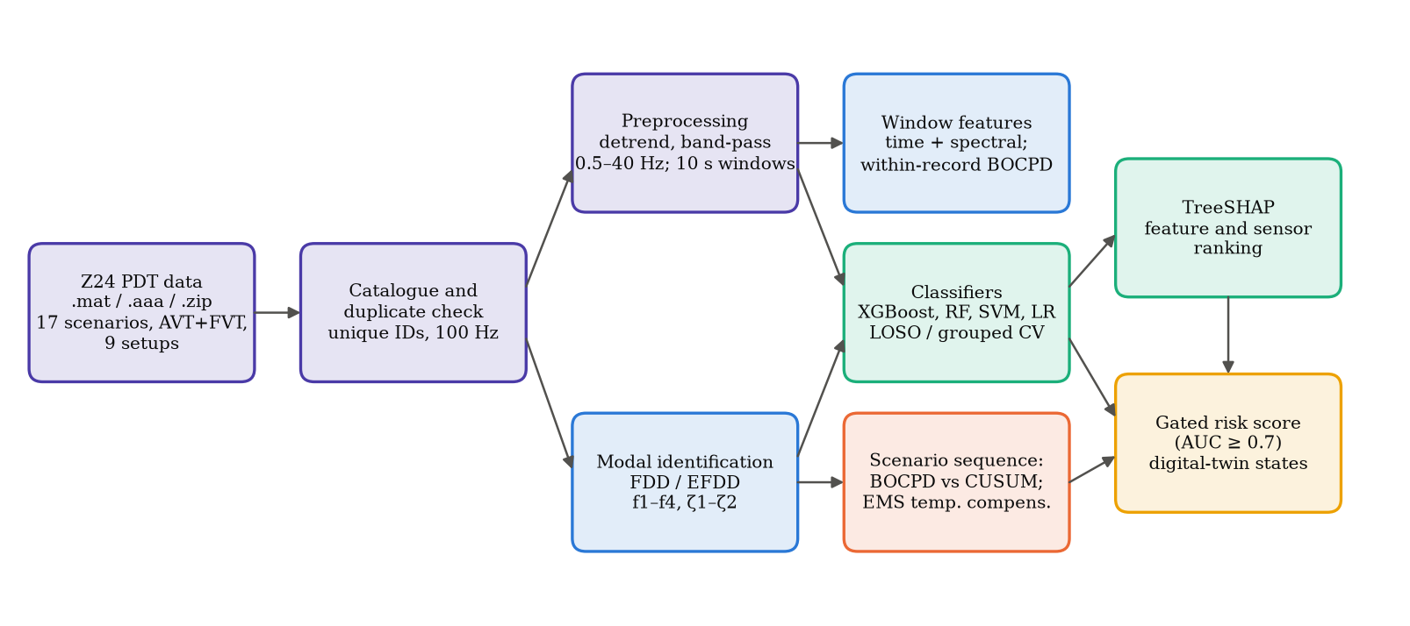
The implemented workflow is shown in Fig. 1. Every stage writes its output to a file, so that the digital-twin dashboard and any later analysis read exactly the same evidence.
Fig. 1. Processing pipeline of the digital-twin SHM prototype
4.1. Preprocessing and windowing
Each channel is validated, NaN and infinite samples are interpolated, and the signal is linearly detrended and band-pass filtered (Butterworth, order 4, 0.5–40 Hz, zero phase). No amplitude normalisation is applied; per-record z-score normalisation is evaluated only as an ablation. Windows last 10 s (1000 samples) with 50% overlap and inherit the scenario, test, setup, sensor and recording metadata.
4.2. Window and modal features
Each window is described by 20 features: 11 time-domain statistics (mean, standard deviation, variance, RMS, minimum, maximum, absolute peak, peak-to-peak, crest factor, skewness, kurtosis) and 9 spectral descriptors from the Welch PSD (segment length 256, 0.39 Hz resolution): dominant frequency, spectral energy, frequency centroid, spectral bandwidth, PSD peak and band energies in 0–1, 1–5, 5–20 and 20–40 Hz (Table 3). Modal features are identified per record by frequency domain decomposition (FDD): the cross-spectral matrix of all channels (Hann segments of 4096 samples, 0.024 Hz resolution) is decomposed by SVD, and peaks of the first singular value with a prominence of at least 0.3 decades between 1.5 and 15.0 Hz are candidate modes. Baseline modes are the peaks of the averaged spectrum of the nine scenario-01 AVT records (3.91, 5.13, 9.92, 12.61 Hz). Candidates are assigned to the baseline modes by Hungarian matching of the modal assurance criterion (MAC ≥ 0.8, on the five reference sensors R1V, R2L, R2T, R2V and R3V present in every setup) with a relative-frequency penalty. Damping ratios are estimated by enhanced FDD (logarithmic decrement of the correlation function of the MAC ≥ 0.8 bell) and retained only if 0 < ζ < 10% and the fit has R² ≥ 0.95; ζ1 and ζ2 met this criterion in 98.7% and 83.0% of the AVT records and are used, ζ3 and ζ4 (18.3% and 17.0%) are not. The FVT spectra are dominated by the shaker excitation, so modal features are used for the AVT records only.
Table 3
Definitions of selected features for a window x₁, …, x_{N} with PSD S(f_{k})
Feature | Definition
RMS | (1/N Σ x_{n}²)^{1/2}
Crest factor | max|x_{n}| / RMS
Skewness | E[(x − μ)³] / σ³
Kurtosis (excess) | E[(x − μ)⁴] / σ⁴ − 3
Dominant frequency | arg max_{k} S(f_{k})
Frequency centroid f_{c} | Σ f_{k}S(f_{k}) / Σ S(f_{k})
Spectral bandwidth | [Σ (f_{k} − f_{c})²S(f_{k}) / Σ S(f_{k})]^{1/2}
Spectral energy | Σ S(f_{k}) Δf

4.3. Change detection
Two BOCPD configurations are used. Within each record, BOCPD [21] is applied to the window-RMS sequence of every channel. Across states, the AVT recordings are ordered by scenario (01→17) and setup, and the natural frequencies f1–f4 of each recording, standardised with the mean and standard deviation of the nine scenario-01 records, form a multivariate sequence. Let γt(r) denote the joint probability of run length r and the observations up to step t, and πt(r) the product over features of the Student-t posterior predictive densities under independent Normal–Gamma posteriors (missing values are skipped). With a constant hazard h, the growth and reset probabilities are
γ_{t}(r+1) = γ_{t−1}(r) π_{t}^{(r)} (1 − h), (1)
γ_{t}(0) = h π_{t}⁽⁰⁾ Σ_{r} γ_{t−1}(r), (2)
CP_{t} = γ_{t}(0) / Σ_{r} γ_{t}(r). (3)
where πt(0) uses the prior (μ0 = 0, κ0, α0 = 1, β0 = 1). Within records, h = 0.01, κ0 = 1, and a window is flagged when CPt ≥ 0.8. Across scenarios, a change is declared when the maximum a posteriori run length drops, with h = 0.05 and κ0 = 0.01; results for h ∈ {0.02, 0.05, 0.111} and κ0 ∈ {1.0, 0.1, 0.01} are also reported. A two-sided tabular CUSUM (k = 0.5, h ∈ {4.0, 5.0, 8.0}, re-baselined on the 3 records after each alarm) is the baseline detector. A detection is correct if it occurs 0–4 records after one of the 16 scenario boundaries.
4.4. Classification and evaluation
The classifiers operate on non-overlapping AVT windows (every second window) with the 20 window features and the record-level modal features (f1, f2, f3, f4, zeta1, zeta2). XGBoost [20] (300 trees, learning rate 0.05, depth 6, row and column subsampling 0.8) is compared with a random forest (RF; 300 trees, minimum leaf size 5, 25% bootstrap samples), an RBF support vector machine (SVM; C = 1, at most 20 000 stratified training windows per fold), logistic regression (LR) and a natural-frequency threshold (largest relative shift of f1–f4 from the mean of the training reference recordings, with the threshold maximising Youden's index on the training recordings). All models use balanced class weights. Two schemes are used: leave-one-scenario-out (LOSO, 17 folds) and stratified grouped 5-fold cross-validation by recording (GKF), each with 3 seeds. Accuracy, balanced accuracy (BA), macro-F1, ROC-AUC and the Matthews correlation coefficient (MCC) are computed on the pooled out-of-fold predictions (positive class ALTERED_CONDITION), with 95% confidence intervals from a cluster bootstrap over recordings (2000 replicates, metric averaged over seeds in each replicate).
4.5. SHAP attribution and sensor ranking
SHAP [19] decomposes the model output (log-odds of ALTERED_CONDITION) for window i into feature contributions φij:
f(x_{i}) = φ₀ + Σ_{j} φ_{ij}, Φ_{j} = (1/N) Σ_{i} |φ_{ij}|, (4)
where Φj is the global importance of feature j. Exact TreeSHAP values are computed for every held-out window of the LOSO folds, each by the model of its own fold (seed 0). Sensors are ranked by the mean of Σj |φij| over the channel-level features (modal features are shared by all channels of a record) and aggregated by sensor line and direction.
4.6. Risk score and digital-twin dashboard
A bounded risk score combines the BOCPD change probability B, the classifier probability of ALTERED_CONDITION M and the normalised sensor attribution A:
R = (w_{B}B + w_{M}M + w_{A}A) / (w_{B} + w_{M} + w_{A}), (5)
with wB = 0.3, wM = 0.5 and wA = 0.2. B is the sequence-BOCPD probability that a change occurred within the last 4 records, M the out-of-fold LOSO probability of ALTERED_CONDITION and A the normalised SHAP attribution of the sensor, which enters as A·max(B, M) in place of A so that the attribution only prioritises sensors once a change is evident. The classifier term is included only if its LOSO ROC-AUC reaches 0.7; otherwise wM = 0. R is mapped to LOW (< 0.35), MEDIUM (< 0.60), HIGH (< 0.80) or CRITICAL. A sensor is ANOMALY when B ≥ 0.80 and M ≥ 0.5 (if M is included) or R ≥ 0.60, and WARNING when one condition holds or R ≥ 0.35; a recording is POTENTIAL ANOMALY if any sensor is ANOMALY or at least 30% are affected, WATCH if any sensor is affected and NORMAL otherwise. The Streamlit dashboard replays the stored results on a schematic bridge.
5. EXPERIMENTAL RESULTS
5.1. Experimental setup
The pipeline is implemented in Python 3.12.10 with NumPy 2.1.3, SciPy 1.18.1, scikit-learn 1.9.0, XGBoost 3.4.1 and SHAP 0.52.0, and was run on an 8-core Windows PC. Every stage stores a run identifier, the configuration, package versions, seeds, wall time and SHA-256 hashes of its outputs; loading, preprocessing and feature extraction of all 306 recordings took 12.8 min.
5.2. Natural frequencies
The four baseline modes of scenario 01 lie at 3.91, 5.13, 9.92, 12.61 Hz. They were identified in 100.0%, 98.7%, 98.7% and 88.9% of the 153 AVT recordings, with a mean ζ1 of 0.91% (Fig. 2). The largest decreases relative to scenario 01 are -5.8% for f1 (scenario 06), -9.1% for f2 (scenario 07) and -7.0% for f3 (scenario 06). The reference scenarios are not identical: relative to scenario 01, f1 of scenario 02 differs by -0.95% and f2 of scenario 08 by -4.59%, which is comparable to the shifts caused by the smallest interventions (scenario 03: f1 -1.04%).
Covariance-driven stochastic subspace identification [29] (SSI-COV, reference sensors, model orders 20–60 with a stabilisation check) confirmed the FDD modes: a stable SSI pole within 5% was found for 96–100% of the identified modes, with median frequency differences of 0.09–0.69% and a median ζ1 of 0.79% (EFDD 0.87%).
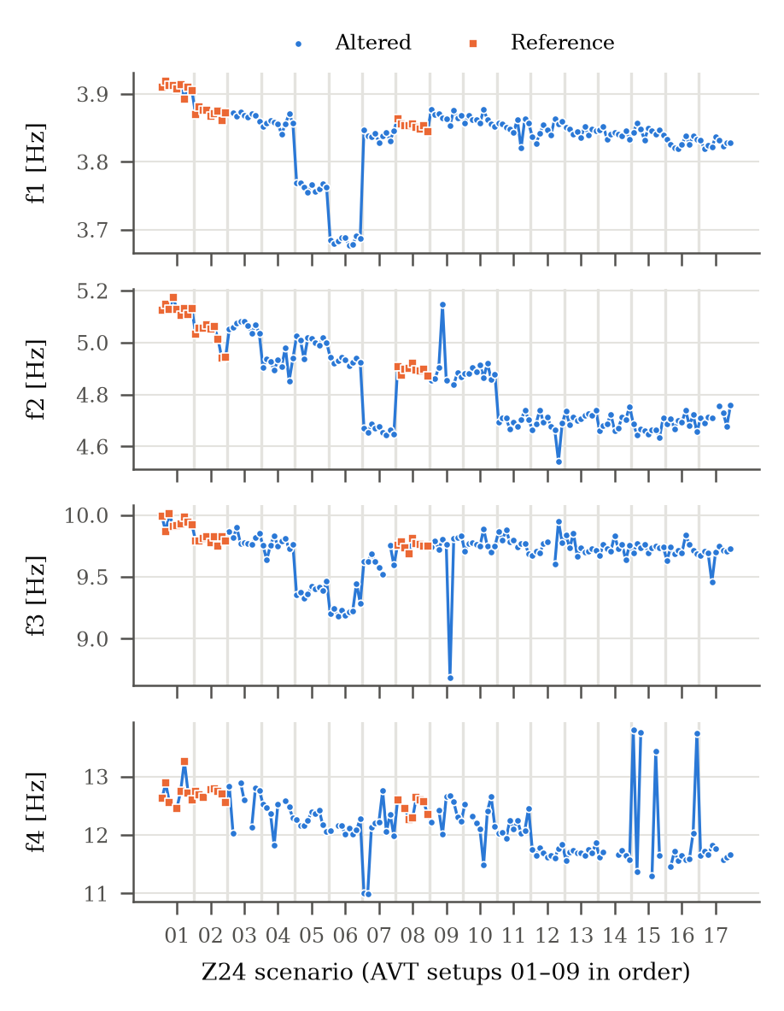
Fig. 2. Natural frequencies f1–f4 of the 153 AVT recordings ordered by scenario and setup (squares: reference scenarios)
5.3. Change detection
Within records, BOCPD processed 10 189 channel sequences (1 324 504 windows). 16 windows crossed CP ≥ 0.8 (maximum 0.876) and 1 939 exceeded 0.5, because the state of the bridge is constant within a recording.
Across scenarios, the 153 AVT recordings contain 16 true boundaries. With h = 0.05 (Table 4), BOCPD with the default prior κ0 = 1 detected only 4 boundaries, because the prior predictive of a new segment is centred within about one baseline standard deviation of scenario 01 whereas later states lie tens of standard deviations away. With the vague prior κ0 = 0.01, BOCPD reached a precision of 0.833, a recall of 0.625 (F1 0.714) and a mean delay of 0.70 records. CUSUM (h = 5) reached a precision of 0.579 and a recall of 0.688 (F1 0.63); for every h tested CUSUM produced more false alarms than BOCPD. Both detectors missed 12→13, 13→14, 16→17, for which |Δf1–f3| ≤ 0.86% (Fig. 3).
Table 4
Detection of the 16 scenario boundaries (AVT sequence, tolerance 4 records; delay in records)
Detector | Det. | TP | Prec. | Recall | F1 | Delay
BOCPD, κ₀ = 1.0 | 6 | 4 | 0.67 | 0.25 | 0.36 | 0.75
BOCPD, κ₀ = 0.1 | 10 | 8 | 0.80 | 0.50 | 0.62 | 1.00
BOCPD, κ₀ = 0.01 | 12 | 10 | 0.83 | 0.62 | 0.71 | 0.70
CUSUM, h = 4 | 22 | 14 | 0.64 | 0.88 | 0.74 | 1.43
CUSUM, h = 5 | 19 | 11 | 0.58 | 0.69 | 0.63 | 1.09
CUSUM, h = 8 | 17 | 12 | 0.71 | 0.75 | 0.73 | 0.92

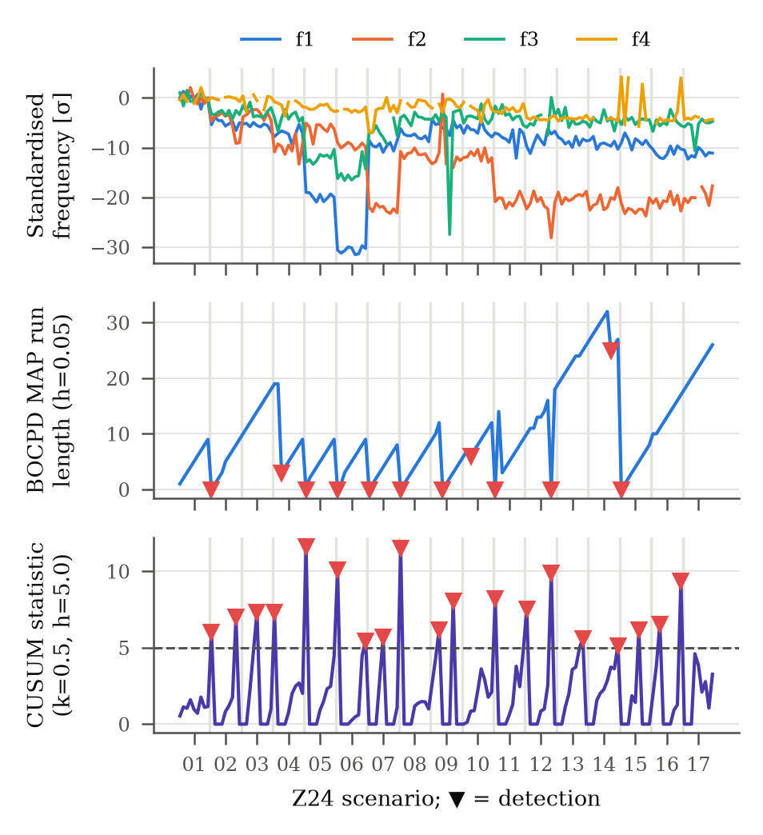
Fig. 3. Change detection along the AVT scenario sequence: standardised f1–f4, BOCPD MAP run length (h = 0.05, κ0 = 0.01) and CUSUM statistic (h = 5); ▼ detections
5.4. Condition classification
The classification data contain 321 425 non-overlapping AVT windows from 153 recordings (27 REFERENCE, 126 ALTERED). Table 5 compares the models. Under grouped 5-fold CV, where other setups of the held-out scenario remain in training, the best ROC-AUC was 0.943 (RF; BA 0.773, MCC 0.591). Under LOSO, where the whole scenario is unseen, the natural-frequency threshold reached a ROC-AUC of 0.821 (BA 0.572), the best ML model 0.759 (SVM) and XGBoost 0.629 (BA 0.474, MCC -0.063).
For XGBoost under LOSO, the recording accuracy on the held-out reference scenarios was 0.11 (S01), 0.11 (S02), 0.00 (S08), while the altered scenarios reached 0.22–1.00 (median 1.00): a classifier trained on two reference states did not recognise the third, whose frequencies differ as much as those of the smallest interventions (Section 5.2).
Table 5
Classification results with 95% bootstrap CIs over recordings (window level; mean over seeds)
Model | CV | BA | Macro-F1 | ROC-AUC | MCC
XGBoost | LOSO | 0.47 [0.42, 0.53] | 0.47 [0.41, 0.53] | 0.63 [0.51, 0.74] | -0.06 [-0.17, 0.08]
RF | LOSO | 0.46 [0.43, 0.48] | 0.43 [0.41, 0.45] | 0.65 [0.53, 0.75] | -0.13 [-0.17, -0.08]
SVM | LOSO | 0.64 [0.56, 0.73] | 0.60 [0.53, 0.67] | 0.76 [0.68, 0.83] | 0.24 [0.09, 0.38]
LR | LOSO | 0.72 [0.62, 0.81] | 0.67 [0.58, 0.74] | 0.61 [0.44, 0.78] | 0.37 [0.20, 0.52]
|Δf| threshold | LOSO | 0.57 [0.48, 0.67] | 0.57 [0.48, 0.65] | 0.82 [0.75, 0.88] | 0.13 [-0.04, 0.31]
XGBoost-M (f, ζ) | LOSO | 0.66 [0.57, 0.76] | 0.66 [0.56, 0.74] | 0.68 [0.55, 0.81] | 0.32 [0.13, 0.49]
XGBoost | GKF | 0.76 [0.68, 0.84] | 0.76 [0.68, 0.83] | 0.92 [0.87, 0.96] | 0.52 [0.36, 0.67]
RF | GKF | 0.77 [0.69, 0.86] | 0.79 [0.71, 0.86] | 0.94 [0.90, 0.97] | 0.59 [0.43, 0.73]
SVM | GKF | 0.83 [0.76, 0.88] | 0.76 [0.68, 0.82] | 0.91 [0.87, 0.95] | 0.55 [0.42, 0.66]
LR | GKF | 0.80 [0.73, 0.87] | 0.73 [0.65, 0.79] | 0.90 [0.84, 0.94] | 0.50 [0.37, 0.62]
|Δf| threshold | GKF | 0.88 [0.82, 0.92] | 0.79 [0.71, 0.86] | 0.90 [0.85, 0.94] | 0.62 [0.51, 0.74]
XGBoost-M (f, ζ) | GKF | 0.76 [0.68, 0.84] | 0.75 [0.67, 0.82] | 0.88 [0.81, 0.94] | 0.51 [0.34, 0.65]

5.5. Ablation
Table 6 isolates the feature groups and the normalisation (XGBoost, 1 seed; the seed s.d. of the main XGBoost AUC is below the CI width). Under LOSO, time-domain features alone gave ROC-AUC 0.544, spectral features 0.609, modal features 0.643 and all features 0.623; per-record z-score normalisation changed the time+spectral result from 0.604 to 0.611, and the all-feature result from 0.623 to 0.622.
Table 6
Ablation of feature groups and per-record normalisation (XGBoost, LOSO, 95% CIs)
Features | Norm. | ROC-AUC | BA | MCC
time | – | 0.54 [0.49, 0.60] | 0.55 [0.51, 0.59] | 0.07 [0.01, 0.14]
spectral | – | 0.61 [0.54, 0.67] | 0.60 [0.55, 0.64] | 0.15 [0.07, 0.23]
modal | – | 0.64 [0.53, 0.74] | 0.47 [0.42, 0.53] | -0.07 [-0.18, 0.08]
time+spectral | – | 0.60 [0.54, 0.67] | 0.59 [0.54, 0.64] | 0.15 [0.07, 0.22]
time+spectral | z | 0.61 [0.55, 0.67] | 0.59 [0.55, 0.64] | 0.15 [0.07, 0.22]
all | – | 0.62 [0.50, 0.74] | 0.48 [0.42, 0.53] | -0.06 [-0.17, 0.08]
all | z | 0.62 [0.50, 0.74] | 0.48 [0.42, 0.53] | -0.06 [-0.17, 0.08]

Two physically motivated variants, added after the first LOSO results, are XGBoost with P(ALTERED) monotone non-increasing in each natural frequency and a threshold on the largest relative frequency decrease; under LOSO they reached ROC-AUC 0.68 [0.55, 0.81] (BA 0.664) and 0.90 [0.85, 0.95] (BA 0.745).
A label-free novelty score, the Mahalanobis distance of a recording's natural frequencies from a baseline, ranked altered above reference recordings with a ROC-AUC of 0.876 [0.803, 0.933] with the 8 scenario-01 records as baseline, but a χ² (99%) threshold flagged 100% of the reference recordings. With both pre-intervention measurements as baseline (scenarios 01 and 02) and an empirical threshold, the largest leave-one-out baseline distance (chosen after the χ² result), it flagged 0% of the held-out reference and 71% of the altered recordings (ROC-AUC 0.892, BA 0.856 [0.814, 0.898]).
5.6. SHAP attribution and sensor ranking
TreeSHAP values were computed for all 321 425 held-out LOSO windows (153 recordings, seed 0); XGBoost's internal TreeSHAP agreed exactly with the SHAP library. The modal, spectral and time-domain groups account for 99.8%, 0.2% and 0.1% of the total mean |SHAP|; the five most important features are f2 (4.353), f4 (3.170), f1 (2.230), zeta2 (1.106), f3 (0.716) (Fig. 4). All 251 sensors were ranked (highest: 343V, 143V, 241V).
The attributions of the sensor groups with at least five sensors differ by only 1.7% of their mean, so the ranking documents what the model uses, a record-level modal signature, and does not localise the interventions. Adding channel-level mode-shape changes relative to scenario 01 (|Δφ1–4|, scenario 01 used as baseline and excluded) left the LOSO ROC-AUC unchanged (0.493 vs 0.494 on scenarios 02–17) and received 0.24% of the attribution.
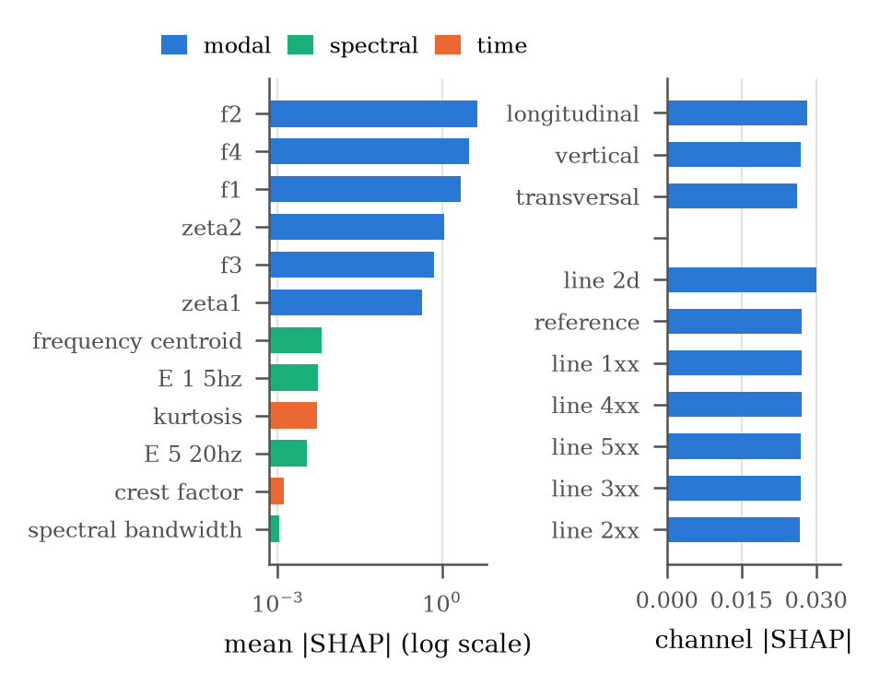
Fig. 4. Mean |SHAP| of the twelve most important features (left, log scale) and mean channel-level attribution by sensor group and direction (right), complete held-out LOSO sets
5.7. Digital-twin states and long-term monitoring
The LOSO ROC-AUC of XGBoost (0.629) is below the required 0.7, so the classifier term is excluded from the risk score (its grouped 5-fold ROC-AUC, 0.919, does not represent a new state of the bridge). With the gated score, 14 of 27 reference recordings and 29 of 126 altered recordings were not in the NORMAL state (mean risk 0.447 vs 0.196).
The higher mean risk of the reference recordings follows from B, the probability of a change within the last four records: it is 1 by construction for the first records of the sequence (scenario 01), the boundaries into the reference scenarios (01→02, 07→08) were detected, and scenarios whose entry boundary BOCPD missed (03, 12, 13, 14, 16, 17) score low; the score marks recent changes of state, not their severity.
In the EMS data of the one-year campaign [23] (5 652 usable hourly records, 1997-11-10 to 1998-09-10), the four modes were tracked in 99.7–100.0% of the records. A piecewise-linear temperature model fitted until 1998-07-01 explains R² = 0.859 of the f1 variance (slope below 0 °C: -0.104 Hz/°C). On the daily compensated frequencies, BOCPD raised 4 alarms in the training period, 0 between 1 July and 4 August 1998, and its first alarm after the start of the tests (5 August) on 1998-08-06 (delay 1 d); CUSUM raised 3 validation alarms and first alarmed on 1998-08-07 (Fig. 5).
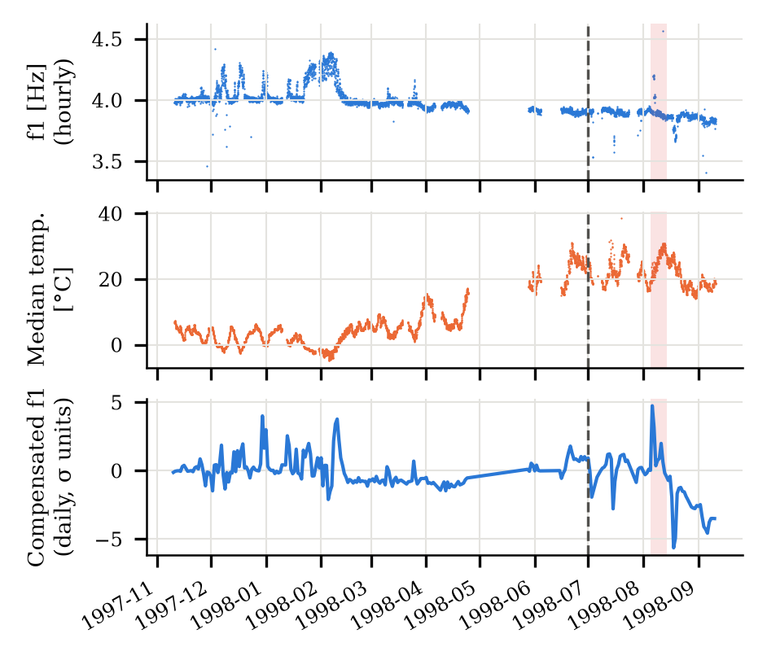
Fig. 5. EMS monitoring year: hourly f1, median temperature and daily temperature-compensated f1; dashed line: end of training period, shaded: onset window of the progressive damage tests
The final XGBoost model occupies 422 kB, was trained on 321 425 windows in 13.8 s and scores 1000 windows in 6.7 ms.
6. DISCUSSION
6.1. Interpretation of the results
With the true sampling rate, all setups and modal identification, the natural frequencies reproduce the known sensitivity of the Z24 bridge to the pier settlement and tendon interventions, and a detector that observes the sequence of states finds most state changes (BOCPD recall 0.625 at precision 0.833). The boundaries missed by both detectors (12→13, 13→14, 16→17) shifted f1–f3 by at most 0.44–0.86%, comparable to the setup-to-setup scatter within a scenario (median coefficient of variation 0.50% for f2 and 0.58% for f3), whereas every boundary found by both shifted at least one frequency by 0.93% or more.
The supervised stage shows why the evaluation protocol matters. ML models that reach ROC-AUC values up to 0.943 when other setups of a scenario are available for training fall to 0.759 (SVM) when the scenario is unseen, below the one-parameter frequency threshold (0.821), because the three reference states differ from each other as much as the smallest interventions. SHAP explains this: 99.8% of the attribution fell on the record-level modal features, so the classifier is in effect a nonlinear function of the natural frequencies that overfits the reference states. For a structure in service, where only its own baseline is known, change detection relative to that baseline is the more appropriate task: calibrated on the two pre-intervention measurements, the label-free novelty score reached a BA of 0.856 without damage labels. A classifier should enter the decision only after it passes a scenario-level validation criterion, which is what the gated risk score enforces.
6.2. Limitations
The labels describe the test protocol, not measured damage, and the three reference states are not identical. Only four modes could be tracked consistently, and damping could be estimated reliably for the first two. The prior of the sequence BOCPD (κ0) was changed after the default value was found to suppress new segments, and the monotone XGBoost variant, the frequency-decrease threshold and the novelty calibration were added after the first results; all are reported next to the original settings. The EMS mode shapes were not comparable across the year, so EMS modes were tracked by frequency only, and the damage onset is known only to within the dates of the test reports. The risk score marks recent changes rather than damage and is high for the first records of any sequence. The sensor layout in the dashboard is schematic and the twin contains no finite-element model.
7. CONCLUSIONS AND FUTURE WORK
This paper presented a digital-twin monitoring framework for bridges that couples modal identification, BOCPD, supervised classification, SHAP and a validation-gated risk score, and evaluated it reproducibly on all Z24 progressive-damage recordings. Natural frequencies from FDD tracked the interventions; sequence BOCPD detected state changes with precision 0.833 and recall 0.625; supervised ML classifiers of reference versus altered states generalised poorly to unseen scenarios (best ML LOSO ROC-AUC 0.759), below a natural-frequency threshold (0.821; 0.902 when only frequency decreases are counted, a post-hoc variant) and a label-free novelty score; and the gate kept the insufficiently validated classifier out of the fused risk score.
Future work will (1) calibrate the baseline-relative novelty score on longer baseline periods, (2) identify higher modes with stochastic subspace identification, (3) couple the twin to a finite-element model for localisation and (4) connect the dashboard to live sensor streams.
REFERENCES
[1] C.R. Farrar and K. Worden, “An Introduction to Structural Health Monitoring,” Philosophical Transactions of the Royal Society A, vol. 365, no. 1851, pp. 303–315, 2007, doi: 10.1098/rsta.2006.1928.
[2] K. Worden and J.M. Dulieu-Barton, “An Overview of Intelligent Fault Detection in Systems and Structures,” Structural Health Monitoring, vol. 3, no. 1, pp. 85–98, 2004, doi: 10.1177/1475921704041866.
[3] S.W. Doebling, C.R. Farrar, M.B. Prime, and D.W. Shevitz, “Damage Identification and Health Monitoring of Structural and Mechanical Systems from Changes in Their Vibration Characteristics: A Literature Review,” Los Alamos National Laboratory Report LA-13070-MS, 1996.
[4] E.P. Carden and P. Fanning, “Vibration Based Condition Monitoring: A Review,” Structural Health Monitoring, vol. 3, no. 4, pp. 355–377, 2004, doi: 10.1177/1475921704047500.
[5] O. Avci, O. Abdeljaber, S. Kiranyaz, M. Hussein, M. Gabbouj, and D.J. Inman, “A Review of Vibration-Based Damage Detection in Civil Structures: From Traditional Methods to Machine Learning and Deep Learning Applications,” Mechanical Systems and Signal Processing, vol. 147, p. 107077, 2021, doi: 10.1016/j.ymssp.2020.107077.
[6] R. Hou and Y. Xia, “Review on the New Development of Vibration-Based Damage Identification for Civil Engineering Structures: 2010–2019,” Journal of Sound and Vibration, vol. 491, p. 115741, 2021, doi: 10.1016/j.jsv.2020.115741.
[7] A. Malekloo, E. Ozer, M. AlHamaydeh, and M. Girolami, “Machine Learning and Structural Health Monitoring Overview with Emerging Technology and High-Dimensional Data Source Highlights,” Structural Health Monitoring, vol. 21, no. 4, pp. 1906–1955, 2022, doi: 10.1177/14759217211036880.
[8] L. Sun, Z. Shang, Y. Xia, S. Bhowmick, and S. Nagarajaiah, “Review of Bridge Structural Health Monitoring Aided by Big Data and Artificial Intelligence: From Condition Assessment to Damage Detection,” Journal of Structural Engineering, vol. 146, no. 5, 2020, doi: 10.1061/(ASCE)ST.1943-541X.0002535.
[9] M. Torzoni, M. Tezzele, S. Mariani, A. Manzoni, and K.E. Willcox, “A Digital Twin Framework for Civil Engineering Structures,” Computer Methods in Applied Mechanics and Engineering, vol. 418, p. 116584, 2024.
[10] D. Jones, C. Snider, A. Nassehi, J. Yon, and B. Hicks, “Characterising the Digital Twin: A Systematic Literature Review,” CIRP Journal of Manufacturing Science and Technology, vol. 29, pp. 36–52, 2020, doi: 10.1016/j.cirpj.2020.02.002.
[11] W. Kritzinger, M. Karner, G. Traar, J. Henjes, and W. Sihn, “Digital Twin in Manufacturing: A Categorical Literature Review and Classification,” IFAC-PapersOnLine, vol. 51, no. 11, pp. 1016–1022, 2018, doi: 10.1016/j.ifacol.2018.08.474.
[12] Z. Sun, S. Jayasinghe, A. Sidiq, F. Shahrivar, M. Mahmoodian, and S. Setunge, “Approach Towards the Development of Digital Twin for Structural Health Monitoring of Civil Infrastructure: A Comprehensive Review,” Sensors, vol. 25, no. 1, p. 59, 2025, doi: 10.3390/s25010059.
[13] A. Jiménez Rios, V. Plevris, and M. Nogal, “Bridge Management Through Digital Twin-Based Anomaly Detection Systems: A Systematic Review,” Frontiers in Built Environment, vol. 9, p. 1176621, 2023, doi: 10.3389/fbuil.2023.1176621.
[14] I.A. Nhamage, C.S. Horas, N.-S. Dang, J.A. Campos e Matos, and J. Poças Martins, “Strategies for Maximising the Value of Digital Twins for Bridge Management and Structural Monitoring: A Systematic Review,” Archives of Computational Methods in Engineering, vol. 32, pp. 4555–4586, 2025, doi: 10.1007/s11831-025-10280-1.
[15] M.M. Yousuf, T.J. Saravanan, and S.R. Dash, “Advancing Bridge Health Assessment and Management Through Digital Twins: A Comprehensive Review,” Structural Health Monitoring, 2026, doi: 10.1177/14759217251403381.
[16] R.S. Chaudhari, S. Nama, M.M. Narkhede, V.P. Bhangale, R.B. Gaikwad, and M.M. More, “Next Generation Vibration-Based Structural Health Monitoring for Bridges: A Systematic Review of AI, IoT, and Digital Twin Integrations,” Journal of Building Pathology and Rehabilitation, vol. 11, p. 136, 2026, doi: 10.1007/s41024-026-00810-0.
[17] M. Franciosi, M. Kasser, and M. Viviani, “Digital Twins in Bridge Engineering for Streamlined Maintenance and Enhanced Sustainability,” Automation in Construction, vol. 168, p. 105834, 2024, doi: 10.1016/j.autcon.2024.105834.
[18] Q. Lu, X. Xie, A.K. Parlikad, and J.M. Schooling, “Digital Twin-Enabled Anomaly Detection for Built Asset Monitoring in Operation and Maintenance,” Automation in Construction, vol. 118, p. 103277, 2020.
[19] S.M. Lundberg and S.-I. Lee, “A Unified Approach to Interpreting Model Predictions,” Advances in Neural Information Processing Systems, vol. 30, pp. 4765–4774, 2017.
[20] T. Chen and C. Guestrin, “XGBoost: A Scalable Tree Boosting System,” in Proceedings of the 22nd ACM SIGKDD International Conference on Knowledge Discovery and Data Mining, 2016, pp. 785–794, doi: 10.1145/2939672.2939785.
[21] R.P. Adams and D.J.C. MacKay, “Bayesian Online Changepoint Detection,” arXiv preprint arXiv:0710.3742, 2007.
[22] J. Maeck and G. De Roeck, “Description of Z24 Benchmark,” Mechanical Systems and Signal Processing, vol. 17, no. 1, pp. 127–131, 2003, doi: 10.1006/mssp.2002.1548.
[23] B. Peeters and G. De Roeck, “One-Year Monitoring of the Z24-Bridge: Environmental Effects versus Damage Events,” Earthquake Engineering & Structural Dynamics, vol. 30, no. 2, pp. 149–171, 2001, doi: 10.1002/1096-9845(200102)30:2<149::AID-EQE1>3.0.CO;2-Z.
[24] C.R. Farrar, H. Sohn, G. Park, et al., “A Statistical Pattern Recognition Paradigm for Structural Health Monitoring,” in Proceedings of the 9th ASCE Specialty Conference on Probabilistic Mechanics and Structural Reliability, 2004.
[25] H. Sohn, C.R. Farrar, F.M. Hemez, J.J. Czarnecki, D.D. Shunk, D.W. Stinemates, and B.R. Nadler, “A Review of Structural Health Monitoring Literature: 1996–2001,” Los Alamos National Laboratory Report LA-13976-MS, 2004.
[26] M.M.R. Taha, A. Noureldin, J.L. Lucero, and T.J. Baca, “Wavelet Transform for Structural Health Monitoring: A Compendium of Uses and Features,” Structural Health Monitoring, vol. 5, no. 3, pp. 267–295, 2006, doi: 10.1177/1475921706067741.
[27] E. Figueiredo, G. Park, C.R. Farrar, K. Worden, and J. Figueiras, “Machine Learning Algorithms for Damage Detection under Operational and Environmental Variability,” Structural Health Monitoring, vol. 10, no. 6, pp. 559–572, 2011, doi: 10.1177/1475921710388971.
[28] A. Santos, E. Figueiredo, M.F.M. Silva, C.S. Sales, and J.C.W.A. Costa, “Machine Learning Algorithms for Damage Detection: Kernel-Based Approaches,” Journal of Sound and Vibration, vol. 363, pp. 584–599, 2016.
[29] B. Peeters and G. De Roeck, “Reference-Based Stochastic Subspace Identification for Output-Only Modal Analysis,” Mechanical Systems and Signal Processing, vol. 13, no. 6, pp. 855–878, 1999, doi: 10.1006/mssp.1999.1249.
[30] J. Maeck, B. Peeters, and G. De Roeck, “Damage Identification on the Z24 Bridge Using Vibration Monitoring,” Smart Materials and Structures, vol. 10, no. 3, pp. 512–517, 2001, doi: 10.1088/0964-1726/10/3/313.

