QUANTIZATION-AWARE KOLMOGOROV-ARNOLD GRAPH NEURAL NETWORKS FOR MOLECULAR TOXICITY PREDICTION WITH EXPLAINABLE AI

ABSTRACT

Molecular toxicity prediction is critical to uncovering potentially dangerous chemicals and their effects on biological systems. The challenge to reliably predict molecular activity by computation is still difficult since the activity of a molecule is related to the complicated molecular patterns and interactions that are hard to be captured through conventional molecular representations. In addition, there are several toxicity endpoints with very skewed class distributions that makes accurate and consistent prediction difficult. Current graph neural network (GNN) methods suffer, however, from limitations in the ability to encode complex molecular structures, the requirement for very imbalanced toxicities data and computational efficiency for deployment. To solve these problems, a novel multi-task molecular toxicity prediction network, namely Explainable and Quantization-Aware Kolmogorov-Arnold Graph Convolutional Network (EQ-KA-GCN), is proposed. The proposed approach is a mixture of molecular graph representations and a 1200-dimensional chemical feature vector from Morgan fingerprints, MACCS keys, and physicochemical descriptors, which complement each other to provide different chemical and structural information. It was tested against the Tox21 benchmark set of 7,831 molecules in 12 biological assay endpoints. To alleviate class imbalance, asymmetric loss was applied, and to decrease the memory usage of the model, adaptive layer-wise quantization-aware training was used. The proposed Fused ASL KA-GCN obtained a macro ROC-AUC of 0.8167 and accuracy rate of 91.39%. After the threshold calibration per endpoint, the model had been reached a 71.14% balanced accuracy, 46.56% precision, 47.34% recall, 0.4359 F1 score and 0.4150 MCC. The Adaptive QAT variant had 1.365× compression and a 26.75% reduction in model size, from 1231.8 KB down to 902.3 KB, and a ROC-AUC of 0.8087. The simulated quantization-aware model had a inference time of 0.219 ms per sample is measured. The results show that EQ-KA-GCN can integrate the molecular graph representation, imbalance learning, chemical feature fusion, explainability, and adaptive quantization into a single framework for multi-endpoint molecular toxicity prediction.

1.INTRODUCTION
Early identification of potentially harmful compounds is an important task in computational toxicology, and can contribute to drug discovery, to chemical safety assessment, and to the prioritisation of experiments. Traditional in vitro and in vivo toxicity studies are time-consuming, expensive and labor-intensive. Tox21 yielded high throughput toxicity data, which has since been adopted as a benchmark for computational prediction of toxicity [1],[2].
Most early computational methods were based on molecular fingerprints, structural keys, and physicochemical descriptors. Here deep learning has been shown to be capable of toxicity prediction in the Tox21 dataset [2]. Combined with a molecular representation that avoided full dependence on molecular fingerprints, molecular graph convolution methods facilitated the ability of models to learn molecular representations from atoms and bonds [3], [4].
To enhance the representation learning of molecules, graph neural networks (GNNs) were introduced to propagate information between neighbouring atoms. The general framework for this was offered by the Message Passing Neural Networks [5] and the standardized molecular learning benchmarks provided by MoleculeNet [6] including Tox21. It was also demonstrated that molecular representations can be learned to give supplementary information to traditional descriptors [7], and PotentialNet can predict molecular properties using graphs in various datasets [8].
There are several endpoints in Tox21 that are highly imbalanced, making it difficult to predict toxicity. Semi-supervised GCNs have been explored in the context of toxicity prediction [9] and conformal prediction has been studied in terms of prediction uncertainty [10]. More recent studies explore equivariant GNNs, multitask learning and transfer learning for toxicity and molecular property prediction [15]–[17].
Another interesting direction is the incorporation of several molecular representations. Molecular graphs represent structural connectivity, fingerprints and physicochemical descriptors are complementary pieces of chemical information. In recent years, multimodal methods have been shown to be effective in using various molecular representations for toxicity prediction [18, 19]. For instance, MoltiTox integrates molecular diagrams, SMILES and 2D images with the information from the ^13C NMR and assesses the framework on the 12 Tox21 endpoints.
Another way to approximate nonlinear functions is by using Kolmogorov–Arnold Networks (KANs). Li et al. added the KAN modules to the GNNs and tested the performance of KA-GNNs on the molecular benchmarks Tox21 [20] to obtain KA-GNNs.
Another important challenge in multi-task toxicity prediction is the class imbalance. An idea is proposed in very imbalanced multi-label classification of easily classifiable negative samples to reduce its impact by using the asymmetric loss (ASL) [22]. Explainability is also important because, researchers would like to know which substructures in the molecules relate to predicted toxicity. There are a number of ways to interpret the prediction made by a GNN [11, 13, 14] in the form of a GNN Explainer and chemistry-based explanation techniques.
Last but not least, small molecule screening efficiency. To reduce the amount of memory required and the complexity of calculations, quantization could be done. Recently, Rasool et al. [21] investigated the quantized GNNs in the context of molecular property prediction and demonstrated the reduced precision models effectiveness.
Therefore, present an Explainable and Quantization-Aware Kolmogorov–Arnold Graph Convolutional Network (EQ-KA-GCN) for the multi-task molecular toxicity prediction in this work. It relies on 1200D chemical feature vector (1200D Morgan fingerprints, MACCS keys and physicochemical descriptors) and molecular graphs. The graph branch is trained with molecular structure information and a Fourier-based KAN is trained after the feature fusion to model a nonlinear relationship. Asymmetric Loss deals with class imbalance, endpoint-specific threshold calibration enhances final classification judgment, GNNExplainer offers molecular-level explanation, while adaptive layer-wise quantization-aware training decreases model-storage requirements.Main Contributions
- Multimodal representation: Molecular graph with a 1200-dimensional chemical feature vector for chemical feature extraction.
- KAN based modeling: A nonlinear relationship is modeled using a Fourier-based KAN in the fused representation.
- Asymmetric Loss for multi-task toxicity prediction: Imbalance-aware learning.
- Threshold calibration: endpoints specific thresholds are applied rather than only 0.50.
- Explainability: GNN Explainer is embedded to find influential molecular structures.
- Quantization: To minimize the model-storage, adaptive layer-wise QAT is used in the quantization process.
2.LITERATURE SURVEY
Traditional experimental toxicity evaluation has taken a lot of time, cost and laboratory resources. Molecular toxicity prediction has been receiving increasingly more attention. Consequently, recent studies were focused on machine learning and deep learning models that could learn the structure-bioactivity relationships from large chemical datasets. The literature had slowly shifted from descriptor- and fingerprint-based approaches toward graph neural networks (GNNs), multitask learning, multimodal representations, explainable models and lightweight architectures.
In early toxicity prediction, the molecular descriptors and fingerprints were the main elements used. As shown by Mayr et al. [2] deep learning is a powerful method for Tox21 prediction. Later, Kearnes et al. [3] and Duvenaud et al. [4] introduced methods to directly learn from molecular structure by using molecular graph convolution techniques. To facilitate molecular learning, both the Message Passing Neural Network (MPNN) framework was introduced by Gilmer et al. [5] and standardized molecular machine-learning benchmarks were introduced by MoleculeNet by Wu et al. [6]. Yang et al. [7] demonstrated the usefulness of learned molecular representations in addition to the traditional molecular descriptions, and Feinberg et al. [8] provided an extension to graph-based molecular prediction using PotentialNet.
The importance of GNNs for toxicity prediction is due to the fact that molecules can be naturally graphically represented. Chen et al. [9] studied semi-supervised GCN learning for the 12 Tox21 toxicity endpoints. Zhang et al. [10] explored the conformal prediction for toxicity using deep-learning and addressed uncertainty in molecular predictions.Cremer et al. [15] explored equivariant GNNs for Tox21, ToxCast, SIDER, and ClinTox toxicity prediction. Multitasking and transfer-learning techniques have also been explored for forecasting when there are only limited data available for individual toxicity tasks, as done by Lin et al. [16] and Buterez et al. [17].
In 2025, a further study proposed a method called JLGCN-MTT for small-scale toxicity prediction and carried out a joint learning and transfer learning (JLTL) on the 12 Tox21 toxicity tasks. There is complementary information contained in the various molecular representations, graphs representing atomic-bond connectivities, fingerprints indicating structural substructures and physicochemical descriptors relating to global chemical properties.
Kengkanna and Ohue [18] studied several molecular graph representations. Park and Lee [19] also followed this trend by creating MoltiTox, which incorporated a graph, SMILES, 2D images, as well as the ^13C NMR spectra for the prediction of Tox21. The outcomes of this indicate the value of multi-modality molecular information in toxicity prediction.The proposed EQ-KA-GCN is based on this concept: it is formed by a fusion of learned graph information, Morgan fingerprints, MACCS keys, and physicochemical descriptors.
KANs are a type of learnable nonlinear functions that can be used instead of the conventional neural-network transformations. KA-GNNs were proposed by Li et al. [20] by adding the KAN modules to the graph-learning parts and tested them with seven molecular benchmarks on KA-GCN and KA-GAT.
But the current KA-GNN framework lacks the aspects addressed in this work, such as multimodal chemical features, asymmetric loss, endpoint-specific threshold calibration, GNN explainability and adaptive quantization-aware training.Often there are many fewer positive samples than negative samples in toxicity datasets. Standard accuracy can then be only a partial measure of the detection of minority classes. To overcome this issue, Ridnik et al. [22] suggested a method named ASL that distinguishes between positive and negative samples.
To gain interpretability, Ying et al. [11] proposed GNN Explainer to find out key graph structures and node features that affect the prediction. In addition, Wu et al. [13] and Amara et al. [14] discussed approaches to explanation in chemistry and chemically meaningful molecular substructures. Many GNN models are large and require significant storage and computation. The process of quantization is a way of compressing the size of a model and its accuracy.
Rasool et al. [21] explored quantized GNN models for molecular property predictions based on reduced precision representations. The study demonstrates the potential of quantization for improving the efficiency of molecular GNN.S.Jacob et al. [23] suggested quantization-aware training strategies to obtain efficient inference of low precision neural networks.
Table 1: Comparison between existing methods
Ref. | Study | Method | Dataset | Main Contribution | Limitation relevant to EQ-KA-GCN
[2] | Mayr et al. | Deep Tox | Tox21 | Deep learning for toxicity prediction | Mainly descriptor-based representation
[8] | Feinberg et al. | PotentialNet | Tox21 | Graph-based molecular prediction | Does not jointly address imbalance, KAN, explainability and compression
[9] | Chen et al. | Semi-supervised GCN | Tox21 | Semi-supervised toxicity prediction | No KAN, multimodal fusion or adaptive QAT
[15] | Cremer et al. | Equivariant GNN | Tox21,  ToxCast,  SIDER,  ClinTox, | 3D-aware toxicity prediction | Higher representation complexity
[19] | Park and Lee | MoliTox | MolecularNet including Tox21 | Multimodal toxicity prediction | Does not integrate KAN, ASL and adaptive QAT
[20] | Li et al. | KA-GCN,  KA-GCT |  | KAN-based molecular GNNs | Does not provide the complete EQ-KA-GCN pipeline
Proposed | EQ-KA-GCN | KA-GCN+ multimodal features + ASL + GNNExplainer + adaptive QAT | Tox21, 12 Endpoints | Unified graph, chemical-feature, imbalance-aware, explainable and quantization-aware toxicity prediction | -
2.1 RESEARCH GAP:
Most of the GNN toxicity models are based on molecular graph representations while ignoring complementary fingerprints and physicochemical descriptors. In EQ-KA-GCN, the molecular graph representation is coupled with a 1200-dimensional chemical feature vector, which includes Morgan fingerprints, MACCS keys and physico-chemical descriptors.
Nonlinear modeling gap: The integration of multimodal toxicity representations with molecular GNNs, based on KAN, has not been well studied. This is addressed by adding a Fourier-based KAN after feature fusion to model the complex nonlinear relationship between the fused molecular representations and toxicity responses.
Imbalance gap: Highly imbalanced Tox21 endpoints call for imbalance-aware learning and the fitting choice of decision thresholds. This deficit is mitigated during training by the use of Asymmetric Loss (ASL) and at the end point by using threshold calibration to make the classification decisions more appropriate.
Explainability gap: The current methods of explanation are not commonly coupled with toxicity prediction, KAN model and model compression. To fill this gap, they use GNNExplainer to recognize influential atoms, bonds and substructures in the molecular graph relevant to the model predictions.
Efficiency gap: Most research about quantized GNNs has been conducted for molecular property prediction and not for multi-task toxicity classification. This gap is compensated by the adaptive layer-wise quantization-aware training (QAT) method that alleviates the need for a large amount of model storage and maintains predictiveness.
Limited integration gap: The unified framework of graph learning with chemical-feature fusion and KAN with ASL with threshold calibration with GNNExplainer with adaptive QAT is still limited. The lack of this is filled by embedding these into a single multi-task Tox21 toxicity-prediction framework.
To tackle the aforementioned challenges, EQ-KA-GCN is introduced, integrating complementary molecular representations, nonlinear KAN modeling, imbalance-aware training, end-point-specific threshold calibration, molecule-level interpretability, and adaptive KA training into a unified framework for multi-task Tox21 toxicity prediction.
3 PROPOSED METHODOLOGY
For multi-task molecular toxicity prediction, the proposed EQ-KA-GCN architecture is described. Figure 1. represents this proposed methodology.
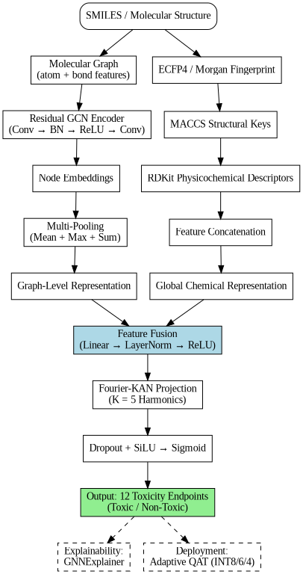

Fig.1. Proposed Methodology

3.1 DATASET
The proposed method was validated on the Tox21 molecular toxicity benchmark dataset, a widely used resource for chemical toxicity prediction. After removing molecules that could not be converted into valid molecular representations 7,823 valid molecules were kept for experimentation.
The dataset comprises 12 binary toxicity endpoints, grouped in two biological panels:
Nuclear Receptor (NR) panel (7 endpoints)
Stress Response (SR) panel (5 end points)
The multi-task target vector for each molecule i is defined as:
$Y_{i}=[y_{1},y_{2},y_{3},.......y_{12}]$ $y_{it}∈ \{0,1\}$ (1)

Where $y_{it}$ =1 is a positive toxicity assay label for endpoint t and ${\text{y}}_{\text{it}}\text{=0}$ denotes a negative label.
A training, validation and testing set was created using an 80:10:10 ratio of the complete data set.
Table 2: 12 Endpoint Details:
Panel | Endpoint | Description
Nuclear Receptor (NR) | NR AR | Androgen receptor
Nuclear Receptor (NR) | NR AR LBD | Androgen receptor ligand binding domain
Nuclear Receptor (NR) | NR AhR | Aryl hydrocarbon receptor
Nuclear Receptor (NR) | NR Aromatase | Aromatase
Nuclear Receptor (NR) | NR ER | Estrogen receptor
Nuclear Receptor (NR) | NR ER LBD | Estrogen receptor ligand binding domain
Nuclear Receptor (NR) | NR PPAR γ | Peroxisome proliferator activated receptor gamma
Stress Response (SR) | SR ARE | Antioxidant response element
Stress Response (SR) | SR ATAD5 | DNA damage/stress response
Stress Response (SR) | SR HSE | Heat shock response
Stress Response (SR) | SR MMP | Mitochondrial membrane potential
Stress Response (SR) | SR p53 | p53 stress response

The multi-task learning framework enabled a common molecular representation for all 12 endpoints. The design allowed the model to make use of the commonalities of related biological assays while keeping the prediction output separate for each endpoint. It is formulated in such a way that it helps in improving the level of generalization by leveraging the relationship between the toxicity endpoints.
3.2 MOLECULAR GRAPH AND FINGERPRINT GENERATION

3.2.1. MOLECULAR GRAPH APPRAOCH
Every valid SMILES string was converted to an undirected molecular graph in the form of Eq.(2) with help of RDKit.
$G=(V,E),$ (2)
This is in reference to the set of atoms V and the set of chemical bonds E.
The molecule containing N atoms, the node-feature matrix was defined as given in Eq.(3)
$X={[x_{1},x_{2},x_{3}, ......,x_{n}] }^{T}ℰ R^{N × F}$ ,F=32 (3)
For a molecule containing N atoms, the node-feature matrix was defined as: There were 13 indicators of atomic symbols, 6 indicators of hybridization, 6 indicators of degrees, and 7 scalar physicochemical descriptors per atom feature vector. thus
32=13+6+6+7.

Six descriptors that represented the bond information using four bond type indicators, conjugation status, and ring membership were used:
$$e_{uv}∈R^{6}$$

The following are the descriptors that were retained in the molecular graph representation: The graph connectivity matrix/edge index was used to represent the topology of the GCN. The implementations that follow the standard GCNConv operation propagate according to the connectivity of the graph and don't explicitly accept the 6 dimension edge feature vector.

Table 3. Molecular Feature Configuration

Component | Feature composition | Dimension
Bond descriptors | Bond type (4) + conjugation (1) + ring membership (1) | 6
ECFP4/Morgan fingerprint | Radius = 2 | 1024
MACCS fingerprint | Structural keys | 166
Physicochemical descriptors | Molecular-level descriptors | 10
Global fingerprint | ECFP4 + MACCS + physicochemical descriptors | 1200

3.2.2. GLOBAL MOLECULAR FINGERPRINT
The local graph representation was concatenated with three global molecular descriptors: a 1024-bit ECFP4/Morgan fingerprint, a 166-bit MACCS fingerprint and 10 physicochemical descriptors.. So the molecular representation for the whole molecule was set to be:
$f=[ f_{ECFP4} ∥ f_{MACCS} ∥ f_{phys}] ∈ℝ^{1200}$ (4)
The local connectivity and atom level information were reflected by the graph representation, while the information about the whole molecule structure was reflected by the global fingerprint.
3.3 PROPOSED NETWORK ARCHITECTURE

3.3.1 RESIDUAL GRAPH ENCODER
The molecular connectivity is then normalized for the spectral graph convolution. As in Eq. (4) the self-connections are added to the adjacency matrix A . given in Eq.(5)
$\tilde{A}=A+I_{N}$ (5)
here is identity matrix. The degree matrix of the corresponding matrix is

${\tilde{D}}_{ij}= \sum_{j=1}^{N}{{\tilde{A}}_{ij}}$ (6)

Adjacency matrix for message passing in the given Eq,(6) that is symmetric and normalized.
$\hat{A}$ = ${\tilde{D}}^{−1/2} \tilde{A }{\tilde{D}}^{−1/2}$ (7)
A graph convolution layer was used to transform the node representations based on.
${ H}^{(l+1)}=σ(\hat{A} H^{(l)}W^{(l)}+ b^{(l)}$) (8)
Where $H^{(l)}$ represents the representation of the node at the layer $l$ and $W^{(l)}$and $b^{(l)}$ are learnable parameters, and $σ$ $(.)$ is a non-linear activation function. For an individual node $v_{i}$ , the update of Eq.(8) can equivalently be expressed at the node levels given in Eq(9).
$h_{v}^{(l+1)}=σ(\sum_{uϵN(v)∪\{v\}}{\frac{1}{\sqrt{\tilde{D_{vv}}\tilde{D_{uu}}}}}$ $h_{u}$($l)w^{(l)}$ + $b^{(l)}$) (9)
The atoms $N(v$) in here are those that are directly attached to atom $v$ so that the information for each of the node representations contains information from the neighboring atoms. Two of these graph convolution layers are cascaded followed by batch normalization, ReLU activation, dropout, and a residual connection between the two layers as shown in Eq. (10) and Eq. (11).

$H_{1}= Dropout (ReLU(BN(GCNConv_{1}(X,E))))$ (10)
$H_{2}=ReLU(BN(GCNConv_{2}(H_{1},E))+H_{1})$ (11)
In this case,$GCNConv_{1}\left(.\right)$, $GCNConv_{2}\left(.\right)$, implement the Eq. (8)-(10), and $BN\left(.\right)$represents batch normalization. The additive term $H_{1}$ in Eq. (11) creates a residual connection to reduce over-smoothing and to stabilize flow of gradient over the two-hop receptive field.
3.3.2 MULTISCALE READOUT AND CROSS-MODAL FUSION
The atom-level representations after graph convolution are shown below
$H={[h_{1},h_{2},h_{3}, ......,h_{n}] }^{T}$, are summarized into the graph level representation with three complementary graph level pooling operators. The mean pooling is defined as in given in Eq. (12).

The Mean pooling is defined as:
$h_{mean}= \frac{1}{N} \sum_{i=1}^{N}{h_{i}}$ (12)
Max pooling is defined element-wise as:
$h_{max}= \max_{1≤i≤N}{h_{i}}$ (13)
The Sum pooling is :
$h_{sum}=\sum_{i=1}^{N}{h_{i}}$ (14)
here,​ $h_{mean}$ represents the average chemical signature of the molecule, $h_{max}$​ represents the most activated "hotspot" atom of the potential toxicophore and $h_{sum}$ represents a size-aware aggregate. The three representations are glued together in Eq. (15).
$z_{graph} = h_{mean}∥ h_{max}∥ h_{sum}$ , $dim{ (z}_{graph})= 3H$ (15)
here, $\text{H}$ indicates the underlying dimension for each of the pooled representations. This topological summary is ${\text{z}}_{\text{graph}}$ fused with the global fingerprint $\text{f}\text{ ∈}{\text{R}}^{\text{1200}}$ of Eq. (4) by concatenation and projected back to ${\text{R}}^{\text{H}}$ as given in Eq. (16).
$h= ReLU(LayerNorm(W_{proj}[z_{graph}||f] + b_{proj}))$ (16)
here, $W_{proj} ,z_{graph}$ are fusion parameters that are learned. This hybrid fusion enables the classifier to learn both graph-topological features and fixed bits of the fingerprint obtained from pre-learned chemistry-informed patterns (e.g., known toxicophore substructure alerts, coded in the MACCS keys .so that the network is not restricted to patterns that are visible from graph connectivity alone).
3.3.3 FOURIER-KAN CLASSIFIER HEAD
The fused representation h is given to a Fourier based Kolmogorov–Arnold Network (Fourier-KAN) layer instead of a typical multilayer perceptron (MLP) classifier. A learnable univariate edge function is parameterized by a finite Fourier expansion, given in Eq. (17)
$ϕ(x) = wx+\sum_{k=1}^{K}{[a_{k} cos(kx) +b_{k} sin(kx)]+c}$ (17)
In this case, a linear coefficient $w$, and $a_{k}$​,​$b_{k}$ Fourier coefficients, are learnable;harmonic $index k$ and $c$ is a bias term, and $K$ is the number of Fourier harmonics used. The complete Fourier-KAN mapping for an input unit mapped to an output unit of dimension dimensional is a generalization of Eq. (17) to Eq. (18).
${ y}_{o}=\sum_{i=1}^{d_{in}}{[w_{o,i}x_{i}+\sum_{i=1}^{d_{in}}{\sum_{K=1}^{K}{a_{o,i,k} cos(kx_{i })+ b_{o,i,k} sin(kx_{i})}}}$]$+c_{o}$ (18)

Here, ${\text{x}}_{\text{i} }$ denotes the i th input feature , ${\text{w}}_{\text{oi}}$ is a linear coefficient, ${\text{a}}_{\text{o}\text{,}\text{i}\text{,}\text{k}} \text{and} {\text{b}}_{\text{o}\text{,}\text{i}\text{,}\text{k}}$ are learnable Fourier coefficients, and ${\text{c}}_{\text{o}}$ is the output bias term In the proposed implementation, five harmonics are used (K=5). Applying Eq. (16)–(17) to the fused representation h gives Eq. (19)–(20).
$u=ϕ_{KAN}(h), \acute{u}$=Dropout(SiLU(u)) (19)
$z=W_{out} \acute{u}+b_{out} ∈ ℝ^{\begin{aligned}12 \\ \end{aligned}}$ (20)
The Fourier-KAN layer in this case is denoted as ${\text{ϕ}}_{\text{KAN}}\text{(.) }$ in Eq.(19) and SiLU(.) represents the activation function; the 12 raw endpoint logits are $\text{z}$ one per Tox21 task. The probability of each task is calculated independently with the help of the sigmoid function, which is presented in the following equation given in Eq.(21).
${ p}_{t}=σ(z_{t}$) =$\frac{1}{1+e^{−z_{t} }},t=1,....,T$ (21)
Thus, the complete multi-task prediction vector is $P=[p_{1},p_{2},....,p_{n}]$ in fact the sigmoid of Eq. (20) only at inference /probability-reporting time while the training objective is left in the logit space for numerical stability. Most of this is the model's main architectural novelty: it renders a fixed pointwise nonlinearity learned per-neuron harmonic decision boundary, which is hypothesized to be more suitable to capture the non-smooth structure–toxicity mapping triggered by discrete toxicophores, while introducing only two additional parameter tensors (${\text{a}}_{\text{o}\text{,}\text{i}\text{,}\text{k}} \text{and} {\text{b}}_{\text{o}\text{,}\text{i}\text{,}\text{k}}$) per layer compared to a standard linear layer.

3.4 ADAPTIVE LAYER WISE QUANTIZATION TRAINING
In order to minimize the memory and inference overhead of the model for low-resource edge deployments, the model is subjected to three-stage Adaptive QAT procedure.
Phase1–Calibration: A MinMaxObserver keeps track,$T$={conv1,conv2,fourier_kan,fc_out} for each layer ℓ, of the running minimum, maximum, mean and variance of its activations in B calibration mini-batches, providing a statistic on the range of activations for each layer, as given in Eq.(22): .
$R_{l}=max(x_{l})−min(x_{l})$ (22)
Here ${\text{x}}_{\text{l }}\text{ means observed activation tensor of layer l.}$
Phase 2 – Adaptive Bit Assignment Layers are ranked in descending order of ${\text{R}}_{\text{l}}$​ (larger dynamic range translates to more sensitive to coarse quantization) and are partitioned into three precision tiers from the set of supported bits width $\text{B}$={4,6,8} as given in Eq.(23).
$b^{l }=\left\{\begin{aligned}8 , rank(l) in top 35\% by R_{l} \\ 6, rank(l) in next 35\% \\ 4, remaining 30\%\end{aligned}\right.$ (23)

The uniform symmetric quantization generates a scale for a floating-point weight $\text{w}$ in a layer that has been assigned bit-width $\text{b}$ using Eq. (24) and Eq. (25).

$α=max |w|$ (24)

$s=\frac{α}{2^{b−1}−1}$ (25)
The quantized parameter is an integer-valued parameter. Is given in Eq.(26)

$q(w)=clip(round(\frac{w}{s}), −q_{max} ,q_{max}$) (26)

Where $q_{max}=2^{b−1} −1$

The quantized parameter is re-generated in floating point as described in Eq. (27).

$\hat{w} = s.q(w)$ (27)

Phase 3 — QAT Injection Each target layer has its weight tensors wrapped up with a fake-quantization module that mimics the Eq. (24)-(27) operation. The weights are quantized (during each forward pass) before the computation for the layer is done. The forward pass "$\hat{\text{w}}$ " in the Straight-Through Estimator, the forward pass uses the quantized weight “w” directly; however, since the true derivative of round(∙) is approximately zero almost everywhere, the backward pass instead substitutes the identity gradient, as presented in Eq. (28).

${\hat{\text{w}}}_{\text{STE}}\text{=}\text{w}\text{ +}\text{sg}\text{[}\hat{\text{w}}\text{-}\text{w}\text{]}$ ( 28)
here, $\text{sg}\left[\text{∙}\right]$ denotes the stop-gradient operator, which enables training the network end-to-end, as it would be if it was already running at mixed low precision.
Compression accounting. The size of the model trained under full precision is compared to the number of parameters assigned to the mixed precision scheme as in Eq.(29) when given Pℓ parameters in layer ℓ.
$S_{FP32}=\frac{32 \sum_{l}{P_{l}}}{8192} KB , S_{Q}=\frac{ \sum_{l}{{b_{l}P}_{l}}}{8192} KB , CR=\frac{S_{FP32}}{S_{Q}}$ (29)
In memory reduction reported as ($1−{S_{Q}}/{S_{FP32}})×100\%$

3.5 CLASS-IMBALANCE-AWARE OPTIMIZATION
Given the severe negative-to-positive ratio typical of individual Tox21 endpoints, training minimizes the total Asymmetric Loss objective for a binary toxicity task with target $y_{t}$ $∈ \{0,1\}$ and predicted probability $p_{t}=σ{(z}_{t})$,the asymmetric loss is given in Eq.(30).
$ℒ_{ASL}= −{y_{t}(1−p_{t})}^{γ_{+}}log(p_{t})−(1−y_{t}){{\hat{p}}_{t}}^{γ_{−}}$ log(1$− {\hat{p}}_{t})$ (30)
The contribution of easily classified negative samples is reduced by applying a probability margin before calculating the negative-branch term as given in Eq.(31)
${\hat{p}}_{t}=clip(p_{t} − m,0,1−$ $ℰ$) (31)
Here, m = 0.05 is the probability margin (so that any sample ${\text{p}}_{\text{t}}\text{≤ }\text{m}$ is in the confidently -negative class, the loss and gradient are both zero) , $\text{E}$ is a small constant to prevent log(0),${\text{γ}}_{\text{+}}\text{=0.0}$, leaves the positive -class gradient unattenuated, and,,${\text{γ}}_{\text{-}}\text{=}$3.0 strongly attenuates the gradient of easy -negative samples. The total loss is the task-averaged asymmetric loss for the 12 multi-task toxicity endpoints given in Eq(32).
$ℒ = \frac{1}{T} \sum_{t=1}^{T}{ℒ_{ASL}^{(t)}}$ (32)
$w_{t}=min(\frac{N_{t}^{−}}{N_{t}^{+}},w_{max}), w_{max}=30$ (33)
.Here ${\text{N}}_{\text{t}}^{\text{+}} \text{and}$ ${\text{N}}_{\text{t}}^{\text{−}}$ the counts of negative and positive labels for task t are taken from the training split and are clamped $w_{max}$ to prevent gradient instability on extremely rare endpoints. All these configuratio to prevent gradient instability on endpoints that appear extremely rarely. All of these settings—from Eq.(30) to Eq.(33)—are combined and referred to as the Balanced-Margin Asymmetric Loss (BM‑ASL). The network is trained with AdamW using a learning rate ${\text{10}}^{\text{-3}}$ and a batch size of 64 for, up to 60 epochs. Early stopping is applied with a patience of 15 epochs, based on the validation macro‑F1.
Table 4. Optimization Hyperparameters.
Hyperparameter | Value
Optimizer | AdamW
Learning rate | 10⁻³
Weight decay | 10⁻⁴
Batch size | 64
Max epochs | 60
Early-stopping patience | 15 epochs (monitored on validation macro-F1)
ASL margin m | 0.05
ASL γ₊ / γ₋ | 0.0 / 3.0
Per-task weight cap w_{max} | 30

3.6 DECISION THRESHOLD CALIBRATION
Rather than relying on the default fixed threshold of τ = 0.5, the best threshold (in the presence of class imbalance) for each of the endpoints is determined through an exhaustive grid search over the interval of τ = [0.05, 0.95] in steps of 0.02, to obtain an optimum threshold vector for each of the endpoints, whose value maximizes the F1 score for each endpoint, as per Eq. (34).

$τ_{t}^{∗ }=arg \max_{ τ}{ {F1}_{t}}($ $τ$), $t=1,.....T$ (34)

here, ${\text{F}\text{1}}_{\text{t}}\text{ ( }\text{τ}\text{) }$ represent F1-score of endpoint t in decision threshold $\text{τ}\text{.}$ The calibrated threshold vector ${\text{τ}}^{\text{*}}$= [${\text{τ}}_{\text{1}}^{\text{*}}\text{ , .......}{\text{τ}}_{\text{12}}^{\text{*}}\text{]}$ is preserved and used both at test time and during live inference

3.7 EXPLAINABILITY VIA GNNEXPLAINER
Attributions for individual predictions are produced by learning continuous masks over the molecular graph of a trained, frozen model. Let ${\text{M}}_{\text{X}}\text{ ∈ }{\text{[0,1]}}^{\text{N}\text{ ×32}}$ be the node-feature mask and ${\text{M}}_{\text{A}}\text{ ∈ }{\text{[0,1]}}^{\text{|}\text{E}\text{|}}$ be the edge (adjacency) mask. The masked graph is represented as in Eq. (35).
${\text{G}}_{\text{M}}\text{=(}\text{A}\text{ ⨀ }{\text{M}}_{\text{A}}\text{ , }\text{X}\text{ ⨀ }{\text{M}}_{\text{X}}\text{)}$ (35)
The element-wise multiplication is denoted by where $\text{⨀}$ .The following explanation is designed to keep both the model's representation on the original graph unchanged and to keep the length of the explanation as short as possible, using the same general optimization objective as in Eq. (36).
$\underset{{\text{M}}_{\text{A} }\text{,}{\text{M}}_{\text{X}}}{\text{min}}{{\text{L}}_{\text{pred}}\text{(}\text{f}\text{(}{\text{G}}_{\text{M}}\text{),}\text{f}\text{(}\text{G}\text{))+}{\text{λ}}_{\text{A}} \text{R}\text{(}{\text{M}}_{\text{A}}\text{)+}{\text{λ}}_{\text{X}}\text{R}\text{(}{\text{M}}_{\text{X}}\text{))}}$ (36)
here, $\text{f}\left(\text{∙}\right)$ is the trained KA-GCN model, ${\text{L}}_{\text{pred}}$ is the discrepancy between the prediction on the original graph and the prediction on the masked graph ${\text{G}}_{\text{M}}$ , $\text{R}\left(\text{∙}\right)$and the sparsity and regularization term on the learned masks. Under the proposed implementation, $\text{R}\left(\text{∙}\right)$ combines an ${\text{l}}_{\text{1}}$​ sparsity penalty in addition to a binary entropy penalty on the mask values, which is as given by Eq. (37).
$\text{ R}\text{(}\text{M}\text{) = }{\text{||}\text{M}\text{||}}_{\text{1}}\text{ -}{\text{λ}}_{\text{H}}\sum{\text{M} \text{log}\text{(}\text{M}\text{ + ∈ ) + (1-}\text{M}\text{) }\text{log}\text{(1-}\text{M}\text{ + }\text{e}\text{)}}$ (37)
Sparsity weight ${\text{λ}}_{\text{A}}$= ${\text{λ}}_{\text{X} }\text{=0.05}$ and entropy weight ${\text{λ}}_{\text{H}}$ driving masks to crisp, compact 0/1 decisions. Once optimized, node and edge masks are min–max normalized to get relative atom/bond importance scores, ranked, and plotted on the 2D molecular structure to highlight candidate toxicophores (for toxic prediction) or stabilizing motifs (for non-toxic prediction).

3.8 PERFORMANCE EVALUATION METRICS

Various performance metrics were employed to assess the performance of the suggested EQ-KA-GCN model for multi-task molecular toxicity prediction. The metrics offered a complete overview of the model's classification performance across the 12 Tox21 toxicity endpoints where there was a significant class imbalance. For each endpoint, the forecasts were compared with ground-truth parts of the binary confusion matrix mentioned below:

True Positives (TP): Toxic molecules predicted correctly as being toxic.

True Negatives (TN): Non-toxic molecules predicted correctly as being non-toxic.

False Positives (FP): Non-toxic molecules which were wrongly classified as toxic.

False Negatives (FN): Toxic molecules which were wrongly classified as non-toxic

3.8.1 ACCURACY
The accuracy is the ratio of the total number of correctly classified molecular samples to the total number of evaluated instances and is defined as:

$\text{ACCURACY=}\frac{\text{TP}\text{+}\text{TN}}{\text{TP}\text{+}\text{TN}\text{+}\text{FP}\text{+}\text{FN}}$ (38)

accuracy gives a general measure of performance of classification but has to be carefully interpreted for the Tox21 toxicity endpoints, where a large skew toward negative samples exists.

3.8.2 PRECISION

Precision is the fraction of correctly identified toxic molecules out of all molecules identified as toxic:
$\text{ PRECISION}\text{ = }\frac{\text{TP}}{\text{TP}\text{+}\text{FP}}$ (39)

A higher precision value implies the model generates fewer false-positive toxicity alerts and thereby reduces unnecessary rejection of compounds during the early stage of virtual screening.

3.8.3 RECALL
Recall (also called sensitivity or true-positive rate) is the ability of the model to find true toxic molecules from all the actual positive instances:
$\text{ RECALL}\text{=}\frac{\text{TP}}{\text{TP}\text{+}\text{FN}}$ (40)

Recall is especially important for safety-oriented bioactivity screening, as a false negative (missing a toxic compound) is a risk further down the line.

3.8.4 F1 - SCORE
The F1 Score is the harmonic mean of precision and recall, and it is a single balanced metric when both false-positive and false-negative errors have significant weight:

$\text{F}\text{1 }\text{SCORE}\text{=}\frac{\text{PRECISION} \text{×}\text{RECALL}}{\text{PRECISION}\text{ + }\text{RECALL}}$ (41)

This gives a solid evaluation benchmark for imbalanced target distributions where the high accuracy can be misleading due to the poor recognition of minority classes.

3.8.5 AREA UNDER THE RECEIVER OPERATING CHARACTERISTIC CURVE (ROC-AUC)
ROC-AUC is a metric that tells how well a classifier can tell the difference between non-toxic compounds across many possible cut-off points. ROC curve represents the true positive rate versus the false positive rate, with the false positive rate being determinedby:
$\text{ FPR}\text{=}\frac{\text{FP}}{\text{FP}\text{+}\text{TN}}$ (42)
The value range for ROC-AUC is from 0 to 1 and 1.0 indicates that the model can completely separate the classes.A value of 0.5 is equivalent, to a guess. We choose ROC-AUC as our primary metric since it is invariant to decision threshold changes across the 12 multi-task targets.

3.8.6 AREA UNDER THE PRECISION-RECALL CURVE (PR-AUC)

Precision-Recall-AUC is a performance measure for a model that plots precision/recall for multiple operating points. PR-AUC, compared to ROC-AUC, focuses on the minority (positive/toxic) class, and thus is especially sensitive to false positives when the data is highly imbalanced. The higher the PR-AUC the better the identification of the toxic active compound would be and the lower the number of false alarms would be.

3.8.7 MACRO-AVERAGED MULTI-TASK PERFORMANCE

EQ-KA-GCN conducts multi-task prediction at 12 different Tox21 endpoints simultaneously, the performance indicators are calculated for each target endpoint separately and then combined by macro-averaging. For a given metric M, the macro-averaged score
${\text{M}}_{\text{macro}}\text{=}\frac{\text{1}}{\text{T}} \sum_{\text{t}\text{=1}}^{\text{T}}{{\text{M}}_{\text{t}}}$ (43)
where T=12 is the total number of toxicity tasks, and is the metric score evaluated on the t-th endpoint. Macro averaging gives equal weight to every endpoint , regardless of its class prevalence.

RESULTS AND DISCUSSION
In this section, the experimental evaluation of the proposed EQ-KA-GCN (Explainable, Quantization-Aware Kolmogorov–Arnold Graph Convolutional Network) for multi-task molecular toxicity prediction on the Tox21 dataset is presented. The overall model performance, the discrimination based on the ROC-AUC, the endpoint-wise toxicity prediction across the 12 Tox21 toxicity endpoints, the threshold calibration, the probability calibration, the quantization and computational efficiency, as well as the performance in toxicity screening and comparison with existing published approaches are reviewed. The accuracy, balanced accuracy, ROC-AUC, precision, recall, specificity, F1-score, and Matthews correlation coefficient (MCC) were used to compare the evaluated models. Moreover, the impact of endpoint-specific threshold optimization for improving the threshold-dependent classification performance was investigated, and the probability calibration was evaluated by Brier MSE, RMSE, and expected calibration error (ECE). The model-size reduction and predictive performance retention were assessed by the quantization analysis, while the molecule level toxic and safe molecule detection was evaluated by the toxicity screening analysis.

4.1 OVERALL MODEL PERFORMANCE
The performance of the model configurations evaluated are shown in Table 5. GCN was achieved accuracy of 94.51% and ROC-AUC of 0.7790 at the Baseline. The relatively low recall (23.40%), precision (18.20%), F1-score (0.2030) and MCC (0.1782) indicate that the method does not perform well in terms of identifying toxic molecules at the selected decision threshold. However, the Multi-task Focal KA-GCN achieved a ROC-AUC score of 0.8024 and an F1 score of 0.3474. The F1-score of the ASL KA-GCN is even higher at 0.3802. The Fingerprint fusion results for the Fused ASL KA-GCN model was tested with the ROC-AUC of 0.8167, F1-score of 0.3867 and MCC of 0.3570 at default threshold 0.50.

Table 5. Overall performance comparison of evaluated models
Model | Accuracy (%) | Bal. Acc. (%) | ROC-AUC | Precision (%) | Recall (%) | Specificity (%) | F1-score | MCC
Baseline GCN | 94.51 | 59.87 | 0.7790 | 18.20 | 23.40 | 96.80 | 0.2030 | 0.1782
Multi-Task Focal KA-GCN | 88.69 | 67.21 | 0.8024 | 31.43 | 43.26 | 90.10 | 0.3474 | 0.3027
ASL KA-GCN | 91.24 | 66.85 | 0.7929 | 40.98 | 36.80 | 93.40 | 0.3802 | 0.3412
Fused ASL KA-GCN (τ=0.50) | 91.39 | 67.39 | 0.8167 | 43.08 | 39.99 | 71.76 | 0.3867 | 0.3570
Fused ASL KA-GCN (τ* vector) | 91.39 | 71.14 | 0.8167 | 46.56 | 47.34 | 73.29 | 0.4359 | 0.4150
Adaptive QAT KA-GCN | 93.20 | 65.24 | 0.8087 | 50.73 | 33.04 | 97.80 | 0.3884 | 0.3683
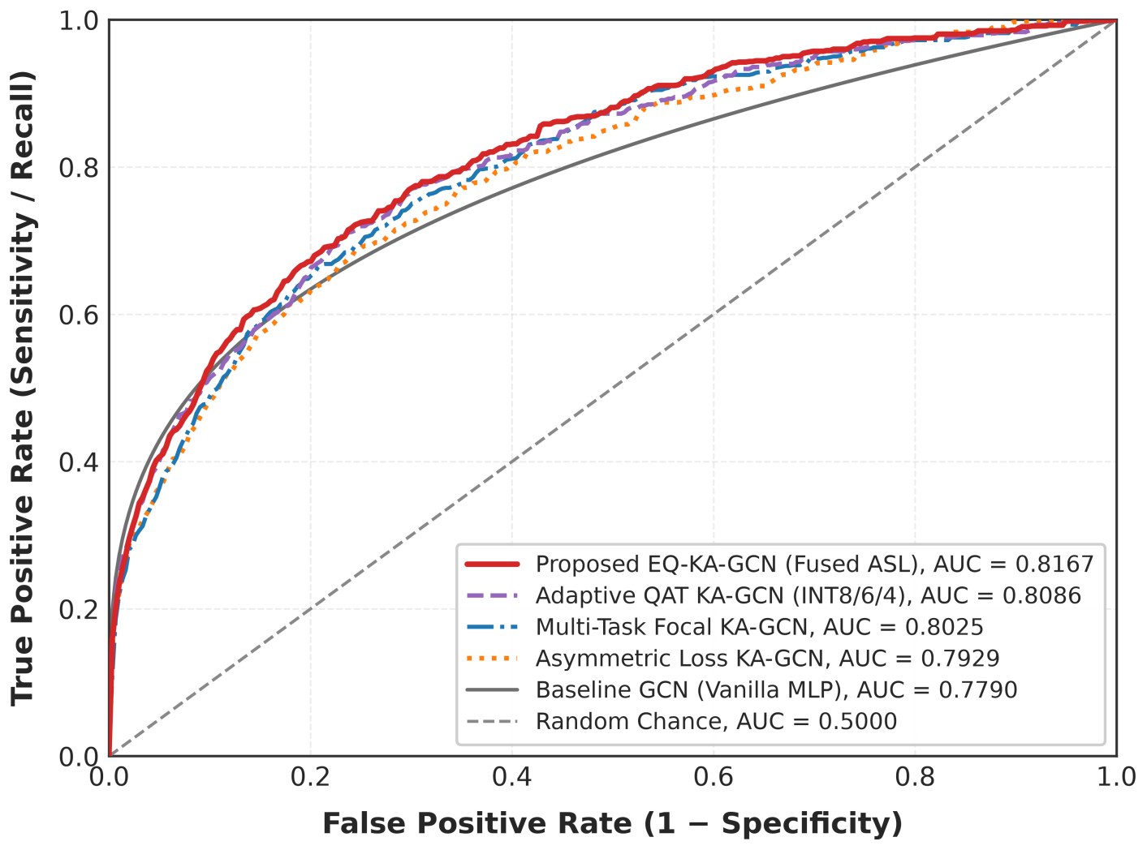
Fig. 2. ROC curves for evaluated model configurations.
Figure 2 shows the ROC curves of the model sets evaluated and the discriminating ability of the model sets across the Tox21 test set is threshold independent. The curves are used to visually compare the ability of the models to separate toxic from non-toxic molecular samples.
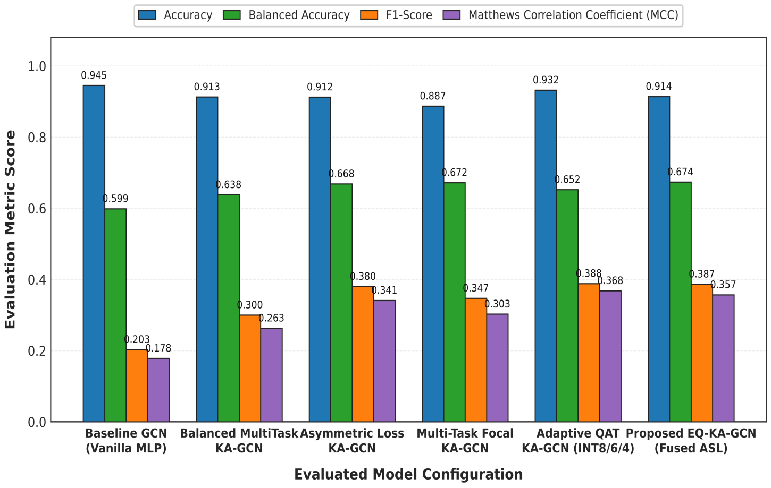
Fig.3. Comparative performance for evaluated models use accuracy, balanced accuracy, F1-score and MCC.
The results of the evaluated models are compared in terms of accuracy, balanced accuracy, F1 score and MCC in figure 3. The figure shows the comparison results of the overall classification and class-balanced classification performance for each model configuration.

4.2 ROC-AUC ANALYSIS

The main threshold-independent discrimination measure was the ROC-AUC. The Baseline GCN's ROC-AUC of 0.7790 was compared to Multi-Task Focal KA-GCN's 0.8024. The best performance was achieved by the Fused ASL KA-GCN with a ROC-AUC of 0.8167 and ASL KA-GCN with 0.7929. The proposed Fused ASL KA-GCN achieved an ROC-AUC of 0.0377 higher than that of the Baseline GCN. The quantized Adaptive QAT model achieved an ROC-AUC of 0.8087, which is a relatively small loss compared to the FP32 Fused ASL KA-GCN model.

Table 6. ROC-AUC comparison
Model | ROC-AUC
Baseline GCN | 0.7790
Multi-Task Focal KA-GCN | 0.8024
ASL KA-GCN | 0.7929
Fused ASL KA-GCN | 0.8167
Adaptive QAT KA-GCN | 0.8087
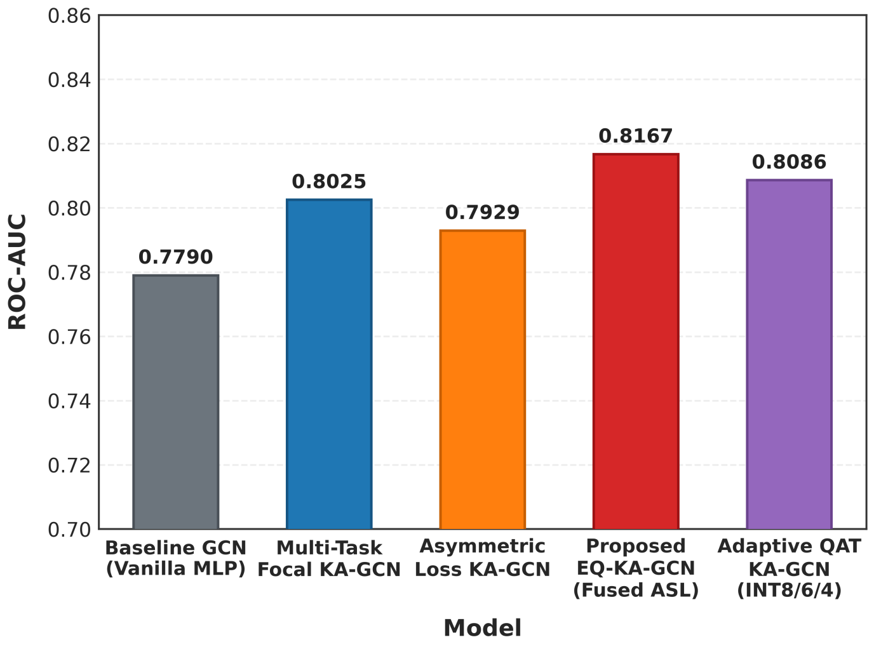
Fig. 4. ROC-AUC comparison for evaluated model configurations.
In the figure 4, the ROC-AUC values of the various model configurations are shown. The comparison reflects the benefits the proposed model configurations are able to provide in terms of threshold-independent discrimination, as compared to the baseline.

4.3 ENDPOINT-WISE TOXICITY PREDICTION

The Fused ASL KA-GCN was tested by the 12 Tox21 toxicity endpoints. The results of the endpoints are given at the default threshold, τ=0.50, in Table 7.

Table 7. Endpoint-wise performance of Fused ASL KA-GCN

Endpoint | ROC-AUC | Accuracy (%) | Precision (%) | Recall (%) | F1 | MCC
NR-AR | 0.7903 | 95.66 | 70.37 | 42.22 | 0.5278 | 0.5247
NR-AR-LBD | 0.8656 | 97.32 | 75.00 | 48.39 | 0.5882 | 0.5898
NR-AhR | 0.8868 | 84.80 | 41.03 | 70.33 | 0.5182 | 0.4576
NR-Aromatase | 0.8312 | 90.80 | 21.74 | 45.45 | 0.2941 | 0.2711
NR-ER | 0.7152 | 90.80 | 70.73 | 32.58 | 0.4462 | 0.4397
NR-ER-LBD | 0.8965 | 96.42 | 80.95 | 41.46 | 0.5484 | 0.5643
NR-PPAR-γ | 0.7495 | 97.83 | 0.00 | 0.00 | 0.0000 | -0.0071
SR-ARE | 0.7855 | 82.76 | 34.43 | 43.30 | 0.3836 | 0.2874
SR-ATAD5 | 0.8144 | 93.36 | 24.32 | 27.27 | 0.2571 | 0.2229
SR-HSE | 0.7551 | 93.36 | 27.03 | 28.57 | 0.2778 | 0.2431
SR-MMP | 0.8850 | 86.85 | 50.94 | 51.43 | 0.5118 | 0.4358
SR-p53 | 0.8253 | 86.72 | 20.39 | 48.84 | 0.2877 | 0.2545
Macro Average | 0.8167 | 91.39 | 43.08 | 39.99 | 0.3867 | 0.3570
The ROC-AUC values, for each endpoint ranged from 0.7152 to 0.8965. NR-ER-LBD achieved the ROC-AUC value of 0.8965 while NR-AhR recorded a ROC-AUC of 0.8868 and SR-MMP recorded a ROC-AUC of 0.8850. One of the interesting points was the performance of NR-PPAR-γ. It achieved 97.83% accuracy, but at default threshold, the precision, recall, and F1-score were all 0.00%. This outcome shows the influence of endpoint imbalance and confirms that the accuracy has to be read together with the other metrics when assessing the multi-task toxicity prediction.
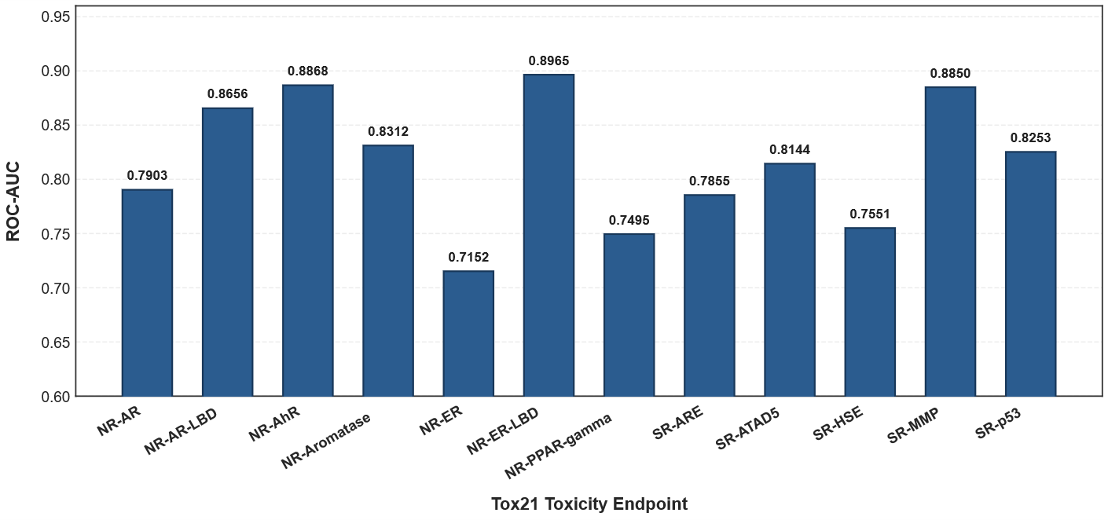
Fig. 5. ROC-AUC performance across 12 Tox21 toxicity endpoints.
The ROC-AUC performance of the Fused ASL KA-GCN is shown over the 12 Tox21 toxicity endpoints in Figure 5. The figure shows that the individual toxicity assays have varying predictive discrimination.
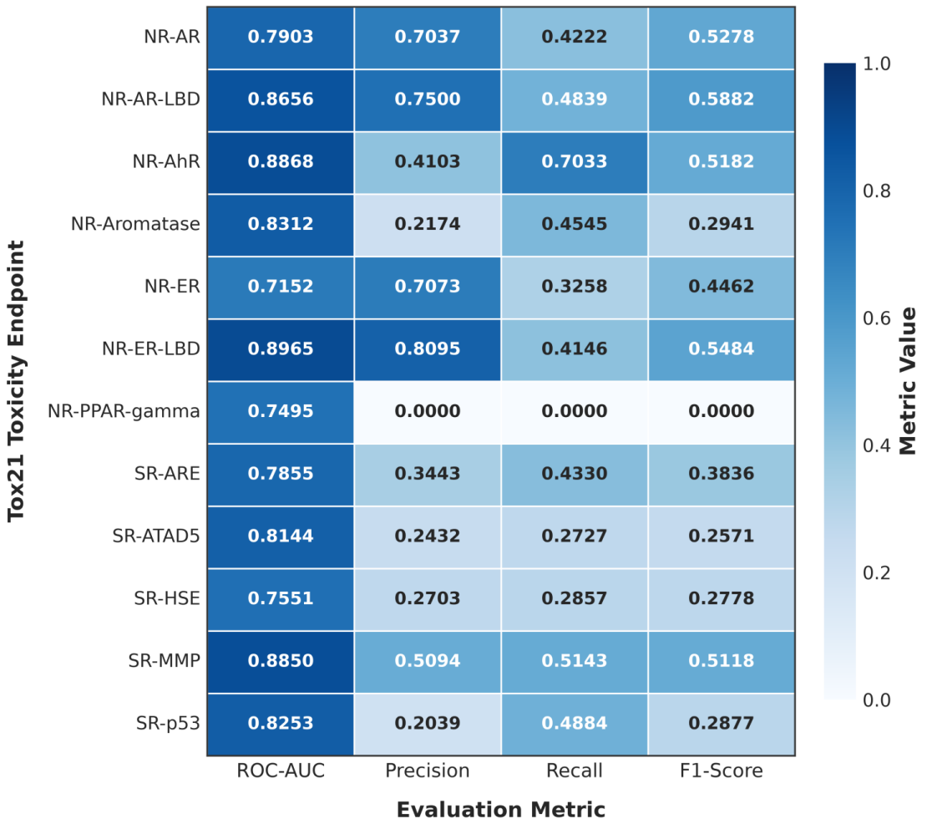
Fig. 6. Heatmap of endpoint-wise ROC-AUC, precision, recall and F1-score.
The endpoint-wise ROC-AUC, precision, recall and F1 scores are shown in the heatmap in figure 6. It allows a small comparison of the performance of the model in the various toxicity endpoints and emphasizes performance variation at the endpoint level.

4.4 EFFECT OF THE THRESHOLD CALIBRATION
Calibrated with endpoint specific thresholds: Fused ASL KA-GCN. The calibrated thresholds improved the threshold-dependent classification performance.
Table 8. Effect of endpoint-specific threshold calibration

Metric | Default τ=0.50 | Calibrated τ* | Change
Balanced Accuracy | 67.39% | 71.14% | +3.75 points
Precision | 43.08% | 46.56% | +3.48 points
Recall | 39.99% | 47.34% | +7.35 points
F1-score | 0.3867 | 0.4359 | +0.0492
MCC | 0.3570 | 0.4150 | +0.0580
ROC-AUC | 0.8167 | 0.8167 | Unchanged
The accuracy, precision, recall, F1 score and MCC are improved after threshold calibration. The F1 score was increased from 0.3867 to 0.4359.The MCC value had been increased from 0.3570 to 0.4150. As predicted, the ROC-AUC did not change as this is independent of the classification threshold.
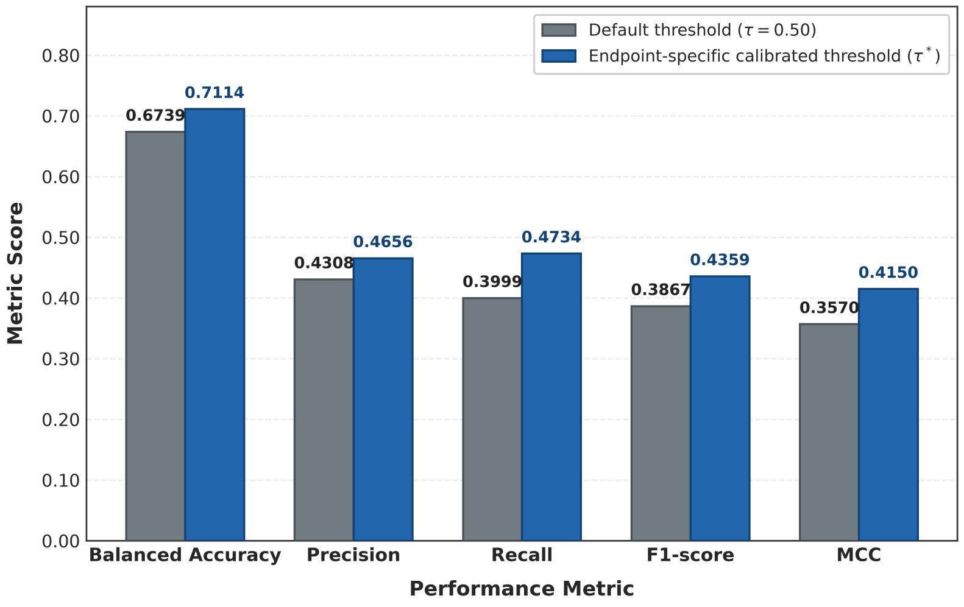
Fig. 7. Performance comparison before and after endpoint-specific threshold calibration.
The model performance (before and after endpoint-specific threshold calibration) is displayed in Figure 7. Calibrated thresholds enhance the threshold dependent measures, such as balanced accuracy, precision, recall, F1 score and MCC, and do not affect the ROC-AUC measure.

4.5 PROBABILITY CALIBRATION
The probability calibration results is represented in Table 9

Table 9. Probability calibration performance

Model | Calibration | Brier MSE | RMSE | ECE
Fused ASL KA-GCN | Raw logits | 0.0983 | 0.3136 | 0.2064
Fused ASL KA-GCN | Platt scaling | 0.0518 | 0.2277 | 0.0529
Focal KA-GCN | Raw logits | 0.0995 | 0.3155 | 0.2152
Focal KA-GCN | Platt scaling | 0.0521 | 0.2282 | 0.0500
Focal KA-GCN | Temperature scaling | 0.1220 | 0.3492 | 0.2649
Baseline GCN | Platt scaling | 0.0493 | 0.2220 | 0.0080
Baseline GCN | Temperature scaling | 0.0492 | 0.2219 | 0.0185
Platt scaling reduced Brier MSE from 0.0983 to 0.0518 and ECE from 0.2064 to 0.0529 for Fused ASL KA-GCN. This reflects a better agreement between the predicted probabilities and the observed outcomes after calibration
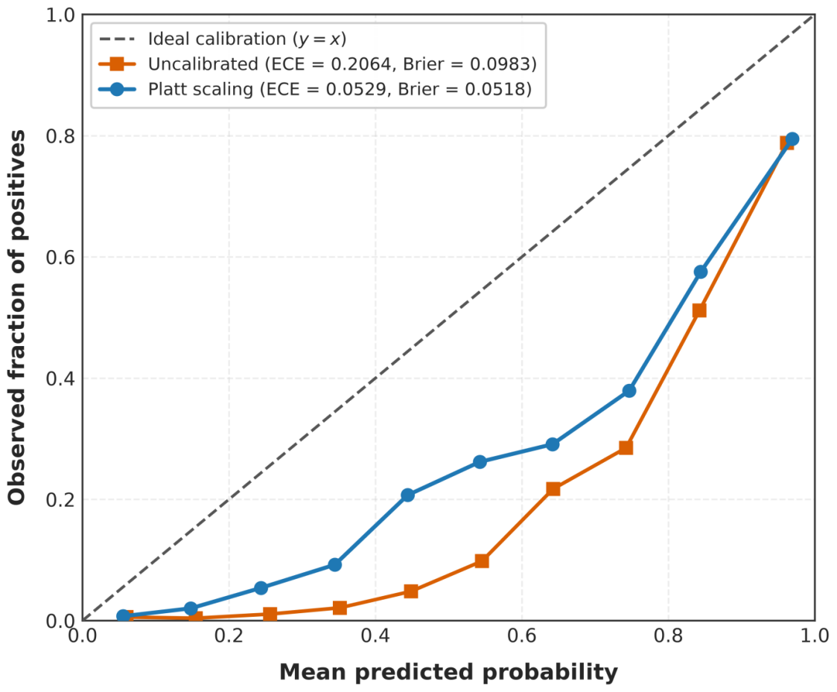
Fig. 8. Reliability diagram of Fused ASL KA-GCN before and after Platt scaling
Figure 8 displays the reliability diagram for the Fused ASL KA-GCN both prior to and following Platt scaling. Results of calibrated predictions are more consistent with observed results indicating better probability reliability.

4.6 QUANTIZATION PERFORMANCE AND COMPUTATIONAL EFFICIENCY
The Adaptive QAT configuration has been tested. The mixed precision allocations of INT8, INT6 and INT4 have been tested.

Table 10. FP32 and Adaptive QAT comparison
Metric | Fused ASL KA-GCN | Adaptive QAT KA-GCN
Model size | 1,231.80 KB | 902.32 KB
Compression ratio | 1× | 1.365×
Accuracy | 91.39% | 93.20%
ROC-AUC | 0.8167 | 0.8087
Precision | 43.08% | 50.73%
F1-score | 0.3867 | 0.3884
Latency/sample | 0.154 ms | 0.219 ms

By using Adaptive QAT the model size was reduced by 26.75% going from 1231.80KB down to 902.32KB. After quantization the model still achieved an ROC-AUC of 0.8087 and an F1-score of 0.3884. The quantized model also showed a latency of 0.219ms, per sample.. The quantized version reported the latency of 0.219ms/sample. This value is not meant to be interpreted as speeding up the inference on real low-bit processors, because the quantization experiment was conducted using a fake quantization, not real low-precision computation. The most important computational advantage demonstrated here is the decrease in the model size.
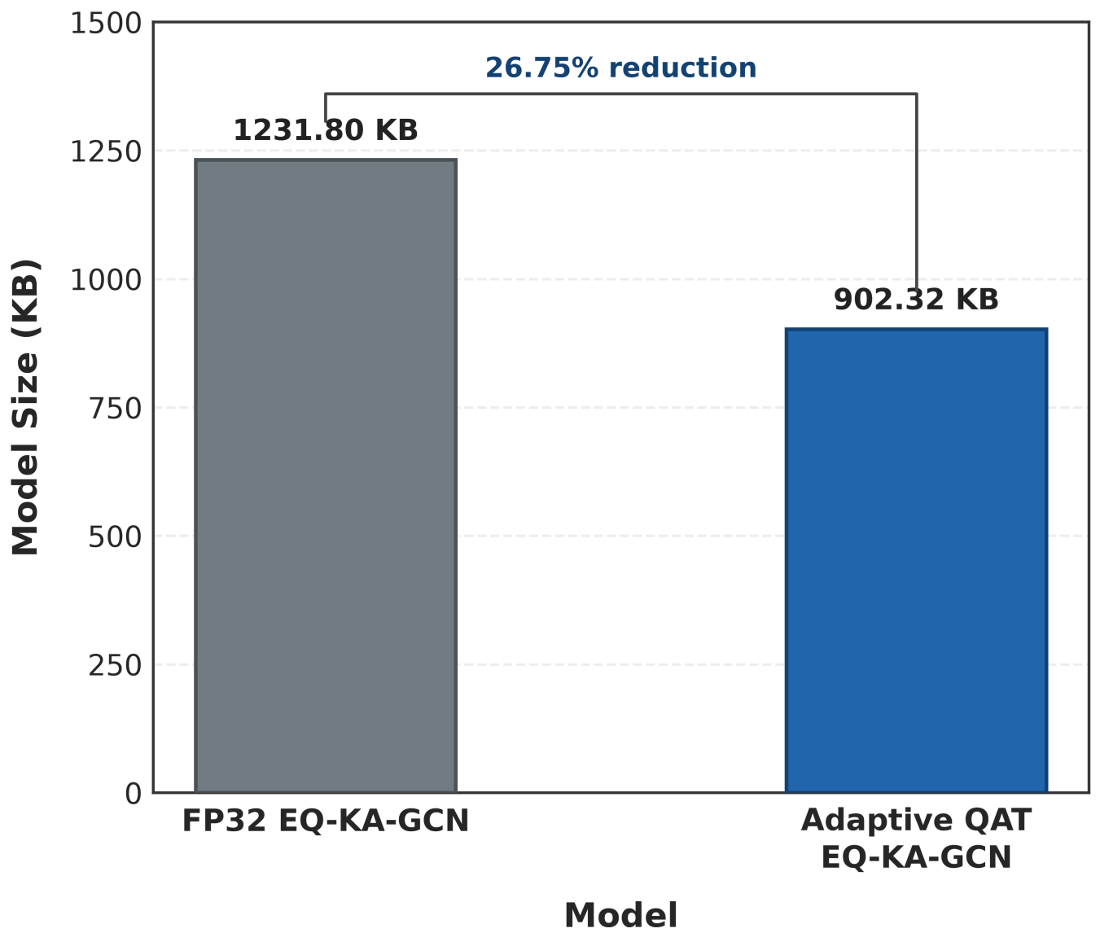

Fig.9. Model-size comparison between FP32 and Adaptive QAT models.
Figure 9 shows the comparison of the model sizes of the FP32 Fused ASL KA-GCN and Adaptive QAT KA-GCN. The comparison illustrates the amount of storage saved in the model by adaptive quantization.
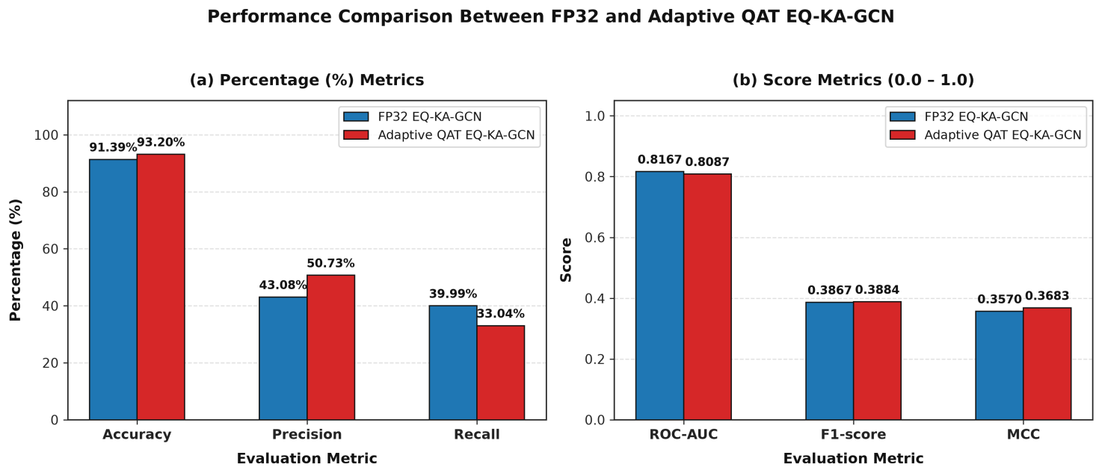
Fig. 10. Performance comparison between FP32 and Adaptive QAT models.

The performance of the Adaptive QAT configuration is compared to that of the FP32 configuration in Figure 10. The figure shows the amount of classification performance preserved against the decrease in the size of the model representation due to quantization.

4.7 TOXICITY SCREENING ANALYSIS
Based on the screening analysis, 312 active toxic molecules were identified. Of them, 219 toxic molecules were successfully detected (with the reported sensitivity of 70.19%). The 338 safe molecules with 71.0% (240 molecules) correctly reported as safe. These statistics of screening are a further molecular level view of the model behaviour. They must be presented separately to the macro-averaged endpoint metrics, however, due to the fact that they are two different types of aggregation.
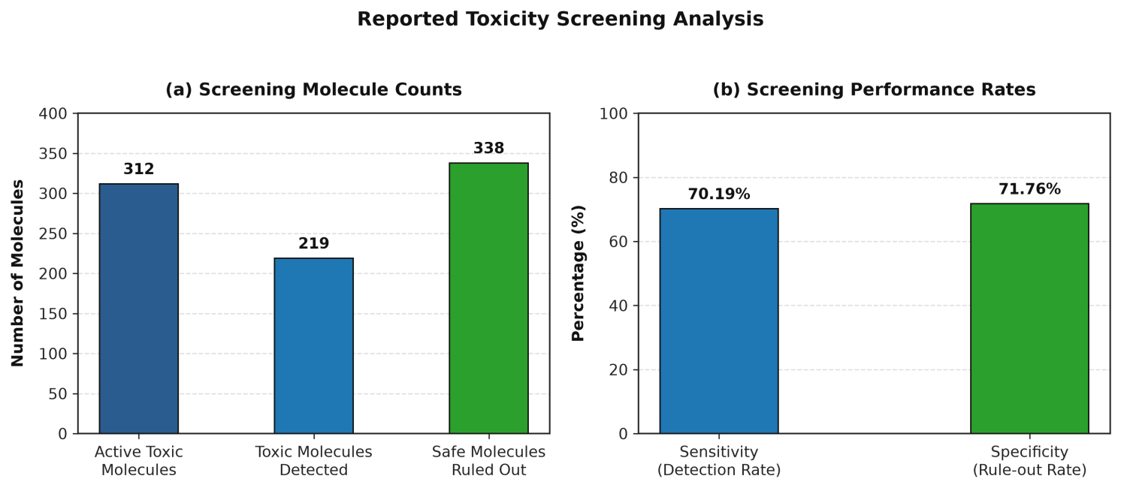
Fig. 11. Reported toxicity screening analysis.
The outcomes of the molecule level toxicity screening done for the model tested are demonstrated in Figure 11. The analysis presents the count of the molecules detected that are toxic and the count of the molecules correctly identified that are safe, giving an additional perspective on the screening performance.

4.8 Comparison with Existing Published Approaches
The Fused ASL KA‑GCN obtained a ROC‑AUC of 0.8167 in the present evaluation. The published GCN, KA-GCN and KA-GAT results offer an additional comparison with previously reported Tox21 studies [9] and KA-GCN and KA-GAT [20] are the models used in this work with the Baseline GCN model. It is important to be mindful when comparing two graph constructions as they could differ in the molecular features, training method, loss functions, data splitting, or implementation, all of which can have an impact on the reported performance.

Table 11. Comparison with published approaches on Tox21

Approach | Dataset | ROC AUC
Published GCN [9] | Tox21 | 0.747
Published KA GCN [20] | Tox21 | 0.799
Published KA GAT [20] | Tox21 | 0.800
Our Baseline GCN | Tox21 | 0.7790
Our Fused ASL KA GCN | Tox21 | 0.8167
Our Adaptive QAT KA GCN | Tox21 | 0.8087

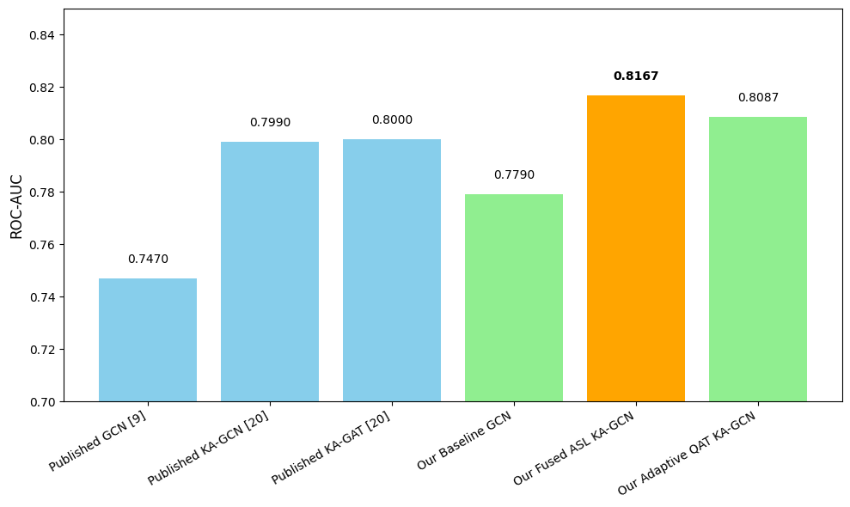
Fig.12. ROC-AUC comparison between the proposed model and published methods
Figure 12. ROC-AUC comparison of published baselines (GCN, KA-GCN, KA-GAT) with our implemented models (Baseline GCN, Fused ASL KA-GCN, Adaptive QAT KA-GCN) on the Tox21 dataset. The Fused ASL KA-GCN achieved the highest ROC-AUC score of 0.8167, which is higher than all the published and baseline methods.
5.CONCLUSION AND FUTURE WORK
5.1 CONCLUSION
the research provided a successful deep learning system, EQ-KA-GCN, for multi-task chemical toxicity prediction using the Tox21 dataset.The proposed method integrates Kolmogorov-Arnold graph learning and asymmetric loss, fingerprint feature fusion, probability calibration, and adaptive quantization to boost toxicity prediction. The ROC-AUC for the Fused ASL KA-GCN is 0.8167, and threshold calibration improved the F1-score and the MCC. The probability calibration improved the reliability of the projected probabilities, and the adaptive quantization reduced the model size by 26.75%, while maintaining the ROC-AUC at 0.8087. The results showed that the proposed framework is capable of accurate and compact prediction of molecular toxicity.
5.2 FUTURE WORK
Future work will focus on validating EQ-KA-GCN on other toxicity datasets and independent molecular screening benchmarks to assess its generalizability. More research on low-bit quantization based hardware will be required for a more rigorous evaluation of the practical memory, computational and inference efficiency. Additionally, advanced molecular representations and explainability methodologies will be investigated to improve predictive accuracy and to provide further mechanistic insights into toxicity-related molecular patterns.
6. REFERENCES
[1] R. Huang et al., “Modelling the Tox21 10K chemical profiles for in vivo toxicity prediction and mechanism characterization,” Nature Communications, vol. 7, Art. no. 10425, 2016.
[2] A. Mayr, G. Klambauer, T. Unterthiner, and S. Hochreiter, “DeepTox: Toxicity prediction using deep learning,” Frontiers in Environmental Science, vol. 3, Art. no. 80, 2016, doi: 10.3389/fenvs.2015.00080.
[3] S. Kearnes, K. McCloskey, M. Berndl, V. Pande, and P. Riley, “Molecular graph convolutions: Moving beyond fingerprints,” Journal of Computer-Aided Molecular Design, vol. 30, no. 8, pp. 595–608, 2016, doi: 10.1007/s10822-016-9938-8.
[4] J. Duvenaud et al., “Convolutional networks on graphs for learning molecular fingerprints,” in Advances in Neural Information Processing Systems, vol. 28, 2015.
[5] J. Gilmer, S. S. Schoenholz, P. F. Riley, O. Vinyals, and G. E. Dahl, “Neural message passing for quantum chemistry,” in Proc. ICML, 2017, pp. 1263–1272.
[6] Z. Wu et al., “MoleculeNet: A benchmark for molecular machine learning,” Chemical Science, vol. 9, no. 2, pp. 513–530, 2018, doi: 10.1039/C7SC02664A.
[7] K. Yang et al., “Analyzing learned molecular representations for property prediction,” Journal of Chemical Information and Modeling, vol. 59, no. 8, pp. 3370–3388, 2019, doi: 10.1021/acs.jcim.9b00237.
[8] E. N. Feinberg et al., “PotentialNet for molecular property prediction,” ACS Central Science, vol. 4, no. 11, pp. 1520–1530, 2018, doi: 10.1021/acscentsci.8b00507.
[9] J. Chen, Y.-W. Si, C.-W. Un, and S. W. I. Siu, “Chemical toxicity prediction based on semi-supervised learning and graph convolutional neural network,” Journal of Cheminformatics, vol. 13, Art. no. 93, 2021.
[10] J. Zhang, U. Norinder, and F. Svensson, “Deep learning-based conformal prediction of toxicity,” Journal of Chemical Information and Modeling, vol. 61, no. 6, pp. 2648–2657, 2021, doi: 10.1021/acs.jcim.1c00208.
[11] R. Ying, D. Bourgeois, J. You, M. Zitnik, and J. Leskovec, “GNNExplainer: Generating explanations for graph neural networks,” in Advances in Neural Information Processing Systems, vol. 32, 2019.
[12] Y. Wang, J. Wang, Z. Cao, and A. B. Farimani, “Molecular contrastive learning of representations via graph neural networks,” Nature Machine Intelligence, vol. 4, pp. 279–287, 2022, doi: 10.1038/s42256-022-00447-x.
[13] Z. Wu et al., “Chemistry-intuitive explanation of graph neural networks for molecular property prediction with substructure masking,” Nature Communications, vol. 14, Art. no. 2585, 2023.
[14] K. Amara, R. Rodríguez-Pérez, and J. Jiménez-Luna, “Explaining compound activity predictions with a substructure-aware loss for graph neural networks,” Journal of Cheminformatics, vol. 15, Art. no. 67, 2023, doi: 10.1186/s13321-023-00733-9.
[15] J. Cremer et al., “Equivariant graph neural networks for toxicity prediction,” Chemical Research in Toxicology, vol. 36, no. 10, pp. 1561–1573, 2023.
[16] R.-H. Lin, P. Lin, C.-C. Wang, and C.-W. Tung, “A novel multitask learning algorithm for tasks with distinct chemical space: Zebrafish toxicity prediction as an example,” Journal of Cheminformatics, vol. 16, Art. no. 91, 2024.
[17] D. Buterez, J. P. Janet, S. J. Kiddle, D. Oglic, and P. Lió, “Transfer learning with graph neural networks for improved molecular property prediction in the multi-fidelity setting,” Nature Communications, vol. 15, Art. no. 1517, 2024.
[18] A. Kengkanna and M. Ohue, “Enhancing property and activity prediction and interpretation using multiple molecular graph representations with MMGX,” Communications Chemistry, vol. 7, Art. no. 74, 2024.
[19] J. Park and S. Lee, “MoltiTox: A multimodal fusion model for molecular toxicity prediction,” Frontiers in Toxicology, vol. 7, Art. no. 1720651, 2025.
[20] L. Li, Y. Zhang, G. Wang et al., “Kolmogorov–Arnold graph neural networks for molecular property prediction,” Nature Machine Intelligence, vol. 7, pp. 1346–1354, 2025, doi: 10.1038/s42256-025-01087-7.
[21] A. Rasool, J. Ul Rahman, and R. Uwitije, “Enhancing molecular property prediction with quantized GNN models,” Journal of Cheminformatics, vol. 17, Art. no. 81, 2025, doi: 10.1186/s13321-025-00989-3.
[22] T. Ridnik et al., “Asymmetric loss for multi-label classification,” in Proc. IEEE/CVF International Conference on Computer Vision (ICCV), 2021, pp. 82–91.
[23] B. Jacob et al., “Quantization and training of neural networks for efficient integer-arithmetic-only inference,” in Proc. IEEE/CVF Conference on Computer Vision and Pattern Recognition (CVPR), 2018, pp. 2704–2713.
[24] S. Monem, A. H. Abdel-Hamid, and A. E. Hassanien, “Drug toxicity prediction model based on enhanced graph neural network,” Computers in Biology and Medicine, vol. 185, Art. no. 109614, 2025.
[25] X. Zhao, S. Zhang, T. Zhang, Y. Cao, and J. Liu, “A small-scale data driven and graph neural network based toxicity prediction method of compounds,” Computers in Biology and Chemistry, vol. 117, Art. no. 108393, 2025, doi: 10.1016/j.compbiolchem.2025.108393.

