WEEK 2 TASK
Exploratory Data Analysis (EDA) and Visualization Framework Design
Python-Based Framework for General Dataset Analysis
Internship / Task | Yuva Intern – Data Science
Week | Week 2
Project Type | EDA and Visualization Planning
Primary Technology | Python

1. Introduction to Exploratory Data Analysis
Exploratory Data Analysis (EDA) is the systematic process of inspecting, summarizing, visualizing, and questioning a dataset before formal statistical modeling or machine learning. EDA helps understand data structure and quality, discover patterns and relationships, identify unusual observations, and form hypotheses for later analysis. This Week 2 task does not require a specific dataset; instead, it defines a reusable EDA and visualization framework that can be applied to customer, sales, finance, healthcare, product, or other structured datasets.

2. Objectives
- Understand dataset dimensions, variables, data types, and distributions.
- Assess missing values, duplicates, inconsistencies, and unusual observations.
- Perform univariate, bivariate, and multivariate exploration.
- Select visualizations appropriate to variable types and analytical questions.
- Document findings clearly and reproducibly.
- Create a framework adaptable to different datasets.

3. Proposed EDA Workflow
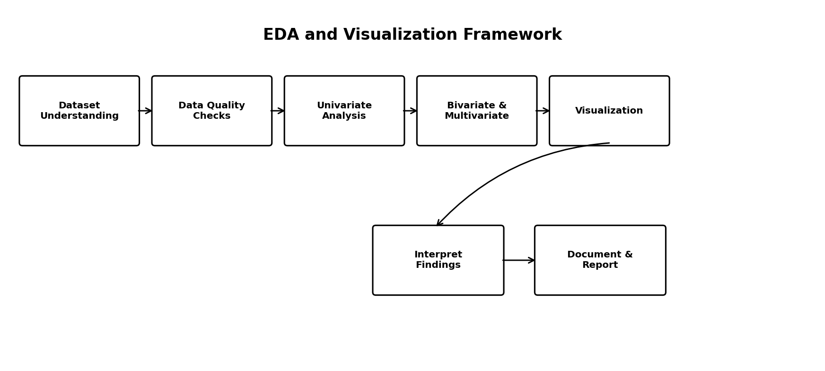
Figure 1. Proposed EDA and visualization workflow

4. Dataset Understanding and Data Types
The first stage records rows, columns, names, data types, unique values, sample records, and descriptive statistics. A data dictionary should explain each variable, its business meaning, valid range, and expected analytical treatment.
Type | Examples | Typical EDA
Numerical | Age, income, quantity, price | Summary statistics, histogram, box plot, scatter plot
Categorical | Region, product, segment | Counts, proportions, bar charts
Ordinal | Low/Medium/High | Ordered summaries and bar charts
Datetime | Date, timestamp | Trends, seasonality, time-based summaries
Boolean | Yes/No, True/False | Counts, proportions, grouped comparisons

5. Data Exploration Techniques

5.1 Univariate Analysis
Analyze one variable at a time. Numerical variables can be examined using minimum, maximum, mean, median, quartiles, standard deviation, histograms, density plots, and box plots. Categorical variables can be examined with frequency tables, proportions, and ordered bar charts.

5.2 Bivariate Analysis
Analyze relationships between two variables. Numerical pairs can use scatter plots and correlation measures. Categorical versus numerical variables can use grouped summaries, box plots, or violin plots. Categorical pairs can use contingency tables, grouped bars, or heat maps.

5.3 Multivariate Analysis
Analyze several variables together using correlation matrices, selected pair plots, grouped visualizations, faceting, and focused heat maps. Only meaningful combinations should be displayed to avoid clutter.

6. Missing Data, Duplicates and Consistency
- Calculate missing counts and percentages for every variable.
- Check whether missingness is concentrated in specific groups or periods.
- Distinguish true missing values from codes such as Unknown or N/A.
- Identify exact duplicates and investigate whether they are legitimate repeated events.
- Standardize category spelling, capitalization, whitespace, dates, units, and codes.
- Document all cleaning decisions in a data-quality log.

7. Outlier Analysis
Outliers are observations that differ substantially from the majority of values. They should not be removed automatically because an extreme value may be genuine. Box plots, IQR rules, percentiles, histograms, and domain knowledge will be used to identify candidates. Depending on the cause, values may be retained, corrected, transformed, capped, or excluded with documented justification.

8. Visualization Strategy
Chart | Purpose
Histogram | Distribution, spread and skewness
Box Plot | Quartiles and potential outliers
Bar Chart | Category counts or aggregated values
Scatter Plot | Numerical relationships
Line Chart | Trends over time
Heat Map | Correlation or matrix relationships
Violin Plot | Distribution comparison across groups
Pair Plot | Selected multivariate relationships
Pie Chart | Simple low-cardinality composition when appropriate

9. Python Tools and Libraries
Tool | Contribution
Pandas | Loading, cleaning, grouping, aggregation and tabular summaries
NumPy | Numerical and array operations
Matplotlib | Flexible base plotting
Seaborn | Statistical visualization
Plotly | Interactive charts
Jupyter Notebook / JupyterLab | Interactive analysis and documentation

10. Recommended EDA Sequence
- Load and inspect the dataset.
- Create a data dictionary and classify variables.
- Run missing-value, duplicate, consistency, and range checks.
- Generate descriptive statistics.
- Perform univariate analysis.
- Perform bivariate and focused multivariate analysis.
- Investigate outliers using statistical and domain context.
- Create purposeful visualizations linked to analytical questions.
- Record findings, limitations, and hypotheses for later modeling.

11. Reporting and Documentation Plan
- Executive summary of major observations.
- Dataset overview and data dictionary.
- Data-quality assessment.
- Univariate, bivariate, and multivariate findings.
- Key visualizations with captions and interpretations.
- Important patterns, anomalies, limitations, and future questions.

12. Week 2 Timeline – 30 to 35 Hours
The core work allocation below is 29 hours. An additional 2–4 hours should be reserved for dataset-specific revisions, chart refinement, final documentation, and review, giving an overall effort of approximately 31–33 hours.
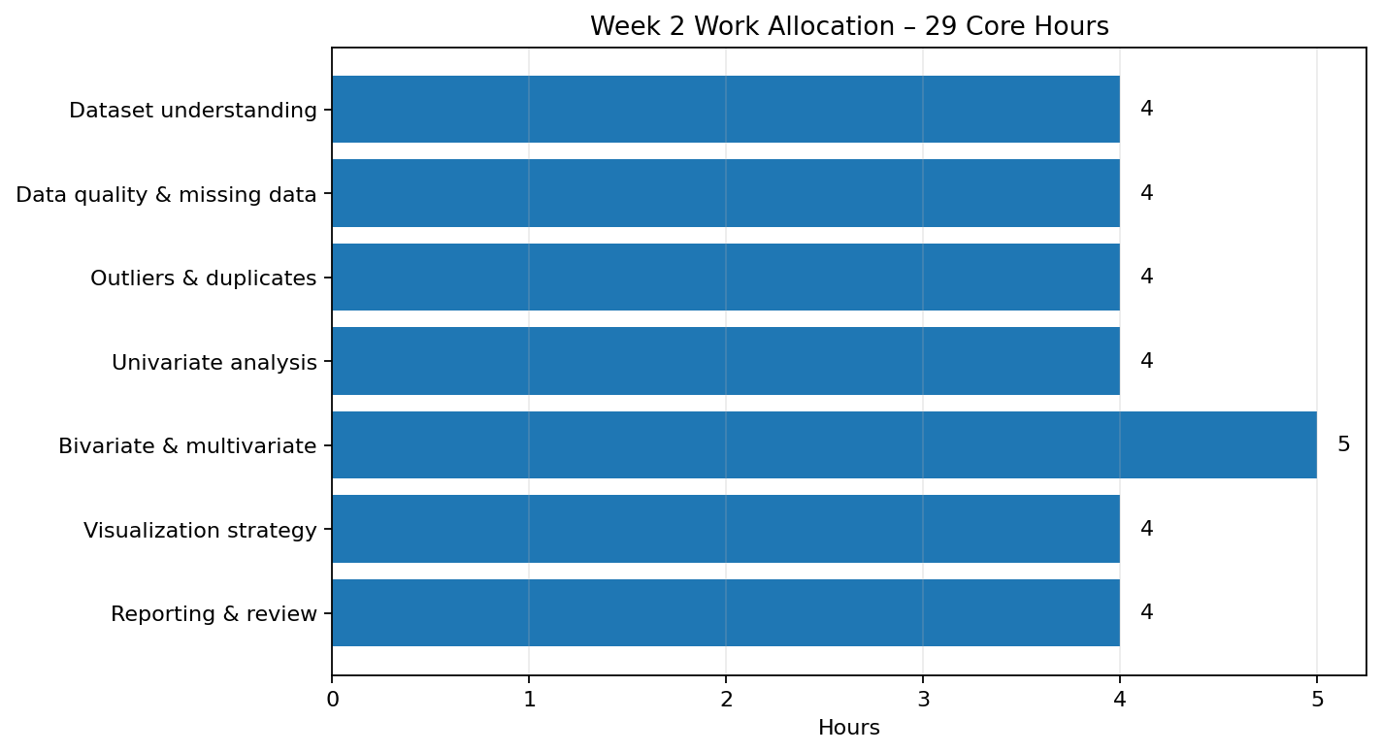
Figure 2. Planned Week 2 work allocation

13. Expected Outcomes
- Reusable EDA workflow.
- Clear data-quality assessment method.
- Structured univariate, bivariate, and multivariate analysis.
- Visualization decision framework.
- Documented Python toolkit.
- Professional reporting structure.
- Questions and hypotheses for later modeling.

14. Challenges and Mitigation Strategies
Challenge | Mitigation
Large datasets | Use sampling for initial visualization and summarize intelligently.
High missingness | Quantify patterns and select context-appropriate treatment.
Many categories | Group rare categories or focus on top relevant groups.
Extreme values | Check domain validity before transformation or exclusion.
Overcrowded charts | Reduce variables, filter groups, facet, or change chart type.
Misleading scales | Use correct axes, labels, units, and consistent comparisons.
Correlation confusion | Treat correlation as association, not proof of causation.

15. Evaluation Criteria
- Depth and clarity of the EDA process.
- Well-organized visualization methodology.
- Appropriate chart selection.
- Clear treatment of missing values and outliers.
- Logical process adaptable to different datasets.
- Clear interpretation and professional documentation.

16. Conclusion
This Week 2 framework establishes a systematic approach to exploratory data analysis and visualization. It starts with understanding the dataset, continues through data-quality assessment and statistical exploration, and ends with purposeful visualization and documentation. The framework is adaptable to different datasets while allowing analytical questions to determine the final charts and summaries. Pandas, NumPy, Matplotlib, Seaborn, Plotly, and Jupyter provide a practical Python environment for implementing the planned process.

17. Submission Description (200+ Words)
This Week 2 report presents a comprehensive Exploratory Data Analysis (EDA) and Visualization Framework designed for data science projects using Python. The purpose of the report is to define a structured and reusable process for understanding a dataset before applying advanced statistical analysis or machine learning. The framework begins with dataset understanding, including dimensions, column names, data types, unique values, and a data dictionary. It then covers data-quality checks such as missing values, duplicate records, inconsistent categories, invalid ranges, and potential outliers. The report explains three major levels of exploration: univariate analysis for individual variables, bivariate analysis for relationships between two variables, and multivariate analysis for interactions among multiple variables. A detailed visualization strategy is included, covering histograms, bar charts, box plots, scatter plots, line charts, heat maps, violin plots, and pair plots, with guidance on when each visualization can be used. Python tools including Pandas, NumPy, Matplotlib, Seaborn, Plotly, and Jupyter Notebook are identified along with their roles in the EDA workflow. The report also provides a reporting structure for documenting observations, visual findings, limitations, and future analytical questions. A planned work allocation of approximately 31–33 hours is provided to organize the Week 2 task. Potential challenges such as large datasets, high missingness, many categorical levels, extreme values, overcrowded charts, and misleading visual scales are addressed with mitigation strategies. Overall, the report demonstrates a clear understanding of the initial stages of data analysis and provides a practical framework that can be adapted to different datasets and future data science projects.

