Twitter Sentiment analysis

# Summary:

Twitter sentiment analysis is a web application that gives us insights about the tweets or any query and trending topics on twitter. Help know a person's interests based on liked posts.

Useful for businesses to target advertisement and promoting their products.

# Background:

There are already several tons of project with Twitter analysis as their base in the software development community, however there are only a handful of software that give precise and free results without signing up or without a credit card information. We wanted to enhance their functionality as well as provide it as an open-source software.

# Problem Definition:

Twitter is a trending and a formal social media that provide quality content rather than entertainment. The analysis of the current situation and how people feel about a decision or a proposal is a crucial information for media and government to notice. Such a tool should be available for everyone to be aware of current affairs. Therefore, we wanted to take a step forward and provide it as an open-source software that anyone can use.

# Iterative Waterfall model

Iterative waterfall model is an improved classical waterfall model with feedback paths from every phase to its preceding phases.

When errors are detected at some later phase, these feedback paths allow correcting errors committed by programmers during some phase. The feedback paths allow the phase to be

reworked in which error are committed and these changes are reflected in the later phases.

We choose this model of development because:

* Our major requirements are defined and clear.
* Technologies to be used are understood.
* Our project does not involve high reliability and risk features.
* There is no need to get the product to the market immediately.

These characteristics better suit the Iterative waterfall model on comparison to any other development model.

# Functions of Software:

## Tweet count

* 1. Displays the total tweet counts based on topic or a hashtag.

## Analysis

* 1. Link to the top 5 post’s user's account on a topic. b) Recent tweets with high retweets and like.

c) Download information as xlsx Document

## User Sentiment

* 1. Sentiment of the tweets categorised as positive, negative, neutral

## Find interest

* 1. Define a person's interest based on the posts they liked.

## Targeted ADS For Business

* 1. Targeted advertisement for business based on an information about the users who liked a post.

For example: An Education institute can get users who liked a post related to Web development and target ads for them.

**Project Detail Report**

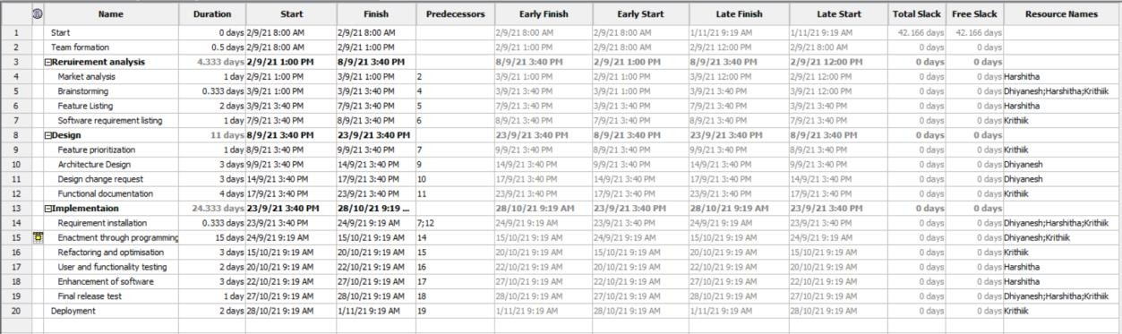

**1 A) Work Break Down Structure**

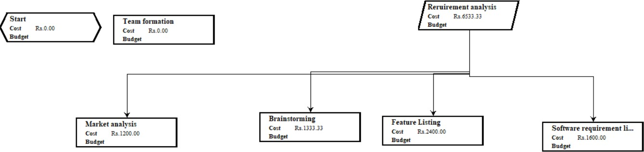

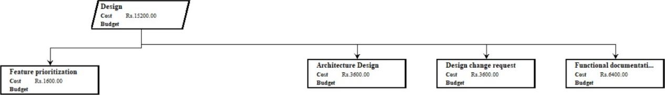

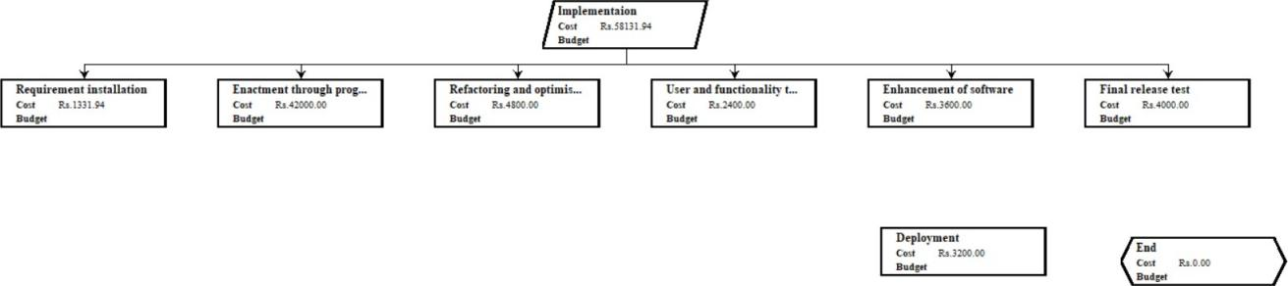

**1 B) Activity Network**

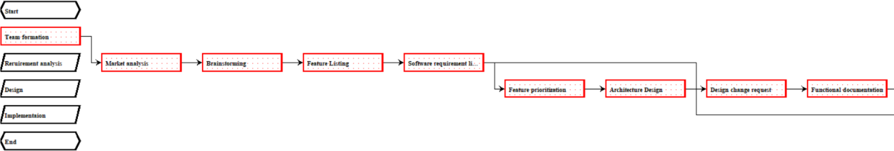



**2A) PERT Chart**

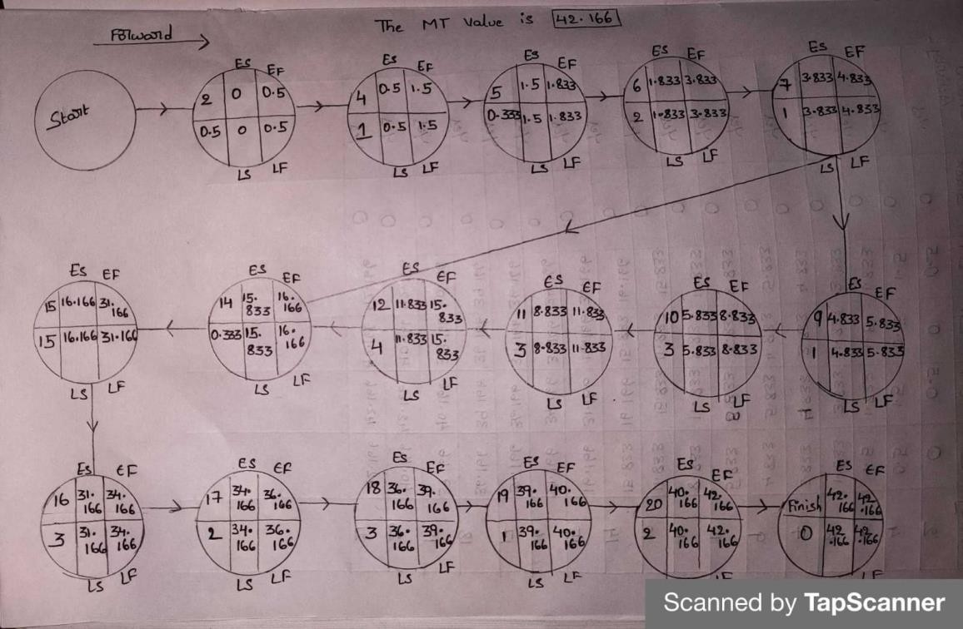

**2B) ES, EF, LS, LF, Slack Time**

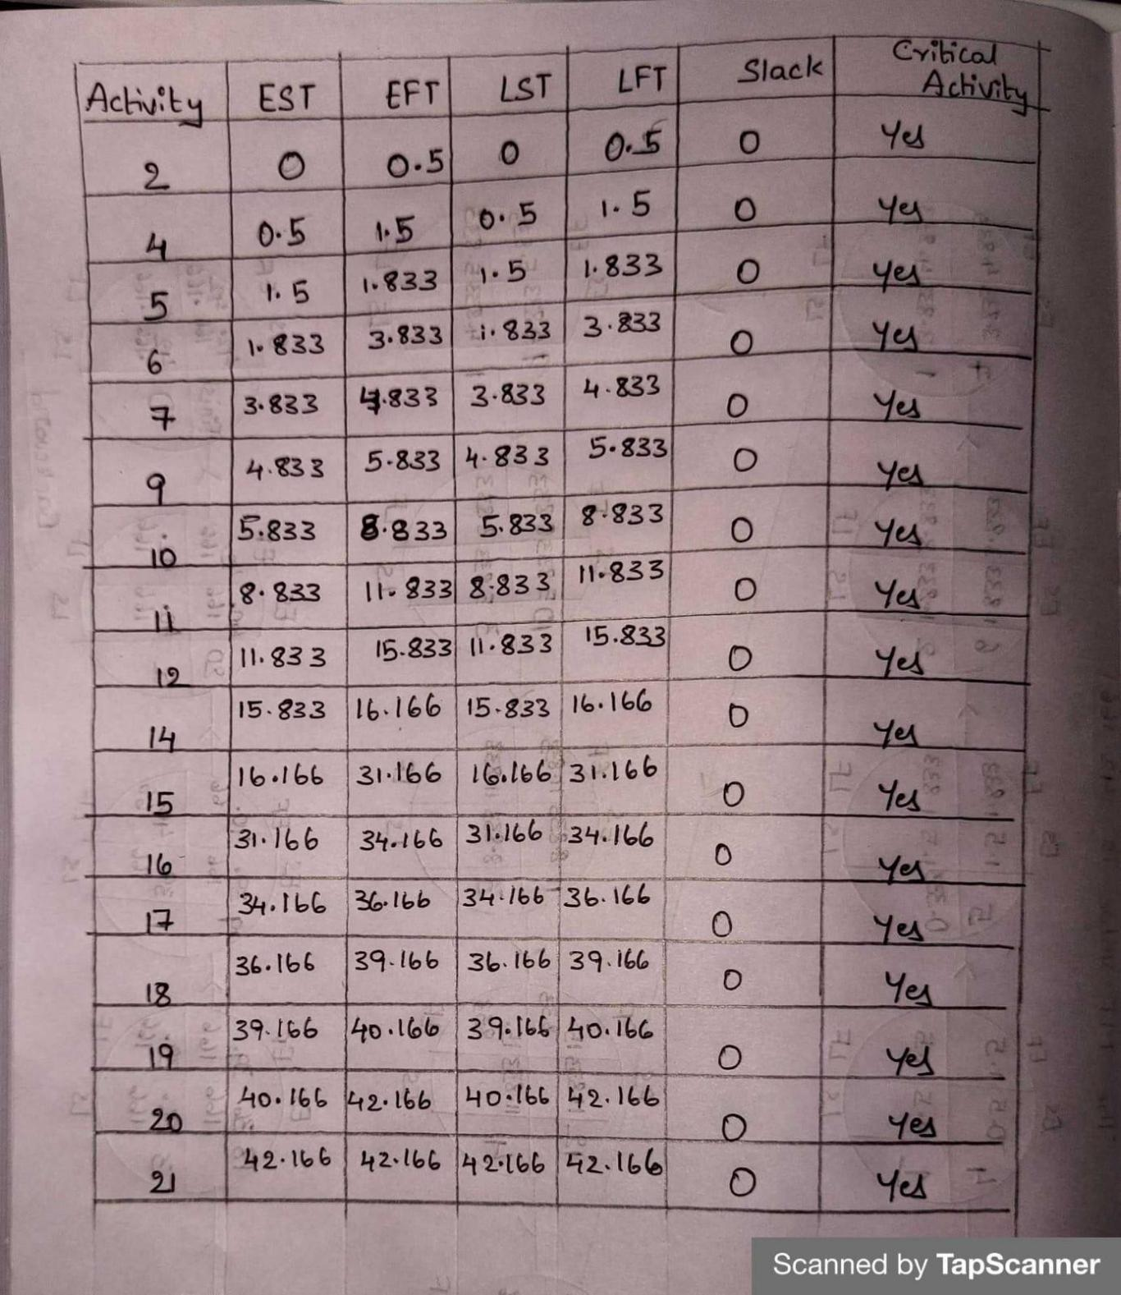

**2C) Critical path**

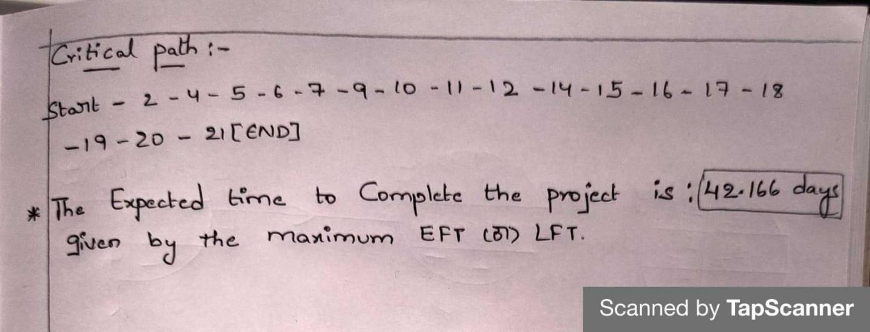

**3A) Resources**



**3B) Resource Allocation Report**



**3C) Histogram**

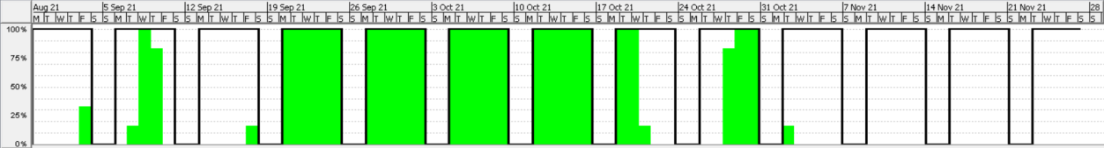

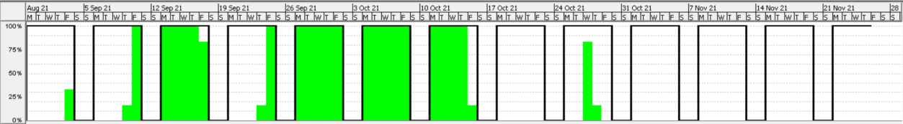

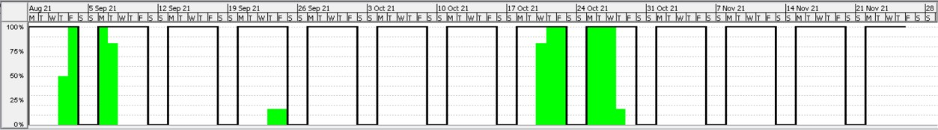

1. **Gantt Chart**

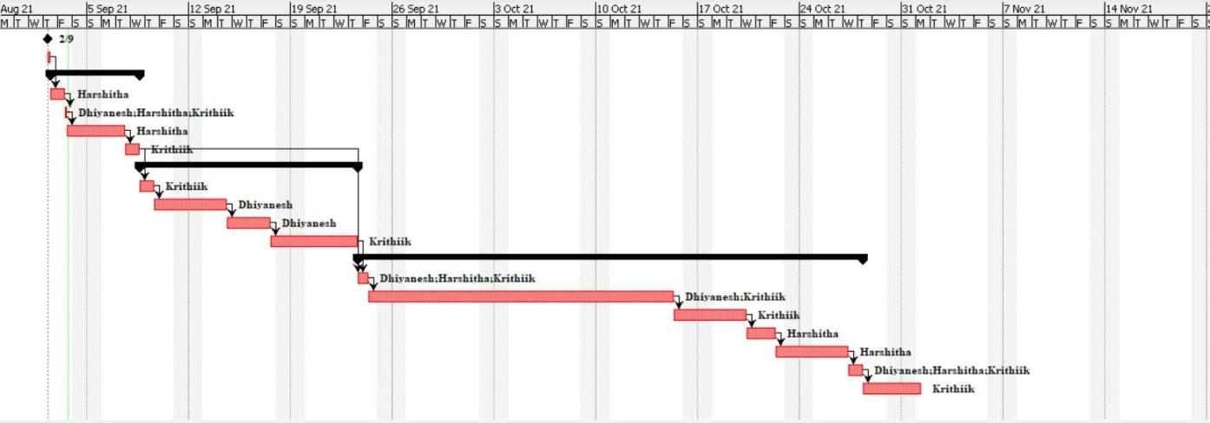

1. 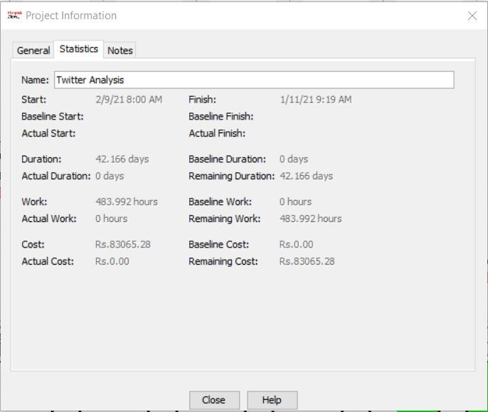**Statistics of Project**