**Assignment**

Q : 1

**Are the html tags and elements are same things?**

Ans :

HTML Tags are building blocks of HTML Page. HTML Elements are components that are used in HTML Page.

Ex :

<p> JAY DHOLAKIA </p>

Opening tag Closing tag

Content

Element

Q : 2

**What are tags & attributes in HTML ?**

Ans :

**Tags :** HTML tags are used to hold the HTML element. HTML element holds the content.

**Attributes :** HTML attributes are used to describe the characteristic of an HTML element in detail.

Tags starts with < and end with > .

Attributes are found only in the starting tag.

Q : 3

**What are void elements in HTML ?**

Ans :

A void element is an element whose content model never allows it to have contents under any circumstances.

Void elements can have attributes. The following is a complete list of the void elements in HTML : area , base , br , col , command , embed , hr , img , input , keygen , link , meta , param , source , track , wbr.

Q :4

**What are HTML Entities ?**

Ans :

Entities are character sequences placed in the text of an HTML document to print out reserved characters which may otherwise be interpreted as HTML code by a browser, or other special characters that would be difficult to generate with a typical keyboard.

List Of Entity Values

|  |  |
| --- | --- |
| Non-breaking space | &nbsp; |
| Less-than sign < | &lt; |
| Greater-than sign > | &gt; |
| Ampersand & | &amp; |
| Quote " | &quot; |
| Apostrophe ' | &apos; |
| Copyright © | &copy; |
| Degree ° | &deg; |
| Euro € | &euro; |
| Bullet character • | &bullet; |

Ex :

&lt; Jay &gt;

Output : < Jay >

Q : 5

**What are different types of list in HTML ?**

Ans :

HTML list are used to specify list of information’s.

All list may contain one or more list elements.

There are 3 types of list in HTML.

1. OL : ordered list / numbered list

2. UL : unordered list / bullets list

3. DL : description list / definition list

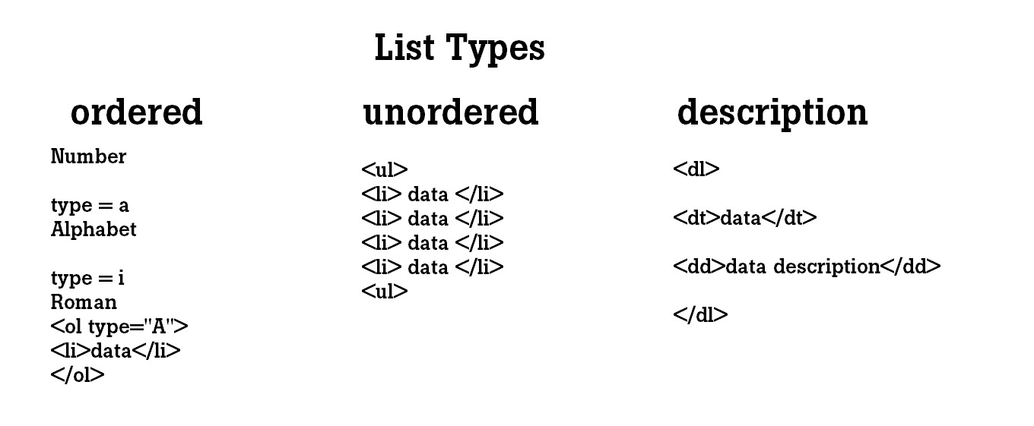

Q : 6

**What are the class attribute in HTML ?**

Ans :

The HTML class attribute specifies one or more class names for an element.

Class are used by CSS & JavaScript to select and access specific element.

The class attribute can be used on any HTML element.

The class names is case sensitive difficult HTML element can point to the same class name.

Ex :

<head>

<style>

.txt color

{

Color : red;

}

</style>

</head>

<body>

<p class=”txt color”>Jay</p>

</body>

Output : Jay

Q : 7

**What is the difference between the id and class attributes in HTML ?**

Ans :

A Class name can be used by multiple HTML elements, while an ID name must only be used by one HTML element within the page.

While an ID is specific to a single element, classes can be assigned to multiple elements on a page or throughout the website.

Q : 8

**What are the various formatting tags in HTML ?**

Ans :

Formatting elements were designed to display special types of text:

|  |  |
| --- | --- |
| <b> | Bold text |
| <strong> | Important text |
| <i> | Italic text |
| <em> | Emphasized text |
| <mark> | Marked text |
| <small> | Smaller text |
| <del> | Deleted text |
| <ins> | Inserted text |
| <sub> | Subscript text |
| <sup> | Superscript text |

Q : 9

**How cell padding different from cell spacing ?**

Ans :

Their difference is the amount of space that the content between cells takes up. Cell padding and cell spacing are two different things. Cell spacing refers to the distance between the cells in a grid layout, and cell padding refers to the space around each cell.

Ex :

**Cell padding :**

<head>

<style>

th,td

{

Padding: 15px;

}

</style>

</head>

**Cell spacing :**

<head>

<style>

th,td

{

Border-spacing: 30px;

}

</style>

</head>

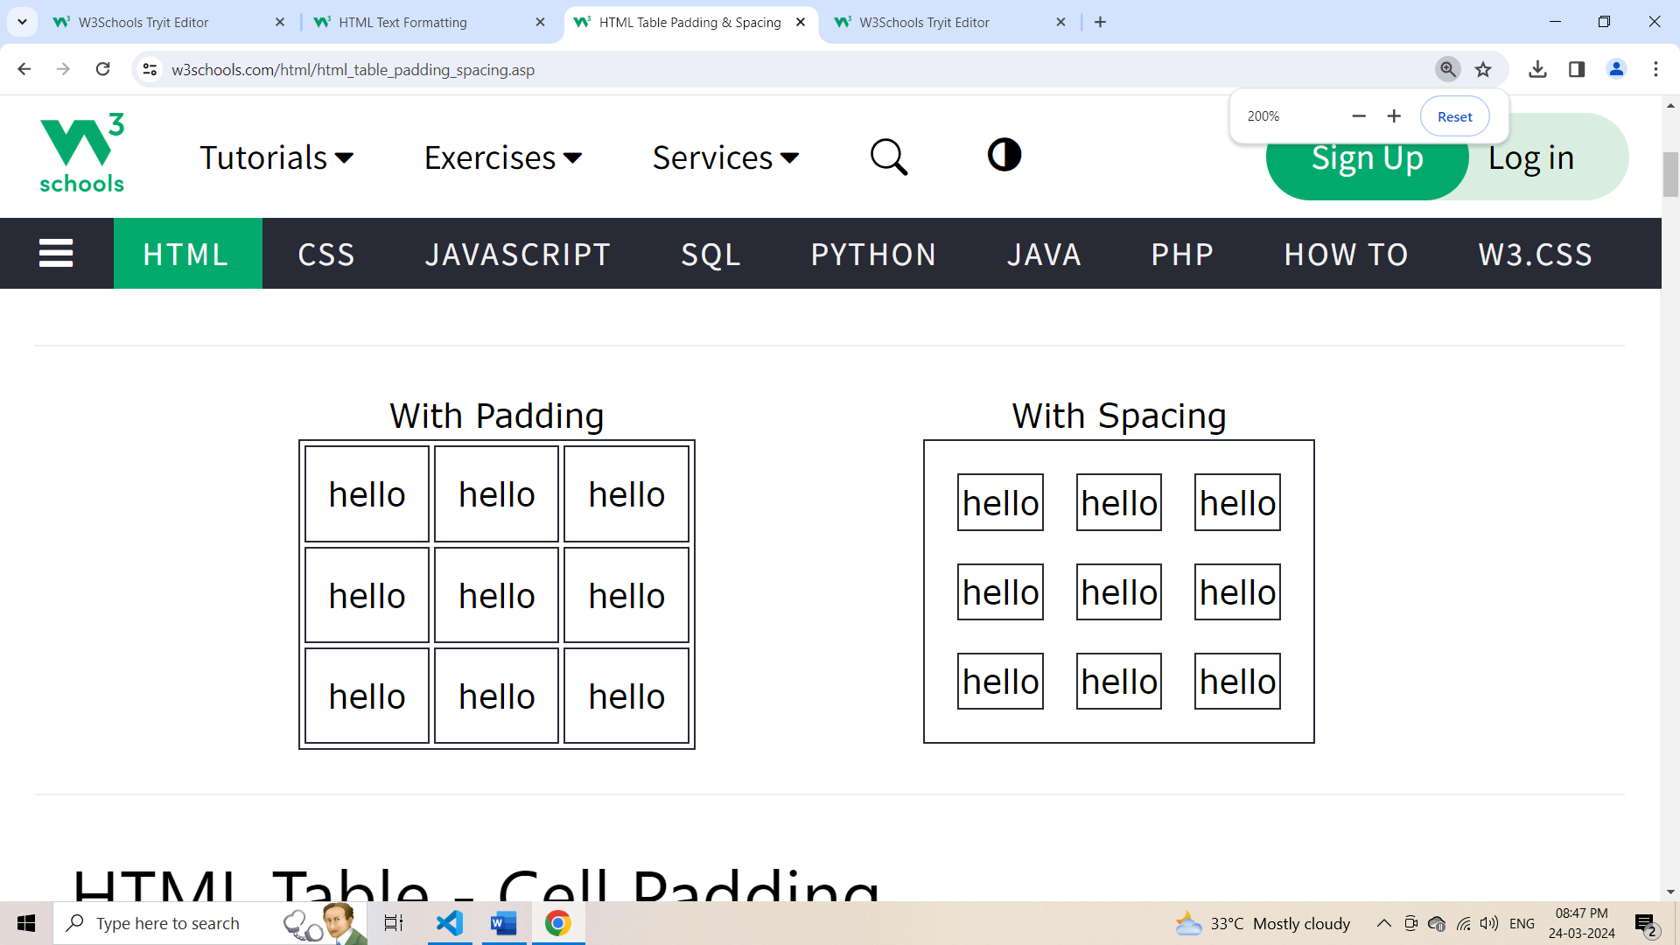

Q : 10

**How can we club two row or more rows or columns into single row or column in HTML table ?**

Ans :

To merge two or more row cells, use the **rowspan** attribute. If you want to combine the first two cells in the first column, you can use the **colspan="2"** attribute in the first tag. The number represents how many cells to use (merge) for the tag.

Ex :

**Rowspan :**

<table>

<tr>

<th>Name</th>

<th>Balance</th>

<th>Account Type </th>

</tr>

<tr>

<td>Jay </td>

<td>20,000</td>

<td rowspan="2"> Saving</td>

</tr>

<tr>

<td>Pratik </td>

<td>10,000</td>

</tr>

</table>

**Output :**

|  |  |  |
| --- | --- | --- |
| **Name** | **Balance** | **Account Type** |
| Jay | 20,000 | Saving |
| Pratik | 10,000 |

Ex :

**Colspan :**

<table>

<tr>

<th>Name</th>

<th>Balance</th>

</tr>

<tr>

<td>Jay</td>

<td>20,000</td>

</tr>

<tr>

<td>Pratik</td>

<td>10,000</td>

</tr>

<tr>

<td colspan="2">Total: 30,000</td>

</tr>

</table>

**Output :**

|  |  |
| --- | --- |
| **Name** | **Balance** |
| Jay | 20,000 |
| Pratik | 10,000 |
| Total: 30,000 | |

Q : 11

**What is the difference between a block-level element and inline-level element ?**

Ans :

**Block-Level :** Block Elements occupy the full width irrespective of their sufficiency.

**Inline-Level :** Inline elements occupy only sufficient width required.

**Note:** Inline elements don't start in a new line. Block elements always start in a line.

Q : 12

**How to create hyperlink in HTML ?**

Ans :

The <a href=”**Link**”> tag defines hyperlink, which is a used to link from one page to another page.

The most important attribute of the <a> element is **href** attribute which indicate the link is destination.

Ex :

<a href=<https://www.google.com>>Go to google</a>

Q : 13

**What is the use of an iframe tag in HTML ?**

Ans :

An inline frame (iframe) is a HTML element that loads another HTML page within the document. It essentially puts another webpage within the parent page. They are commonly used for advertisements, embedded videos, web analytics and interactive content.

generally, this tag use to some another site page

implement in your site.

Q :14

**What is the use of span tag? explain it with example.**

Ans :

In HTML, the span tag is generic inline container element you can use this element to wrap sections of text for styling purpose or to add attributes to a section of text without creating a new line content.

It's a similar but not same as <div> tag.

Ex :

<p> My name is

<span style=”color:red;”>Jay</span>

**Output :**

My name is Jay

Q : 15

**How to insert a picture into background image of webpage?**

Ans :

To add background image on an HTML element, use the HTML style element attribute and the CSS background property.

In Element :

<p style=”background-image: url(‘jay.png’);”>

In Body :

<style>

Body

{

Background-image : url (‘jay.png’);

}

</style>

Q : 16

**How are active link different from normal links ?**

Ans :

A normal link is just a line of code that contains a pointer to another resource.

A active link is that line of code in action, pending that other resource.

Active link means you can hold cursor on link (hold click on particular link).

Ex :

<style>

a:link

{  
color : bule;

}

a:active

{

color : red;

}

</style>

**Output :**

**Google.com**

**Google.com**

Q : 17

**What are different tags to separate section of text?**

Ans :

We separate a section of text in HTML using the below tag

<br>

<br> tag it is used to separate the line of text <p> tag is used to write a paragraph.

In HTML we have <section> tag for create section for text.

<section> Content </section>.

Q : 18

**What is SVG in HTML ?**

Ans :

SVG used to define vectors based graphics for web.

SVG defines graphic in XML format, each element & attribute in SVG file can be animated.

SVG is a W3C recommendation.

SVG integrates with other standards such as CSS, DOM, XSl & JavaScript.

Q : 19

**What is the difference between HTML & XHTML ?**

Ans :

HTML Hypertext Markup Language & XHTML extensible Hypertext Markup Language are both markup language used to creating & displaying webpage.

The main difference between them is the syntax & structure.

HTML is more lenient.

Syntax, while XHTML has more strict syntax and follows XML rules.

Q : 20

**What are logical and physical tags in HTML?**

Ans :

In HTML the formatting tags are divided into two categories.

Physical Tags:

These tags are used to provides the visual appearance to the text.

Logical Tags:

These tags are used to add some logical or semantic value to the text.

Logical Tags :

<abbr>

<acronym>

<cite>

<code>

<blockquotes>

<del>

<ins>

<q>

<samp>

<var>

Physical Tags:

<b>

<big>

<i>

<small>

<sup>

<sub>

<u>.