Assignment

**Q-1 : What are the benefits of using CSS?**

**Ans :**

**CSS : Cascading Style Sheet**

CSS offers several advantages:

* Including improved website aesthetics.
* Easy updates across multiple pages.
* Faster loading times and the ability to create responsive designs that adapt to various devices.

**Syntax of CSS :**

p {

color:red;

}

<p> Jay Dholakia </p>

**Output :**

Jay Dholakia

**Q-2 : What are the disadvantages of CSS?**

**Ans :**

**Disadvantage of CSS :**

1. **Browser compatibility.**
2. **Learning Curve.**
3. **Lack of security.**
4. **Limited layout control.**
5. **Performance impact.**
6. **Overriding style.**
7. **Maintenance challenges.**

1. Browser Compatibility

CSS may render differently in various web browsers, leading to inconsistencies in the visual presentation.

2. Learning Curve

One among the main disadvantages of cascading style sheets is that while it is essential for web development, it can be complex, especially for beginners.

3. Lack of Security

CSS itself does not offer security features, and it can be vulnerable to attacks like Cross-Site Scripting (XSS) when used inappropriately. Developers must be cautious when implementing CSS to prevent security risks.

4. Limited Layout Control

CSS has limitations when it comes to controlling complex layouts. Achieving specific layouts, such as equal-height columns, can be challenging without resorting to workarounds or additional technologies like Flexbox or Grid.

5. Performance Impact

Extensive or poorly optimized CSS files can slow down page load times. It's essential to minimize and optimize CSS to maintain optimal website performance.

6. Overriding Styles

The "cascading" nature of CSS can sometimes lead to unexpected styling conflicts. Specificity and the order in which styles are applied can result in unintended consequences.

7. Maintenance Challenges

As websites grow and evolve, maintaining and refactoring CSS can become complex and time-consuming. It's crucial to follow best practices and use naming conventions to keep styles manageable.

**Q-3 : What is the difference between CSS2 and CSS3?**

**Ans :**

The biggest difference between CSS-2 and CSS-3 is that CSS-3 has been split into different sections, called modules.

Each of these modules is making its way through the W3C in various stages of recommendation process.

The following features are new in CSS2 vs CSS3

Combinator

CSS Selectors

Pseudo-elements

Style properties

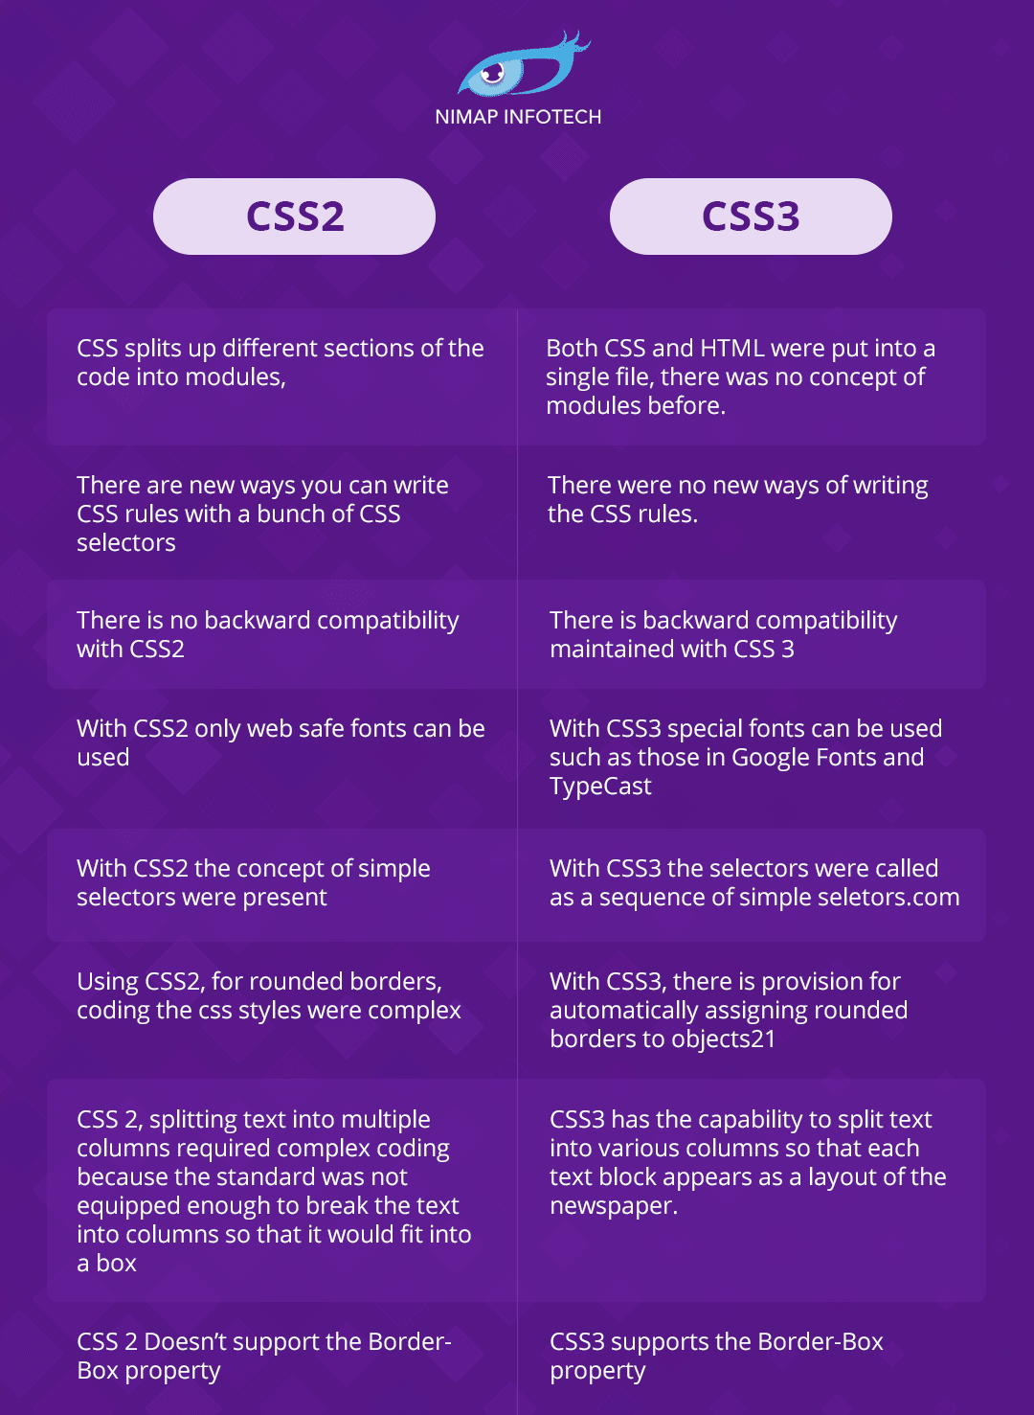

**Q-4: Name a few CSS style component?**

**Ans:**

**The components of a CSS style are:**

**Selector:**

This is the HTML element or elements that the style will be applied to.

**Examples:**

<h1>, <p>, .class-name, or #id-name.

**Property:**

The specific aspect of the element that you want to style, such as **color**, **font-size**, **background-color**, etc.

**Value:**

The value assigned to the property, such as

**red**, **16px**, or **#ffffff**.

**For Example:**

**selector** {

property: value;

property: value;

}

**h1** {

**color**: blue;

**font-size**: 24px;

**font-weight**: bold;

**color**: red;

**text-align**: center;

}

**.class-name**

{

background-color: #f2f2f2;

padding: 10px;

margin-bottom: 20px;

}

**#id-name** {

text-align: center;

font-family: Arial, sans-serif;

}

As above example, h1, .class-name, and #id-name are the selectors, the properties are things like **color, font-size, background-color**, etc.…., and the values are the actual settings applied to those properties.

**Q-5 :** **What do you understand by CSS opacity??**

**Ans :**

The opacity CSS property sets the opacity of an element. Opacity is the degree to which content behind an element is hidden, and is the opposite of transparency.

**Ex:**

<style>

P

{

**Opacity:1; (it’s display 100% of visibility)**

}

</style>

<p>Jay Dholakia</p>

<h1> 3691</h1>

**Output:**

**Jay Dholakia**

**3691**

**When Opacity: 0.8;**

**Jay Dholakia**

**3691**

**When Opacity: 0.6;**

**Jay Dholakia**

**3691**

**When Opacity: 0.4;**

**Jay Dholakia**

**3691**

**When Opacity: 0.2;**

**Jay Dholakia**

**3691**

**When Opacity: 0; (it’s display none )**

**3691.**

**Q-6: How can the background color of an element be changed?**

**Ans:**

We can set background color by selecting the element by its class name of id name and then apply the background-color property on it to set the background color.

**Ex:**

**<html>**

**<head>**

**<title>bg</title>**

**<style>**

**.box1**

**{**

**Height:100px;**

**Width:100px:**

**Background-color:red;**

**}**

**.box2**

**{**

**Height:100px;**

**Width:100px:**

**Background-color:blue;**

**}**

**.box3**

**{**

**Height:100px;**

**Width:100px:**

**Background-color:green;**

**}**

**</style>**

**</head>**

**<body>**

**<div class=”box1”>**

**</div>**

**<div class=”box2”>**

**</div>**

**<div class=”box3”>**

**</div>**

**</body>**

**</html>**

**Output:**

**Q-7: How can image repetition of the backup be controlled?**

**Ans:**

By using the **background-repeat property** that will help us to control the repetition of the image. The background-repeat property in CSS is used to repeat the background image both horizontally and vertically. It also decides whether the background image will be repeated or not.

**Ex:**

<html>

<head>

<title>img-rep</title>

<style>

.bg

{

Background-image:url(‘red.png’);

Background-repeat:no-repeat;

}

</style

</head>

<body>

<div class=”bg”></div>

</body>

</html>

**Output:**

**Without background-repeat property :**

**Q-8 :** **What is the use of the background-position property?**

**Ans :**

The background-position CSS property sets the initial position for each background image. The position is relative to the position layer set by background-origin .

**Ex:**

**<html>**

**<head>**

**<title>bg img pos</title>**

**<style>**

**bg{**

**height:100px;**

**width:100px;**

**background-position: top-left;**

**background-position: bottom-left;**

**background-position: left;**

**background-position: right;**

**background-position: center;**

**}**

**</head>**

**<body>**

**<div class=”bg”></div>**

**</body>**

**</html>**

**Output:**

Top-right

Top-left

Center

Bottom-right

Bottom-left

**Q-9 :** **Which property controls the image scroll in the background?**

**Ans:**

background-attachment property

The background-attachment property sets whether a background image scrolls with the rest of the page, or is fixed.

**scroll**

The background image will scroll with the page. This is default

**fixed**

The background image will not scroll with the page

**local**

The background image will scroll with the element's contents

**initial**

Sets this property to its default value.

**Inherit**

Inherits this property from its parent element.

**Ex:**

**<html>**

**<head>**

**<title>bg img attch</title>**

**<style>**

**.bg**

**{**

**Background-image:url(“red.png”);**

**Background-repeat:no-repeat;**

**Background-position:left;**

**Background-attechment:fixed;**

**}**

**</style>**

**</head>**

**<body>**

**<div class=”bg”>**

**Hi….**

**My name is jay ….**

**My ……..long paragraph**

**</div>**

**</body>**

**</html>**

**Output :**

Hii…

My name Jay

My……Any long paragraph………………….

…………………………………………………………

………………………………………………………..

**Q-10 : Why should background and color be used as separate properties?**

**Ans:**

**There are two reasons behind this:**

It enhances the legibility of style sheets.

The background property is a complex property in CSS, and if it is combined with color, the complexity will further increase.

Generally background use to set background-color, image or more properties of background in CSS, and color use to set color on text.

Background has own color property in CSS which is background-color.

Background has many properties in CSS

Background-color

Background-size

Background-position

Background

Many more

Color has only one property which is change only text color.

If we use color only so we can change text color but with background we can change color, size, position, alignment etc….

So that’s why background and color both are separated properties in CSS.

**Q-11 :** **How to center block elements using CSS1?**

**Ans:**

To horizontally center a block element (like <div>), use margin: auto; Setting the width of the element will prevent it from stretching out to the edges of its container.

Another way to set element center like generally

used code margin:50px auto; its help to set div center.

**Ex:**

Div

**With :**

**div**

**{**

**margin:50px auto;**

**}**

div

**Q-12 :** **How to maintain the CSS specifications?**

**Ans:**

CSS specifications?

The Specification defines how CSS properties should be implemented by browser vendors along with detailed algorithms, code samples and tabular information.

The CSS specifications are maintained by the World Wide Web Consortium (W3C).

Even though every browser supports CSS, there are many inconsistencies in the supported specification version. Some browsers even have their own implementation of the specification and have proprietary (vendor) prefixes.

**Q-13 :** **What are the ways to integrate CSS as a web page?**

**Ans:**

There are 3 steps/way to integrate CSS in web page.

1. Inline
2. Internal / embedded
3. External

1.Inline: in inline styling you have to set styling in tag using style tag

Ex. <p style=” color:red; ”> Jay Dholakia </p>

Output : Jay Dholakia

2.internal/embedded:

In internal/embedded styling we have to apply style tag on same page.

You want to set some style common for one or more tags than you can gives class (.) name or you want to set styling only for one tag than use id (#) so you can apply styling using style tag on same page.

Ex :

<head>

<style>

p

{

color:white;

background-color:red;

wi

text-align:center;

font-size:36px;

}

</style>

</head>

Output:

Jay Dholakia

3.External:

In External styling you have to create another file which is (file-name).css (.css) necessary to create any css file, and link that file into your web-page.

Ex :

Create style.css

Add some styling in that file.

P

{

Color:red;

Font-size:36px;

}

Web-page :

<head>

<link rel=”stylesheet” href=”style.css”>

Rel:use to relation with files.

</head>

<body>

<p>Jay Dholakia.</p>

</body

Output : Jay Dholakia.

**Q-14 :** **What is embedded style sheets?**

**Ans:**

An embedded style sheet is declared within the <head> element of an XHTML document. It applies to the whole document, rather than just one element. Each style declaration (or CSS rule) gets applied to everything in the document that matches that rule.

Embedded file its also called internal style,

It’s applied in our <**head> on the webpage.**

<html>

<head>

<title>File-1<title>

<style>

p

{

color:red;

word-spacing:5px;

}

</style>

</head>

<body>

<p>Jay Dholakia</p>

</body>

</html>

**Output:** J a y D h o l a k I a

**Q-15 : What are the external style sheets?**

**Ans:**

An external style sheet is a separate CSS file that can be accessed by creating a link within the head section of the webpage. Multiple webpages can use the same link to access the stylesheet. The link to an external style sheet is placed within the head section of the page.

First create File-name.css

Applied in <head>

<link rel=”stylesheet” href=”style.css”>

Now you can easily access all the styling which you set for the tags.

**Q-16: What are the advantages and disadvantages of using external style sheets?**

**Ans:**

**The advantages of External Style Sheets**:

With the help of External Style Sheets, the styles of numerous documents can be organized from one single file.

In External Style Sheets, Classes can be made for use on numerous HTML element types in many forms of the site.

In complex contexts, Methods like selector and grouping can be implemented to apply styles.

**The disadvantages of External Style Sheets:**

An extra download is essential to import style information for each file.

The execution of the file may be deferred till the external style sheet is loaded.

While implementing style sheets, we need to test Web pages with multiple browsers in order to check compatibility issues.

**Q-17: What is the meaning of the CSS selector?**

**Ans:**

A CSS selector is the first part of a CSS Rule.

It is a pattern of elements and other terms that tell the browser which HTML elements should be selected to have the CSS property values inside the rule applied to them.

CSS selectors are used to "find" (or select) the HTML elements you want to style.

In CSS we have so many selectors :

By name / tag

By class (.)

By id (#)

Universal (*)

**Some other selectors:**

Combinator selector: (no-space)

Descendent selector: (space)

Child selector: (>)

Adjacent selector: (+(for next of sibling),~( for general ))

Pseudo selector: hover, checked, before, after many more…

Attributes selector

Nth-child selector: select particular child or child group.

**Many more selector….**

**Q-18: What are the media types allowed by CSS?**

**Ans:**

**There are many media type allow in CSS like**

**all**

Suitable for all devices.

**braille**

Intended for braille tactile feedback devices.

**embossed**

Intended for paged braille printers.

**handheld**

Intended for handheld devices (typically small screen, limited bandwidth).

**print**

Intended for paged material and for documents viewed on screen in print preview mode. Please consult the section on paged media for information about formatting issues that are specific to paged media.

**screen**

Intended primarily for color computer screens

**tv**

Intended for television-type devices (low resolution, color, limited-scrollability screens, sound available).

**Q-19: What is the rule set?**

**Rule set :**

A CSS ruleset consists of an element selector and a properties declaration block.

Each (valid) declaration block is preceded by one or more comma-separated selectors, which are conditions selecting some elements of the page. A selector list and an associated declarations block, together, are called a ruleset, or often a rule. A CSS ruleset (or rule) is visualized in the diagram below.

Example :

<style>

h1 (selector)

{ (declaration)

color (property) :red (value) ;

} (declaration)

</style>