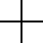
12/21

REALISTIC POST-MECHANICAL TOUCH-TYPING ASSIGNMENTS
Left-Hand Fingers |  |  |  |  |  |  |  |  |  |  |  |  |  |  |  |  |  | Right-Hand Fingers
Little |  |  |  |  | Ring |  |  |  | Middle |  |  |  | Index |  |  |  |  | Index |  |  |  |  | Middle |  |  |  | Ring |  |  |  | Little
Sec. Sign |  |  | Grave |  |  | 1 |  | 2 |  |  | 3 | 4 |  |  | 5 |  |  | 6 |  |  | 7 |  |  | 8 | 9 |  |  | 0 |  | [ |  |  | ]
\ | - |  |  | ’ |  |  | , |  |  | . |  |  | P |  |  | Y |  | F |  | G |  |  | C |  |  | R |  |  | L |  |  | / |  |  | =
Back Sp. |  | A |  |  | O |  |  |  | E |  |  |  | U | I |  |  | Caps Lk. |  | D |  |  | H | T |  |  |  | N |  |  |  | S |  |  | Enter
Shift |  | ; |  |  | Q |  |  |  | J |  |  |  | K | X |  |  | Tab |  | B |  |  | M | W |  |  |  | V |  |  |  | Z |  |  | Shift

Fig. 23

78 78

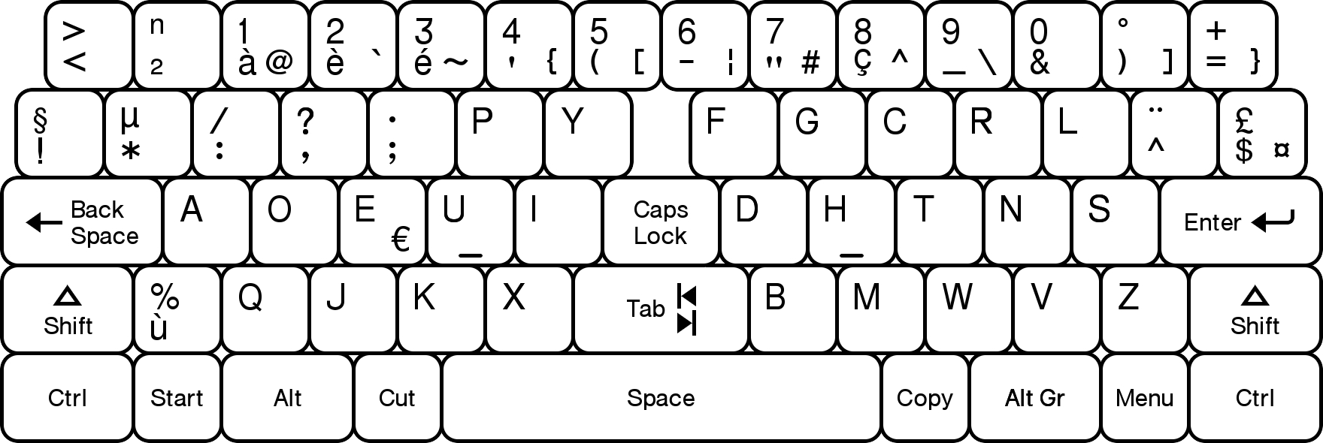

Fig. 24

13/21

52 80 54

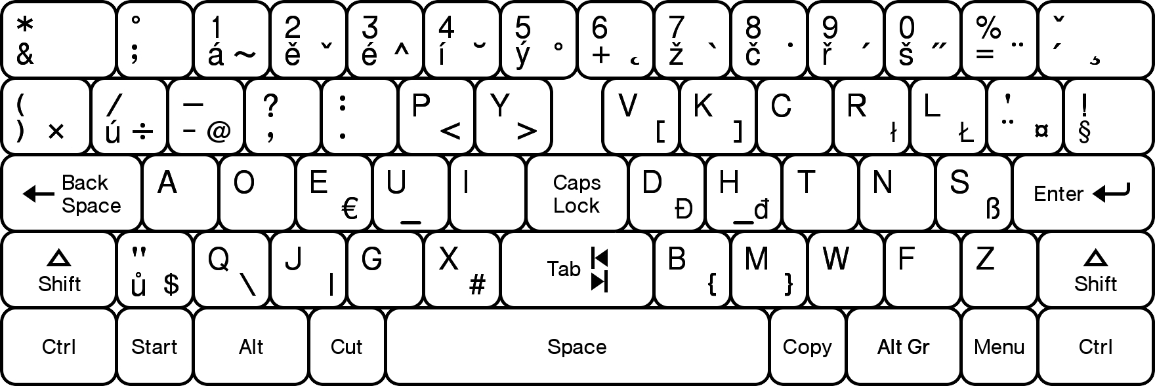

72 76
Fig. 25

EASE AND QUALITY OF REACHES FOR CONSONANT KEY-POSITIONS
Left-Hand Fingers |  |  |  |  | Right-Hand Fingers
Little | Ring | Middle | Index |  | Index |  | Middle | Ring | Little
Apostrophe | Comma | Period | 16 | Y | 10 | 9 | 6 | 7 | 8
A | O | E | U | I | 5 | 1 | 2 | 3 | 4
Semicolon | 20 | 19 | 17 | 18 | 12 | 11 | 13 | 15 | 14

Fig. 26

14/21

WESTERN EUROPEAN LANGUAGES CONSONANT FREQUENCIES
German |  | Dutch |  |  |  |  |  | Danish |  | Norwegian |  | Swedish |  | Spanish |  | Portuguese |  | French |  | Italian |  |  |  |  | Dvorak
First Tier |  |  |  |  |  |  |  |  |  |  |  |  |  |  |  |  |  |  |  |  |  | Right-Home
N |  | N |  |  |  |  |  | N |  | R | +6 | N |  | S |  | S |  | S |  | N |  |  |  |  | H
S |  | T |  |  |  |  |  | D |  | N |  | T |  | R | +5 | R | +5 | T |  | T |  |  |  |  | T
R |  | R |  |  |  |  |  | T |  | T |  | R |  | N |  | N |  | N |  | R |  |  |  |  | N
T |  | D |  |  |  |  |  | R |  | S |  | S |  | D |  | D |  | R |  | L |  |  |  |  | S
D |  | S |  |  |  |  |  | S |  | L |  | L |  | L |  | M | +6 | L |  | S |  |  |  |  | D
Second Tier |  |  |  |  |  |  |  |  |  |  |  |  |  |  |  |  |  |  |  |  |  |  |  | Right Top
H | *5 | L |  |  |  |  |  | L |  | K | +11 | D |  | C |  | T |  | D |  | C |  |  |  |  | C
L |  | G |  |  |  |  |  | G |  | D |  | M |  | T | *5 | L |  | C |  | D |  |  |  |  | R
C |  | H |  |  |  |  | *7 | H | *7 | G |  | G |  | M |  | C |  | M |  | P |  | *8 |  |  | L
G |  | V |  |  |  |  | +6 | M |  | M |  | K | +8 | P | *7 | P | *7 | P | *7 | M |  |  |  |  | G
M |  | K |  |  |  |  | +7 | K | +7 | V | +5 | V | +5 | B |  | H | *9 | V | +5 | V |  | +5 |  |  | F
Third Tier |  |  |  |  |  |  |  |  |  |  |  |  |  |  |  |  |  |  |  |  | Right Bottom
B |  | M |  |  |  |  |  | V |  | F |  | H | *10 | G |  | V |  | Q | +9 | G |  |  |  |  | M
W |  | B |  |  |  |  |  | F |  | P |  | F |  | V |  | Q | +8 | G |  | H |  | *11 |  |  | B
F |  | P |  |  |  |  |  | B |  | B |  | P |  | Q | +7 | G |  | F |  | F |  |  |  |  | W
K |  | W |  |  |  |  |  | P |  | H | *13 | B |  | H | *13 | F |  | B |  | B |  |  |  |  | Z
Z |  | J |  |  |  |  |  | J |  | J |  | C | -9 | F | -5 | B |  | H | *14 | Q |  | +5 |  |  | V
Fourth Tier |  |  |  |  |  |  |  |  |  |  |  |  |  |  |  |  |  |  |  |  |  |  | Left-Hand
V |  | C |  |  |  |  | -10 | C | -10 | C | -10 | J |  | Z |  | Z |  | J |  | Z |  |  |  |  | P
P |  | Z |  |  |  |  |  | X |  | W |  | X |  | J |  | J |  | X |  | J |  |  |  |  | K
J |  | F |  |  |  |  | -8 | Q |  | Z |  | W | -5 | X |  | X |  | Z |  | K |  |  |  |  | X
Q |  | X |  |  |  |  |  | W | -6 | X |  | Z | -5 | W | -6 | K |  | W | -6 | W |  | -6 |  |  | J
X |  | Q |  |  |  |  |  | Z | -6 | Q |  | Q |  | K |  | W | -7 | K |  | X |  |  |  |  | Q

Fig. 27

15/21

SUGGESTED MODIFICATIONS TO THE DVORAK SEQUENCE
Western European Language | Letter Pairs Exchanged | Family Classification (Indo-European)
German | No changes needed | West Germanic / High German
Dutch | C-K and F-V | West Germanic / Low Franconian
Danish | C-K | North Germanic / East Scandinavian
Norwegian | C-K | North Germanic / East Scandinavian
Swedish | C-K | North Germanic / East Scandinavian
Spanish | No changes made | Ibero-Romance
Portuguese | No changes made | Ibero-Romance
French | No changes made | Gallo-Romance / Oïl
Italian | No changes needed | Italo-Romance

Fig. 28

16/21

EASTERN EUROPEAN LANGUAGES CONSONANT FREQUENCIES
Turkish |  | Hungarian |  |  |  |  | Czech |  | Polish |  | Slovak |  | Belarusian |  |  | Russian |  |  |  |  |  |  | Dvorak
First Tier |  |  |  |  |  |  |  |  |  |  |  |  |  | Latin Alpha |  |  | Latin Alpha |  |  | Right Home
N |  | T |  |  |  |  | N |  | N |  | S |  | Н | N |  | Н |  | N |  |  |  |  | H
R | +5 | L |  |  |  | +6 | T |  | Z | +12 | N |  | С | S |  | Т |  | T |  |  |  |  | T
L | +5 | N |  |  |  |  | V | +12 | R |  | T |  | Р | R |  | С |  | S |  |  |  |  | N
D |  | S |  |  |  |  | L |  | S |  | R |  | К | K | +13 | Л |  | L |  |  |  |  | S
K | +12 | K |  |  |  | +12 | S |  | W | +8 | V | +10 | Л | L |  | В |  | V | +10 |  |  |  | D
Second Tier |  |  |  |  |  |  |  |  |  |  |  |  |  |  |  |  |  |  |  |  |  | Right Top
M | +5 | M |  |  |  | +5 | R |  | C |  | L |  | Я | ja=Q | +14 | Р |  | R |  |  |  |  | C
T | *5 | Z |  |  |  | +7 | D |  | T | *5 | K | +10 | Т | T | *5 | Д |  | D |  |  |  |  | R
S |  | R |  |  |  |  | K | +9 | D |  | D |  | Д | D |  | К |  | K | +9 |  |  |  | L
B |  | G |  |  |  |  | P | *7 | K | +8 | M |  | М | M |  | М |  | M |  |  |  |  | G
Z |  | D |  |  |  | *5 | M |  | P | *6 | C |  | В | V | +5 | П |  | P | *6 |  |  |  | F
Third Tier |  |  |  |  |  |  |  |  |  |  |  |  |  |  |  |  |  |  | Right Bottom
G |  | B |  |  |  |  | C | -5 | M |  | P | *5 | З | Z |  | Г |  | G |  |  |  |  | M
H | *11 | V |  |  |  |  | H | *11 | J | +7 | Z |  | П | P |  | Я |  | ja=Q | +8 |  |  |  | B
V |  | H |  |  |  | *12 | Z |  | L | -5 | H | *12 | Ц | ts = C | -7 | Б |  | B |  |  |  |  | W
C | -8 | J |  |  |  | +5 | J | +5 | B |  | J | +5 | Г | G | -5 | З |  | Z |  |  |  |  | Z
P |  | F |  |  |  | -5 | B |  | G | -6 | G | -6 | Б | B |  | Ч |  | ch = H | *14 |  |  |  | V
Fourth Tier |  |  |  |  |  |  |  |  |  |  |  |  |  |  |  |  |  |  |  |  | Left-Hand
F | -6 | P |  |  |  |  | G | -7 | H | *15 | F | -6 | Ч | ch = H | *15 | Й |  | i = J |  |  |  |  | P
J |  | C |  |  |  | -11 | F | -7 | F | -7 | B | -5 | Ш | sh = W |  | X |  | X |  |  |  |  | K
W | -5 | X |  |  |  |  | W | -5 | V |  | Q |  | Х | X |  | Ш |  | sh = W | -5 |  |  |  | X
Q |  | W |  |  |  | -6 | X |  | Q |  | W | -6 | Й | i = J |  | Ц |  | ts = C | -13 |  |  |  | J
X |  | Q |  |  |  |  | Q |  | X |  | X |  | Ф | F | -10 | Ф |  | F | -10 |  |  |  | Q

Fig. 29

17/21

SUGGESTED MODIFICATIONS TO THE DVORAK SEQUENCE
Eastern European Language | Letter Pairs Swapped | Family Classification
Turkish | C-K | Altaic / Turkic / Oghuz
Hungarian | C-K and F-Z | Uralic / Finno-Ugric
Czech | G-K and F-V | Indo-European / West Slavic
Polish | G-K and F-Z | Indo-European / West Slavic
Slovak | G-K and F-V | Indo-European / West Slavic
Belarusian | C-K and F-V | Indo-European / East Slavic
Russian | C-K and F-V | Indo-European / East Slavic

Fig. 30

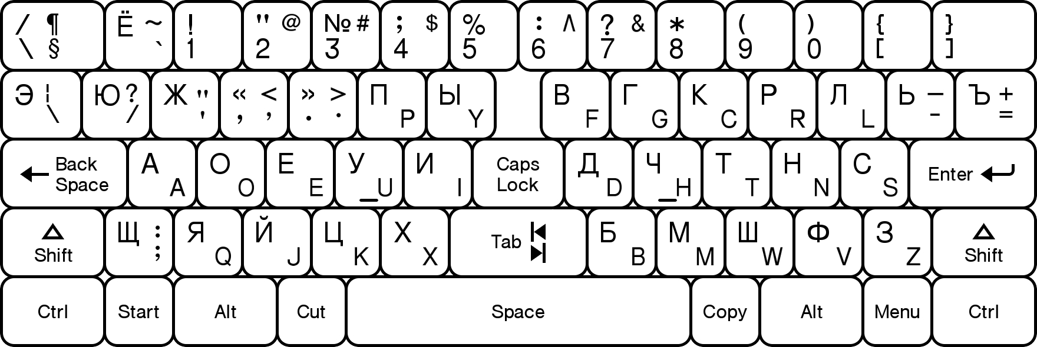

Fig. 31

18/21

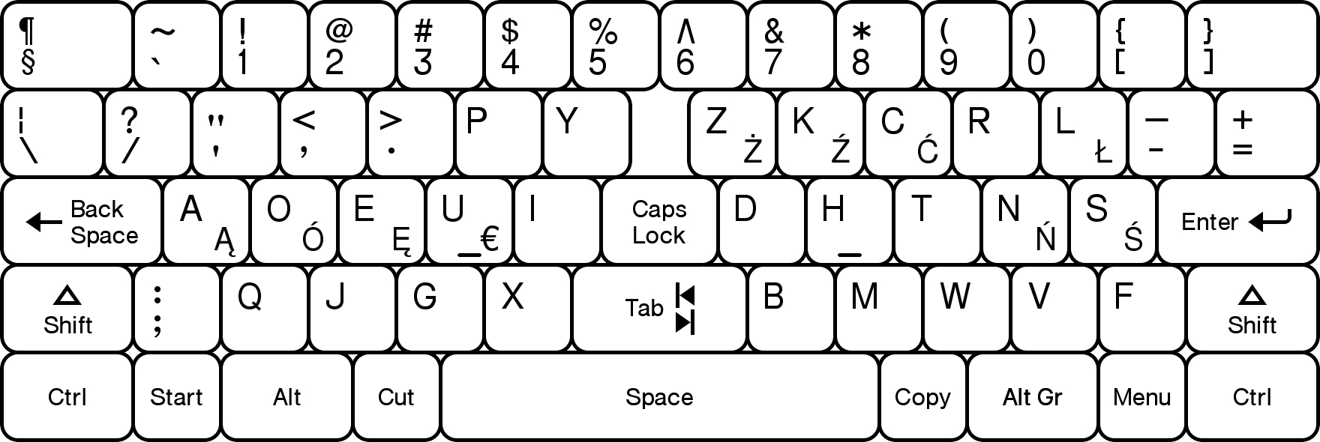

Fig. 32

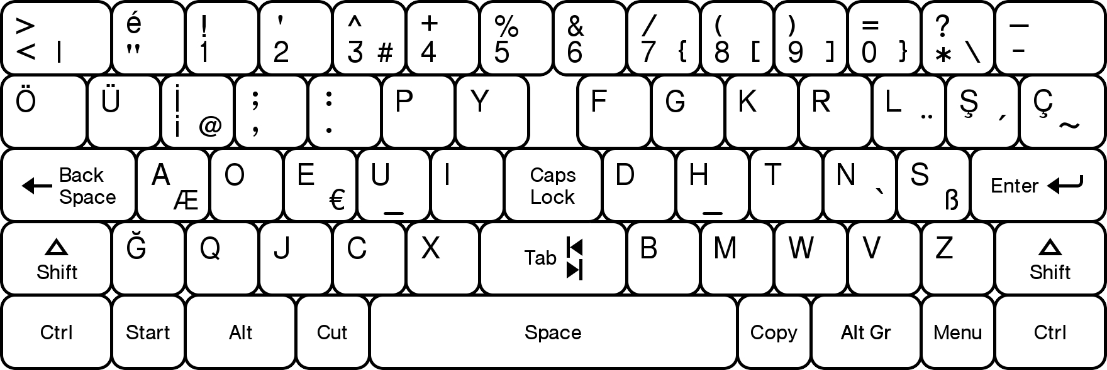

Fig. 33

19/21

MODERN GREEK LANGUAGE CONSONANT FREQUENCIES
 | Right Home |  |  |  |  | Right Top |  |  |  |  | Right Bottom |  |  |  |  | Left-Hand
Greek | Τ | Σ | Ν | Η | Ρ | Π | Κ | Μ | Λ | Δ | Γ | Χ | Θ | Φ | Β | Ξ | Ζ | Ψ
Latin Alpha | T | S | N | H | R | P | K | M | L | D | G | V | W | F | B | X | Z | C
Offset |  |  |  |  |  | *10 | +10 |  |  | *5 |  |  |  |  |  |  |  | -12
Dvorak | H | T | N | S | D | C | R | L | G | F | M | B | W | Z | V | P | K | X

Fig. 34

82 84

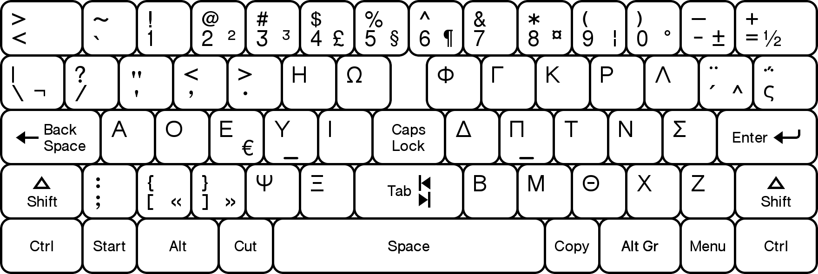

62 86

Fig. 35

20/21

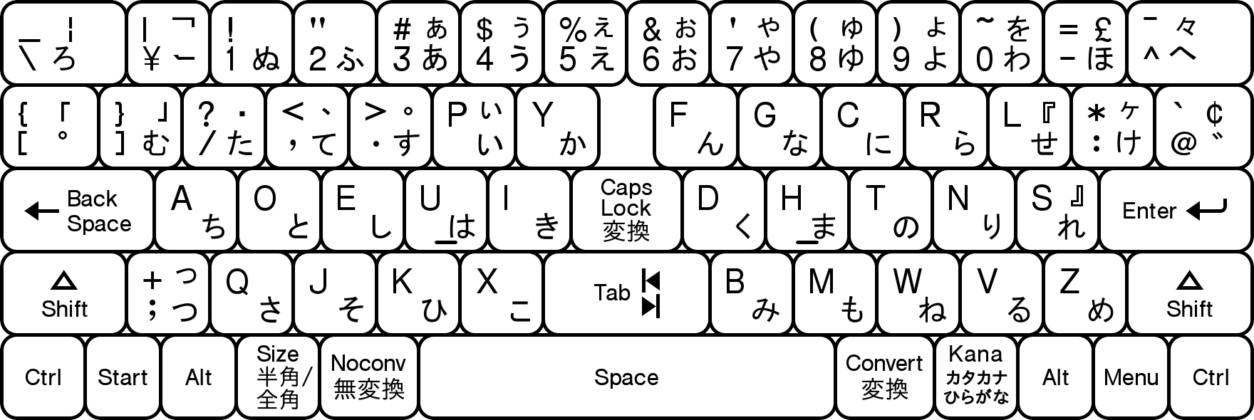

92 90 88 94

Fig. 36

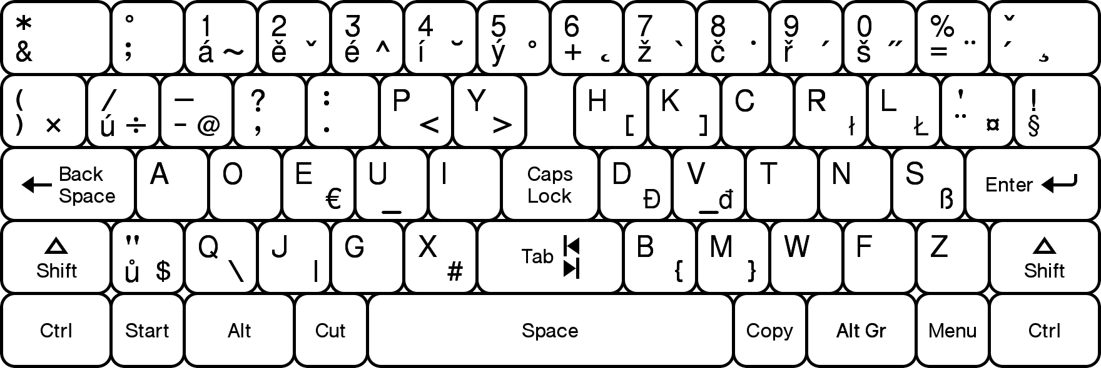

Fig. 37

21/21

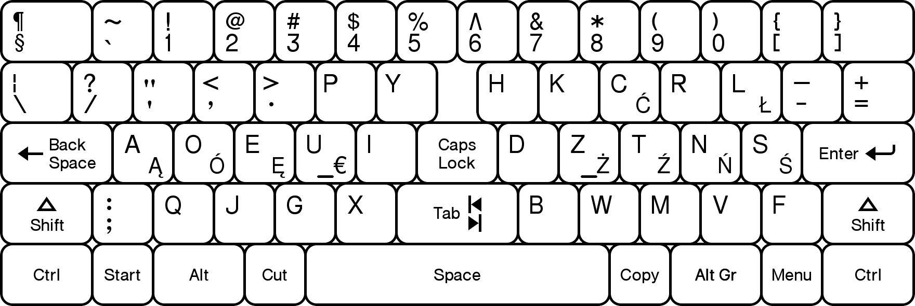

Fig. 38

