# Microsoft 365 CSV User Import

1. Sign in to your **Microsoft 365 tenant** using your Microsoft 365 login credentials.
2. Go to **Microsoft 365 admin center** by selecting the **Admin** tab.



1. Go to **Active Users** page as shown in the image.



1. Click the **Add multiple users** option, scroll down and select ‘**I’d like to upload a CSV with user information**’ checkbox as shown in the image.



1. You can directly upload the CSV file or make use of the sample CSV template provided if you don’t know how the file should be formatted. Let’s assume this is your first attempt. So click ‘**Download a CSV file that includes example user info**’ as shown in the image.



1. Open the downloaded file and **add your domain users’ details** as shown in the image. Ensure you don’t mess with the configured CSV headers.



1. Once your CSV file is ready, **upload** the same as shown in the image.



1. Once your users are successfully uploaded, the **success message** shows up as shown in the image. As you can see, you also have the option mailing the user details to yourself. Click **Close** button to complete the process.

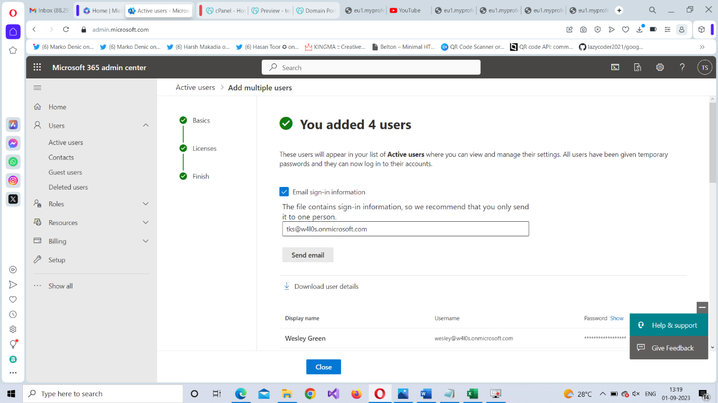

**Title**: Microsoft 365 User Import Using CSV File

**Meta Description**: This Microsoft 365 User Import tutorial explains how you can bulk import users into Microsoft 365 portal using a CSV file. It also contains GIFs that help the reader understand the process easily.

**Image alt text:**

1 image 🡪 “Accessing Microsoft 365 Admin Center”

2 image 🡪 “Accessing Active Users page”

3 image 🡪 “Selecting CSV file upload option”

4 image 🡪 “Downloading sample CSV file”

5 image 🡪 “Adding user details to the CSV file”

6 image 🡪 “Uploading the CSV file”

7 image 🡪 “User uploaded confirmation message”