Blame Report

Ok ok, I'll change the name. This is an example paragraph with any information you want to add statically to the report. I can format elements in **bold** and *italic.*

# Report

Problem type being reported

* First issue being reported
* Second issue being reported

1. Proof pictures can be added here

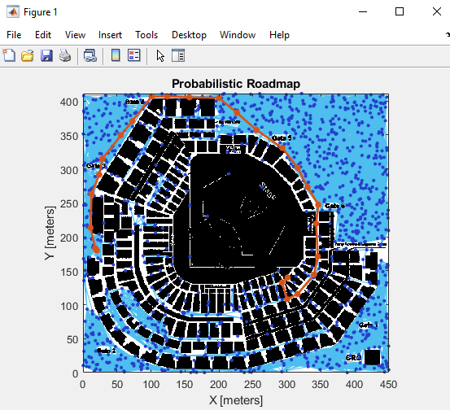

|  |  |  |
| --- | --- | --- |
| Name | Student Id | Reason for report |
| John Doof | 22345678 | Mill uncleaned |
| Jane Dirty | 21354126 | unreported tool breakage |
| Innocent Accused | 20967347 | Unmatched signin |