Workshop Tutorial 13: (part 1) A Car Indicator System Using 8051 Microcontroller.

The purpose of this experiment was to design and implement a multi-mode LED indicator system using an 8051 microcontroller. The system simulates the behaviour of vehicle indicator lights by using three external switches to select between different LED flashing patterns. The project demonstrates digital input handling, debouncing, state-machine design, and LED pattern generation using bitwise operations.

LIST OF COMPONENTS USED:

    - C80551F120x Development Kit + Power adapter
    - Silicon Labs USB Debug adapter + USB cable
    - Solderless Breadboard
    - Box with Wires
    - Jumper cables (Female-to-Male mainly)
    - 8 Bit LED Bar
    - TTP223 Capacitive Touch Switch
    - 1/4W 220ohms resistors

Case Study: A Car Indicator
It uses three external switches to indicate turning left (tail flashing), right (tail flashing)
And the hazard (simultaneous flashing) on an external strip of LEDs.

Hardware Function Overview:

Inputs (Port 1)
- P1.1 → Switch 1 (Blink All)
- P1.2 → Switch 2 (Left-Right)
- P1.4 → Switch 3 (Right-Left)

Each switch is active-high and uses internal pull-ups.

Outputs (Port 2)
- P2.0 – P2.7 drive the LED strip
- LEDs are controlled using bit-patterns written to P2
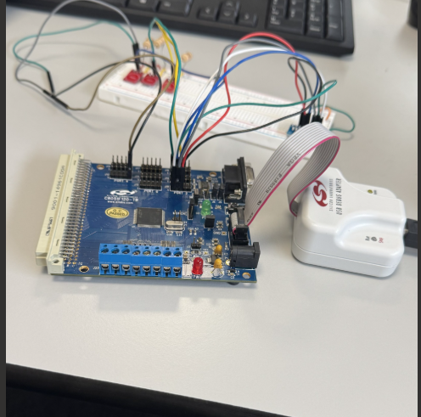

The project implements a multi-mode LED indicator controller using an 8051 microcontroller.
Three external switches select between:

- Blink All LEDs
- Left-to-Right scanning
- Right-to-Left scanning

Each mode is toggled ON/OFF by pressing its corresponding switch.
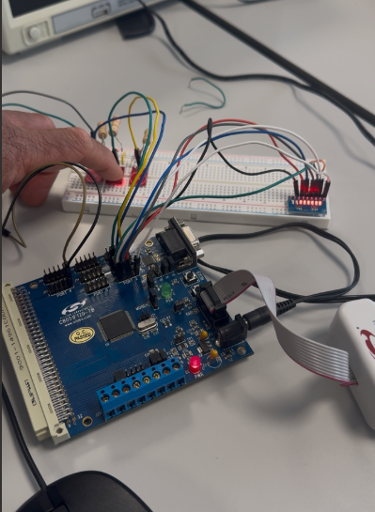
Software Architecture
The program uses a state machine with a single variable:

MODE = 0 → Idle
MODE = 1 → Blink All
MODE = 2 → Left → Right
MODE = 3 → Right → Left

Each switch toggles its mode:
- If MODE ≠ selected mode → switch sets it
- If MODE = selected mode → switch resets to 0 (idle)
This prevents multiple animations from running at once.

Switch Handling:

Each switch is processed with:
- Debouncing
- Toggle logic
- Release detection

This ensures:
- No false triggers
- No repeated activation while holding the switch
- Clean transitions between modes

- LED Animation Logic

- 1. Blink All
- All LEDs ON → delay → all LEDs OFF → delay
Repeats while MODE = 1.

2. Left → Right
- Bit pattern shifts from P2.0 → P2.7:
0000 0001
0000 0010
0000 0100
...
1000 0000 …… then set back to the start.
3. Right → Left
Bit pattern shifts from P2.7 → P2.0:
1000 0000
0100 0000
0010 0000
...
0000 0001 …... Then wraps back to the start.
Timing:
A software delay loop that provides approximately 0.8-1.0 seconds per step. Giving a clear visible indicator effect.

Conclusion:
The project successfully implements a functional car-indicator simulation using the 8051-microcontroller. The system demonstrates reliable switch input handling, structured program design, and visually clear LED animations. The final implementation meets all functional requirements and provides a strong foundation for more advanced embedded-systems applications such as interrupt-driven control, PWM dimming, or hardware timer-based flashing

