Workshop Tutorial 14: Group Case Study (part 2) A Traffic Light Controller.

LIST OF COMPONENTS USED:
  - Arduino Uno microcontroller board + USB cable
  - 2x Traffic Light LEDs / G/Y/R
  - 1x Pedestrian Crossing LEDs / G/R
  - Solderless Breadboard
  - 1x Push Button
  - Male-male jumper wire
  - USB cable / 5V
Arduino Traffic Light Controller and one pedestrian crossing.

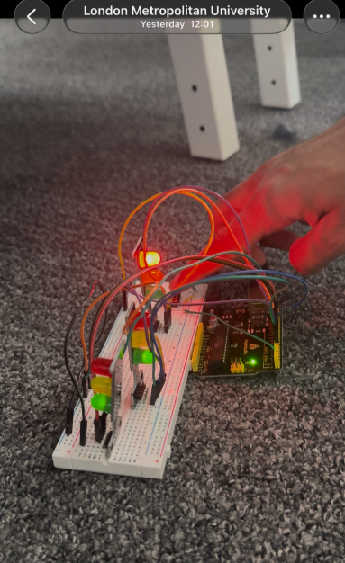
System Overview

The Arduino controls two vehicle traffic lights (Left and Right) and one pedestrian crossing. A push-button acts as the pedestrian request input. In the default state, both vehicle directions remain GREEN, and the pedestrian signal remains RED.

Default State
- Left traffic light: GREEN
- Right traffic light: GREEN
- Pedestrian light: RED
- System continuously monitors the push-button using INPUT_PULLUP.

Hardware Wiring Description:

Traffic Light LEDs (Right Side)
- Green LED to Arduino pin 5
- Yellow LED to Arduino pin 6
- Red LED to Arduino pin 7
- Each LED’s ground leg is connected to the breadboard ground rail

Pedestrian LEDs
- Pedestrian Red LED to Arduino pin 10
- Pedestrian Green LED to Arduino pin 9
- Each LED’s ground leg goes to the breadboard ground rail

Push Button
- One leg of the button is connected to the breadboard row that goes to Arduino pin 2
- The other leg of the button is connected to the breadboard ground rail
- Arduino pin 2 is configured as INPUT_PULLUP, so the button reads LOW when pressed

Power Distribution
- Arduino 5V pin is connected to the breadboard positive power rail
- Arduino GND pin is connected to the breadboard ground rail
- All LED grounds and the button ground connect to this shared ground rail
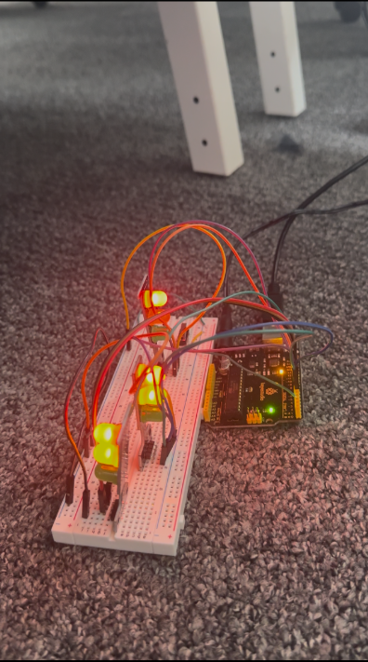

Pedestrian Request Sequence:

When the button is pressed (logic LOW), the Arduino runs setTransitionGR(), which performs the following phases:
Phase 1 – Vehicle Green (2 seconds)
Both directions remain green briefly to complete the current flow.

Phase 2 – Vehicle Amber (1 second)
Both directions switch to amber to warn drivers that the lights are about to change.

Phase 3 – Red + Red/Amber (1 second)
Both directions go to RED+AMBER, preparing to stop fully.

Phase 4 – All Red (0.5 seconds)
Both directions are held at solid red to ensure the junction is fully clear.

Phase 5 – Pedestrian Green (3 seconds)
Pedestrian signal turns GREEN, allowing safe crossing.

Phase 6 – Pedestrian Red (0.5 seconds)
Pedestrian signal returns to RED, ending the crossing period.

Phase 7 – Vehicle Red/Amber (1 second)
Both directions show RED+AMBER, preparing to return to green.

Phase 8 – Vehicle Amber (2 seconds)
Both directions show amber as part of the restart sequence.

Phase 9 – Vehicle Green (2 seconds)

Code Operation:
Normal traffic flow resumes.
The Arduino program is structured using modular helper functions that control each individual light state (green, amber, red, and red-and-amber) for both traffic directions and the pedestrian crossing. The system begins in a default state where both vehicle directions are set to green, and the pedestrian signal is held at red. The push-button is connected to digital pin 2 and configured using INPUT_PULLUP, meaning a button press registers as a LOW signal.
When the button is pressed, the program calls the function setTransitionGR(), which executes a complete pedestrian-crossing sequence. This sequence follows UK-standard traffic-light behaviour and is implemented using timed delays to ensure each phase is displayed for the correct duration.

Observation:
LEDs lighting in correct sequence
Button triggering pedestrian phase
Arduino responding correctly

In this lab, we implemented a complete traffic-light control system using an Arduino, two vehicle signal sets, and a pedestrian crossing. The system operates in a default green-light state and responds to a pedestrian button press by executing a full UK-standard transition sequence, including green, amber, red, red-and-amber phases, and a timed pedestrian-crossing interval. The design uses modular helper functions to manage each light state clearly and consistently, and the timing logic ensures safe and realistic operation of the junction. Overall, the system demonstrates effective event-driven control and correct sequencing behaviour suitable for real-world traffic management.
As hardware lead, I designed the LED and button interface and refined the firmware to ensure the physical system operated safely. My main contribution was implementing the blinking pedestrian-green phase, which provides a clear visual warning and gives anyone already crossing extra time to finish before traffic resumes.

