**STUDENT MARKS AND GRADING MANAGEMENT SYSTEM**

NAME: Dhritam Kalita

INSTITUTION: Assam Downtown University

COURSE: C Programming

SUPERVISOR’S NAME: Gautam Ahuja

DATE OF SUBMISSION: 24 April, 2025

**ABSTRACT**

This project provides a straightforward console-based application meant to accept a student's scores in five subjects and calculate the total marks, average score, and final grade. The major aim is to illustrate the utilization of basic programming elements like functions, conditional statements, and optionally, arrays for improved data handling.

The program applies single functions to modularize the basic operations: one function returns the sum of marks, another returns the mean, and a third calculates the grade from predefined grading rules based on an if-else if-else ladder. The grading scheme classifies performance as Grade A, B, C, D, or Fail based on average score thresholds.

This approach lends itself to code reusability, readability, and logical flow. The output is neatly presented so that each part of the result — total marks, average, and final grade — is displayed in a clear, easily readable format. The project is an evident illustration of how the basic programming principles can be used in a working, real-world situation.

**INTRODUCTION**This project aims to develop a simple program that takes a student's marks in five subjects and calculates the total, average, and grade. It uses basic programming concepts such as functions, conditional statements, and optionally arrays to keep the code organized and clear.

The program helps automate a common academic task, reducing manual errors and saving time. It also serves as a practical exercise in applying logical structures like the if-else-if ladder for decision-making. The final output gives a neat summary of the student's performance in terms of total marks, average score, and grade.

**BACKGROUND STUDY**

This project is based on basic programming concepts such as functions, conditional statements, and optionally, arrays. These are commonly taught in beginner-level computer science courses to promote clean, modular code.

Functions are used to organize tasks like calculating the total, computing the average, and assigning grades. The grading system follows standard thresholds, similar to those used in schools.

This simple program reflects the core idea behind larger systems like student management software and helps beginners practice problem-solving and logical thinking in programming.

**IMPLEMENTATION**

The program was implemented in the C programming language using a function-based approach. The logic is divided into three main functions:

calculateTotal(): Adds all marks in the array to get the total.

calculateAverage(): Divides the total by the number of subjects to get the average.

calculateGrade(): Uses an if-else if-else ladder to assign a grade based on the average.

The program accepts user input using a loop, stores the marks in an array, and displays the total, average, and grade with clear formatting.

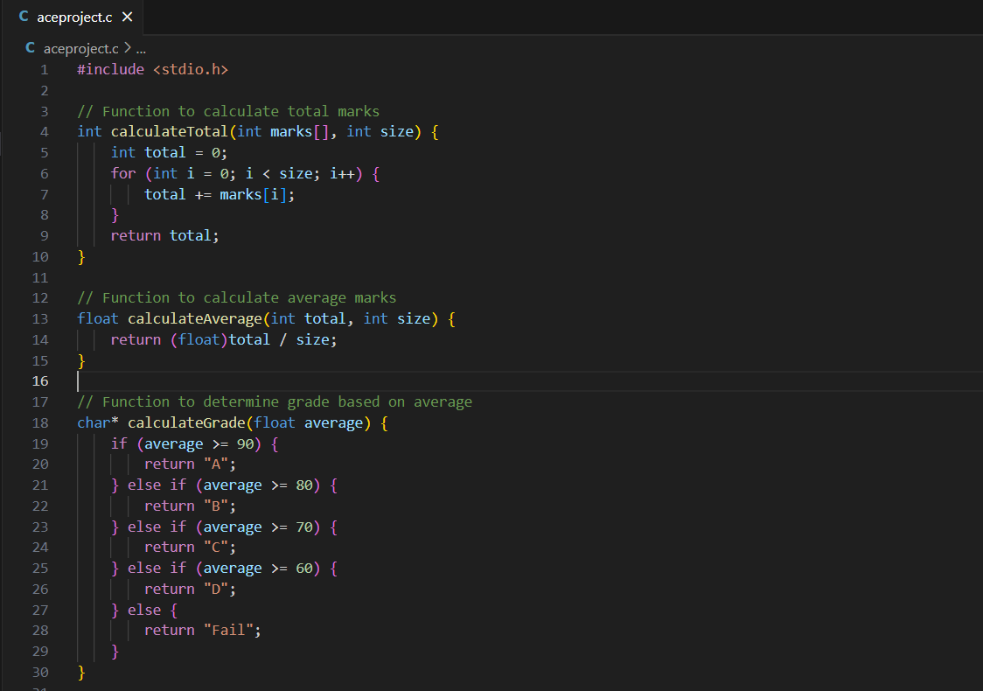

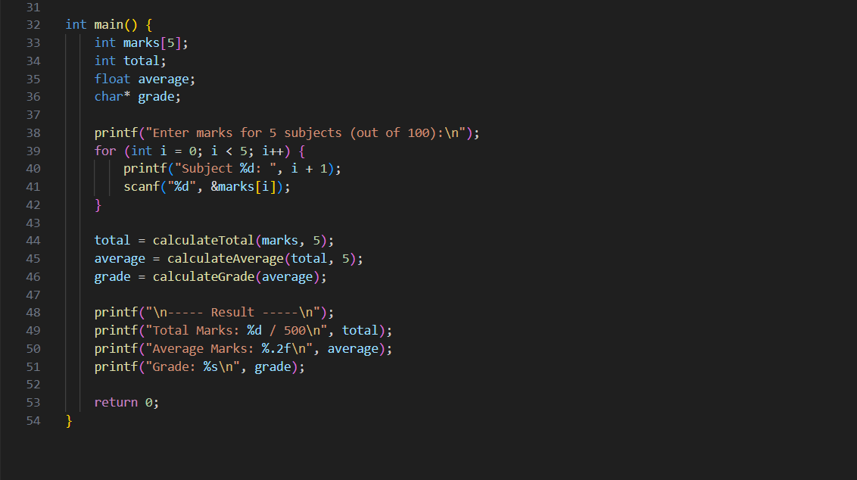

**RESULT**

The program successfully takes the marks of five subjects as input, calculates the total and average, and assigns the correct grade based on the average score. The output is displayed in a clean and readable format, making it easy for users to understand the result.

Output-

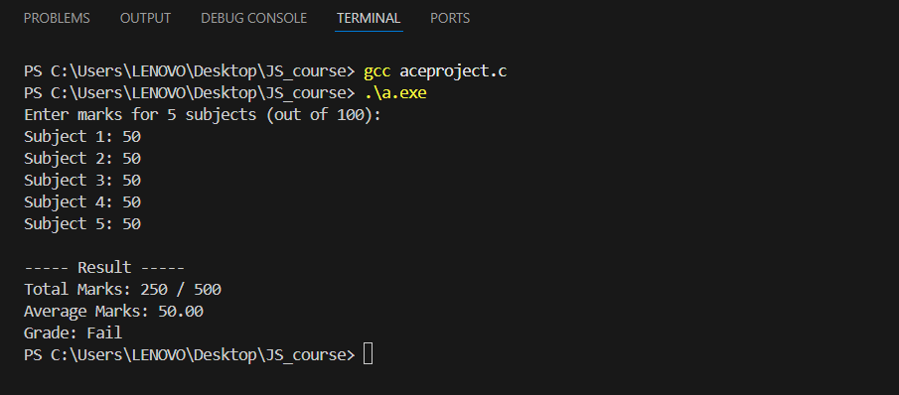

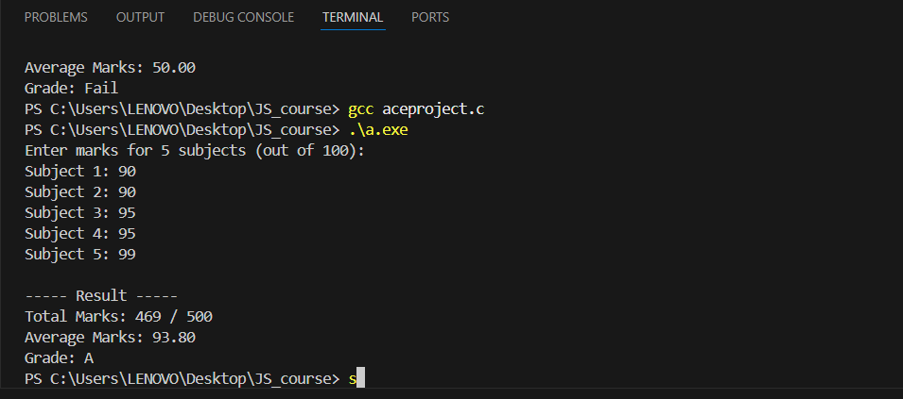

**CONCLUTION**

The project is able to effectively show how the process of computing total marks, average, and grade can be automated using user input. With the use of functions to perform various tasks, the code is reusable, modular, and easy to comprehend. The program functions as expected, returning correct results for different inputs and grade assignments.

This project not only serves its purpose of calculating grades but also aids in the learning of basic programming concepts like functions, if statements, and handling user input. The program can be developed further in the future to include more subjects, error handling, or other grading systems.