Phase 2 Project
Role-Based Access Control System

Laravel 9 | PHP | MySQL
DHROOV SINGH

1. Project Overview
This project implements a Role-Based Access Control (RBAC) system using Laravel 9. The core idea is that there is one login page for two types of users — Admin and User — and each one gets redirected to their own panel based on their role after logging in.

Both panels are protected using middleware, which acts like a security guard on each route. If someone tries to open a panel they do not belong to, they are blocked and shown a 403 Access Denied page.

Tech Stack
- Laravel 9.52
- PHP 8.2.12
- MySQL via XAMPP
- Laravel Breeze
- Bootstrap 5
- Git and GitHub

2. Project Setup — Step by Step
Step 1 — Creating the Laravel Project
The project was created using Composer, which is a PHP dependency manager. The command used was:

composer create-project laravel/laravel:^9.0 phase2-app

This downloads Laravel version 9 and sets up the entire folder structure automatically. The :^9.0 part specifically locks it to Laravel 9 so it does not accidentally install a newer version.

Step 2 — Connecting the Database
Laravel uses a file called .env to store environment settings like database name, username, and password. The following values were set:

DB_DATABASE=phase2db
DB_USERNAME=root
DB_PASSWORD=

The database itself (phase2db) was created manually in phpMyAdmin before running any migrations.

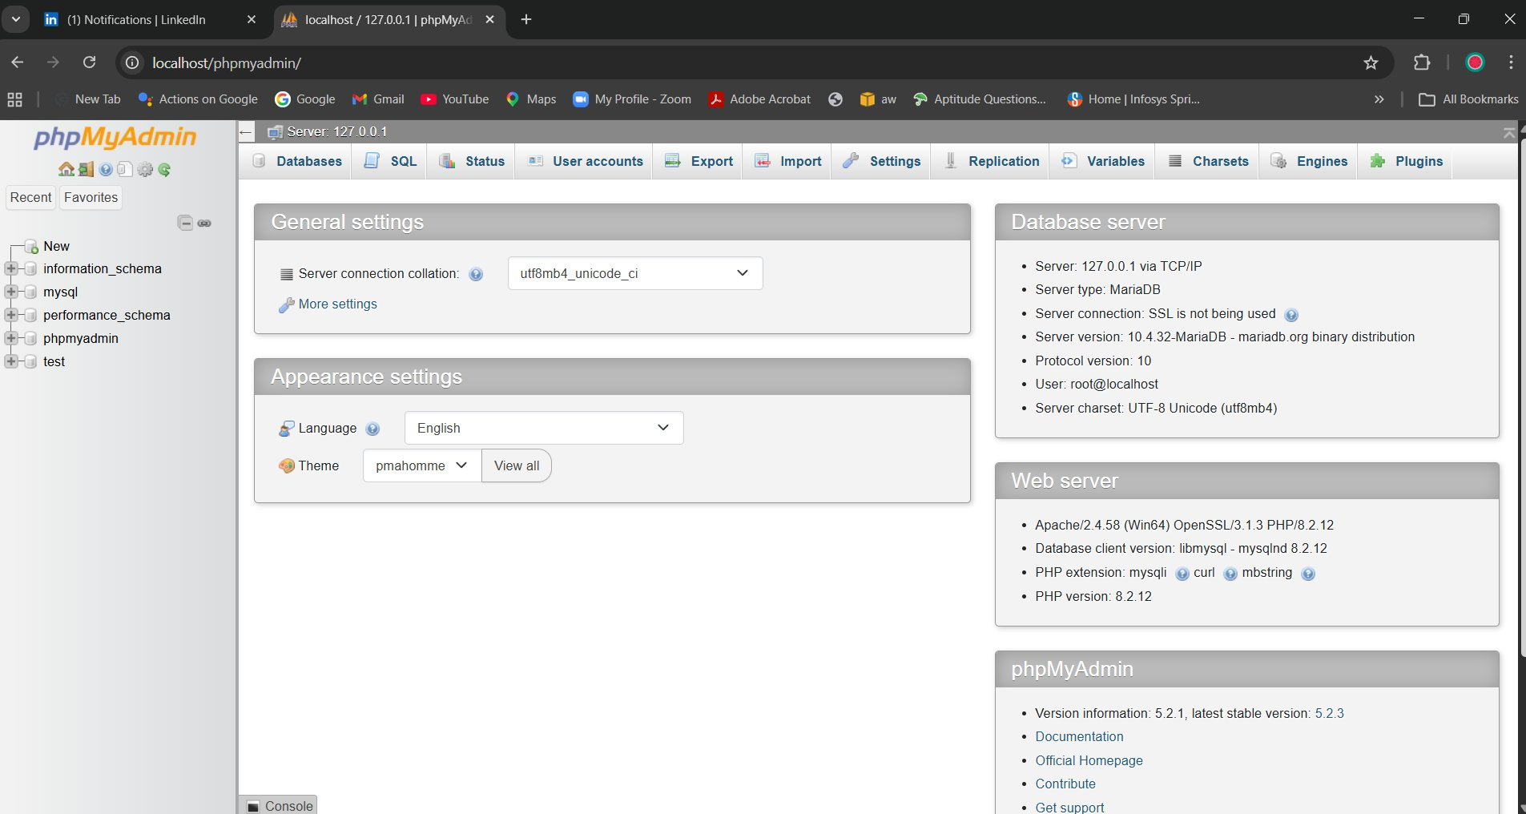
phpMyAdmin — phase2db database connected successfully

Step 3 — Running Migrations
Migrations in Laravel are PHP files that define the structure of database tables. Instead of manually creating tables in phpMyAdmin, we write migration files and run one command:

php artisan migrate

This created all the default Laravel tables (users, password_resets, etc.) automatically. Later, a custom migration was added to put a role column in the users table, and another to create the records table.

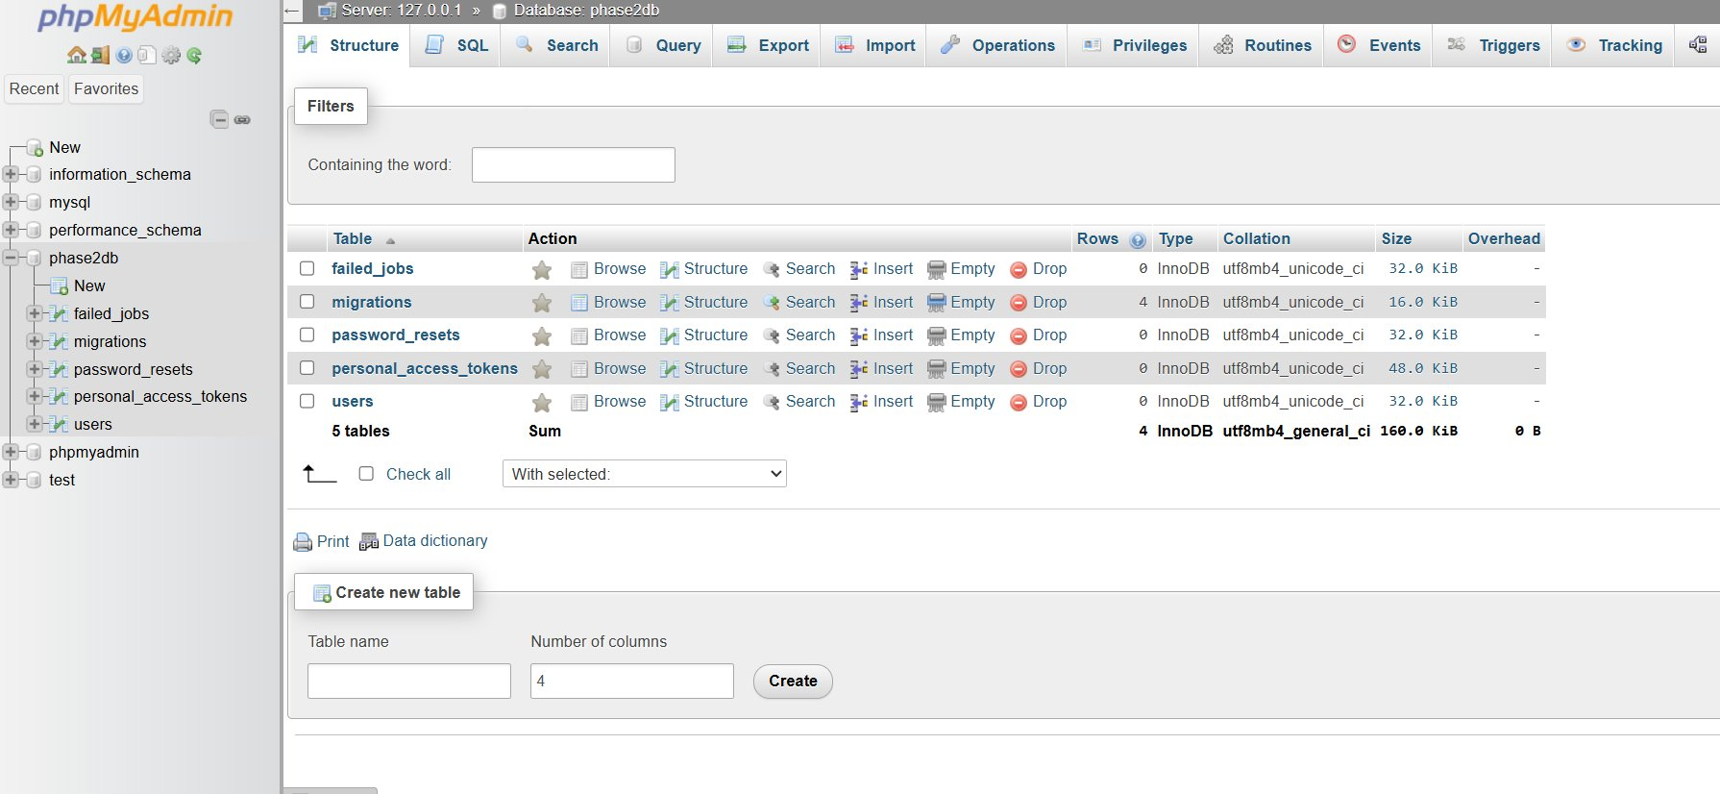
All tables created by migrations in the phase2db database

Step 4 — Adding the Role Column
By default, Laravel's users table has no role column. A new migration file was created to add it:

php artisan make:migration add_role_to_users_table --table=users

Inside that migration file, this line was added:

$table->string('role')->default('user');

This adds a role column to the users table. The default value is set to user, meaning any newly registered account will automatically be a regular user unless changed.

Step 5 — Installing Laravel Breeze
Breeze is an official Laravel package that gives a complete authentication system out of the box — login, register, logout, and password reset pages. It was installed with:

composer require laravel/breeze:^1.9 --dev
php artisan breeze:install
npm install && npm run dev

The npm install and npm run dev commands compile the CSS and JavaScript assets that Breeze needs to style the login and register pages.

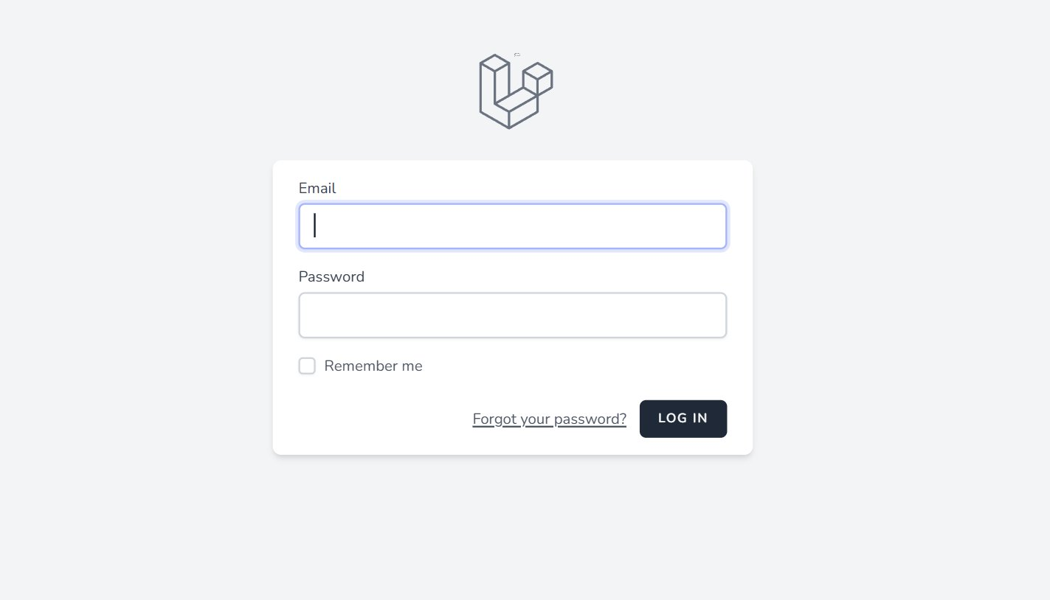
The login page that Breeze generated — used by both Admin and User

Step 6 — Seeding the Database
A seeder file was created to automatically insert the default Admin and User accounts into the database. The command to run it was:

php artisan db:seed --class=UserSeeder

Inside the seeder, the bcrypt function is used to hash the passwords before saving them. This is a security practice — passwords should never be stored as plain text in a database.

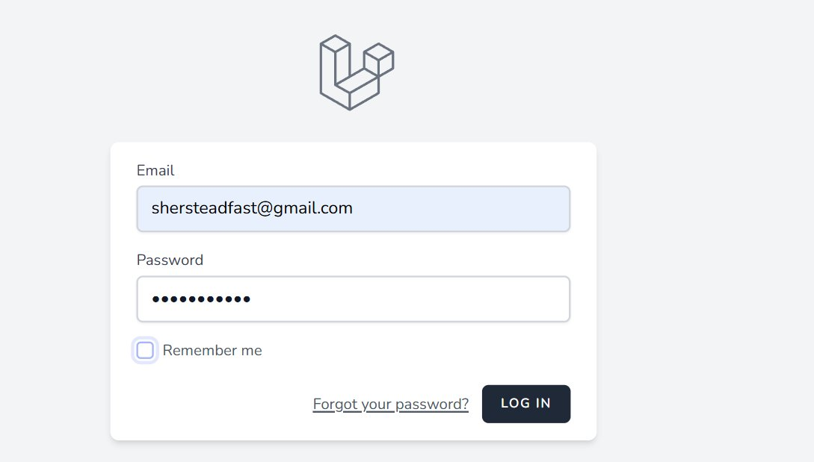
Users table — two accounts created with roles assigned correctly

3. How the Role-Based System Works
The Role Column
Every user in the database has a role field. It is either admin or user. When someone logs in, Laravel reads this field to decide where to send them. This logic was added inside the AuthenticatedSessionController:

if (auth()->user()->role === 'admin') {
return redirect('/admin/dashboard');
}
return redirect('/user/dashboard');

auth()->user() gives us the currently logged in user. We check their role and redirect accordingly. If they are admin, they go to the admin dashboard. Otherwise they go to the user dashboard.

Middleware — The Security Guards
Middleware in Laravel is code that runs before a request reaches a controller. Think of it as a security check at the door. Two middleware files were created:

AdminMiddleware.php
This middleware checks if the logged in user has the admin role. If yes, the request is allowed through. If not, a 403 error is shown.

if (auth()->check() && auth()->user()->role === 'admin') {
return $next($request);
}
abort(403, 'Access Denied');

Note: auth()->check() first confirms someone is actually logged in. Then it checks if their role is admin. Both conditions must be true.

UserMiddleware.php
This does the same thing but for the user role. It blocks anyone who is not a regular user from accessing user routes.

Registering Middleware in Kernel.php
After creating the middleware files, they need to be registered in the Kernel.php file so Laravel knows they exist. They were added under the routeMiddleware array with short names:

'admin' => \App\Http\Middleware\AdminMiddleware::class,
'user' => \App\Http\Middleware\UserMiddleware::class,

These short names (admin and user) are then used directly in the routes file to protect groups of routes.

Routes and Middleware Groups
In the routes/web.php file, routes are grouped by middleware. This means every route inside a group automatically goes through the middleware check before running:

Route::middleware(['auth', 'admin'])->group(function () {
Route::get('/admin/dashboard', [AdminController::class, 'index']);
Route::get('/admin/records/create', [AdminController::class, 'create']);
// ... more admin routes
});

Route::middleware(['auth', 'user'])->group(function () {
Route::get('/user/dashboard', [UserController::class, 'index']);
});

The auth middleware (built into Laravel) makes sure the user is logged in at all. Then our custom admin or user middleware checks the role on top of that.

4. Controllers — What They Do
AdminController.php
The AdminController handles everything on the admin side. It has five methods:

- index() — loads all records from the database and passes them to the admin dashboard view
- create() — just returns the create record form page
- store() — validates the form input, saves a new record with status set to Pending by default
- edit() — finds a specific record by ID and loads the edit form with its current data
- update() — validates the updated data and saves the changes including status
- destroy() — finds the record by ID and deletes it

The validate() method is Laravel's built-in request validation. It checks that required fields are not empty before saving anything to the database. If validation fails, the user is sent back to the form with error messages.

UserController.php
The UserController is much simpler. It only has one method — index(). It fetches all records from the database and passes them to the user dashboard view. Users cannot create, edit, or delete anything — they can only see what is there.

public function index() {
$records = Record::all();
return view('user.dashboard', compact('records'));
}

Record::all() is an Eloquent call — Eloquent is Laravel's ORM (Object Relational Mapper). It handles all the SQL queries in the background. So instead of writing SELECT * FROM records, we just write Record::all() and Laravel does the rest.

5. Views — The Pages
Admin Dashboard
The admin dashboard shows a table of all records. Each row has Edit and Delete buttons. The status is shown as a color-coded badge using Bootstrap classes — yellow for Pending, green for Approved, red for Rejected. If there are no records yet, a message is shown instead.

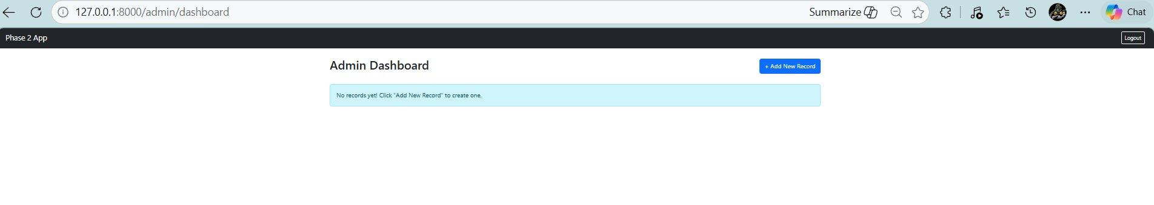
Admin Dashboard — no records yet

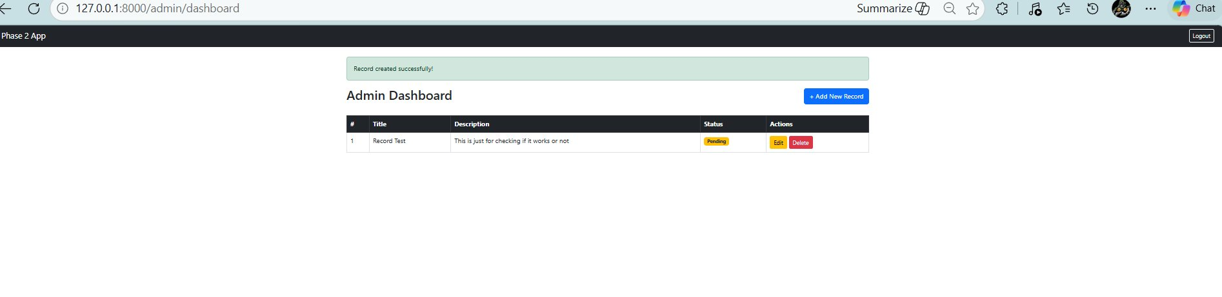
Admin Dashboard — record added with Pending status

Edit Record Page
The edit page pre-fills all the fields with the current record's data. The status field is a dropdown with three options. When the form is submitted, it sends a PUT request to the update route. The @method('PUT') blade directive is used because HTML forms only support GET and POST natively.

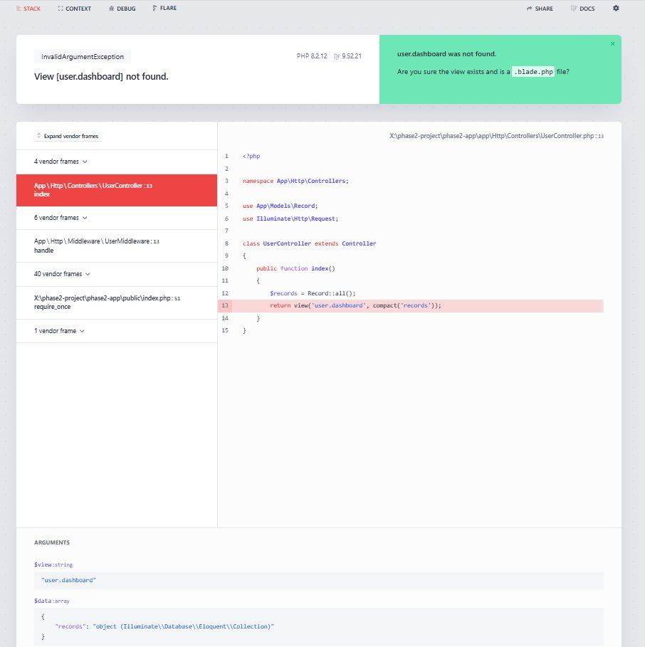
Edit Record form — pre-filled with current data

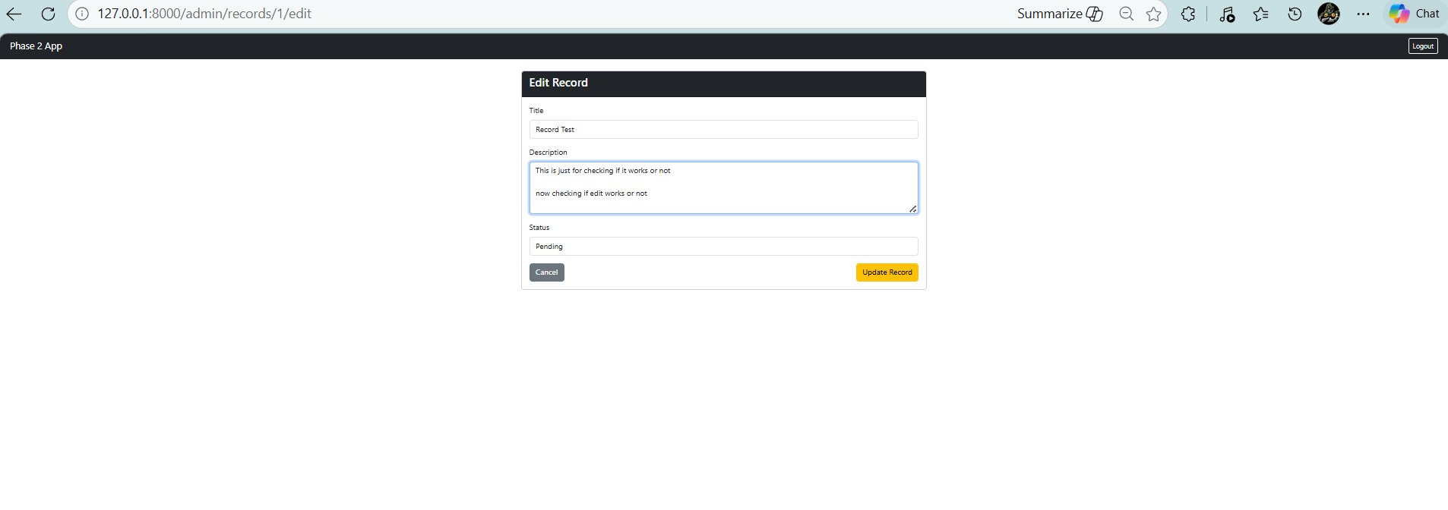
After updating — success message shown at top

User Dashboard
The user dashboard shows the same records but without any action buttons. Users can only read. The status badges are the same color-coded system so users can clearly see the current state of each record.

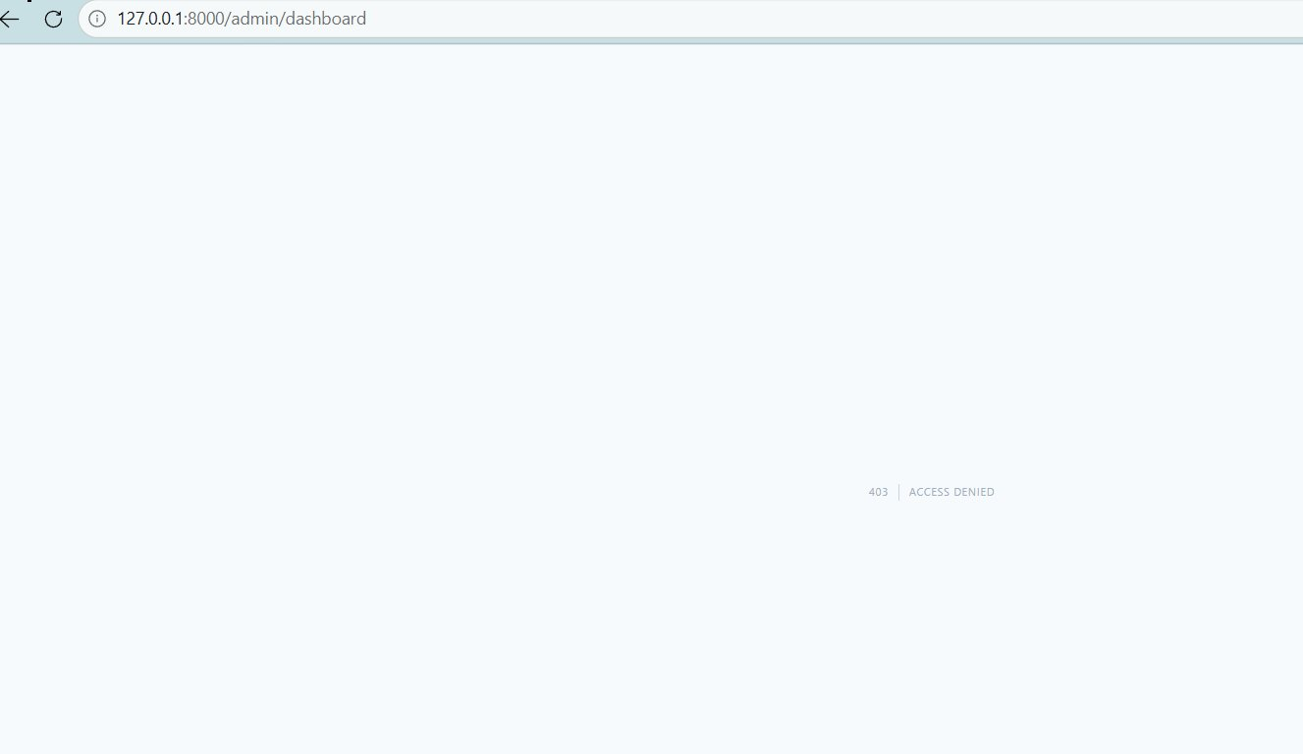
User Dashboard — read-only view with status badges

Access Denied Page (403.blade.php)
When middleware blocks a request, Laravel looks for a 403.blade.php file in the views folder. A custom page was made for this that clearly shows the error and has a Go Back button.

Layout File
All pages extend a shared layout.blade.php file. This layout includes the Bootstrap CSS link, the navbar with the app name and logout button, and a content slot (@yield('content')) where each page injects its own content. This avoids repeating the same HTML on every page.

6. Database and Models
The Records Table
The records table was created through a migration. It has these columns:

- id — auto-incrementing primary key
- title — a short text field for the record name
- description — a longer text field for details
- status — stores Pending, Approved, or Rejected (defaults to Pending)
- created_at and updated_at — timestamps automatically managed by Laravel

The Record Model
The Record model is a PHP class that represents the records table. The $fillable array tells Laravel which columns are allowed to be mass-assigned (written to the database directly from a form). Without this, Laravel would throw a mass assignment protection error:

protected $fillable = ['title', 'description', 'status'];

This is a security feature in Laravel — it prevents someone from injecting unexpected fields into a database write operation.

Default Credentials
Role | Email | Password
Admin | admin@admin.com | admin123
User | user@user.com | user123

Setup Steps for Anyone Cloning the Project
- git clone https://github.com/Dhroovs/phase2-project.git
- cd phase2-project
- composer install — this reinstalls all the vendor packages
- cp .env.example .env — creates the environment config file
- php artisan key:generate — generates the app encryption key
- Create a database named phase2db in phpMyAdmin
- Update .env: set DB_DATABASE=phase2db, DB_USERNAME=root, DB_PASSWORD=
- php artisan migrate — creates all the tables
- php artisan db:seed --class=UserSeeder — adds admin and user accounts
- php artisan serve — starts the local development server

8. Requirements Checklist

- Single login page for both Admin and User — done
- Role-based redirect after login — done
- Admin goes to /admin/dashboard after login — done
- User goes to /user/dashboard after login — done
- User trying to access admin panel sees 403 — done
- Admin trying to access user panel sees 403 — done
- Admin can add new records — done
- Admin can edit records — done
- Admin can delete records — done
- Records have Pending, Approved, Rejected status — done
- User can view all records with their status — done
- Pushed to GitHub with correct structure — done
- README with setup steps included — done

Finally we got same output as expected for differently accessed system for admin & User.

— End of Document —

