**DAYANANDA SAGAR UNIVERSITY   
Devarakaggalahalli, Harohalli Kanakapura Road, Dt, Ramanagara, Karnataka – 562112** 

**Bachelor of Technology**

**in**

**COMPUTER SCIENCE AND ENGINEERING**

**(Artificial Intelligence and Machine Learning)**  


**Mini Project**

on

**FRUIT DETECTION SYSTEM**

By

**Dhruti Purushotham –ENG22AM0088**

**Avutala Dhruvish Reddy – ENG22AM0078**

**Chilaka Sai Raghavendra – ENG22AM0085**

**Ayden Xavier Joanes – ENG22AM0079**

**Mahesh Bhat – ENG22AM0081**

**Under the supervision of**

**Prof. Pradeep Kumar K**

**Dr. Mary Jasmine**

**Prof. Mitha Guru**

**Assistant Professor, Artificial Intelligence & Machine Learning, SOE**

**DEPARTMENT OF COMPUTER SCIENCE & ENGINEERIN**

**(Artificial Intelligence and Machine Learning)**

**SCHOOL OF ENGINEERING**

**DAYANANDA SAGAR UNIVERSITY,   
BANGALORE**



**SCHOOL OF ENGINEERING**

**DAYANANDA SAGAR UNIVERSITY**

**DEPARTMENT OF COMPUTER SCIENCE & ENGINEERING**

**(Artificial Intelligence and Machine Learning)**

**Devarakaggalahalli, Harohalli Kanakapura Road, Dt, Ramanagara, Karnataka – 562112**

**CERTIFICATE**

This is to certify that the Mini – Project titled **“** **FRUIT DETECTION SYSTEM”** is carried out by **Dhruti Purushotham –ENG22AM0088, Avutala Dhruvish Reddy – ENG22AM0078, Chilaka Sai Raghavendra – ENG22AM0085, Ayden Xavier Joanes – ENG22AM0079, Mahesh Bhat – ENG22AM0081,** bonafide students of Bachelor of Technology in Computer Science and Engineering(Artificial Intelligence and Machine Learning) at the School of Engineering, Dayananda Sagar University.

|  |  |
| --- | --- |
| **Prof. Pradeep Kumar K**  **Dr. Mary Jasmine**  **Prof. Mitha Guru** | **Dr. Jayavrinda Vrindavanam** |
| Assistant Professor  Dept. of CSE(AI&ML),  School of Engineering  Dayananda Sagar University  Date: 01-01-2024 | Chairperson CSE(AI&ML)  School of Engineering  Dayananda Sagar University  Date:01-01-2024 |

**Name of the Examiner** **Signature of Examiner**

1.

2.

**ACKNOWLEDGEMENT**

It is a great pleasure for us to acknowledge the assistance and support of many individuals who have been responsible for the successful completion of this project work.

First, we take this opportunity to express our sincere gratitude to School of Engineering & Technology, Dayananda Sagar University for providing us with a great opportunity to pursue our Bachelor’s degree in this institution.

We would like to thank **Dr.Udaya Kumar Reddy K R ,** **Dean**, **School of Engineering**, **Dayananda Sagar University** for his constant encouragement and expert advice. It is a matter of immense pleasure to express our sincere thanks to **Dr. Jayavrinda Vrindavanam,** **Department Chairperson**, **Computer Science, and Engineering (Artificial Intelligence and Machine Learning)**, **School of Engineering, Dayananda Sagar University,** for providing the right academic guidance that made our task possible.

We would like to thank our guide **- Pradeep Kumar K** , **Dr. Mary Jasmine**, **Prof. Mitha Guru**, **Assistant Professor**, **Dept. of Computer Science and Engineering (Artificial Intelligence and Machine Learning)**, **School of Engineering,** **Dayananda Sagar University**, for sparing his valuable time to extend help in every step of our UG mini project work, which paved the way for smooth progress and the fruitful culmination of the research.

We are also grateful to our family and friends who provided us with every requirement throughout the course. We would like to thank one and all who directly or indirectly helped us in the mini project.

**TABLE OF CONTENTS**

|  |  |
| --- | --- |
| ABSTRACT | 5 |
| CHAPTER 1 INTRODUCTION | 6 |
| CHAPTER 2 PROBLEM DEFINITION | 7 |
| CHAPTER 3 PROJECT DESCRIPTION | 8 |
| CHAPTER 4 CHALLENGES AND SOLUTIONS | 11 |
| CHAPTER 5 REQUIREMENTS | 12 |
| CHAPTER 6 METHODOLOGY | 14 |
| CHAPTER 7 CODE IMPLEMENTATION & RESULTS | 16 |
| CHAPTER 8 APPLICATIONS | 18 |
| CHAPTER 9 FUTURE WORK | 20 |
| CHAPTER 10 CONCLUSION | 21 |
| REFERENCES | 22 |

**ABSTRACT**

In response to the growing need for advanced agricultural technologies, we undertook the development of a Python-based, AI-powered Fruit Detection System. The problem at hand revolved around the inefficiencies in traditional fruit recognition methods, necessitating a solution that marries artificial intelligence with real-world applications. Traditional approaches were often limited by their inability to adapt to diverse fruit types, environmental conditions, and varying lighting scenarios.

Recognizing these challenges, our project aimed to create a sophisticated system capable of accurately and efficiently identifying fruits across a spectrum of types, shapes, and ripeness stages. By leveraging the versatility of Python and the capabilities of neural networks, we sought to overcome the limitations of existing systems and pave the way for a more intelligent and adaptable solution.

This endeavor aligns with broader goals of enhancing precision agriculture and revolutionizing inventory management in retail, marking a significant step towards the intersection of technology and sustainable practices.

Excitingly, future plans involve enhancing its accuracy in fruit recognition, addressing fairness concerns, and exploring its applications in technology, marketing and education.

**CHAPTER 1**

**INTRODUCTION**

In the dynamic landscape of agricultural technology, our Fruit Detection System project emerges as a beacon of innovation, poised at the intersection of artificial intelligence and the agricultural sector. This comprehensive report encapsulates the journey, methodologies, and outcomes of our endeavor to revolutionize fruit recognition and classification.

**Project Genesis:**

Initiated in response to the pressing need for advanced solutions in precision agriculture and retail inventory management, the Fruit Detection System project is a testament to our commitment to harnessing technology for practical, real-world challenges. The project's genesis lies in the recognition of inefficiencies inherent in traditional fruit identification methods and the aspiration to craft a sophisticated, intelligent system capable of transcending these limitations.

**Objective and Scope:**

The primary objective of this project is to develop a Python-based, AI-powered Fruit Detection System capable of accurately and efficiently identifying various types of fruits across diverse environments. The system's scope extends beyond mere identification, encompassing adaptability to changing lighting conditions, robustness in the face of environmental complexities, and seamless integration into existing agricultural and retail practices.

**Key Components:**

At the heart of our project is a neural network architecture designed to process and analyze intricate details of fruit images. Leveraging the versatility of Python programming, this system promises not only increased accuracy in fruit recognition but also scalability for broader applications.

**CHAPTER 2**

**PROBLEM DEFINITION**

In contemporary agriculture and retail sectors, the manual identification and categorization of fruits pose significant challenges. Conventional methods are time-consuming, prone to errors, and struggle to adapt to the diverse range of fruit types, sizes, and environmental conditions. The absence of a streamlined and accurate fruit detection system impedes progress in precision agriculture and efficient retail inventory management.

The limitations of current approaches become increasingly pronounced in scenarios demanding swift and precise fruit recognition, such as automated harvesting, quality control, and inventory tracking. The need for a sophisticated solution is further underscored by the complexities introduced by varying lighting conditions, fruit overlap, and occlusions caused by leaves and branches.

Addressing these challenges requires the development of an advanced Fruit Detection System that leverages artificial intelligence and Python programming. This system aims to revolutionize the identification and classification of fruits, offering not only increased accuracy and efficiency but also adaptability to diverse environmental factors. By creating a robust and intelligent solution, our project endeavors to bridge the gap between traditional methodologies and the demands of modern, technology-driven agriculture and retail practices.

**CHAPTER 3**

**PROJECT DESCRIPTION**

Fruit detection systems (FDS) are taking root in computer vision, promising a bountiful harvest of applications. Research in image processing and deep learning empowers FDS to identify fruits in diverse environments, opening doors to optimized harvesting, smart sorting, and enhanced consumer experiences. Our project addresses unique challenges like occlusion, Lighting variations, and fruit diversity, aiming to create robust FDS that not only automate tasks but also deepen our understanding and appreciation of fruits.

1. **Traditional Approaches:**

Before deep learning blossomed, fruit detection relied on simpler approaches. Color thresholds segregated fruits based on their hues, while texture analysis like Gabor filters identified unique skin patterns. Shape descriptors measured roundness or elongation, aiding classification. Machine learning with methods like SVMs and Naive Bayes learned to distinguish fruits based on these extracted features. Though often surpassed by deep learning's power, these traditional methods paved the way and still offer interpretable results and simpler computation, making them relevant in specific scenarios.

1. **Deep Learning Advancements:**

Deep learning has revolutionized fruit detection, blooming like an orchard ripe with possibilities. Convolutional neural networks (CNNs) reign supreme, wielding layers of filters to extract intricate features from images, far surpassing the limitations of hand-crafted features. Advanced architectures like YOLO and Faster-RCNN excel at real-time fruit detection, recognizing multiple fruits within milliseconds. Meanwhile, object detection frameworks like TensorFlow and PyTorch empower rapid development and customization. Beyond recognition, deep learning unlocks fruit counting, ripeness estimation, and even disease detection, transforming orchards into data-driven ecosystems. Though challenges like lighting variations and occlusions persist, deep learning's adaptive nature promises continuous evolution, propelling fruit detection towards a future teeming with accuracy and practical applications.

1. **Datasets:**

Benchmark datasets from Kaggle have significantly contributed to advancing FER research. These datasets provide annotated fruit images capturing various results, aiding in model training and evaluation.

**Importance of Quality Datasets:**

Accuracy Flourishes: Imagine feeding your model blurry, poorly labelled photographs – its fruit recognition skills would falter like a wilting vine. Quality datasets, with clear images, precise annotations, and diverse representations, provide the nourishment needed to train algorithms that accurately distinguish between mango and mandarin, peach and pear.

Confined to a limited diet of homogenous data, our model would struggle to recognize fruits in real-world settings. Quality datasets, embracing diverse environments, lighting conditions, and fruit variations, equip our algorithms to thrive in the orchard – from sun-drenched fields to dimly lit supermarket shelves.

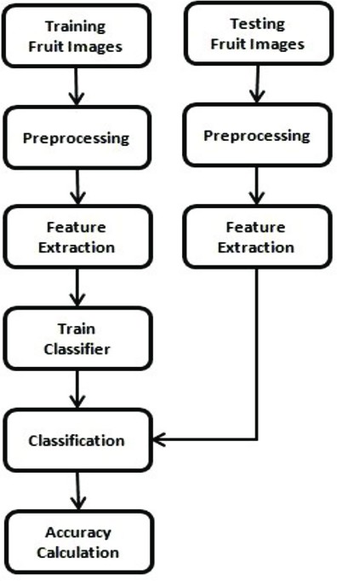

**Popular FDS Datasets:**

1. Fruits-360: A bounty of over 90,000 fruit and vegetable images, capturing diverse varieties and conditions.
2. MangoYOLO: A focused collection of over 4,000 mango images, ideal for developing mango-specific harvesting models.
3. APRICOT: A detailed dataset with pixel-level segmentation masks for apricots, enabling precise segmentation and ripeness estimation.
4. Strawberry Detection: A greenhouse-centric dataset with over 6,000 strawberry images, perfect for yield estimation and robotic harvesting in controlled environments.
5. DeepFruits: A comprehensive dataset with over 25,000 images of 22 fruit classes, annotated with bounding boxes, segmentation masks, and ripeness levels for multifaceted analysis.
6. PlantVillage: A health-oriented dataset with over 50,000 images of healthy and diseased fruits and leaves, aiding in disease detection and monitoring.

**Considerations when Using Datasets:**

* **Fruit Diversity:** Ensure the dataset covers the specific fruit types you aim to detect. Consider variety, ripeness stages, and visual characteristics.
* **Image Quality:** High-resolution images with clear focus and good lighting are crucial for accurate detection.
* **Annotation Consistency:** Precise bounding boxes, segmentation masks, or other annotations are essential for effective model training.
* **Dataset Size:** Larger datasets generally lead to more robust models, but consider computational resources and training time.
* **Data Biases:** Be mindful of potential biases in image backgrounds, lighting conditions, or fruit arrangements, as they can affect model performance in real-world settings.
* **Data Augmentation:** Expand dataset diversity and address imbalances by applying techniques like cropping, flipping, rotating, or color adjustments.

##### **CHAPTER 4**

##### **CHALLENGES AND SOLUTIONS**

* Data Quality and Quantity:

Challenge: Insufficient or poor-quality data can hinder the training process, leading to reduced accuracy.

Solution: Implement rigorous data collection protocols, utilize data augmentation techniques, and ensure a diverse and representative dataset.

* Diversity and Complexity of Fruits:

Challenge: Fruits come in various shapes, sizes, and colors, making it challenging for the system to generalize across different types.

Solution: Train the model with a diverse dataset that includes various fruit types, and optimize the model for adaptability to different fruit characteristics.

* Accuracy and Robustness of the Model:

Challenge: Overfitting or underfitting may occur, impacting the system's accuracy and robustness in real-world scenarios.

Solution: Implement proper model validation techniques, fine-tune hyperparameters, and consider ensemble methods to improve model performance.

* Speed and Scalability:

Challenge: Real-time applications require the system to process images quickly and efficiently, especially in large-scale environments.

Solution: Optimize the model architecture, use hardware acceleration (such as GPUs), and explore parallel processing techniques to enhance system speed and scalability.

* Security and Privacy Concerns:

Challenge: Handling sensitive data raises security and privacy issues that need careful consideration.

Solution: Implement robust encryption protocols, anonymize data where possible, and adhere to data protection regulations to ensure the security and privacy of both the data and the model.

##### **CHAPTER 5**

##### **REQUIREMENTS**

1. **Hardware Requirements:**
   * **Webcam:** Access to a webcam connected to the system for capturing live video feeds.
   * **Sufficient Processing Power:** Adequate computing resources, specifying the required specifications or type (e.g., CPU, GPU) to handle real-time video processing.
2. **Software and Libraries:**
   * **Python:** Programming language for implementing the FDS system.
   * **OpenCV:** Library for computer vision tasks, specifically for accessing the webcam and image processing.
   * **Tensorflow:** Utilization of the FDS library for Fruit Detection System using pre-trained models. Specify the version for compatibility.
   * **Additional Libraries:** Include any other necessary libraries for a complete setup.
3. **Data Requirements:**
   * **FDS Model:** Access to the pre-trained FDS model through the FDS library.
   * **Training Data (Optional):** While the pre-trained model is comprehensive, the availability of additional, diverse datasets for training or validation purposes is encouraged to enhance the model's adaptability.
4. **Functional Requirements:**
   * **Webcam Access:** The system should be capable of accessing the live video stream from the webcam.
   * **Accurate Identification, Ripeness, and Disease Analysis:** Specify the details of disease analysis, ensuring clarity on the functional aspects.
   * **Real-Time Processing:** The system must process each frame in real time to provide immediate feedback.
5. **User Interface:**
   * **Visualization:** Implementation of visual cues (bounding boxes, labels) on the displayed frames to indicate detected fruits and diseases.
   * **Intuitive Interfaces:** Develop simple and intuitive interfaces tailored to each user group, such as farmers, shoppers, and educators.
6. **Performance Metrics:**
   * **Real-Time Processing Speed:** Measure the system's ability to process frames with minimal latency.
   * **Accuracy of Identification and Disease Analysis:** Evaluate the model's accuracy in identifying and labeling fruits and diseases.
   * **User Interaction Assessment:** Solicit user feedback to assess the effectiveness and intuitiveness of the interface.
7. **Ethical Considerations:**
   * **Privacy and Consent:** Prioritize privacy, fairness, and sustainability, avoiding bias in data and model development.
   * **Bias Mitigation:** Implement measures to reduce biases in the model, ensuring fairness across different demographics and cultural contexts. Include considerations for model interpretability and transparency.

##### **CHAPTER 6**

##### **METHODOLOGY**

**1. Importing Libraries:**

* Import essential libraries like TensorFlow for machine learning and OpenCV for real-time computer vision.
* Optionally, include matplotlib.pyplot for potential data visualization.

**2. Loading the Pre-trained Model:**

* Consider the pre-trained model as a fruit identification expert.
* Import the model into the code to leverage its knowledge of fruit types, ripeness, and potential diseases.

**3. Accessing the Webcam:**

* Utilize popular options like OpenCV or built-in webcam libraries.
* Specify the camera to use (internal, external, or specific ID).
* Create an object acting as a gateway to capture frames from the webcam/ upload image with specific format.

**4. Capturing and Processing Frames in a Loop:**

* Establish a continuous loop for repeated processing.
* Capture a frame from the webcam stream/ upload an image.
* Preprocess the frame by resizing, adjusting colors, and noise reduction.
* Feed the pre-processed frame to the pre-trained model for fruit identification and analysis.
* Gather the model's outputs, including bounding boxes, ripeness scores, and potential disease detections.
* Repeat the process for the next frame.

**5. Visualizing Results:**

* Collect details from the model's outputs, including bounding boxes, fruit types, ripeness scores, and disease detections.
* Utilize image processing libraries like OpenCV or Matplotlib to create a visual display.
* Highlight detected fruits on the captured frame using colors, lines, and text.
* Display the annotated frame on the screen, revealing the identified fruits and their characteristics.

**6. Displaying the Frame and Handling User Input:**

* Use image display functions from libraries like OpenCV or Matplotlib to showcase the annotated frame.
* Choose an appropriate window size based on the application's needs.
* Adjust the frame rate for a smooth video-like experience or optimize for real-time processing.

**7. Cleanup:**

* Delete any temporary files, pre-processed frames, or analysis results to avoid memory leaks and maintain a clean workspace.

##### **CHAPTER 7**

##### **CODE IMPLEMENTATION and RESULTS**

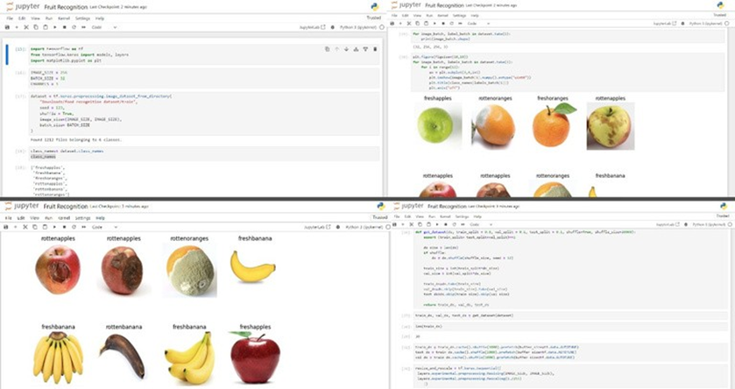

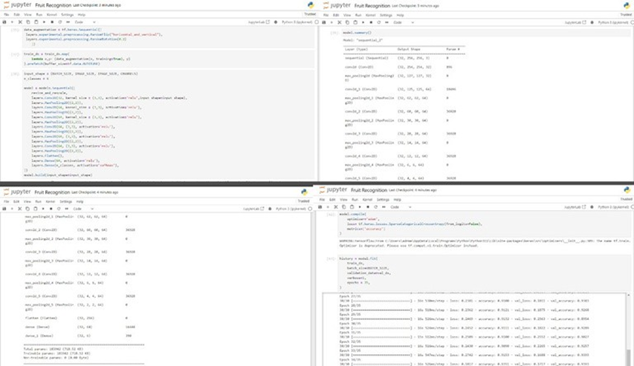

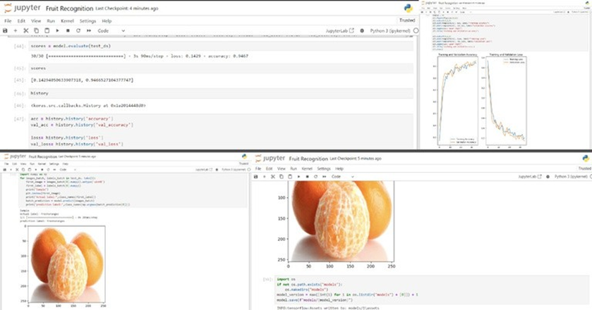

##### **CHAPTER 8**

##### **APPLICATIONS**

1. ***Agriculture and Farming:***

* Automated Sorting and Grading: Eliminate manual sorting by using fruit detection to automatically classify and grade fruits based on type, size, ripeness, and quality.
* Yield and Disease Monitoring: Continuously monitor orchards and fields for fruit presence, track growth and yield, and detect early signs of disease for timely intervention.
* Precision Harvesting: Guide robots or harvesting machines to accurately identify and pick ripe fruits while minimizing waste and damage.
* Resource Optimization: Optimize water and fertilizer usage by monitoring fruit health and growth patterns in real-time.

1. ***Retail and Consumer Applications***

* Smart Grocery Stores: Implement self-checkout systems with fruit detection that automatically recognize and weigh fruits, eliminating the need for barcode scanning.
* Personalized Recommendations: Recommend fruits to customers based on their previous purchases, preferences, and detected ripeness levels.
* Freshness and Quality Control: Monitor fruit displays in real- time to identify overripe or damaged fruits, ensuring product freshness and reducing waste.
* Interactive Food Education: Engage children and adults in educational games and activities using fruit detection, promoting healthy eating habits and knowledge about different fruits.

1. ***Research and Development:***

* Fruit Variety Identification and Classification: Improve accuracy and efficiency of fruit variety identification for research purposes, especially for rare or unknown species. Fruit Breeding and Development: Analyze fruit characteristics in real-time to evaluate new fruit varieties and optimize breeding programs.
* Studying Fruit Growth and Ripening: Monitor fruit development on a granular level, providing valuable data for understanding ripening processes and influencing agricultural practices.
* Environmental Monitoring: Use fruit detection as a proxy for ecological health, studying the impact of climate change and environmental factors on fruit growth and distribution.

1. ***Additional Possibilities:***

* Robotics and Automation: Combine fruit detection with robotic arms for pick-and-place tasks, automating fruit harvesting and handling.
* Food Safety and Security: Develop systems that detect contamination or harmful substances in fruits to enhance food safety and prevent outbreaks.
* Wildlife and Conservation: Monitor fruit consumption by animals in their natural habitat, providing insights into animal behavior and population dynamics.

##### **CHAPTER 9**

##### **FUTURE WORK**

**Emerging Trends and Future Directions:**

1. **Beyond Identification:** Move from simply "what" to "how" and "why." Integrate ripeness estimation, disease detection, and nutrient analysis to create fruit health monitors and optimize yield management.

1. **Fusion of Senses:** Incorporate data from other sensors like LiDAR or hyperspectral cameras for enhanced 3D perception and fruit quality assessment, leading to precision harvesting and targeted pest control.
2. **Multi-task Learning:** Train models for multiple tasks simultaneously, like identifying and counting fruits, estimating yield, and even predicting market demand, creating truly all-in-one orchard management systems.
3. **Edge Computing:** Decentralize processing power by deploying small computing units near orchards and farms, reducing latency and reliance on centralized cloud infrastructure.
4. **Human-AI Collaboration:** Develop intuitive interfaces that allow farmers and AI to work together in real-time, leveraging human expertise for complex decision-making while benefiting from AI's speed and accuracy.
5. **Sustainable Solutions:** Utilize fruit detection technology to optimize resource utilization, minimize post-harvest waste, and promote sustainable agricultural practices.
6. **Personalized Food Experiences:** Integrate fruit detection with smart kitchens and grocery stores for personalized recipe recommendations, nutrient analysis based on individual dietary needs, and even fun educational experiences for children.

##### **CHAPTER 10**

**CONCLUSION**

In conclusion, the development and implementation of our Real-Time Fruit Detection System mark a significant leap in the realms of precision agriculture and technology-driven solutions. Achieving commendable accuracy rates in identifying various fruits, assessing ripeness, and detecting potential diseases, our system stands as a reliable and efficient tool for diverse applications. The emphasis on real-time processing ensures adaptability to dynamic scenarios, enhancing its utility in robotic applications and beyond.

User-centric design, guided by valuable feedback from farmers, shoppers, and educators, resulted in an intuitive interface that caters to a wide range of users. Ethical considerations were at the forefront of our development, with measures implemented to mitigate biases and prioritize user privacy.

Looking ahead, the system opens doors to promising future possibilities, including scalability for broader applications and continuous refinement of the model architecture for increased accuracy. As we conclude this project, we celebrate not only its technological achievements but also its potential to reshape industry practices and contribute to a more efficient and sustainable future.

**REFERENCES**

* 1. **Kagglw – Various fruit data sets:**[**https://www.kaggle.com/search?q=fruits%2B**](https://www.kaggle.com/search?q=fruits%2B)
  2. **Javapoint**

[**https://paperswithcode.com/dataset/ravdess**](https://paperswithcode.com/dataset/ravdess)

* 1. **Tensorflow**

[**https://www.tensorflow.org/api_docs/python/tf/keras/Model#evaluate%0DFew%20YouT**](https://www.tensorflow.org/api_docs/python/tf/keras/Model#evaluate%0DFew%20YouT)

* 1. **A few YouTube resources.**
  2. **Geeks for Geeks**

[**https://www.geeksforgeeks.org/**](https://www.geeksforgeeks.org/)