Game Design Document

Fill up the following document

1. Write the title of your project.

Professional racer.

1. What is the goal of the game?

My goal of the game is that we have to win two races.

1. Write a brief story of your game.

There is racer who want to retire but someone had convinced him to

play last two races for him. And he is ready to play last 2 games. So,

we have to win the two races. And when the racer will win he will be retired.

If we will win the two races we will be doing a great deed for the racer.

1. Which are the playing characters of this game?

* Playing characters are the ones who respond to the user based on the input from the user.
* Cars, monkeys, dinos, wizards, etc., are the playing characters in the game.

|  |  |  |
| --- | --- | --- |
| Number | Character Name | What can this character do? |
| 1 | Our own car | We will control it and win from our car only. |
| 2 | Enemy car 1 | It is just like an obstacle which will be resisting us. |
| 3 | Enemy car 2 | It is just like an obstacle which will be resisting us. |
| 4 | Enemy car 3 | It is just like an obstacle which will be resisting us. |
| 5 | Enemy car 4 | It is just like an obstacle which will be resisting us. |
| 6 | The road obstacles ( there are several obstacles included ). | If we touched it we our car will destroy. |
| 7 |  |  |
| 8 |  |  |

1. Which are the Non-Playing Characters of this game?

* Non-Playing characters are the ones that don't have an action or behavior when the user interacts with the game.
* Hurdles, stones, bananas, coins, etc., are non-playing characters in the game.

|  |  |  |
| --- | --- | --- |
| Number | Character Name | What can this character do? |
| 1 | The text in our game | It is used to give our game attractiveness. |
| 2 |  |  |
| 3 |  |  |
| 4 |  |  |
| 5 |  |  |
| 6 |  |  |
| 7 |  |  |
| 8 |  |  |

Draw your imagination of this game. What does this game look like?

* Draw the game either on your computer or on paper.
* Add images of the game scenes to show each of the playing and non-playing characters at least once.

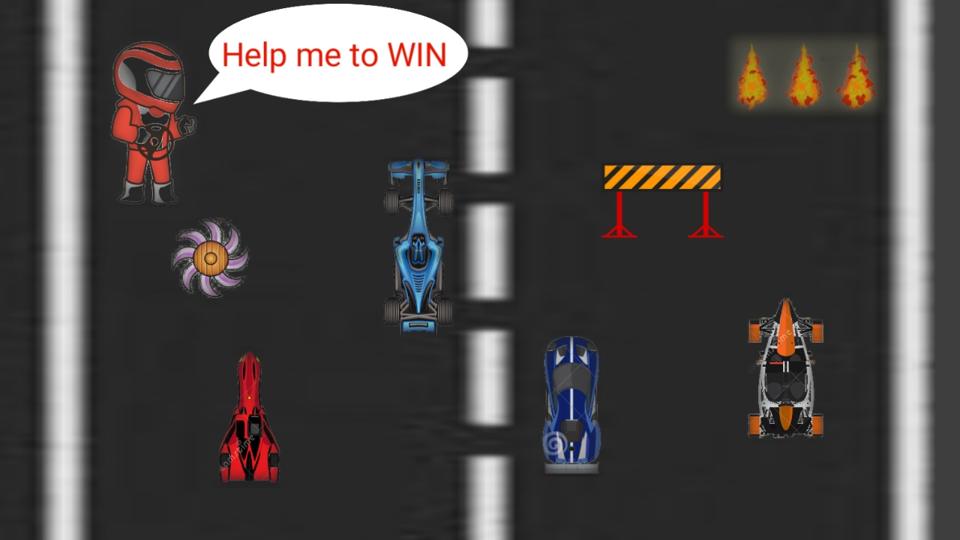

How do you plan to make your game engaging?

I will not make it too eazy but not impossible.

I will add sounds to it and I will make a situation that if the player loses attention he / she will lose.

So, it would have fun also and the attention will also not lose.

😎 THANKS👍