Game Design Document

Fill up the following document

1. Write the title of your project.

Ninja Run.

1. What is the goal of the game?

My goal of the game is to kill the enemies and collect the ninja stars.

1. Write a brief story of your game.

There is a ninja who had gone on a mission of killing the enemies of

his country who are planning to attack his country. We have to help him in

complition of his goal and to collect the maximum number of ninja weapons

So, we to help him.

1. Which are the playing characters of this game?

* Playing characters are the ones who respond to the user based on the input from the user.
* Cars, monkeys, dinos, wizards, etc., are the playing characters in the game.

|  |  |  |
| --- | --- | --- |
| Number | Character Name | What can this character do? |
| 1 | Ninja | It is our own player whom we will control |
| 2 | Obstacle 1 | This is our opponent to whom we have to kill ( many in number) |
| 3 | Obstacle 2 | This is our opponent to whom we have to kill ( many in number) |
| 4 | Obstacle 3 | This is our opponent to whom we have to kill ( many in number) |
| 5 | Weapons | These are the things we need to collect |
| 6 |  |  |
| 7 |  |  |
| 8 |  |  |

1. Which are the Non-Playing Characters of this game?

* Non-Playing characters are the ones that don't have an action or behavior when the user interacts with the game.
* Hurdles, stones, bananas, coins, etc., are non-playing characters in the game.

|  |  |  |
| --- | --- | --- |
| Number | Character Name | What can this character do? |
| 1 | The text in our game | It is used to give our game attractiveness. |
| 2 | Game over images | This the image which will do nothing but still necessary |
| 3 |  |  |
| 4 |  |  |
| 5 |  |  |
| 6 |  |  |
| 7 |  |  |
| 8 |  |  |

Draw your imagination of this game. What does this game look like?

* Draw the game either on your computer or on paper.
* Add images of the game scenes to show each of the playing and non-playing characters at least once.

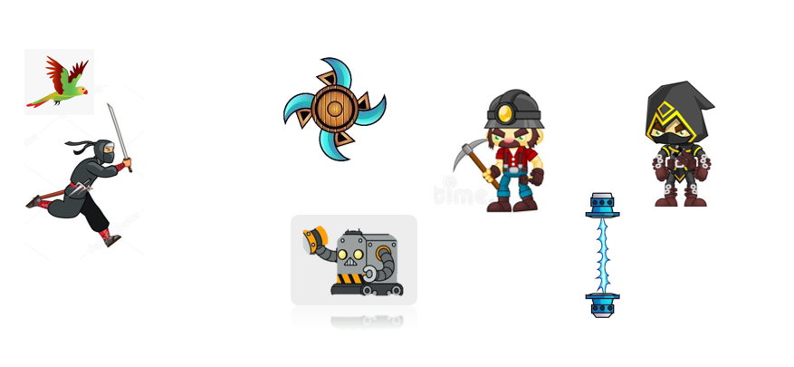

How do you plan to make your game engaging?

I will not make it too eazy but not impossible.

I will add sounds to it and I will make a situation that if the player loses attention he / she will lose.

So, it would have fun also and the attention will also not lose.

😎 THANKS👍