**Analysis of the U.S. Stock Market during**

**Health Crises**

**By**

**Kush Patel**

**Katherine Thai**

**Jonathan Perez**

**Ron Nathaniel**

**Justin Molina**

**Dhrumil Rana**

**a) Overview:**

The overall goal of this project is to better understand the US economy through stock trends and events that affect trends. We intend to achieve this goal by studying the S&P 500 index, crude oil price, and gold price per ounce. In this analysis, gold prices, oil prices, and S&P 500 index will be maintained as our representation of the overall stock market. We will look at time periods of the first 6 months specifically during health crises such as the SARS outbreak in 2002, the Swine Flu pandemic in 2009, and the current COVID-19 pandemic. Through this analysis we intended to learn: the effect health has on the US economy by analyzing how the current pandemic compares, economically, to past health crise; compare short versus long investment in crude oil price, gold price per ounce, and the S&P 500 index during health crises; how does the governmental policies tackling health crises affect the stock market. In conclusion, based on the trends of these attributes from the previous health crises, we believe that we can predict the behaviour of the stock market of the current COVID-19 pandemic.

**b) Problem Definition:**

For this analysis, there are three main goals:

1. Determine the similarity of different health crises based off of gold and oil prices and S&P 500 index? How did the introduction of the treatment affect these attributes?

Through this question we want to analyze how similar these events were and how the introduction of a possible vaccine for COVID-19 can potentially affect said attributes, hence affecting the stock market.

1. Will a short or long-term investment be better suited during a health crisis?

Through this question we want to identify the profit or loss probability during a health crisis. Within this question we would also like to explore other lurking variables that affect the conclusive yield.

1. How do the policies of the Presidential administrations (Bush, Obama, and Trump) affect the stock market during their respective health crises?

Through this question we will see how each administration’s actions affected the stock market during each health crisis.

**c) Period of Analysis:**

This analysis lasted from 20201009- 20201203.

**d) Contact Information(vendor of Data sets):**

[kt352@njit.edu](mailto:kt352@njit.edu)

Yahoo Finance: <https://help.yahoo.com/kb/finance-for-web>

**e) Documentation (usually given by Vendor):**

Crude Oil (CL=F): <https://finance.yahoo.com/quote/CL%3DF/history?period1=1036108800&period2=1598745600&interval=1mo&filter=history&frequency=1mo&includeAdjustedClose=true>

S&P 500 (^GSPC): <https://finance.yahoo.com/quote/%5EGSPC/history?period1=1036108800&period2=1598745600&interval=1mo&filter=history&frequency=1mo&includeAdjustedClose=true>

Gold (GC=F): <https://finance.yahoo.com/quote/GC%3DF/history?period1=1036108800&period2=1598745600&interval=1mo&filter=history&frequency=1mo&includeAdjustedClose=true>

**f) Sample data with Links:**

Sample data shared through drive.

<https://tinyurl.com/cs301g5>

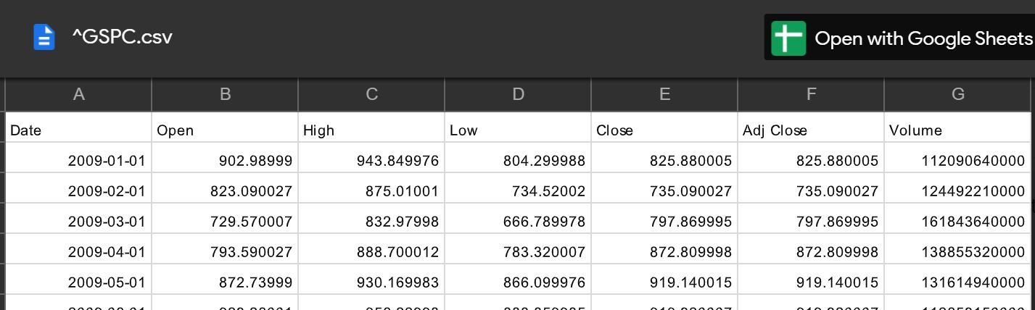

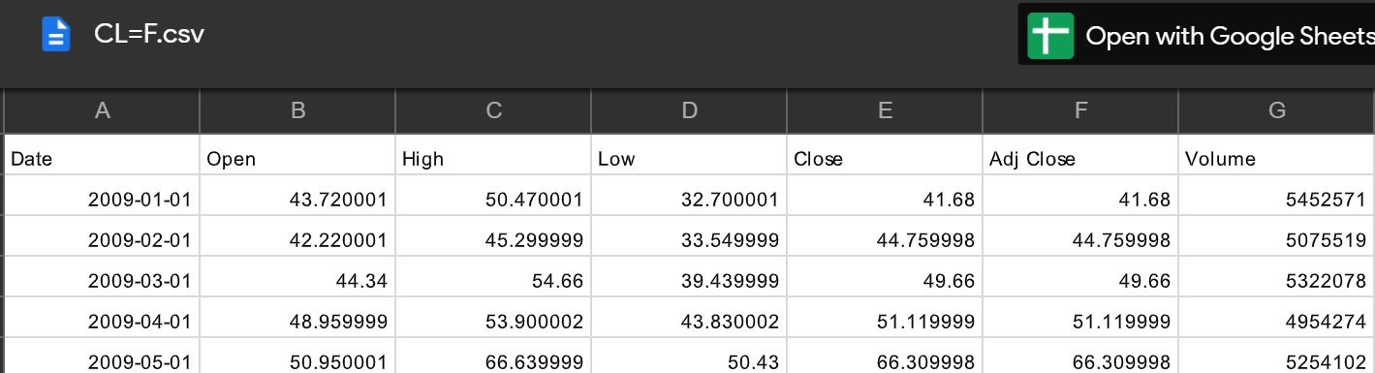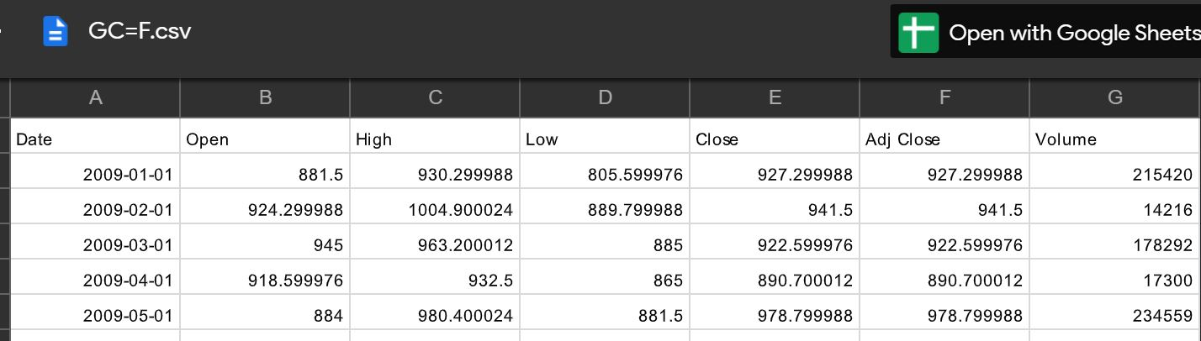

Deliverable 2 ( comment)

**Data documentation: Data exploration:**

1. **Data Collection:**
2. For the data we look at the multiple source and preferred to take yahoo data