200 Water Street
Rooftop Virtual Showroom
Master Case Study — from the original rooftop viewer to the current interactive system-flow experience
RUHL TecDesign | UX/UI + 3D interaction + frontend development + accessibility + performance
This document is intentionally comprehensive. It is written as a source-of-truth master narrative that can later be condensed into a portfolio page, interview story, or technical case study.

Executive Summary
I transformed the 200 Water Street rooftop experience from a limited rooftop-detail viewer into a standalone, browser-based virtual showroom that explains how the rooftop ventilation and energy-recovery system works through a guided six-step narrative. The final experience combines an interactive 3D building/rooftop model, system-focused camera choreography, equipment identification, animated airflow and energy-transfer cues, impact information, responsive controls, accessibility support, and production-level performance and legal checks.
The work was not a single visual redesign. It became a systems problem spanning UX, information architecture, 3D interaction design, frontend engineering, performance optimization, responsive behavior, accessibility, licensing, deployment, and integration back into the 200 Water Street case-study page.
The final implementation is integrated directly into the 200 Water project as a self-contained, lazy-loaded showroom module. The existing “Explore rooftop systems” entry point launches the new showroom instead of the older rooftop viewer, while the rest of the 200 Water page remains independent.

My role
- UX/UI design: interaction hierarchy, flow structure, responsive patterns, information density, controls, modals, and equipment callouts.
- 3D experience design: camera framing, active/related/context hierarchy, airflow visualization, equipment focus, and scene composition.
- Frontend development: Three.js-based interaction, UI states, lifecycle behavior, lazy loading, responsive integration, and production build work.
- Performance and QA: memory diagnosis, city-context optimization, progressive loading, DPR control, lifecycle testing, and repeated-flow stability checks.
- Accessibility: keyboard interaction, focus behavior, reduced motion, semantic controls, accessibility-tree checks, and 200% zoom testing.
- Launch readiness: asset-rights audit, third-party notices, privacy/network review, production-only deployment, and integration into the live project page.

Core tools and technologies
Area | Tools / technologies
3D / rendering | Three.js 0.170.0, WebGLRenderer, PerspectiveCamera, GLTFLoader, RGBELoader, MeshoptDecoder, PMREM environment lighting
Animation / interaction | Three.js animation loop and camera transitions; GSAP/ScrollTrigger existed in the earlier 200 Water building journey; later showroom flow uses its own guided interaction logic
Assets | GLB/glTF models, HDR environment, procedural UI/SVG elements, generic equipment illustrations, city-context assets
Frontend | HTML, CSS, JavaScript; production-only static build; local/self-hosted runtime modules in the final audited showroom
QA / diagnostics | Chrome DevTools/CDP-style automated checks, renderer.info counts, heap/resource sampling, network audits, axe/accessibility checks
Design workflow | Figma-style interaction thinking, rapid visual ideation, iterative Codex implementation, responsive visual QA

1. Context: Why the rooftop needed a better experience
The 200 Water Street page already had a cinematic 3D building journey. Users could move from the full building toward the roof and enter a rooftop detail mode through the “Explore rooftop systems” CTA. That earlier experience was useful as a visual inspection layer, but it did not yet function as a complete explanatory showroom.
The original rooftop implementation already contained meaningful technical foundations: a separate rooftop detail overlay, dedicated roof-only loading, camera alignment to the building inspection view, drag rotation, reset behavior, labels projected into screen space, and rooftop-specific presentation logic. It was designed as an extension of the larger 200 Water building-scroll experience rather than as an independent product.

What the earlier rooftop viewer already did
- Loaded an optimized full-building model for the main building journey and a separate roof-only model for detailed rooftop inspection.
- Used a “Explore rooftop systems” entry point from the building experience.
- Swapped from the full-building scene to the roof-only detail scene when the rooftop mode opened.
- Aligned the roof-only model to the building inspection camera rather than showing an unrelated default view.
- Allowed pointer drag rotation around the rooftop and provided a reset control after rotation.
- Supported rooftop labels/callouts using projected 3D anchors and DOM/SVG overlays.
- Included code for camera fitting, rooftop-band sampling, material preparation, and screen-space layout.
- Used lazy/prefetch behavior for the roof model rather than loading every detail immediately at page start.

Technical note on the earlier model pipeline
Retrieved project documentation for the earlier 200 Water experience described a separate optimized building GLB of roughly 3.2 MB and a dedicated roof-only GLB of roughly 19.2 MB. Later standalone-showroom performance work referenced a different/current rooftop model around 3.3 MB. These values belong to different stages of the project and should not be presented as one unchanged asset throughout the entire timeline.

The UX gap
The main limitation was not “the model looked bad.” The limitation was that users still had to infer the system. A rooftop filled with ducts, equipment, pipes, and colored components is meaningful to an engineer, but a general audience needs a guided explanation of what moves where, what each unit does, and why the retrofit matters. The project therefore shifted from “rooftop viewer” to “virtual showroom.”
Design challenge
How might we turn a technically dense rooftop into a guided, understandable, and visually polished story without reducing it to a static diagram or overwhelming the browser?

2. Reframing the project: from model viewer to guided showroom
The new direction treated the rooftop as an explorable product experience. Instead of asking users to interpret the roof on their own, the showroom would explicitly guide them through the ventilation and energy-recovery story while preserving the ability to see the real spatial relationship between rooftop components.

Core experience principles
- Keep the 3D rooftop as the hero. UI should explain the scene, not replace it.
- Tell the HVAC story in a strict sequence. Each step should answer one clear question before introducing the next.
- Use animation to communicate direction and energy transfer, not as decoration.
- Do not imply air mixing where the system story says only energy is transferred.
- Keep equipment identity understandable for non-engineers through small visual callouts.
- Treat the city/environment as context, not competing content.
- Design for real browser limits: memory, decoded textures, WebGL resources, mobile viewport constraints, and cleanup.
- Make the final experience deployable, auditable, and accessible rather than leaving it as a prototype.

Standalone modular architecture
The showroom was developed as a modular experience rather than tightly rewriting the existing 200 Water page. That separation made it possible to iterate on the 3D environment, controls, system flow, responsive behavior, and performance without destabilizing the larger case-study page. Later, the completed showroom was integrated back into the 200 Water project behind the existing rooftop CTA.

3. Information architecture: the six-step System Flow
The central UX decision was to convert the rooftop mechanical story into six sequential steps. The final approved sequence was:
Step | Title | Purpose in the story
1 | Return Air | Establishes that used indoor air comes from the building through ducts to the rooftop AHU and still carries recoverable heating or cooling energy.
2 | Energy Recovery | Explains that warmth or coolness is transferred to incoming fresh air without mixing the two air streams.
3 | Exhaust | Shows that after energy is recovered, the remaining exhaust air is discharged outdoors.
4 | Fresh Outdoor Air | Introduces the incoming outdoor-air side and connects it to the previously recovered energy before final conditioning.
5 | Heat Pump | Explains that the heat pump supplies additional heating or cooling when recovered energy alone is not enough.
6 | Supply Air | Completes the loop by showing conditioned fresh air delivered back into the building.

Final Return Air wording
“Used indoor air is carried through ducts from the building to the rooftop AHU, bringing heating or cooling energy that can be recovered.”
This wording was deliberately revised because Step 1 needed to establish origin, path, destination, and value before introducing recovery. It is more understandable than beginning with the abstract statement that return air “carries valuable heating or cooling energy.”

Equipment involvement
The AHU is relevant across most of the airflow story, while the heat pump becomes the explicit hero in the Heat Pump step. The experience intentionally separates the idea of energy recovery from the heat pump’s supplemental heating/cooling role so users do not confuse the two functions.
A strict constraint throughout implementation was not to guess which specific physical units perform an engineering function purely from visual appearance. Equipment-to-step mappings were to follow project configuration and approved engineering understanding.

4. Turning invisible airflow into something people can understand
Airflow is difficult to communicate because the important behavior happens inside ducts or in free space where there is no physical object to see. The showroom therefore used a layered visual language rather than relying on one effect.

Three-layer airflow language
- Smoke/vapor layer: communicates the volume of moving air in free space.
- Ribbon/path layer: communicates the primary route and directional structure.
- Bright directional particles: reinforce motion and direction without filling the scene with visual noise.

Fresh/outdoor air
Fresh air was represented with blue/cyan styling. In open air it could appear broader and more irregular, then converge toward the intake, narrow, and become slightly faster/denser near the intake. It was explicitly not designed as buoyant smoke rising upward.

Exhaust air
Exhaust was represented with orange/amber styling. It starts more concentrated at the discharge point, then expands, drifts laterally in a restrained way, softens, and fades. The visual was meant to read as clean airflow, not combustion or pollution.

Energy transfer
Cyan highlighting was used for the energy-recovery concept. The storytelling emphasized that the air streams stay separate while energy is transferred. The implementation avoided visuals that would imply the exhaust and fresh-air streams physically mix.

Performance constraints on airflow effects
- No true volumetric rendering, CFD, fluid simulation, voxels, or ray-marched smoke.
- Use lightweight pooled sprites/billboards/particles and small shared textures.
- Only active plume systems update; inactive effects sleep.
- No per-frame material creation or unnecessary allocations.
- Pause, resume, restart, previous/next, and exit must leave the effect system stable.

5. Focus hierarchy: making the active system readable
One early problem was that the active system could disappear visually inside the complexity of the rooftop and surrounding context. The solution was a hierarchy that separated active, related, context, and obstruction states.

Focus model
Layer | Treatment
Active | Highest prominence; illuminated or brighter material response; active flow path clearly visible.
Related | Still readable, but secondary to the active component.
Context | Subdued so the rooftop remains understandable without competing for attention.
Obstruction | Only actual blocking walls/enclosures become translucent; unrelated geometry is not globally blurred or hidden.

Important visual decision
The project explicitly avoided heavy blur, depth of field, monochrome gray treatment, broad transparency, or fog-heavy focus effects. The goal was architectural clarity: the same rooftop and city, but with less visual information competing with the current step.

6. City context: enough realism without stealing focus
The surrounding city went through both visual and performance scrutiny. The final context was not the official NYC Planning/MN01 model. The audited runtime city context traced to the Quaternius Downtown City MegaKit under CC0, used as generic urban context.

City asset strategy
- Source kit contained 153 glTF files plus matching buffers and many textures/modules.
- Only three complete building assets were needed at runtime: Building_Large_2, Building_Medium_2_001, and Building_Small_1.
- Those three assets were reused to create a sparse skyline ring around 200 Water.
- The city was excluded from camera-fit calculations so it would never control framing of the hero building.
- City shadows were disabled and context materials were intentionally muted.
- The final audited city optimization replaced texture-heavy source materials with a small set of shared PBR materials: muted facade, muted glass, and muted roof.

Visual art direction
The city was treated as architectural context: lower contrast, quieter materials, reduced visual detail, restrained reflections, and no attempt to make distant buildings as visually rich as the rooftop. The design principle was “same urban context, less visual information.”

7. Environment lighting and HDRI
The active outdoor environment used the Canary Wharf HDRI from Poly Haven. It served both as the visible scene background and, through PMREM, as the environment for physically based reflections. The runtime audit identified the file as approximately 24.95 MiB on disk.
A key technical tradeoff was that the source HDR remained resident because it was still being used as the visible background, while the PMREM texture remained resident for PBR reflections. This was intentional rather than a confirmed duplicate-load bug.

8. Equipment identification and product imagery
Small equipment-identification popups were added so a non-technical viewer could connect the name of a unit to what it looked like in the 3D scene. These callouts were intentionally secondary to the model and flow animation.

Callout principles
- Small image + equipment name only; not another explanatory card.
- Use established white marker locations as anchors where practical.
- Never block active equipment, ducts, airflow, hydronic piping, System Flow text, or impact UI.
- If a marker position obstructs the active story, use another established anchor rather than moving the camera just for the popup.
- Support step-specific equipment involvement rather than showing all equipment continuously.

AHU and heat-pump imagery
Manufacturer/reference imagery was used during exploration, but the public-facing direction moved toward generic equipment visuals without manufacturer branding, model numbers, or copied product text. The heat-pump visual was specifically corrected away from a fan-dominant air-source appearance toward a generic water-source heat-pump/chiller-style representation. The exact installed commercial product was not claimed from the illustration.

9. Impact information: useful, but not allowed to overpower the 3D story
The impact layer was designed as lightweight HTML/CSS/SVG rather than WebGL. It was intentionally not shown at every step. The left side of the experience explained what was happening, the 3D scene showed where it happened, and impact content explained why it mattered.

Impact concepts used in the flow
- Airflow rebalancing: before/after exhaust and pressure-balance concept.
- Energy recovery: “Recover energy, not air,” reinforcing the no-mixing concept.
- Heat pump: explanatory role without forcing another large statistic into the step.
- Final ventilation impact: approved project metrics, shown only after engineering/source approval.

Approved values associated with the project
During the project, the following values were used in the impact experience after engineering review/approval: exhaust airflow 74,780 CFM before and 21,480 CFM after; 53,300 CFM less exhaust; approximately 72% heat-recovery effectiveness; 26% ventilation energy reduction; 11.9M kBtu/year ventilation energy saved; 664 tCO₂e/year avoided; and the pressure story moving from 284% negative toward balanced/slight positive. The project also discussed supply airflow figures of 26,330 to 28,316 CFM in source/project material.
The case study should not conflate broader whole-building roadmap figures with the rooftop ventilation intervention. Broader decarbonization numbers discussed elsewhere on the 200 Water page belong to the larger retrofit roadmap, not automatically to this showroom system alone.

10. Performance crisis: when visual richness became a memory problem
As the showroom became richer, Chrome tab memory reached roughly 1 GB in user observation. That triggered a dedicated performance investigation. The important lesson was that browser tab memory is not the same thing as JavaScript heap or Three.js renderer counts; decoded images, WebGL textures, GPU allocations, PMREM, browser overhead, shaders, and driver resources all contribute.

What the diagnostic found
Area | Finding
Before city | 33 geometries, 8 renderer textures, 14 programs, 13 draw calls, 568,790 triangles in the controlled diagnostic.
After city | 58 geometries, 41 renderer textures, 24 programs, 65 draw calls, 656,894 triangles.
City texture objects | 64 explicitly referenced textures after city insertion, including 61 city textures.
Dominant estimated category | City textures were estimated at ~842.7 MiB decoded footprint across runtime texture objects in the diagnostic methodology.
2K texture concentration | 37 runtime 2048×2048 RGBA textures with mipmaps accounted for ~827.7 MiB of that estimate.
HDRI + PMREM | Estimated roughly 64 MiB source HDR + 96 MiB PMREM; exact driver allocation unknown.
Flow resources | Small and stable; no evidence that repeated System Flow navigation was the memory problem.

Duplicate-resource finding
Three separately parsed city glTF documents created separate runtime texture/source objects for repeated source imagery. The three source manifests referenced only 19 unique PNG files, while the runtime inventory found 61 city texture objects. This was a concrete reason to focus optimization on city assets rather than reducing the System Flow experience.

Stability testing
Three complete forward/reverse System Flow cycles, including pause/resume, restart, exit, and re-entry, stabilized at 88 geometries, 70 textures, 29 programs, 65 draw calls, and 656,894 triangles. JavaScript heap changed by only about 88 KB across the recorded post-exit samples. This was evidence against a continuously growing flow-related leak, while still not claiming an exact total-GPU-memory measurement.

11. Performance optimizations that preserved the experience
The performance strategy deliberately started with low-risk architectural changes before degrading visual quality.

Implemented changes
- Load the essential rooftop GLB and HDRI concurrently.
- Make controls, hotspots, and System Flow usable before optional city context finishes loading.
- Treat city loading as optional/non-blocking; city failure does not kill the rooftop experience.
- Cap WebGL device pixel ratio at 1.5 while leaving HTML/CSS resolution unaffected.
- Disable shadow casting on city meshes while preserving hero rooftop shadows.
- Pause the renderer when the document is hidden and restart the Three.js clock on return to avoid hidden-time jumps.
- Add lifecycle/disposal guards so late async loads cannot attach resources to a disposed showroom.
- Keep the flow/smoke system unchanged when diagnostics showed it was not the dominant memory issue.

City optimization direction
The later city-context pass reduced runtime dependency on the large modular kit: only three complete building assets were used, cloned for six distant placements, with texture-heavy materials replaced by three shared PBR materials. Original texture/material references were disposed after replacement, city shadows stayed disabled, and frustum culling remained enabled.
Performance philosophy
Optimize the context before sacrificing the hero experience.

12. Responsive design: desktop, mobile, and tablet became different composition problems
The showroom could not simply scale the desktop UI down. On phones and tablets, large floating cards competed directly with the rooftop, equipment popups, and flow animation. Responsive work therefore focused on preserving the same interaction model while changing the spatial layout.

Mobile evolution
The original mobile layout had a large top control card, a separate floating Legal & Credits control, and a large System Flow panel. This left too little viewport for the model. The approved mobile direction moved to a bottom-sheet model.
- Back control became icon-only on mobile while retaining an accessible label.
- Normal mobile state moved Reset view, Equipment details, and Explore System Flow into a compact bottom sheet.
- System Flow reused the same sheet rather than stacking another large panel.
- Impact stayed collapsed by default to preserve 3D visibility.
- Previous/Next remained the primary flow controls; Pause/Restart/Exit were secondary.
- Legal & Credits moved out of the floating 3D viewport into the mobile sheet/menu area.
- Mobile changes were strictly scoped so desktop/tablet were not allowed to regress.
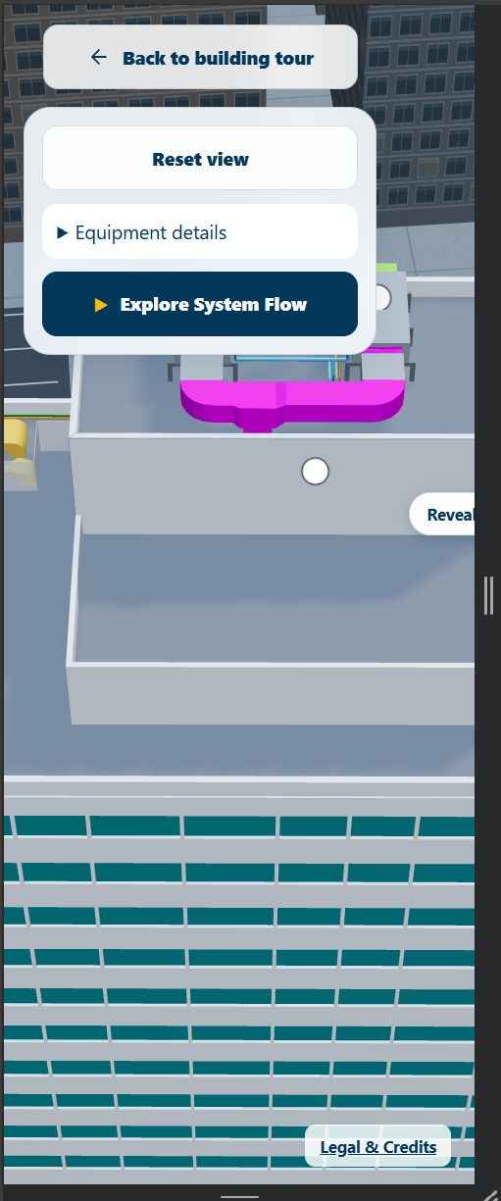
Earlier mobile state: controls and flow UI competed heavily with the 3D viewport.

Tablet evolution
Tablet initially inherited desktop-style panels, which were usable but visually too heavy. After exploring left rails, floating cards, side panels, and bottom docks, the design returned to the same bottom-sheet mental model as mobile for consistency, but with tablet-specific proportions.
- Tablet portrait became the primary reference orientation.
- Collapsed System Flow sheet was required to fit without a scrollbar.
- Expanded state had to remain bottom-anchored rather than turning into a left-side panel.
- Camera framing was adjusted only for tablet so the active rooftop used the exposed viewport above the sheet instead of leaving large areas of irrelevant city visible.
- Equipment popup placement was re-evaluated against the available screen space after sheet expand/collapse.
- All tablet work was explicitly isolated from mobile, desktop, and the parent 200 Water site.
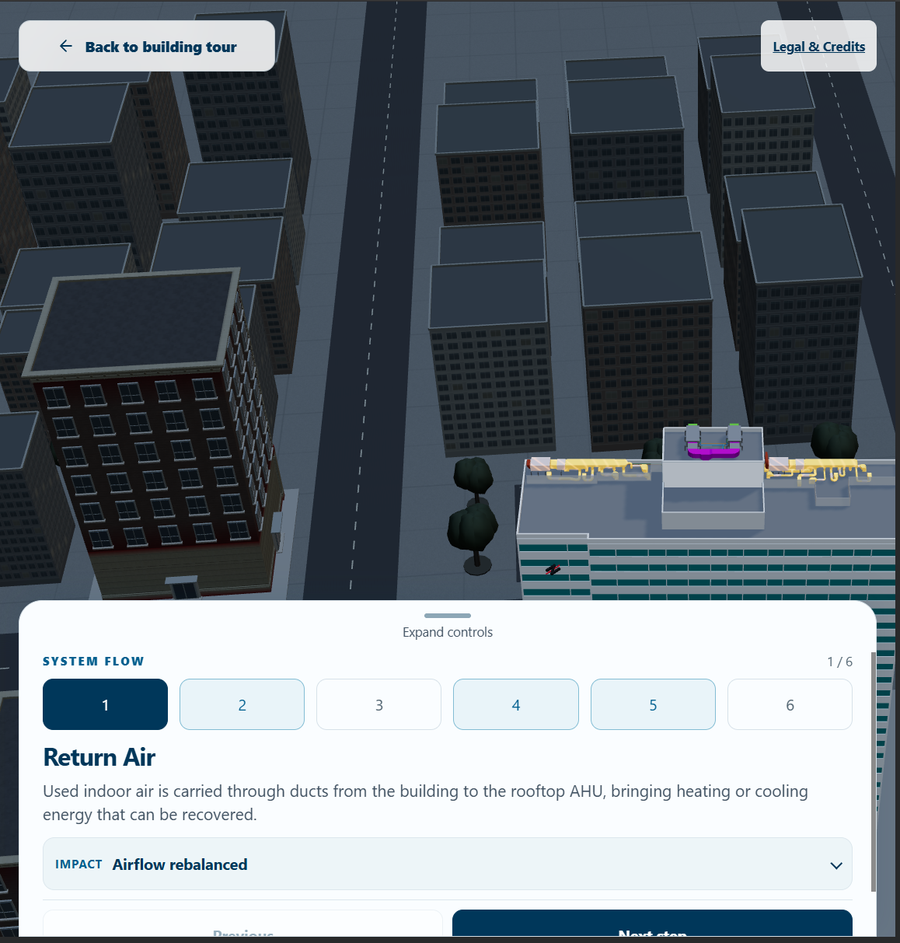
Tablet iteration: bottom sheet introduced, but the early version still needed camera and overflow refinement.

Desktop
Desktop retained the established floating control and System Flow presentation. The responsive redesign was intentionally not allowed to ripple upward and change the desktop experience that already had sufficient canvas area.

13. Accessibility: from visual experience to operable experience
The accessibility audit initially identified a key issue: the 3D canvas had an accessible name but no keyboard interaction equivalent for pointer-based OrbitControls. The final remediation added keyboard controls/instructions and verified the guided flow could be completed without a mouse.

Accessibility work completed
- Semantic buttons and visible focus treatment for controls.
- Keyboard-accessible 3D interaction, including rotate/zoom/reset behavior.
- Keyboard completion of System Flow: launch, previous/next, pause/resume, restart, exit.
- Accessible dialog behavior for equipment details and Legal & Credits, including focus entry, Escape close, and focus restoration.
- Meaningful alt text for equipment imagery and appropriate handling of decorative content.
- Reduced-motion support.
- Accessibility-tree inspection across multiple UI states.
- Automated axe checks across 16 states.
- Actual 200% browser zoom verification and responsive checks.

Final automated accessibility status
The final pre-launch report recorded automated accessibility PASS, keyboard-only flow PASS across three complete cycles, accessibility-tree PASS, and actual 200% zoom PASS. A short real NVDA/VoiceOver sanity check remained recommended as the final human verification rather than claiming formal WCAG/ADA certification solely from automation.

14. Legal, licensing, privacy, and release hardening
The project underwent a dedicated pre-launch rights and privacy audit. This was important because a visually polished 3D demo can still carry launch risk through undocumented model rights, copied manufacturer imagery, third-party code notices, analytics, or accidental exposure of internal files.

Asset/licensing conclusions
- 200 Water building/rooftop model: developed internally within RUHL by RUHL employees; project owner approved public use. The audit was updated from unknown provenance to internal-publication confirmation.
- Quaternius Downtown City MegaKit: traced to CC0; commercial use/modification permitted; visible attribution not required.
- Canary Wharf HDRI / Poly Haven: CC0; commercial use/modification permitted; visible attribution not required.
- Swegon/GOLD manufacturer material: no Swegon/GOLD imagery or manufacturer marks were found in the final runtime; reference material was not to be shipped.
- Three.js: MIT notice preserved through THIRD-PARTY-NOTICES.
- Lucide on the parent 200 Water page: audit recommended preserving the package license notice in the shared third-party notices file rather than adding promotional UI credit.

Privacy/security conclusions
- Production build excluded internal docs, QA scripts, audits, source-kit files, local paths, and development tooling.
- Three.js modules were self-hosted in the audited showroom to remove the only third-party runtime host observed during an earlier network audit.
- Final production network audit reported zero third-party runtime requests, no cookies, no localStorage/sessionStorage, and no console/network errors.
- No obvious API keys, passwords, .env files, production source maps, or internal absolute project paths were found in the production artifact scan.
- The remaining privacy consideration was host-level request logging and final Privacy Policy linkage, which depends on the production host rather than the app itself.

Legal & Credits UX
The first Legal & Credits implementation displayed the full MIT license body inside a large modal. This was legally acceptable but poor UX. The public-facing direction was simplified: a concise Legal & Credits modal with a link to the complete THIRD-PARTY-NOTICES file. Internal provenance/audit records remain private and are not exposed in the public build.

15. Integrating the finished showroom back into 200 Water
Once the standalone experience was stable, the goal became replacing the existing rooftop-model experience in the 200 Water page without harming the rest of the site.

Final integration pattern
- The showroom was integrated directly into the 200 Water project as a self-contained submodule/folder, not embedded as an iframe to a separate URL.
- The existing “Explore rooftop systems” CTA remained the entry point.
- The old rooftop viewer behavior was replaced by mounting/opening the new showroom.
- Showroom-heavy assets are lazy-loaded only when the CTA is used, so the main 200 Water page does not pay the full 3D cost on initial load.
- Old rooftop-only initialization was disabled so an obsolete WebGL renderer/assets would not continue running behind the new experience.
- CSS and JavaScript were isolated to prevent the showroom from leaking styles or globals into the parent page.
- On close, the showroom cleans up renderer/lifecycle resources, restores page scroll, and returns focus to the originating CTA.

Why this architecture mattered
It preserved the independently tested showroom while keeping the 200 Water site maintainable. The new page does not need to understand every internal Three.js detail; it only needs a clean mount/unmount integration boundary.

16. Deployment and production issues solved
The final stages also included practical deployment debugging. A production-only build was created in a `dist/` output rather than serving the repository root. This ensured internal documentation and source/reference material were not accidentally public.
Cloudflare deployment initially failed because Wrangler expected `./dist` while the Cloudflare build configuration had no build command, so the directory did not exist. The fix was to ensure the project runs its production build before `npx wrangler deploy`, preserving the production-only deployment model rather than changing Wrangler to publish the repository root.
The production configuration also included security-header guidance, MIME/cache checks, public-artifact verification, and runtime smoke testing.

17. The hardest design and engineering decisions
Challenge | Decision / learning
Dense engineering scene | Do not simplify the rooftop into a flat diagram; guide attention through sequencing, focus states, and camera choreography.
Invisible airflow | Combine vapor volume, directional ribbon/path, and sparse particles instead of using literal smoke or expensive volumetrics.
Equipment identity | Use small image/name callouts tied to actual model markers; avoid making another large information panel.
City realism vs focus | Use muted generic urban context; keep rooftop materials and active system visually dominant.
~1 GB browser memory observation | Profile before degrading the experience; city textures, not the flow system, were the dominant diagnostic target.
Responsive UI | Do not shrink desktop UI. Mobile and tablet require different compositions while preserving the same conceptual interaction model.
Tablet flow panel | Keep the same bottom sheet across collapsed/expanded states; adjust camera framing to the remaining viewport instead of turning the expanded sheet into a different layout.
Legal launch readiness | Separate public notices from private provenance/audit files; do not assume a visually generic asset is automatically licensed.
Integration | Lazy-load and mount/unmount the complete showroom rather than merging all of its logic into the parent page.

18. Final experience
The final Virtual Showroom is a browser-based interactive rooftop experience integrated into the 200 Water case-study page. A user can enter from the existing rooftop CTA, explore the rooftop spatially, inspect equipment, launch a guided six-step System Flow, see airflow/energy movement, understand equipment roles, open impact information, and exit back to the building page.
The experience is intentionally layered: the 3D rooftop remains the primary evidence, the System Flow provides narrative structure, equipment popups provide identification, and impact content explains why the system matters. Responsive layouts adapt that same mental model for desktop, mobile, and tablet rather than treating smaller screens as scaled-down desktop.

Measured/verified technical outcomes from QA
- Progressive city loading allowed controls and System Flow to become usable before optional city context finished loading.
- City failure became non-fatal to the rooftop experience.
- DPR cap reduced the drawing-buffer area on DPR-2 devices by the geometric ratio (1.5/2)^2, i.e. 43.75% fewer pixels, without claiming a measured FPS gain.
- Three repeated full-flow cycles stabilized renderer resource counts and showed only ~88 KB change in recorded JS heap samples.
- Hidden-tab tests confirmed rendering paused while hidden and resumed without a hidden-time camera jump.
- Production runtime audit reported zero third-party runtime origins, no cookies/storage, and no console/network errors.
- Automated accessibility, keyboard-only flow, accessibility-tree, and 200% zoom checks passed in the final pre-launch report.

19. Portfolio-ready narrative

Problem
The existing 200 Water rooftop experience let users inspect a detailed 3D roof, but the mechanical system was still difficult to understand without engineering knowledge. The challenge was to turn a dense rooftop model into an intuitive story about air movement, energy recovery, heat-pump support, and conditioned supply air — without sacrificing spatial realism or browser performance.

Approach
I reframed the experience as a guided virtual showroom. I mapped the system into six sequential steps, established a visual hierarchy for active versus contextual equipment, designed layered airflow cues, added equipment identification, and built responsive interaction patterns for desktop, mobile, and tablet. I also treated performance, accessibility, licensing, and production integration as part of the product rather than post-launch cleanup.

Key design decisions
- Six-step narrative instead of one overloaded technical scene.
- No-air-mixing story reinforced visually and verbally.
- Active/related/context/obstruction focus hierarchy instead of global blur.
- Generic, non-branded equipment visuals for public-facing identification.
- Bottom-sheet interaction on mobile/tablet to keep the rooftop dominant.
- Progressive city loading and context optimization instead of reducing the core flow experience.
- Direct lazy-loaded integration into the 200 Water page instead of an iframe.

Result
The finished experience gives users a clear path from “what is on the roof?” to “how does the system work?” and “why does it matter?” while remaining a real interactive 3D environment rather than a static explanatory graphic. The project also reached a production-ready state with automated accessibility checks, stable repeated-flow resource behavior, third-party licensing documentation, production-only deployment, and final integration into the live 200 Water project.

20. Skills demonstrated
Skill area | Evidence in this project
Product / UX strategy | Reframed a model-viewer into a guided explanatory product; defined narrative order and information hierarchy.
Interaction design | System Flow navigation, pause/restart/exit states, equipment callouts, focus hierarchy, responsive bottom sheets.
3D UX | Camera choreography, screen-space callouts, active-context framing, obstruction transparency, spatial storytelling.
Frontend engineering | Three.js integration, asset loading, lifecycle/disposal, modular architecture, responsive UI, production builds.
Performance engineering | Memory diagnosis, renderer/resource measurement, progressive loading, DPR strategy, city optimization, hidden-tab lifecycle.
Accessibility | Keyboard controls, semantic dialogs, focus restoration, reduced motion, axe/accessibility-tree/zoom QA.
Design systems / responsive design | Scoped desktop/mobile/tablet behavior; prevented cross-breakpoint regressions.
Risk / launch readiness | Asset-rights audit, third-party notices, privacy/network checks, secret/internal-file exposure prevention.
Cross-functional communication | Engineering approval of system flow/claims; project-owner approval of public building/rooftop use.

21. Accuracy guardrails — what NOT to claim in the public case study
- Do not call the current surrounding city the official NYC Planning / MN01 3D model. The audited runtime context is Quaternius-based generic urban context.
- Do not claim the generic equipment illustrations are photographs of the exact installed commercial units.
- Do not imply manufacturer endorsement.
- Do not present the smoke/particle animation as CFD or a physically simulated airflow model.
- Do not claim exact GPU memory from renderer.info or JavaScript heap; the project used estimates and browser/resource diagnostics.
- Do not claim formal WCAG/ADA certification solely from automated checks.
- Do not attribute broader whole-building decarbonization percentages to the rooftop ventilation intervention unless the approved source explicitly does so.
- Do not state that Blender was definitively the source of every active production GLB unless source/export evidence is available. Retrieved technical notes only partially verified Blender involvement, while active GLBs reported glTF-Transform metadata.

Appendix A — Project journey timeline
Phase | What changed
Original 200 Water building journey | Full-building scroll experience approached the roof and exposed an “Explore rooftop systems” CTA.
Rooftop detail mode | Separate roof-only model, camera alignment, drag rotation, reset, labels, and overlay logic.
Showroom reframing | Project became a standalone guided rooftop product rather than only a detail viewer.
System Flow | Six-step Return Air → Energy Recovery → Exhaust → Fresh Outdoor Air → Heat Pump → Supply Air narrative.
Flow visualization | Blue fresh-air vapor, orange exhaust vapor, cyan energy-transfer cues, ribbons/particles, no-mixing story.
Focus hierarchy | Active/related/context/obstruction states; avoid global blur/transparency.
Equipment identification | AHU/heat-pump image/name callouts tied to markers and step involvement.
Impact layer | Lightweight HTML/CSS/SVG impact cards, selectively mapped to relevant steps.
Performance investigation | ~1 GB tab-memory observation triggered diagnostics; city textures identified as dominant estimated category.
Performance pass | Progressive city loading, DPR 1.5, city no-shadow, hidden-tab pause, lifecycle guards.
City simplification | Three source buildings reused for sparse context; shared muted PBR materials; source textures disposed after replacement.
Accessibility pass | Keyboard canvas controls, flow keyboard completion, semantic dialogs, reduced motion, axe/tree/zoom checks.
Legal/privacy pass | Asset-rights register, notices, production-only artifact, zero third-party runtime origins in final audit.
Mobile redesign | Bottom sheet replaced large floating UI; impact collapsed; Legal moved out of viewport.
Tablet redesign | Portrait-first bottom sheet, no collapsed scroll, bottom-anchored expanded state, tablet-only camera reframing.
Final integration | Direct self-contained module inside 200 Water; existing CTA launches new showroom; lazy-loaded; old rooftop viewer disabled.
Deployment | Production dist build, Cloudflare/Workers deployment configuration and final smoke checks.

Appendix B — Source-of-truth notes
This master case study was reconstructed from the project’s technical extraction, performance optimization report, memory diagnostic, city asset audit, legal/rights audit, responsive iteration screenshots, and the implementation decisions recorded during development. Where two values belonged to different implementation stages, they are explicitly described as stage-specific rather than silently reconciled.
Any future public portfolio version should be shorter and should use only screenshots/assets that RUHL has approved for public portfolio use.

Recommended next step
Create a shorter portfolio version from this master: 6–8 sections, 2–3 key visuals per section, and a concise “challenge → decision → result” narrative. Keep this document as the full source-of-truth version for interviews and future editing.

