Perspective
Designing a playable metaphor for constraints, ideation, and human judgment in AI-assisted decision-making
Source document for a UX / product case study. This version preserves the full reasoning journey, workshop context, mechanics, iterations, and known design decisions. It intentionally avoids claiming participant outcomes or testing results that were not established in the project record.

Project | Perspective — browser-based 2D physics game
Context | Designed Minds Workshop 6: decision-making while building products with AI
Role | Concept, UX/game design, interaction design, facilitation framing, implementation direction
Core theme | How clearer criteria and constraints shape the possibility space while human judgment remains responsible for what moves forward

Executive summary
Perspective began as a workshop teaching problem: how do you make an abstract idea about AI-assisted ideation and decision-making tangible enough that participants can experience it rather than only hear about it? The workshop planning had converged on decision-making during ideation with AI as the sharper problem—not the mechanics of building with AI itself.
The resulting game uses a simple physical metaphor. AI-generated possibilities are represented as moving idea-balls. A funnel represents the criteria and constraints that shape the decision space. Two movable bars represent human judgment. A “Bucket of Ideas” represents options relevant enough to move forward. Participants play two versions of the same system: a broader possibility space and a more focused possibility space.
The design evolved significantly because the metaphor had to be conceptually honest. The goal was not to teach that convergence is inherently better than divergence. The intended lesson became more specific: when decision criteria are clearer, more of AI’s suggestions can be relevant to the decision a person is actually trying to make—while the person still owns the judgment about what moves forward.

1. Workshop context: why the game existed
Workshop 6 was being shaped around “Decision making in building a product with AI.” Early planning included ideation, research/analysis, testing, feedback, strategy, and team alignment, but the team narrowed the session toward a more specific pain point: decision-making while ideating with AI.

What emerged from the first workshop-planning discussions
- The real pain point was not the build itself; it was making decisions while ideating with AI.
- A common failure mode was scope creep: brainstorming with AI can become a rabbit hole where the original idea becomes harder to see.
- Different people appeared to use AI differently. One style discussed was more convergent: start with a narrower idea, add explicit constraints, and ask AI to fill gaps. Another was more divergent: begin with open exploration and allow more directions to emerge.
- The workshop objective shifted toward helping participants retain ownership of decisions rather than letting AI suggestions quietly determine the direction.
- A key unresolved question was decision quality: what makes an AI-assisted decision a good decision, and how can a person explain the reasoning behind it?
Working workshop objective: help participants take ownership of decisions while ideating with AI, rather than letting AI’s suggestions steer the direction by default.

Supporting workshop objectives
- Use more human judgment in the decision-making process.
- Show real examples of using AI during ideation.
- Explore decision quality: what makes a decision worth trusting or moving forward with?
- Help participants notice when AI is supporting their thinking versus shaping the direction without enough awareness.

2. The surrounding workshop story
The game was not designed as an isolated activity. It sat inside a broader workshop narrative about self-awareness, AI influence, and deliberate decision-making.
Workshop idea | Purpose | Connection to Perspective
AI ideation pattern | Participants inspect how they naturally think with AI across past conversations: what they ask, notice, ignore, explore, and when they commit. | Creates awareness that people do not use AI neutrally; their habits shape the decision process.
AI steering | A plain-language workshop term for moments when AI starts shaping what a person considers or chooses. | Shows why a person may need to deliberately manage the direction of ideation.
Broad vs. focused possibility spaces | AI can expand possibilities quickly, but more options can also create more judgment work. | Perspective makes this tension physical and playable.
Decision quality | AI can challenge assumptions and surface missing criteria without owning the final decision. | The game establishes the earlier step: shaping the option space before judging what moves forward.

3. The design problem
The initial conceptual statement was straightforward: AI can expand our thinking fast. More ideas lead to more options and more choices. That is useful while exploring, but when it is time to make a decision, more options can also mean more judgment.
That led to two modes in the workshop language:
Mode | Workshop meaning
Explore possibilities | Open the possibility space and discover alternatives.
Narrow toward a decision / define what matters | Set criteria, constraints, or priorities that make the remaining option space more relevant to the decision.

The key design question for the game became:
What changes when we set clearer criteria before asking AI for options?

This wording mattered. Earlier versions asked how to stop the possibility space from becoming “too broad,” but that could imply that divergence itself was the problem. The refined question keeps divergence useful while focusing the activity on the effect of clearer criteria.

4. The final conceptual model
The final game metaphor is intentionally simple enough to understand in seconds, but each element has a specific meaning.
Game element | Meaning | Important nuance
Idea-balls | Options / ideas AI gives you | More balls are not inherently better or worse.
Funnel | Criteria / constraints you give the decision | A wider funnel means less has been decided; a narrower funnel means more of what matters has already been defined.
Two movable bars | Human judgment | Even with constraints, the person still steers, rejects, redirects, and chooses.
Bucket of Ideas | Options that fit the decision well enough to move forward | The bucket does not mean “objectively good ideas.” It means relevant enough to continue.

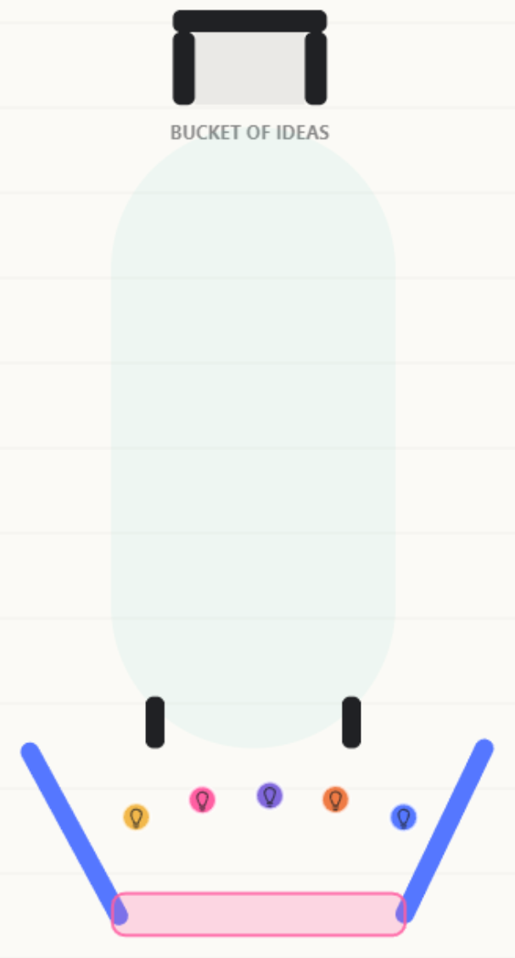
Gameplay reference used to annotate the metaphor: idea-balls, funnel/criteria, judgment bars, and Bucket of Ideas.
Core lesson: when decision criteria are clearer, more of AI’s suggestions can be relevant to the decision you are actually trying to make.

This is deliberately different from saying “convergence is better.” Divergence remains useful for discovering possibilities. The game focuses on what changes once the task shifts toward moving ideas forward into a decision.

5. The everyday example that anchored the explanation
A dinner example was used to translate the game metaphor into a familiar decision.
Broad request | Focused request
“Help me decide what to have for dinner.” | “Help me decide what to have for dinner, but within Indian cuisine and something I can make with ingredients I already have.”

In the broad version, many suggestions can be valid, but the person still has to decide cuisine, ingredients, effort, and other criteria afterward. In the focused version, some of those decisions have already been made by the human. AI is now exploring a smaller remaining uncertainty.
The deeper lesson: constraints are not merely prompt details. Each constraint can represent a small human decision made before AI helps with what remains uncertain.

6. Game experience and flow

Entry and tutorial
Because the game was intended for a live workshop, interaction needed to be understandable with minimal facilitator explanation. A visual tutorial was added before version selection.
- Click the idea ball to launch.
- After launch, the mouse becomes the two vertical bars; the bars move up and down.
- Use the bars to guide the ideas.
- Get as many relevant ideas as possible into the Bucket of Ideas.
The tutorial also included a compact visual legend: Ball = idea / option; Funnel = criteria / constraints; Two bars = human judgment; Bucket = ideas that move forward. The divergence/convergence explanation was intentionally withheld until after play so participants could first experience the contrast.
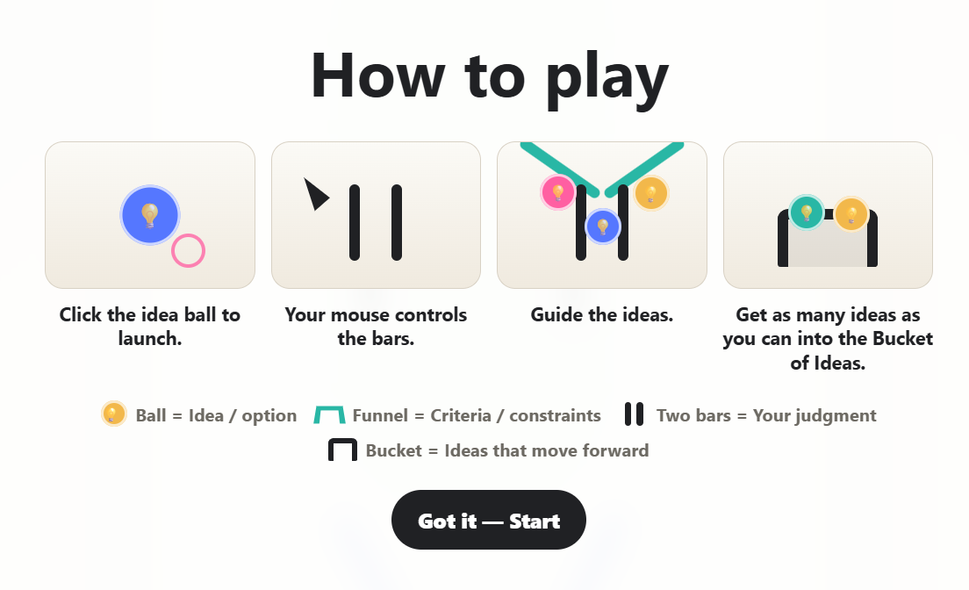
An intermediate tutorial screen showing the shift toward visual-first instructions and a legend for the game metaphor.

Version sequence
- The opening modal presents Version 1 and Version 2.
- Version 2 is locked until Version 1 has been played.
- After Version 1 finishes, Version 1 becomes unavailable and Version 2 unlocks.
- After Version 2, the game shows a side-by-side comparison rather than returning to version selection.
- Play Again resets the experience.

7. Mechanics as teaching devices

Starting and splitting
The player begins with one large ball. Clicking it launches the ball upward. When the ball enters the pink trigger zone at the funnel entrance, it becomes four smaller balls with different trajectories. This visually turns one starting idea into multiple possible directions.

Player control
After launch, the cursor is replaced conceptually by a pair of vertically oriented bars controlled by mouse Y movement. Their horizontal position remains fixed. This keeps the interaction simple: the participant is not “drawing” a path but intervening in the flow of ideas through judgment.

Physics and multiplication
The game used physics-driven trajectories and duplication to make possibility expansion visible. During the design process, bar collisions were identified as a source of conceptual imbalance: if hitting the human-judgment bars creates additional balls, the broad version can accidentally gain more scoring opportunities simply because wider trajectories cause more collisions.
That observation led to a cleaner conceptual principle: the idea space can generate possibilities; human judgment should primarily steer them. This was an important example of evaluating a mechanic not only for playability, but for whether it communicates the intended meaning.

8. Version 1 vs. Version 2
 | Version 1 | Version 2
Working concept | Broad possibility space | Focused possibility space
Earlier label | Open ideation | Constrained ideation
Funnel behavior | Wider / more open geometry; trajectories can spread more broadly | Narrower / more directional geometry; possibilities are more focused
Player | Same participant | Same participant
Goal | Move ideas into the bucket | Move ideas into the bucket
Judgment mechanic | Same bars | Same bars
Intended experience | More spread and more judgment work | Clearer boundaries make more suggestions relevant to the target decision

The fairness principle was important: Version 2 should not “win” because of a larger bucket, extra controls, dramatically slower balls, or an obviously easier rule set. The funnel / possibility-space geometry was intended to be the main conceptual difference.

9. Scoring, balancing, and an important contradiction
The final result screen compares how many ideas moved forward in each version. During tuning, an important problem emerged: because the system remained physics-based and the broad version could generate additional collisions, Version 1 could sometimes tie or outperform Version 2.
This mattered because the workshop demonstration was designed to show a focused possibility space producing more relevant options that can move forward. The cause was not necessarily the conceptual model—it was the interaction between multiplication and the player-controlled bars.

Design response
- Identify where extra balls were being generated rather than simply forcing a score difference.
- Recognize that bar-triggered multiplication conceptually confuses human judgment with idea generation.
- Prefer funnel / possibility-space behavior as the source of divergence while keeping bars focused on redirection.
- Avoid visibly rigging the outcome by enlarging the Version 2 bucket or simply rewriting the score after play.
- Keep any score difference modest enough that the experience still feels like the same game rather than an artificially easier second round.
Design principle learned: if the mechanic can produce the opposite lesson from the concept, the mechanic—not the explanation—needs to be questioned.

10. Language and copy evolved with the concept
Several small copy changes were made because language strongly affected how participants might interpret the game.
Earlier wording | Refined wording | Why it changed
Balls caught | Ideas moved forward | Avoided treating the game as a pure score and connected the bucket to the workshop metaphor.
Bucket | Bucket of Ideas | Made the destination conceptually legible during play.
Open ideation / Constrained ideation | Broad possibility space / Focused possibility space | Reduced the implication that “constrained” is automatically superior.
This is my perspective of ideation with LLM chatbots like ChatGPT. | My AI ideation perspective | Shorter and more natural for the result screen.
“Convergence is better.” | Explicitly rejected as the lesson | The workshop needed to preserve divergence as a useful mode rather than frame it as failure.

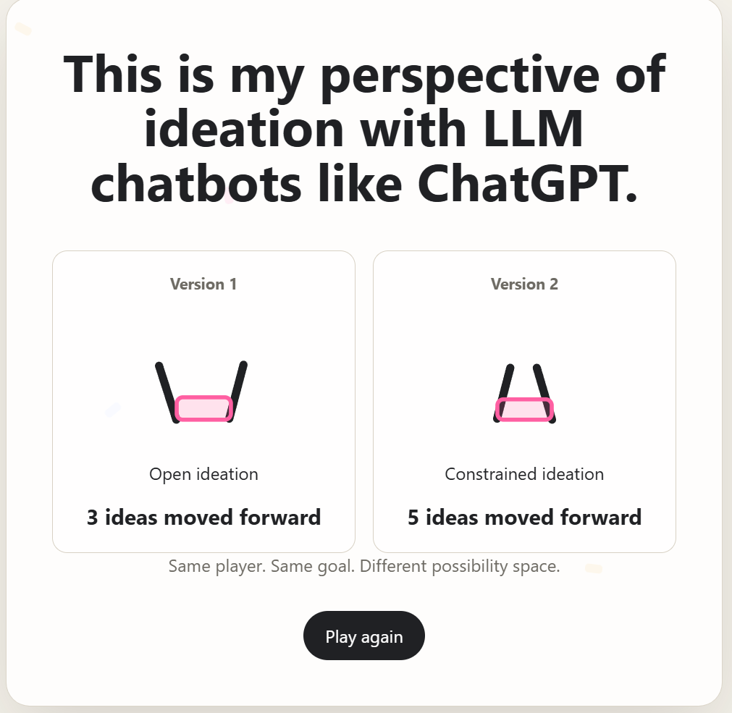
Result-screen iteration: side-by-side versions, “ideas moved forward,” and the neutral line “Same player. Same goal. Different possibility space.”

11. How the game was meant to be debriefed
The learning was designed to happen after play, not only inside the mechanics. The debrief reframes what participants just experienced.

Questions used to unpack the experience
- What changed between the two versions?
- Which version felt harder to control?
- Which gave you more room to explore?
- Which made it easier to move possibilities forward?
- What did you, as the player, still have to do in both versions?

Interpretation
The game is not meant to prove that a narrow funnel produces objectively better ideas. It demonstrates that once a person has decided some criteria, AI can explore a more relevant space. The bars remain important because constraints do not eliminate human judgment.
AI can expand the possibility space. Criteria shape that space. Human judgment still decides what moves forward.

12. Connection to AI steering
The game followed a workshop discussion about AI steering. In this workshop, AI steering was used as a plain-language label for when AI starts shaping what a person considers or chooses. The workshop avoided absolute labels such as “good steering” and “bad steering”; instead, examples were framed subjectively, such as “When AI Steering Added Value” and “When AI Steering Pulled Me Off Track.”
This connected naturally to the game: once participants notice that AI can influence direction, the next question is whether they need more possibilities or clearer criteria. Perspective provides a way to make that directional control visible.

13. Connection to decision quality
Perspective was one part of a larger workshop sequence. Another activity used AI as a devil’s advocate: participants make a decision first, ask AI to challenge assumptions, surface overlooked factors, argue for alternatives, and identify what should be verified, then decide whether to keep, revise, or switch.
The relationship between the two activities is complementary:
Perspective | Devil’s Advocate activity
Shapes the option space before or during ideation. | Challenges the reasoning behind a decision after an initial choice exists.
Asks: what criteria should guide what AI explores? | Asks: what assumptions, risks, alternatives, or missing evidence could change the choice?
Focuses on relevance of possibilities. | Focuses on quality and defensibility of reasoning.

Together, they support the broader workshop message that AI can help expand, challenge, compare, and surface blind spots, while the human remains responsible for the criteria, interpretation, and final judgment.

14. Iteration journey
The project changed through repeated checks against the workshop concept. The most important iterations were conceptual, not cosmetic.
Iteration | What changed | Reason
1. From explanation to experience | Instead of only teaching divergence/convergence, create a physics game participants can play twice. | Make an abstract idea tangible and memorable.
2. Define the metaphor | Balls, funnel, bars, and bucket were assigned explicit meanings. | Prevent the game from feeling like an unrelated arcade activity.
3. Reframe convergence | Move away from “convergence is better.” | Preserve the value of divergence and focus the lesson on relevance to a decision.
4. Clarify the bucket | Rename it “Bucket of Ideas” and describe the result as “ideas moved forward.” | Avoid equating scoring with objective idea quality.
5. Add visual semantics | Add lightbulb symbols to balls. | Make “ideas/options” readable without explanation.
6. Add visual tutorial | Show launch, bar control, guiding, and bucket goal with illustrations. | Reduce workshop friction and facilitator dependence.
7. Diagnose score inconsistency | Notice broad trajectories could create extra bar collisions and extra balls. | Physics behavior could contradict the intended teaching point.
8. Separate generation from judgment | Question/limit multiplication caused by judgment bars. | Make bars represent steering rather than generating more possibilities.
9. Refine result language | Use “Broad possibility space” / “Focused possibility space.” | Keep the comparison neutral and conceptually precise.

15. Implementation notes
The game was implemented as a browser-based 2D physics experience and published as a static GitHub Pages site. The repository includes HTML, CSS, JavaScript, configuration data, and a vendored Matter.js physics library. The interaction was designed primarily for desktop workshop use, with mouse-driven control of the vertical bars.
The implementation was intentionally configurable so physics values, funnel geometry, ball behavior, and layout could be tuned while preserving the same overall interaction. This mattered because the concept depended on a perceptible but credible difference between the two possibility spaces.

16. UX and game-design principles used
- Learn by doing: participants experience the difference before receiving the conceptual explanation.
- One primary interaction: after launch, the only meaningful control is moving the paired bars vertically.
- Progressive disclosure: tutorial first, Version 1, then Version 2, then interpretation.
- Consistency across comparison: keep the player, goal, controls, and core system stable so the possibility-space change remains meaningful.
- Visible mapping: lightbulbs, bucket naming, and legend make the metaphor easier to decode.
- Avoid false precision: the game is a metaphor for decision space, not a scientific measurement of decision quality.
- Protect participant agency: the final explanation emphasizes human judgment rather than positioning AI or constraints as an automatic decision-maker.

17. What this case study should not claim
To keep the portfolio story accurate, the following should not be presented as established outcomes unless later evidence is added:
- Do not claim that the game scientifically proves convergence produces better decisions.
- Do not claim that a higher Version 2 score proves better idea quality.
- Do not claim participant learning, engagement, satisfaction, or behavior-change metrics unless those were actually measured.
- Do not claim usability testing results that were not documented.
- Do not describe “AI steering” as a formally established academic term coined for this exact meaning; in the workshop it was used as a simple facilitator label.
- Do not claim that the game models LLM behavior literally. It is a designed metaphor for the human experience of expanding and narrowing an option space.

18. Strong portfolio narrative
A concise portfolio story can be built around one sentence:
I turned an abstract problem in AI-assisted decision-making into a playable metaphor, then iterated the mechanics until the game taught the intended concept rather than merely looking fun.

Recommended case-study structure
- Context — Workshop 6 and the shift toward decision-making during AI ideation.
- Problem — AI can expand options quickly; more options can also increase judgment work.
- Insight — constraints are human decisions about what matters, not just prompt-writing tricks.
- Concept — balls, funnel, bars, and bucket as a physical decision-space metaphor.
- Prototype — two versions with the same goal and controls but different possibility spaces.
- Critical iteration — physics and multiplication sometimes contradicted the lesson; mechanics were reconsidered.
- Communication design — tutorial, lightbulb semantics, “Bucket of Ideas,” and neutral result language.
- Workshop integration — game debrief, dinner example, AI steering, and decision-quality activities.
- Learning — every mechanic communicates; conceptual accuracy matters as much as functional correctness.

19. Portfolio-ready copy bank

One-line project description
A browser-based physics game that helps workshop participants experience how decision criteria and constraints can shape the possibility space when ideating with AI.

Problem statement
AI makes it easy to generate more directions, but more possibilities can also create more judgment work. I wanted to make the effect of clearer decision criteria tangible without teaching that divergence itself is a failure.

Core insight
Constraints are not only prompt details; they can represent decisions the human has already made about what matters.

Design principle
Same player. Same goal. Different possibility space.

Key takeaway
Clearer criteria can make more AI-generated options relevant to the decision at hand, but human judgment still determines what moves forward.

Reflection
The hardest part was not building the physics interaction. It was making sure the physics did not accidentally teach the opposite of the workshop concept. The project reinforced that in an explanatory experience, mechanics are part of the argument.

20. Source trail used for this document
This document was assembled from the established project discussion and artifacts in the conversation: workshop-planning notes, the evolving divergence/convergence framing, the AI-pattern and AI-steering workshop sections, the game mechanics and implementation prompts, tutorial iterations, gameplay/result screenshots, score-balancing discussion, and the dinner example used to explain constraints. No participant outcome data or unrecorded research findings were added.

