Game Design Document

Fill up the following document

1. Write the title of your project.

Corona Killer

1. What is the goal of the game?

Killing the corona images

1. Write a brief story of your game.

The life was peacfull, but when the corona virus came it made had made it hard for all human beings to survive. No one could go anywhere,

There were curfew lockdowns and many more things. People had to where masks. There was no medecine or treatment for this, But now out great scientist have made the vaccine. We have to kill the virus so we have to give the vaccine so lets start.

1. Which are the playing characters of this game?

* Playing characters are the ones who respond to the user based on the input from the user.
* Cars, monkeys, dinos, wizards, etc., are the playing characters in the game.

|  |  |  |
| --- | --- | --- |
| Number | Character Name | What can this character do? |
| 1 | The player 1 | Move and Kill the corona |
| 2 | The player 2 | Move and Kill the corona |
| 3 |  |  |
| 4 |  |  |
| 5 |  |  |
| 6 |  |  |
| 7 |  |  |
| 8 |  |  |

1. Which are the Non-Playing Characters of this game?

* Non-Playing characters are the ones that don't have an action or behavior when the user interacts with the game.
* Hurdles, stones, bananas, coins, etc., are non-playing characters in the game.

|  |  |  |
| --- | --- | --- |
| Number | Character Name | What can this character do? |
| 1 | Corona virus 1 | Move around |
| 2 | Corona virus 2 | Move around |
| 3 | Corona virus 3 | Move around |
| 4 | Corona virus 4 | Move around |
| 5 | Corona virus 5 | Move around |
| 6 | Corona virus 6 | Move around |
| 7 |  |  |
| 8 |  |  |

Draw your imagination of this game. What does this game look like?

* Draw the game either on your computer or on paper.
* Add images of the game scenes to show each of the playing and non-playing 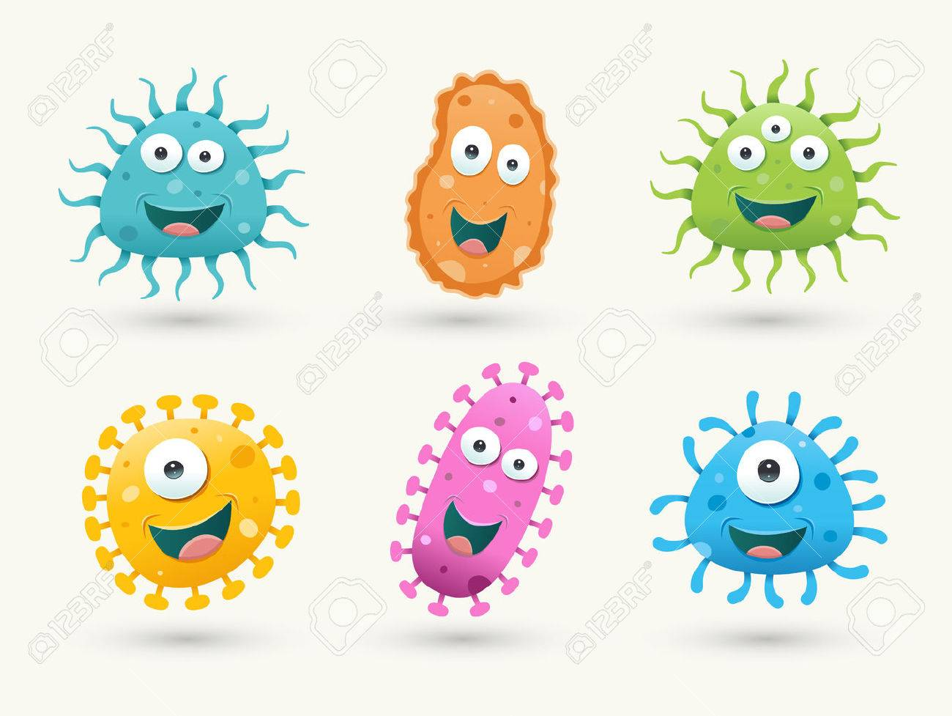characters at least once.

How do you plan to make your game engaging?

The background will be of a hospital and the player will get one injection. When one player kills one virus the score will increase and the player with more score wins.