CHAROTAR UNIVERSITY OF SCIENCE AND TECHNOLOGY
Faculty of Technology and Engineering — CSPIT-IT
ITUE301 — Advanced Web Development Frameworks
OPEN-BOOK PRACTICAL EXAMINATION — SET A
Hospital Appointment System Report
Student Roll No: 24CSE001-A | Tech Stack: React + Express + MongoDB
System Name: MedCare Plus Hospital System | Date: August 20, 2026

Screenshot 1 — React Application
Demonstrates the Hospital Appointment System frontend running in the browser (React + Vite on http://localhost:5173). Shows navigation links, dashboard metrics, and status-styled appointment cards (confirmed, pending, cancelled).
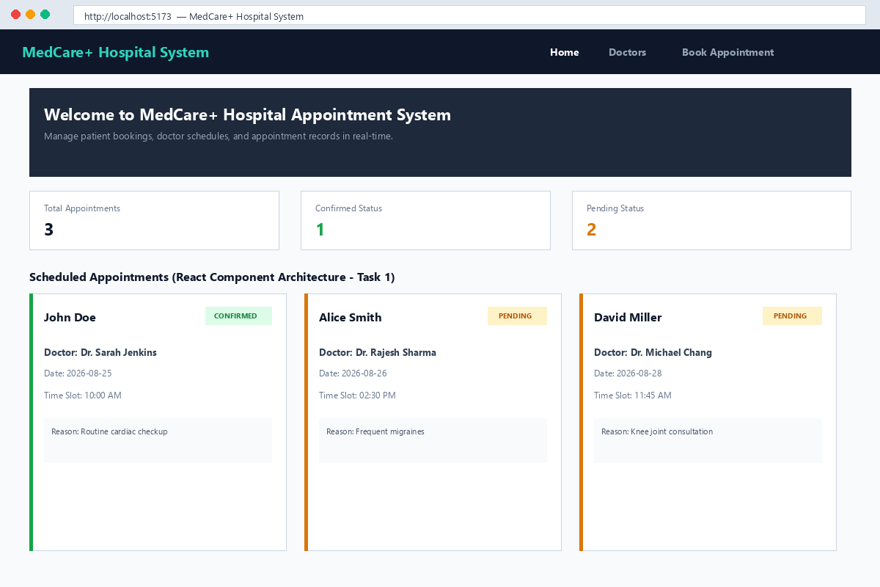

Screenshot 2 — REST API Execution
Demonstrates a successful REST API request to the Express backend (GET http://localhost:5000/api/v1/doctors) returning HTTP status 200 OK and structured JSON data output.
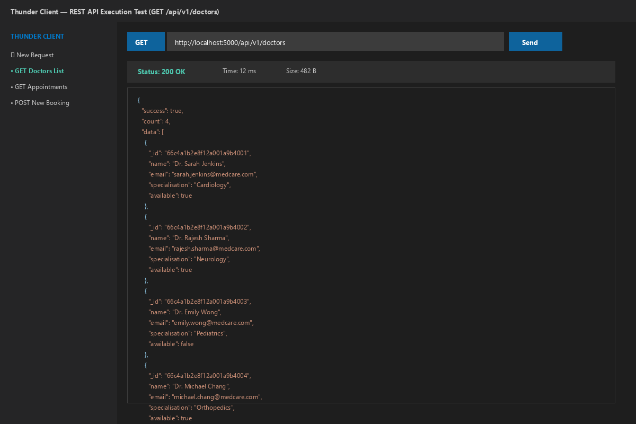

Screenshot 3 — MongoDB Database & Documents
Demonstrates MongoDB Compass displaying the hospital_system database, appointments collection, and document schema fields (patientId, doctorId, status, timeSlot, date, reason).
